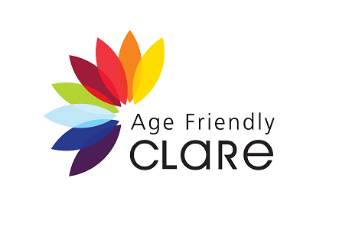
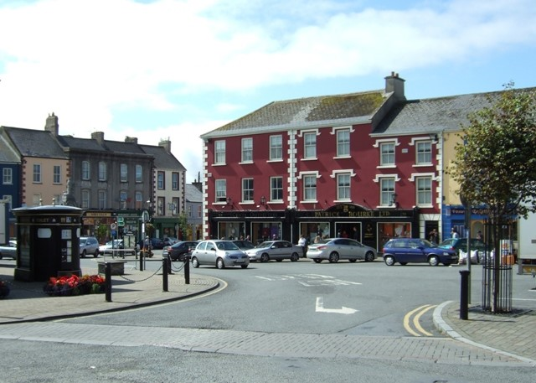

Universal Design Walkability Audit Report
Kilrush, County Clare | 2020

Acknowledgements

The following people and organisations are acknowledged and thanked for their input and participation in this project. Age Friendly Ireland and the Centre for Excellence in Universal Design at the National Disability Authority would like to thank the following:

• | The Alzheimer Society of Ireland
• | Brothers of Charity, Kilrush, County Clare
• | Clare County Council
• | Clare Older People’s Council
• | Kilrush Family Resource Centre
• | Kilrush Tidy Towns

Foreword from Clare County Council
As Chief Executive of Clare County Council and Chairperson of the Clare Age Friendly Alliance, it gives me great pleasure to present this report of the pilot walkability study of Kilrush. It was completed using the Universal Design Walkability Audit Tool, developed by the National Transport Authority in conjunction with the Centre for Excellence in Universal Design and Age Friendly Ireland.

This study is a collaborative approach in keeping with the strategic objectives of the Clare Age Friendly Strategy 2018-2022. Particular thanks to Karen Fennessy, Clare Age Friendly Programme Manager, Derek Whyte, Age Friendly Planning Consultant and Ruth O’Reilly &Aisling Glynn from the National Disability Authority who facilitated the groups on the day. I would also like to thank the Clare Older People’s Council, Brothers of Charity, the Alzheimer Society of Ireland, Kilrush Family Resource Centre & Kilrush Tidy Towns Committee for their participation in this project.

The walkability audit is a practical, low cost method of engaging local people with their town structures. It can provide very useful information on where changes can be made to increase a town’s accessibility.

This report will be shared with local authority staff and other key stakeholders. It will also serve to inform future applications for funding under local and national schemes administered by various Government Departments, State Agencies and non-government organisations (NGO’s). By working together and harnessing productive partnerships the residents of Kilrush will share in the completion of initiatives which will be responsive to their needs.

I would like to acknowledge the contribution of Age Friendly Ireland and the National Disability Authority who have jointly commissioned and funded this report.
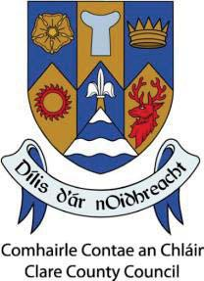
Pat Dowling, Chief Executive
and Chair of the Clare Age Friendly Alliance

Foreword from the National Disability Authority

Good design of roads and streets in our towns and cities is key to ensuring that people can get out and about in their local area and participate in community life. The Centre for Excellence in Universal Design at the National Disability Authority was pleased to work with Age Friendly Ireland on this walkability audit of Kilrush, County Clare, to pilot a draft national Universal Design Walkability Audit Tool being developed by the National Transport Authority. As well as recommending actions to improve the walkability of Kilrush, participants on the audit also provided very useful feedback to inform our advice to the National Transport Authority on further improvements to the audit tool.
A Universal Design approach places people at the heart of the design process, so that buildings and environments can be accessed, understood and used by all people, to the greatest extent possible, regardless of their age, size, ability or disability. A Universal Design approach involves users in the design process from an early stage and prioritises the involvement of users with the most diverse abilities and characteristics, to the greatest extent possible. The involvement of Kilrush residents of different ages and abilities in this walkability audit demonstrates the value of a Universal Design approach, as the actions recommended in the report, if implemented, will benefit all people living in and visiting Kilrush.
We would like to thank the Kilrush residents who participated in the walkability audit, as well as officials from Clare County Council who gave us feedback on an earlier draft of this report, to make it easier to use and implement. We look forward to further opportunities to work in partnership with Age Friendly Ireland.

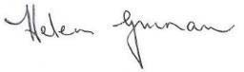
Helen Guinan,
Chair, National Disability Authority

Contents
Executive Summary 1
Introduction 3
Age Friendly Ireland 3
Age Friendly Walkability Audits 3
Why is a Walkability Audit important? 5
Universal Design and Walkability 6
Kilrush Demographics 6
Kilrush Walkability Audit 7
Summary Findings from Walkability Audit 10
Actions 16
Action 1 Pedestrian Crossings 16
Action 2 Footpaths and Dropped Kerbs 19
Action 3 Public Seating 24
Action 4 Parking 27
Action 5 Utility Boxes and Poles 31
Action 6 Signage and Temporary Works 33
Action 7 Town 35
Action 8 Public Toilets 36
Conclusions 37
Recommendations 38
Quotations from Participants 42

Executive Summary
A walkability audit for Kilrush, Co. Clare was organised by Age Friendly Ireland and the Centre for Excellence in Universal Design at the National Disability Authority. The aim of the audit was to pilot a draft Universal Design Walkability Audit Tool which is being developed by the National Transport Authority, with advice and expertise provided by Age Friendly Ireland, An Taisce Green Schools and the Centre for Excellence in Universal Design. Universal Design is the design and composition of an environment so that it can be accessed, understood and used to the greatest extent possible, by all people regardless of their age, size, ability or disability. The Universal Design Walkability audit tool is based on a model used by Age Friendly Ireland in its Age-Friendly Cities and Counties Programme and by the An Taisce Green Schools Programme, comprising community-led public participation walkability audits of roads and streets in Irish towns. The results of the audit set out in this report are a direct result of that public participation process.
Listening to people’s issues and opinions informs a walkability audit. The objective of the audit is to accurately capture the needs and desires of people with a wide range of ages and abilities, in relation to their experience of using their local roads and streets. This includes for example, parents with buggies, older people and persons with disabilities.
Kilrush aims to be walkable and the contents of this report reflects the views and opinions of the stakeholders and participants of the Kilrush walkability audit, which included a representative from Clare County Council on the day of the audit.
Kilrush has a fantastic community spirit and volunteerism is extraordinarily strong in the town. There is a great sense of pride and an acknowledgement of the historic fabric of Kilrush and its sense of place within Co. Clare. The walkability audit was a huge success, with high numbers of participants, across a wide range of ages and abilities and as a result of this, the findings of the walkability audit are very real and truly relevant.
While some of the initial findings reflect the more negative elements of Kilrush’s walkability, it also represents a wide area for significant improvement. Walkability audits, by their very nature, tend to focus on the negative issues – the audit is to identify those issues to help inform solutions. Most of the comments and observations were balanced, participants recognised the problem areas and they were also quick to point out the positive elements of Kilrush. However, overall, the participants were not satisfied with the walkability of Kilrush.
Significant scope exists for Kilrush to improve its public realm and become more walkable. The 10 highlighted actions, which are detailed later in this report, if implemented, should greatly improve the walkability of Kilrush and will therefore improve the lives of people in Kilrush:
- Action 1: Improve the provision of safe, accessible pedestrian crossing points, including pedestrian crossing(s) to access Market Square.

- Action 2: Provide dropped kerbs and tactile paving at pedestrian crossing points and design a priority list for footpath repair works in conjunction with the relevant stakeholders.

- Action 3: Provide public seating at appropriate locations in the town.
- Action 4: Investigate the possibility of additional age-friendly and additional accessible parking spaces in Kilrush and provide in more dispersed locations such as Henry Street and Toler Street. Investigate how parking for business deliveries can be better catered for in the town. This should include engagement at a local level on appropriate locations for age- friendly and accessible spaces and spaces for deliveries.
- Action 5: Undertake an audit of poorly located utility boxes and poles to see if any can be relocated.
- Action 6: Continue to work with businesses in relation to on-street signage and other clutter and create an awareness of the negative impact they can have for pedestrians. Liaise with Local Authority and Service Providers to highlight the impact of temporary works in Kilrush.
- Action 7: Investigate the potential of an urban re-design to improve the public realm at this Market Square with the relevant stakeholders, including the provision of facilities at the bus-stop.
- Action 8: Improve the access to the existing public toilet by creating a safe pedestrian crossing to Market Square, this action is linked to Action 1 above.

- Action 9: Identify the blackspot areas for rain-water pipes discharging onto the footpath and liaise with relevant stakeholders to repair the faulty downpipes.
- Action 10: Identify the blackspot areas for dog-fouling and liaise with local authority regarding possible remedies, for example a local awareness campaign.

Introduction

Age Friendly Ireland

Age Friendly Ireland is a shared service of local government that manages the national Age Friendly Programme in Ireland. We are affiliated to the World Health Organization under their global Age Friendly Cities and Communities Programme. In 2019, Ireland was recognised by the World Health Organization as being the first country in the world to be fully affiliated to their global programme across all administrative areas.
Age Friendly work is delivered in the context of population ageing which will become a significant challenge both in Ireland and internationally. As life expectancy increases, the need to ensure that Ireland becomes a great country in which to grow old is increasing too. We need to plan now to create the kinds of communities in which older people live autonomous and valued lives.
One of the eight pillars of the World Health Organization’s Age Friendly Programme focuses on the built environment. Assessing the ‘walkability’ of a town or village is fundamental to understanding how people access their community.
Each local authority in Ireland manages a local Age Friendly Programme with the involvement of multidisciplinary stakeholders. Older people’s participation and co-design of the programme is facilitated by a local Older People’s Council in every local authority area.
These Local Age Friendly Programmes work to provide walkable streets, housing and transportation options, access to key services and opportunities for older people to participate in community activities. By doing so, these communities are better equipped to become great places, and even lifelong homes, for people of all ages.
Age Friendly principles are a core part of government policy, embedded in the new Programme for Government (2020) particularly with reference to housing, the built environment and health.

Age Friendly Walkability Audits

Good design of roads and streets in our towns and cities is key to ensuring that people can get out and about in their local area and participate in all their community has to offer. Age Friendly Walkability Audits have been carried out in many locations across Ireland over the past decade. The original Age Friendly walkability survey was designed with support from the Centre for Excellence in Universal Design.
The National Transport Authority initiated a process of developing a Universal Design walkability audit tool in 2019. This was largely based on the original Age Friendly survey but was developed further with input from Age Friendly Ireland, the Centre for Excellence in Universal Design and An Taisce, as part of their Green-Schools Programme. To reflect a Universal Design approach, it is

important to have participants with a diverse range of ages and abilities undertaking the audit. This includes for example, parents with buggies, children, wheelchair users, older people with reduced mobility and people with low vision.
This pilot was instigated by a board member of the National Disability Authority who was particularly interested in testing Universal Design Walkability Audit Tool. The National Disability Authority then approached the National Transport Authority to offer to organise the pilot in Kilrush. As a partner in this initiative, Age Friendly Ireland supported the process by connecting the NDA with the local Age Friendly Programme Manager.
Walkability audits using a Universal Design approach provide valuable evidence of the features of roads and streets that can prevent people with a wide range of ages and abilities from easily accessing local amenities, shops and services in their community.
Walkability audits are important in the context of national data on older people’s attitudes to the public realm. Data from the Healthy and Positive Ageing Initiative [HaPAI] found that that 45% of respondents surveyed (aged 55+) were dissatisfied with the availability of seats in outdoor spaces, 27% were dissatisfied with the quality and continuity of pavements, 21% were dissatisfied with the number of pedestrian crossings, and 64% were dissatisfied with the availability of accessible toilets. At local level, walkability audits can highlight where changescan be made that will benefit older people and all members of the community.
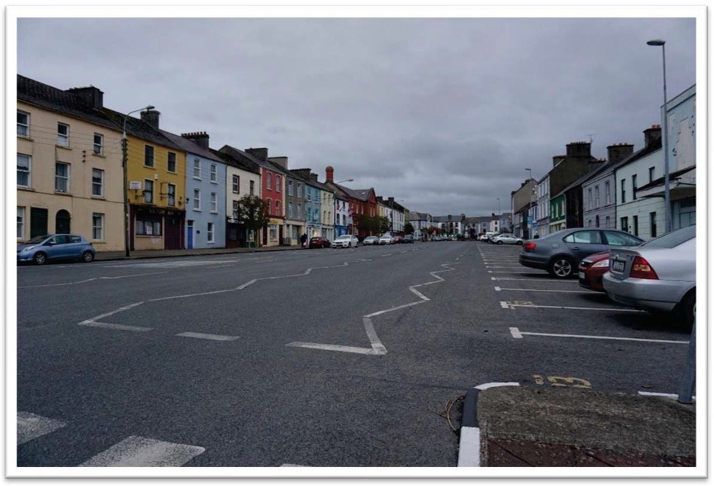

Figure 1 Kilrush is a traditional, attractive Irish Market town.

Why is a Walkability Audit important?

Determining the walkability of Kilrush is essentially an attempt to enhance and improve the lives of all people who live in and visit Kilrush. By attaining a level of walkability, people with a range of ages and abilities are encouraged to actively participate in social places, encouraged to walk their town, city or village, expected to be visible on the street or in the park, as well as contributing to the local business economy. Physical barriers to social inclusion often exist by default and may not be immediately obvious to people, but can be identified in a walkability audit, using a Universal Design approach.
Objective
The objective of this Universal Design Walkability Audit is to increase awareness of the specific spatial needs of people with a wide range of ages and abilities, including for example, parents with buggies, older people and persons with disabilities. It aims to promote walkability and a Universal Design approach in the existing urban environment of Kilrush.
It is anticipated that the evidence-based learnings collected on the walkability audit, can help inform urban designers, architects, engineers, planners, local authority officials, community groups and developers and anybody who intends to improve, develop, repair or maintain the urban environment in Kilrush.
It is hoped that the narrative, bullet points and photograph examples can inform decision makers and allow an understanding of the diverse needs of people of different ages and abilities who live in Kilrush.
Specifically, this publication aims to provide an evidence-based, public-participation informed resource to help inform and deliver potential solutions to the issues raised by the walkability audit.

Note on Cluster Maps in this report:
This report contains several cluster maps and the objective of the cluster map is to highlight the general location of the desired action or objective. It is not intended to be prescriptive in the location of the clusters as the implementation of desired actions or objectives will require a collaborative approach by several stakeholders.

Universal Design and Walkability

“The independence to walk, even short distances, is paramount to feeling involved in a community”1
What is Universal Design?
Universal Design is the design and composition of an environment so that it can be accessed, understood and used to the greatest extent possible by all people regardless of their age, size, ability or disability. An environment (or any building, product, or service in that environment) should be designed to meet the needs of all people who wish to use it. This is not a special requirement, for the benefit of only a minority of the population. It is a fundamental condition of good design. If an environment is accessible, usable, convenient and a pleasure to use, everyone benefits.

What is Walkability?
Burden (2010) defined walkability as “The extent to which the built environment is friendly to the presence of people walking, living, shopping, visiting, engaging or spending time in an area”.
The key word in this definition is “friendly” and it is the subjective nature of the reader’s understanding of “friendly” which is important to the understanding of walkability. Walkability refers to the ease at which people of different ages and abilities can walk an area, building or space. Regardless of age, size, ability or disability, the walkability of an area affects all persons, however older people, persons with disabilities and parents with young children may be more aware of the barriers to walkability.
Thoughtful forward planning and careful consideration in relation to spatial location can greatly increase the walkability of an area and small changes can mean big differences to people who use the area’s roads and streets. It is acknowledged that it is aspirational to have all areas up to a high standard of walkability, but some small interventions can make existing un-walkable areas much more walkable and these interventions can be the catalyst for change.

Kilrush Demographics
The heritage town of Kilrush is the second largest town in Clare with the distinction of having Ireland’s second widest street - Francis Street. It is a historically important market town that lies on the Shannon estuary and has a busy marina. Kilrush Marina is a significant natural tourism and leisure resource located within walking distance of a vibrant town centre.

1 Walkability Participant, Dublin City University Walkability Audit

The town serves as the main retail, administrative and service centre to both local residents and the wider community in West Clare. It is well served by national (N67 and N68), regional (R483, R473) and local routes which link the town to the Hub town of Ennis, Loop Head, the rest of County Clare and the Mid West region. In addition, the Kilimer-Tarbert car ferry, located 10km from Kilrush, provides an efficient and swift link to the road network along the Shannon estuary and onwards to Limerick, Kerry and Cork.
The town centre is focused around the Market Square, with all routes radiating from this point. The sense of place in that part of the town is very strong. The nucleus of the town, Market Square, connects to the harbour area by the powerful axis of Francis Street. The layout clearly shows that the town’s original priority was connection to the water.
Kilrush has a significant network of trails and green amenities. Both Kilrush and Cappa village are situated on the Wild Atlantic Way.
Services in the town include: Super Markets, Shops, Pubs, Restaurants, Pharmacies, Post Office, Bank, Bus Stop, Tourist Office, Golf Course, Marina: Boat trips to Dolphin Watching, Scattery Island.
The small area population statistics (SAPMAPS) from the Central Statistics Office website, was used to determine that Kilrush has a population of 2,716 persons within the small-town area. This does not include the hinterland of Kilrush. Approximately 34% of these people are over 55 years old, with 10% over 75 years old. Currently, the percentage of people registered with a disability in Kilrush is 22%.

Kilrush Walkability Audit
A walkability audit was undertaken in Kilrush on the 16th October 2019. The process involved two walking groups, who walked the dedicated routes shown on the following maps and observed a range of physical barriers to the walkability of Kilrush. Each group consisted of several participants with a range of ages and abilities, including individuals using wheelchairs, people with low vision, older people with reduced mobility and people with intellectual disabilities. A
co-ordinator walked the route with each group. Some participants were accompanied by assistants. There were twenty participants in total.
After the walkability audit a de-briefing meeting was conducted with participants where the issues raised during the walkability audit were discussed. Participants filled out the draft walkability audit tool individually or in a group, based on their preference. Some people were also provided with assistance to complete the audit tool.

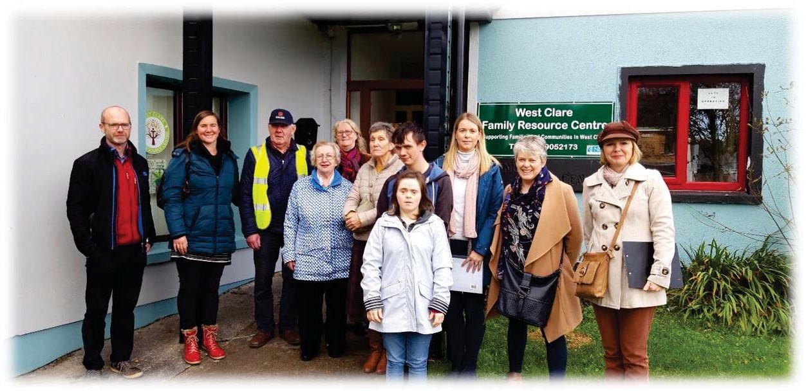

Figure 2 Participants in Kilrush Walkability Audit

It should be noted that this walkability audit was undertaken on two routes in Kilrush Town and as a result, it gives a feel for the overall walkability of the town, including the main street, Frances Street. The routes were selected as priority routes, as they are important for local people, giving access to facilities such as the post office, supermarket, library, community centre, banks, shops, pubs, restaurants, community hospital, nursing home and schools.
The two routes walked are shown on the maps below:
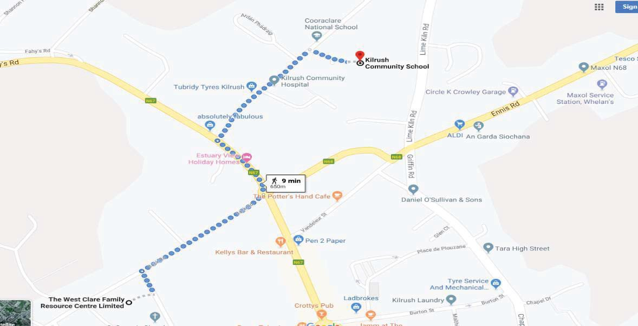

Figure 3 Route 1: Community Centre to Kilrush Community School

Map of Route No. 1 – Community Centre to Kilrush Community School

Route 1 was selected to start at the Community Centre. The group assembled and walked the “Back Road” up to the junction of Fahys Road and the N67 and proceeded up Fahys Road,

turning down the R483 (Cooraclare Road) towards Kilrush Community Hospital and Community School. This route was selected as it included the Community Centre, Kilrush Library, Primary School, Gael Scoil, Secondary School, Youth Centre, a large nursing home and the Community Hospital. Participants walked back the same route on the opposite side of the road to the Community Centre. The route also included the crossing of some busy junctions, a slightly uphill section and is a busy area of Kilrush.
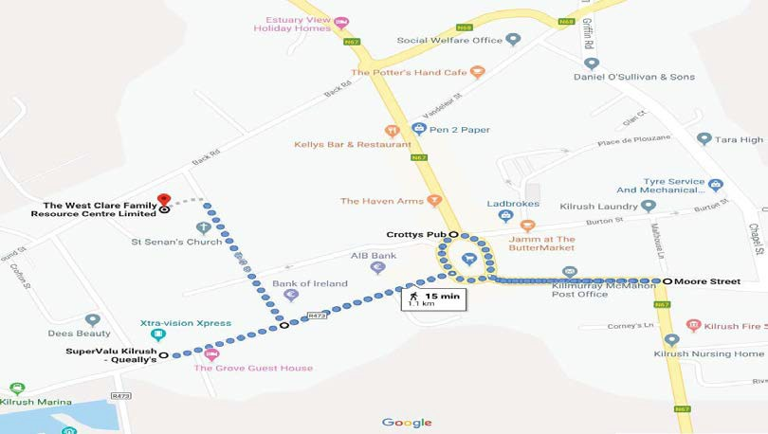

Figure 4 Route 2: Supervalu to Moore Street through Market Square
Map of Route No. 2 – Supervalu to Moore Street through Market Square.

Route No. 2 also started at the Community Centre, down Toler Street, past St. Senan’s Church, proceeded to Super-Valu on Frances Street and then a full about turn and the group walked towards the Market Square passing the banks, pubs and shops on the north side of Frances Street.
Market Square was then navigated in a clockwise direction and a section of Moore Street was walked until the junction of Stewart Street and the N67 road. The group then crossed the road and proceeded back along the south side of Frances Street and back to the Community Centre.
This route would have included most of the major amenities of Kilrush such as shops, pubs, restaurants, doctor’s surgeries, post office, credit union, supermarkets, Market Square and St. Senan’s Church and would deliver a very realistic snapshot of the walkability of the town of Kilrush.

Summary Findings from Walkability Audit

The following graphs represent an overall snapshot of how Kilrush was rated by the audit participants, in terms of Walkability, under a range of different headings below.

Footpaths
Following a series of questions of about footpaths on the route, participants were asked to provide an overall score for ‘footpaths’, in the range Very Poor, Poor, OK, Good, Excellent.

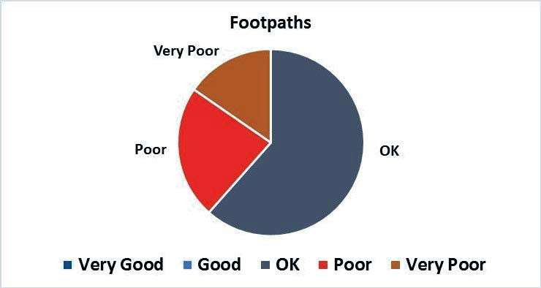
The footpaths were rated from ‘Very Poor’ to ‘OK’ by the participants, with more than half of the respondents rating them as ‘OK’. None of the audit respondents rated the footpaths as ‘Good’ or ‘Very Good’. A number of participants observed that the footpaths are in general very wide and this was welcomed. However, there was a lack of dropped kerbs on both routes audited, which caused difficulties for wheelchair users, who were participants in the audit.
In addition, the footpaths in general are poorly maintained and were hard for participants to negotiate, (refer to cluster map which shows the areas where no dropped kerbs exist) – it was evident that on both routes, wheelchair users were unable to access footpaths leaving them with no choice but to stay on the road, often with busy traffic passing.
This was particularly evident on the route from the Community Centre to Kilrush Community School and on the return journey past the nursing home.
It was also evident around Market Square and along Moore Street. It was simply not possible for a person using a wheelchair to access the streets and amenities around Market Square safely.

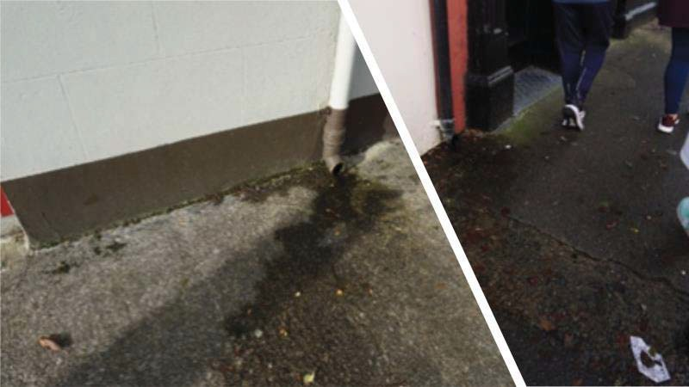

Figure 5 Photos highlighting an example of downpipe discharge onto the public footpath causing additional problems for older people and people with mobility issues. (Toler Street)

Several rainwater downpipes discharge direct to the public footpaths. In winter, the water freezes, and the blackspot areas become unwalkable and dangerous.
Dog Fouling, while minimal on Route 2, was more prevalent on Route 1. The issue of Dog Fouling is a serious public health issue. Considering the demographic analysis of Kilrush, with 22% of the population of Kilrush registered as having some form of disability, the incidences of Dog Fouling on the day of the audits were not acceptable.

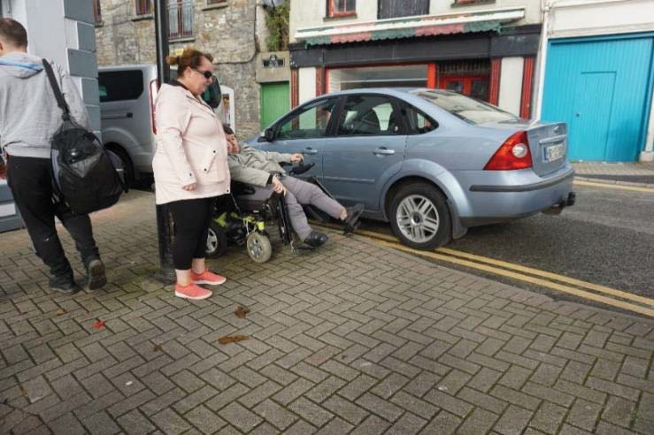
Photo of example of dog-fouling encountered on the day of the walkability audit in Kilrush.

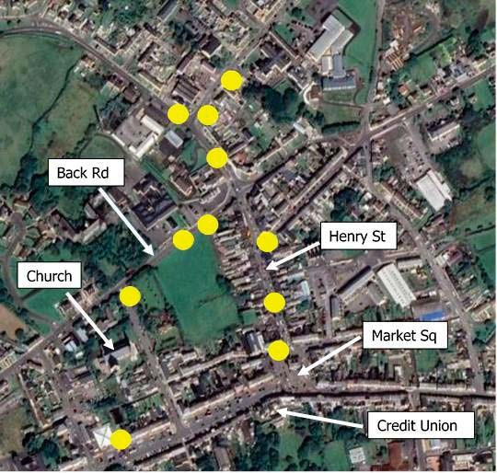

The cluster map above highlights examples of where dog fouling was encountered on the routes.

Facilities
Following a series of questions about facilities on the route, participants were asked to provide an overall score for ‘facilities’, in the range Very Poor, Poor, OK, Good, Excellent.
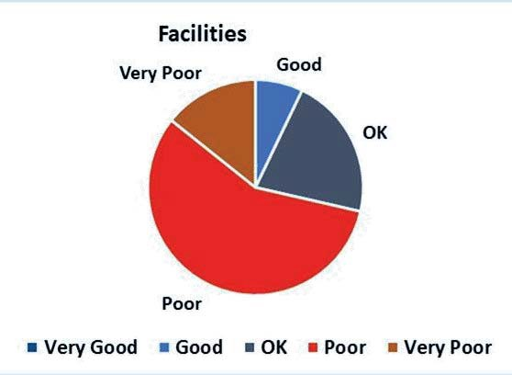

Facilities in Kilrush were deemed to be in the “Poor” and ‘Very Poor’ category by the majority of participants. There are some public seating and resting areas, but participants felt that the location and design of these spaces are in the wrong location. Bins and parking issues were generally perceived not to be a major issue, but the public toilet is located in an area that is difficult to access, as it is very hard to cross the road in Kilrush. Again, this was simply not possible for wheelchair users.

Pedestrian Crossings
Following a series of questions about crossing the road on the route, participants were asked to provide an overall score for ‘crossing the road’, in the range Very Poor, Poor, OK, Good, Excellent.
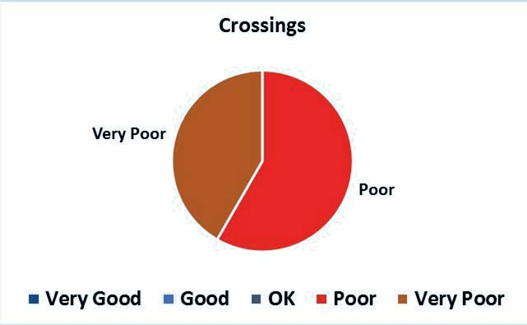
Crossing the road was by far the most discussed element of the walkability audit. It is difficult to cross the road in Kilrush, the town is car-dominated and the pedestrian is secondary to the needs of the car. This was reflected in all the responses being within the “Poor” and “Very Poor” range.

Road Users
Following a series of questions about road user behaviour on the route, participants were asked to provide an overall score for ‘road user behaviour’, in the range Very Poor, Poor, OK, Good, Excellent.

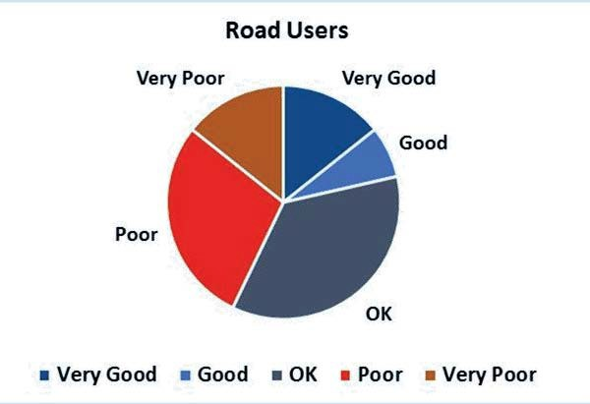

The Road User section had a mixed response from participants with responses ranging from ‘Very Poor’ to ‘Very Good’. This highlights the subjective nature of the participants’ perception of road user behaviour. More than half of the respondents gave a rating of ‘Poor’ or ‘OK’.

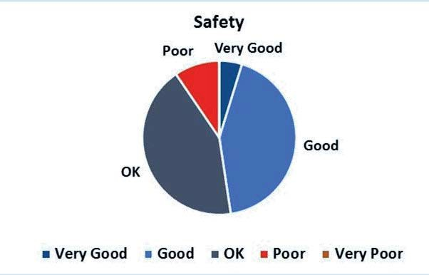

Safety
Following a series of questions about safety on the route, participants were asked to provide an overall score for ‘safety’, in the range Very Poor, Poor, OK, Good, Excellent.
Most respondents rated safety in Kilrush within the “OK” and “Good” range.

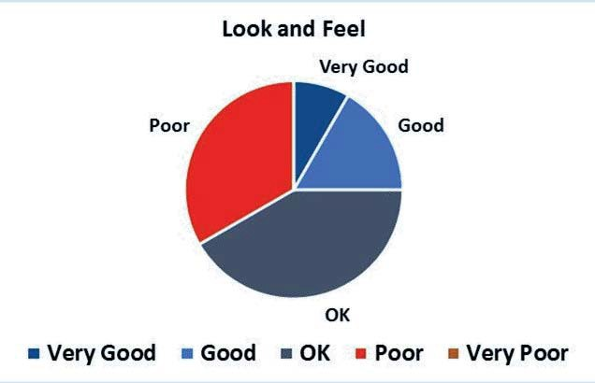
Look and Feel

Following a series of questions about the look and feel of the route, participants were asked to provide an overall score for ‘look and feel’, in the range Very Poor, Poor, OK, Good, Excellent.
The Look and Feel of any town is very important, it is the relatively unquantifiable element that encourages people to walk rather than drive to their destination and complete whatever matter they need to attend to.
The responses to the audit category ‘look and feel’ of Kilrush gives an indication of how the participants perceive their town. In terms of look and feel, about three-quarters of the participants rated the town to be in the ‘Ok’ or ‘Poor’ category. Participants were very vocal on the issues important to them in the town.
The public spaces in Kilrush are perceived as “OK” spaces. There is some public seating but not enough. Participants noted the lack of public seating and the inappropriate style of existing public seating.

Actions

Action 1 Pedestrian Crossings

All participants expressed difficulty with the limited number of pedestrian crossings and the time allowed for pedestrians to cross. Market Square is a major problem for older people and persons with disabilities with the existing design unfairly balanced in favour of the car. Crossing the roads around Market Square, particularly for participants with mobility issues, was the biggest issue raised by participants on the day of the audit.
In addition, participants had difficulty crossing the road at the roundabout at the junction of Back Road and Henry Street. While there is a zebra crossing at Henry Street, the other roads at this roundabout are very wide, and there is an absence of dropped kerbs at the junctions around the roundabout, which is on the route that leads up to Kilrush Community School.
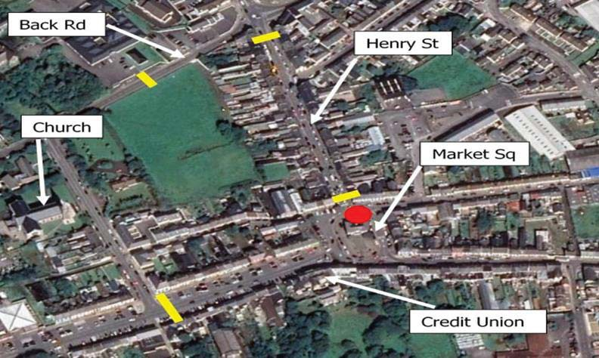

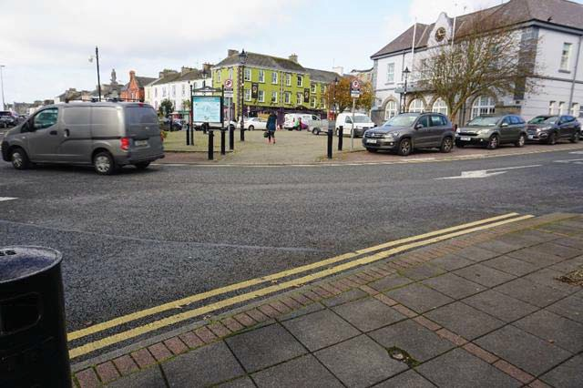

Figure 6 Cluster map showing the existing pedestrian crossings (yellow). There is no pedestrian crossing onto Market Square itself, which means that Market Square itself is inaccessible for pedestrians. The only accessible public toilet in Kilrush is located in

This photo highlights the wide roads surrounding Market Square. There is one dropped kerb onto this central area of the square, but it is not a defined pedestrian crossing, so it is very difficult to cross the road at this location. There is no clearly defined accessible pedestrian crossing for people that want to get to the central area of Market Square, where the public toilet is located.
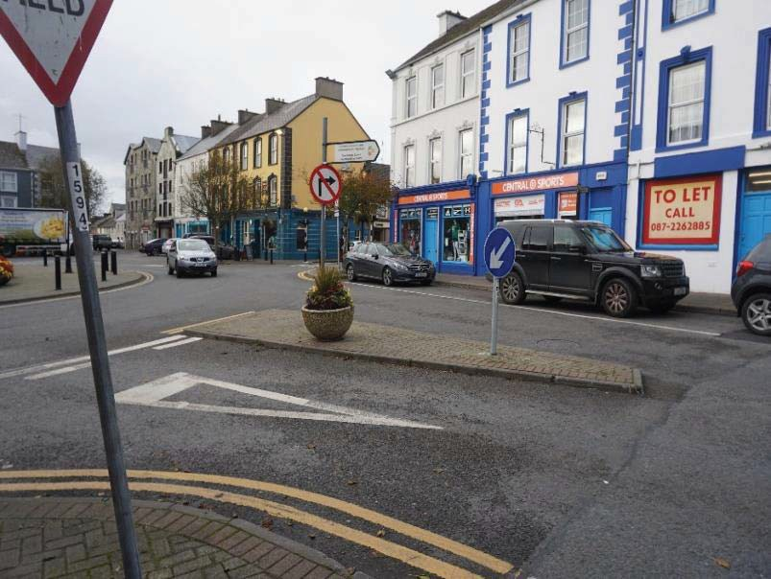

This photo highlights the challenge to cross from Burton Street at the junction with Market Square. The area is entirely car dominated and the pedestrian is subservient. There are no accessible crossing points with dropped kerbs and tactile paving.

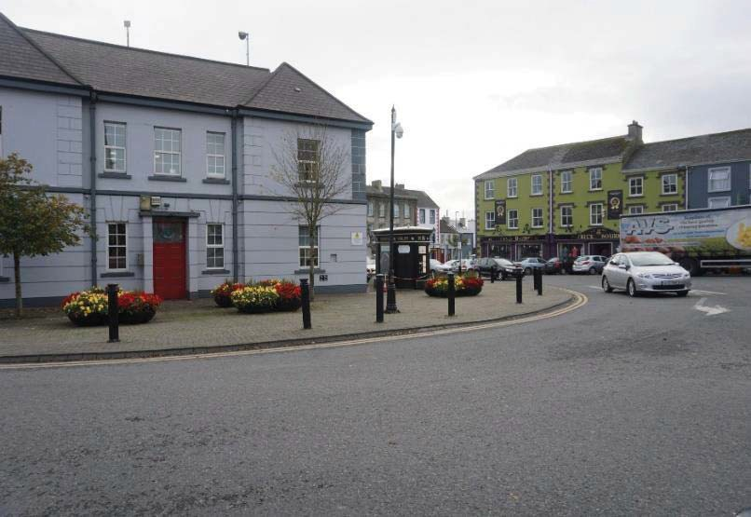

In this photo the grey building in the central area of Market Square contains the offices of West Clare Municipal District, and the only accessible public toilet in Kilrush is located to the right of the building. As above, there is no accessible pedestrian crossing to Market Square.

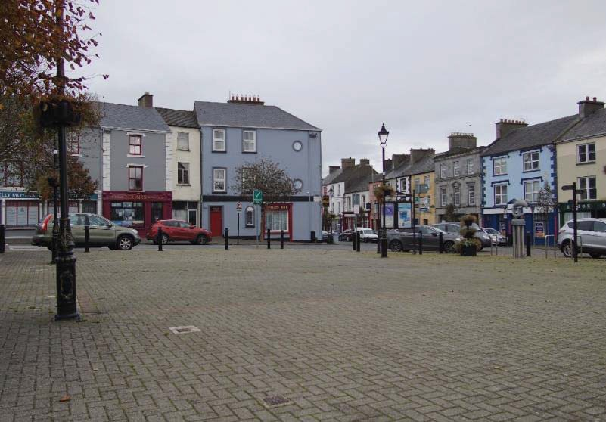
The view from Market Square is a fine example of a traditional Irish Streetscape. Market Square is a calm area with nice planting and is well maintained, but access to the square is very difficult for pedestrians and as a result Market Square tends to be empty.

ACTION 1:
Improve the provision of safe, accessible pedestrian crossing points, including pedestrian crossing(s) to access Market Square.
Lead Stakeholder: Clare County Council
Supporting Stakeholders: Kilrush Tidy Towns, Kilrush Town Team, Clare Older People’s Council.

Design Guidance for accessible pedestrian crossings:

- Building for Everyone: A Universal Design Approach, Booklet 1, External Environment and Approach, Section 1.5.5 Pedestrian Crossing Points

- Being Age Friendly in the Public Realm: Guidelines and Good Practice, Age Friendly Pedestrian Crossings

Action 2 Footpaths and Dropped Kerbs

Public footpaths require considerable attention. There is a lack of dropped kerbs at many junctions, including at the crossing outside the primary school on Back Street.
The absence of dropped kerbs is a significant barrier for people who use wheelchairs, as well those with buggies. Where dropped kerbs are missing, this is a complete barrier to people with reduced mobility. The cluster map below shows the locations where the absence of dropped kerbs creates a barrier to mobility for people with reduced mobility.

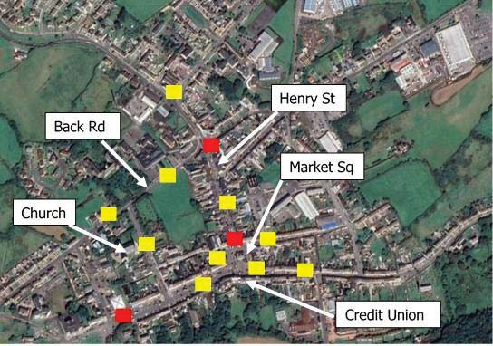
Cluster map 1a shows the locations of existing dropped kerbs (red) and the location where dropped kerbs are needed (yellow).

The condition of the footpaths, on all the routes, were poor with numerous defects and historic maintenance issues. Historically, the footpaths are generally wide in Kilrush, which is a positive element. However, small amendments can be made to make the footpaths considerably better. The cluster map above highlights the general area where an absence of dropped kerbs along the two routes walked was clearly evident. The lack of dropped kerbs, on the routes on the day, highlighted the need for additional dropped kerbs in Kilrush. If a route is to be fully walkable, it must have dropped kerbs with tactile paving at all pedestrian crossing points.

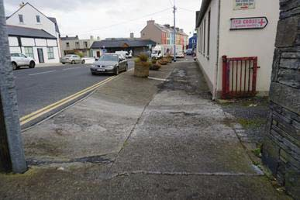

This Photo shows an uneven pathway with an inappropriate slope and lack of maintenance. This area is particularly poor and hard for pedestrian and vulnerable road users to navigate. (Fahy’s Road).

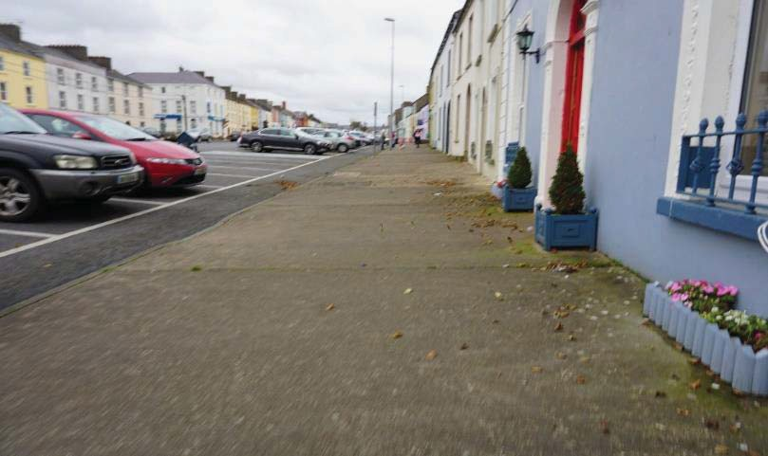
The footpaths are generally wide, which is a positive element. (Frances Street)

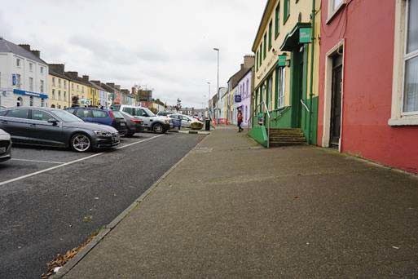
Despite being wide, in some places the footpaths have a severe slope that participants found hard to walk. In this photo, the sloped concrete footpath is quite steep. (Outside Post Office on Frances Street)

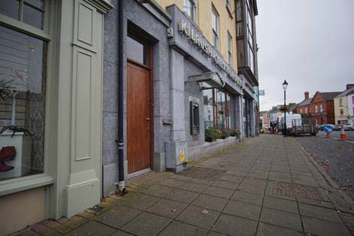

Again, another example that despite being wide, the sloped paved footpath is quite steep, and this path is a more recent addition to the streetscape of Kilrush. (Outside Credit Union on Frances Street).

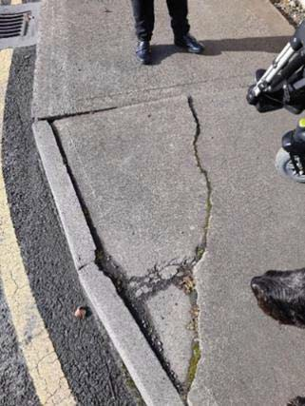

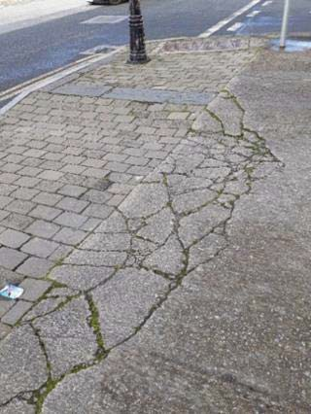

The two photos here are examples of the poor quality of footpath finish. Historic poor maintenance and general lack of investment in the public realm has allowed this path to fail over time. (Fahy’s Road).

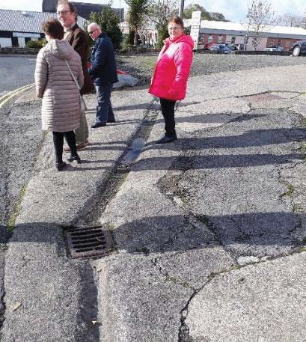

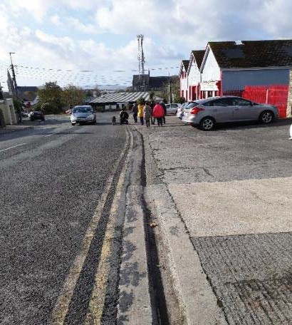

Historic gullies are evident in Kilrush, which would indicate an engineering solution of considerable age. (Fahy’s Road and Cooraclare Road)

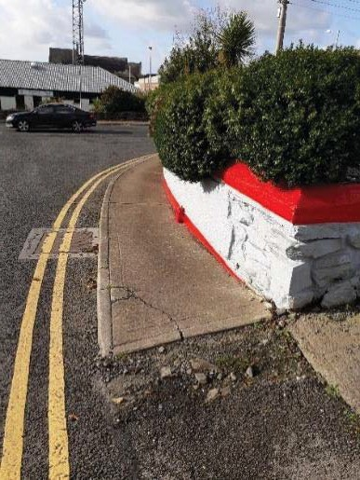
This example of a complete contrast in paving materials – changing from concrete to tarmacadam could cause distress to persons with Dementia. To a person with dementia this change in contrast can appear as a hole and increases the person’s confusion. Strong contrast changes such as this example should be avoided.

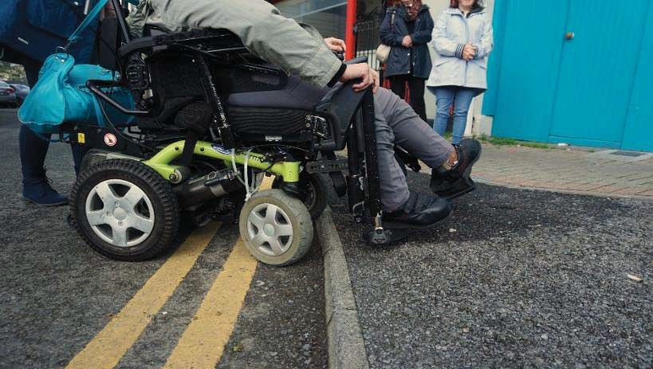

This photograph highlights the difficulty that the lack of dropped kerbs creates for a wheelchair user. Unless Kilrush can be entirely accessible for people with reduced mobility, they will continue to have difficulty accessing the services and facilities in the town. (Market Square)

ACTION 2:
Provide dropped kerbs and tactile paving at pedestrian crossing points and design a priority list for footpath repair works in conjunction with the relevant stakeholders.
Lead Stakeholder: Clare County Council
Supporting Stakeholder: Kilrush Town Team and Clare Older People’s Council.

Action 3 Public Seating

Public seating is important, as it allows for rest, social interaction and enjoyment of the external environment. There is a distinct lack of public seating in Kilrush, despite numerous areas where public seats, formal or informal could be installed. Kilrush has an orientation and a micro-climate that highlights the need to locate seating in the correct location. For example, the South Side of the main street is generally in shade and is the least occupied side of the street, seating will only work here in appropriate shade-less spaces. The North side of the street, receives all the sunlight and seating should therefore be installed on this side of the main street.

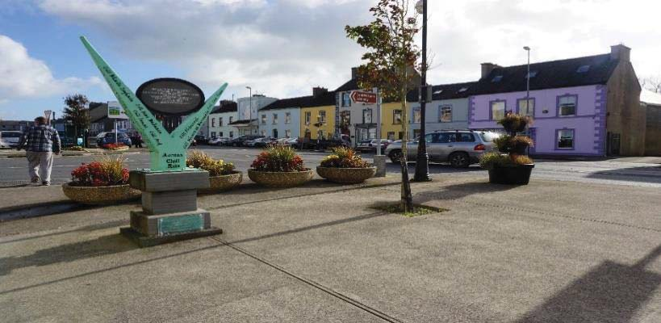

A nice sunny spot but no seating. This would be a convenient place for some public seating. (Near Super-Valu, Frances Street)

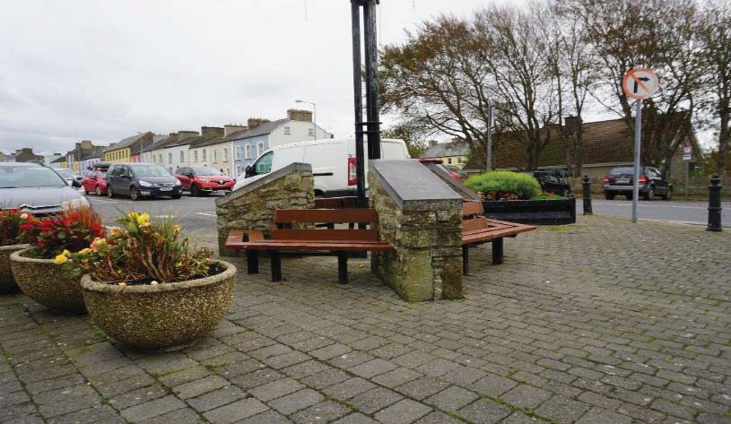

Participants liked this seating in Kilrush – well sheltered, comfortable and plenty to see. (Frances Street)
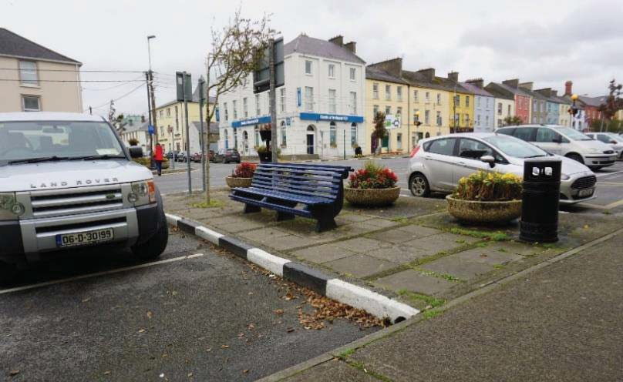

The location of public seating is very important. The local micro-climate of a particular area will determine whether seat location is successful or not. This seat is located in a cold, windy spot with seating which does not have any armrests and does not appear to be a popular spot. (Near Post Office, Frances Street)

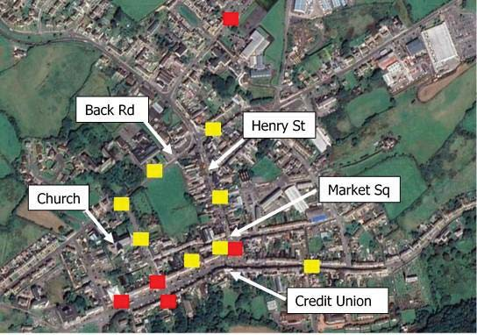

Cluster map 1b shows existing public seating (red) and potential location of public seating (yellow).

ACTION 3:
Provide public seating at appropriate locations in the town.
Lead Stakeholder: Clare County Council.
Supporting Stakeholder: Kilrush Tidy Towns, Kilrush Town Team, Clare Older People’s Council and Clare Age Friendly.

Any public seating provided should follow the guidelines and recommendations set out in the following documents.
Design Guidance for public seating:

- Building for Everyone: A Universal Design Approach, Booklet 1, External Environment and Approach, Section 1.5.4 Street Furniture

- Being Age Friendly in the Public Realm: Guidelines and Good Practice, Age Friendly Public Seating

Action 4 Parking
Kilrush needs more age-friendly and accessible parking spaces. An age-friendly parking area allows older people to park in the town area easily and have easier access to basic services. The current age-friendly space outside the community centre is well-used by older people. This successful area could be an example of the potential for additional age-friendly parking in Kilrush. The Post Office, Super-Valu and the Market Square were areas mooted by participantsas potential areas.

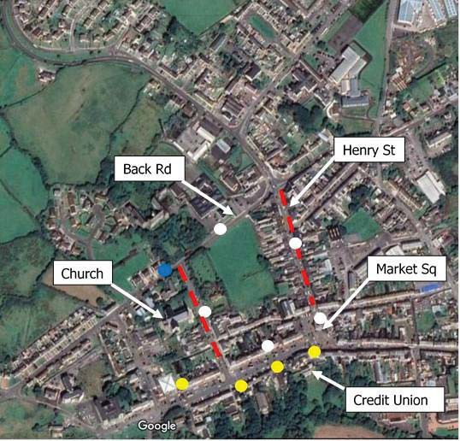

Cluster Map 1c showing existing accessible spaces (yellow) and existing age-friendly space (blue), potential areas for additional spaces (red dash). Suggested additional accessible and age-friendly spaces (white).
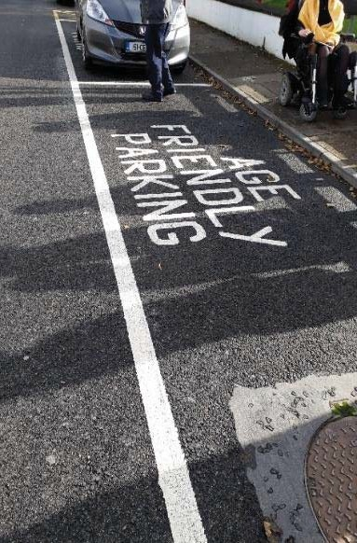

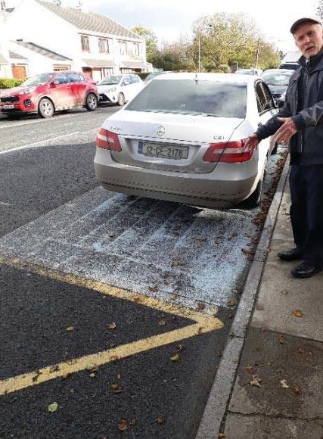

A photo of the Age Friendly Car Parking directly outside the Community Centre, Back Road. Kilrush does have some accessible parking areas but considering the high percentage of persons registered with a disability, more spaces are required. It is also evident that in some cases, the markings that highlight the availability of accessible spaces are faded and not fit for purpose.
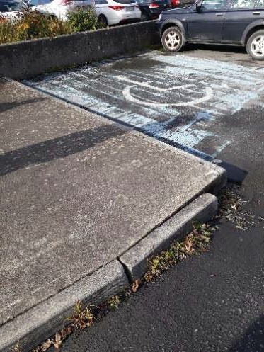

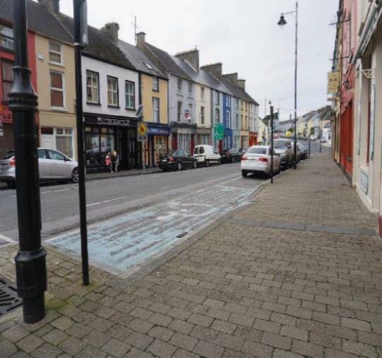
Photos highlight the poor visibility of existing accessible parking spaces, as the markings are poorly maintained. (Frances Street and Moore Street)

Participants also raised the issues of inappropriate parking, which has an impact on all people.

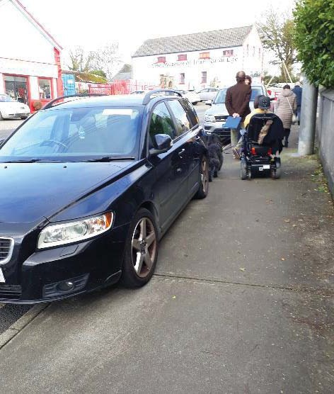

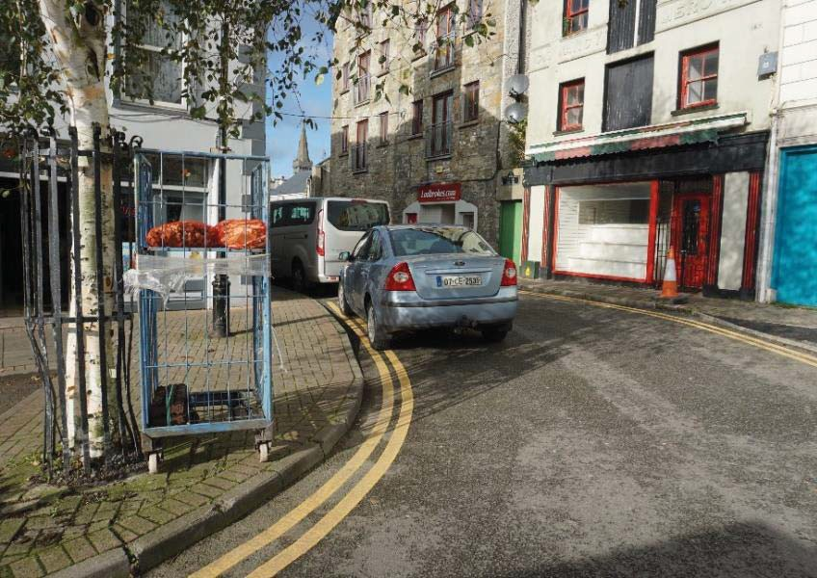

These photographs highlight the inconsiderate nature of “temporary” car parking – parking that people do just for a few minutes. (Fahy’s Road)
Inconsiderate parking is a regular and “normal” occurrence in Kilrush, despite considerable dedicated parking on Main Street. In the second photograph, there was plenty of dedicated parking 80 metres away. (Market Square)
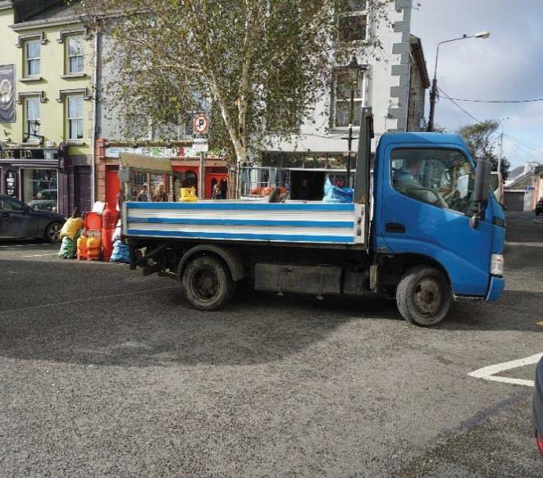

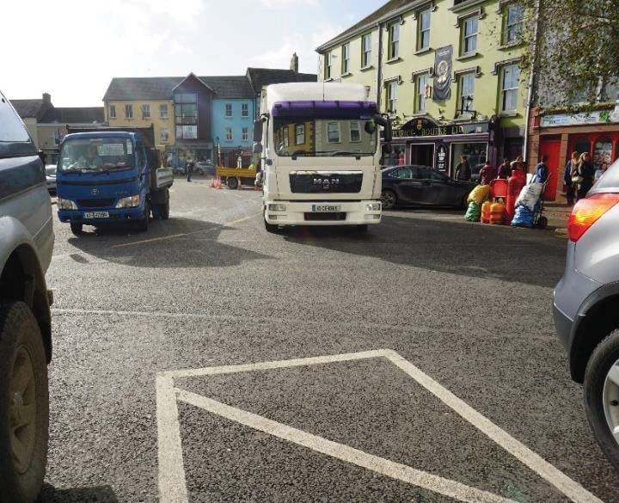

The photos above show that the area around Market Square is busy, which is a positive element in Kilrush. However, inappropriate deliveries, which are entirely inconsiderate to pedestrians are a regular occurrence in Kilrush. This appears to be a habitual practice, normally undertaken on a regular basis by deliveries which “only take a couple of minutes”. It is the cumulative impact of all the deliveries which causes frustration and inconvenience for pedestrians.

ACTION 4:
Investigate the possibility of additional age-friendly and additional accessible parking spaces in Kilrush and provide in more dispersed locations such as Henry Street and Toler Street. Investigate how parking for business deliveries can be better catered for in the town. This should include engagement at a local level on appropriate locations for age- friendly and accessible spaces and spaces for deliveries.

Lead Stakeholder: Clare County Council.
Supporting Stakeholder: Kilrush Tidy Towns and Clare Older People’s Council and Clare Age Friendly.

Action 5 Utility Boxes and Poles
Utility boxes and ESB Poles caused considerable difficulty for participants on the audit. Participants expressed their opinion that the worst place for utility boxes and poles always seems to be picked. Visual clutter in Kilrush was evident on the day of the audit with many participants raising the issue of the necessity for so many signs and poles – leading to a general cluttered feeling in Kilrush.

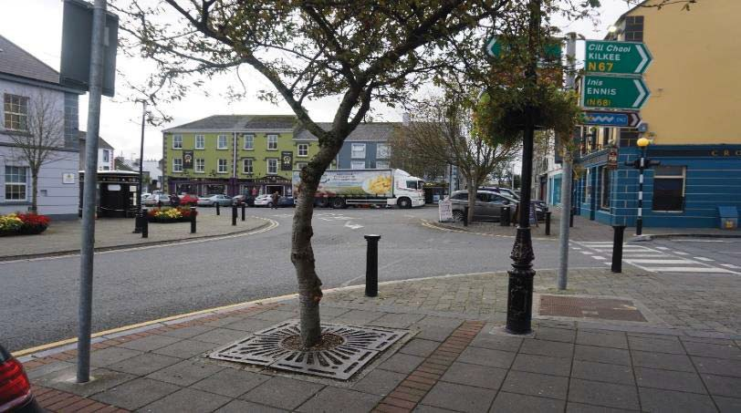

This area is too congested, especially for persons with reduced mobility or low vision. (Market Square)

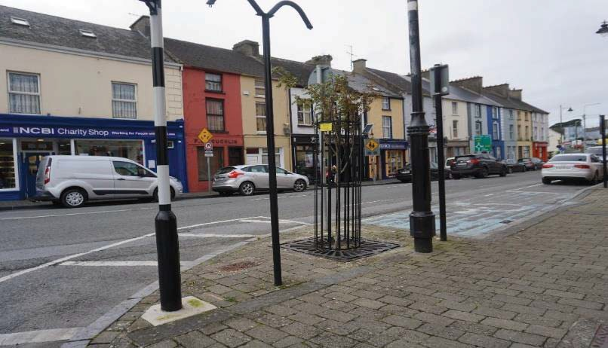
Another example of excessive street clutter. (Moore Street)
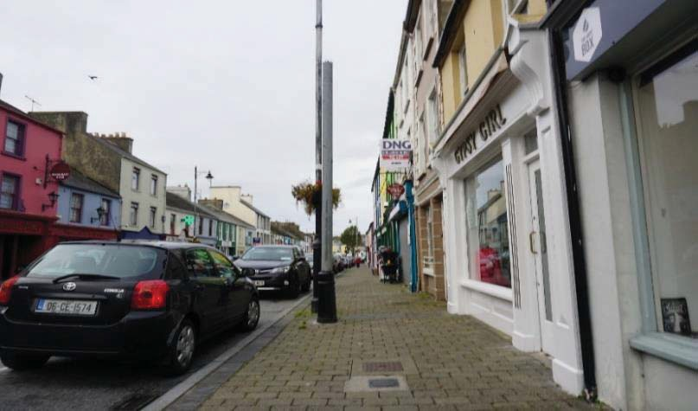
The placement of utility poles and boxes needs to be carefully designed to avoid impact on pedestrians. (Henry Street)

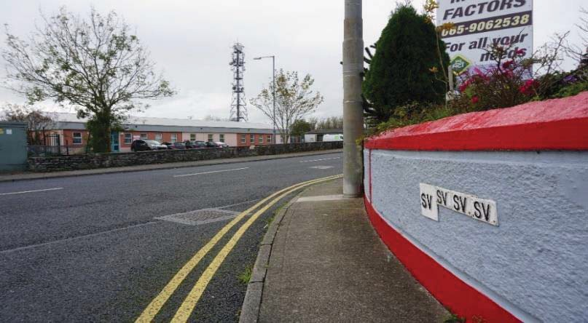

This pole is in a very inappropriate place. (Fahy’s Road at the roundabout)

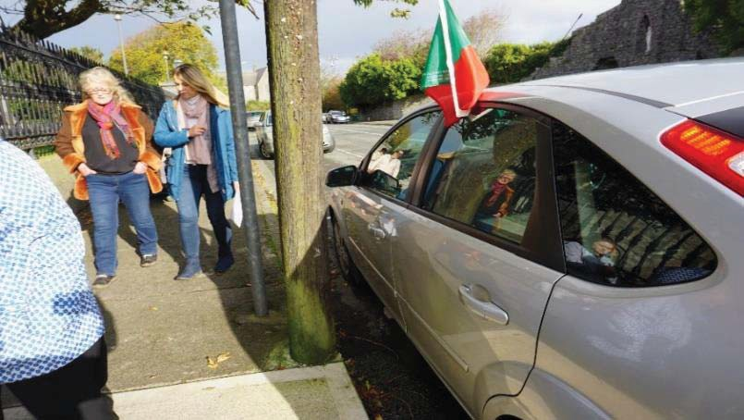
Another example of excessive street clutter. (Moore Street)

ACTION 5:
Undertake an audit of poorly located utility boxes and poles to see if any can be relocated.

Lead Stakeholder: Clare County Council.
Supporting Stakeholder: Service Providers

Action 6 Signage and Temporary Works
There was evidence of businesses cluttering the street with unnecessary signage, which can cause mobility problems and make it harder for people to walk on the street. Improvement works to footpaths by local authority or service providers tend to be a regular occurrence and can cause serious issues for pedestrians trying to find their way around Kilrush.

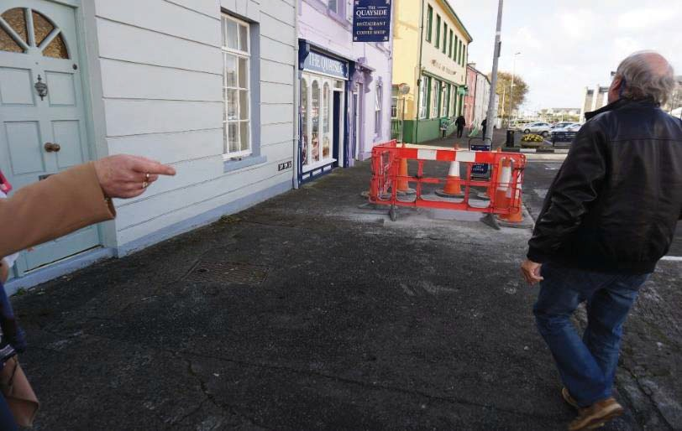

This photo highlights the impact of temporary works on people with mobility issues, the condition of the footpaths adds to the problem. In this photo, the temporary works have left less than one-third of the footpath for pedestrians. This barrier had been in place for two weeks on the day of the audit. (Frances Street)
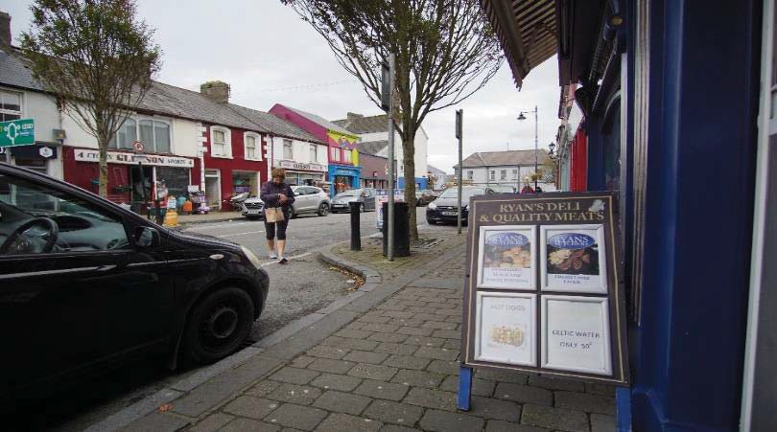
While businesses can be well meaning, the impact of on-street sandwich boards can have a detrimental impact on the walkability of an area, especially for people with sight or mobility difficulties. (Henry Street)

ACTION 6:
Continue to work with businesses in relation to on-street signage and other clutter and create an awareness of the negative impact they can have for pedestrians. Liaise with Local Authority and Service Providers to highlight the impact of temporary works in Kilrush.

Lead Stakeholder: Kilrush Tidy Towns and Clare Older People’s Council and Clare Age Friendly (Business), Kilrush Chamber of Commerce, Kilrush Town Team.

Action 7 Town

Market Square is the main focal point in Kilrush. It is the heart of the town. The pedestrian area located in Market Square is very hard for people to access – it is difficult to cross the road to get to Market Square.
Despite Market Square being a pedestrian area, the only purposely designed public area in Kilrush – it has no well-designed public seating and has no actual pedestrian crossing to access the Market Square. Well-designed public seating should have arm and back-rests, which make it easier for people with a wide range of ages and abilities to use it.
The Bus Stop outside “Patrick Bourke’s” needs attention – it is really an informal Bus Stop with no dedicated Bus Shelter, all participants raised this issue and it is the main reason why a lot of the participants will not use the bus more often.
The public toilet is a welcome addition to Market Square – but again ease of access to use the facility needs to be addressed.

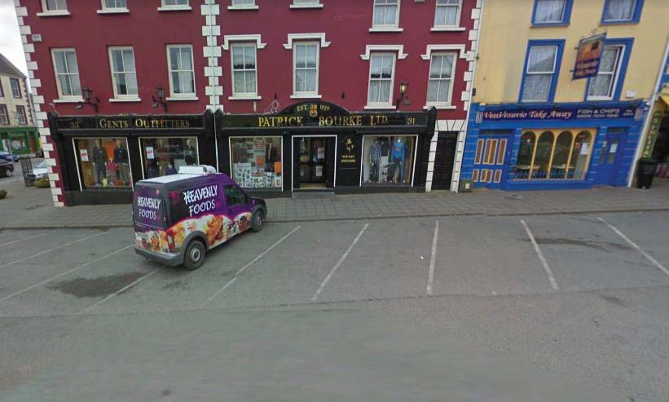
The Bus Stop for Kilrush is outside Patrick Bourke’s on Market Square. There are no seats, no signs, no dedicated area to wait. Participants were very vocal on this issue.

ACTION 7:
Investigate the potential of an urban re-design to improve the public realm at this Market Square with the relevant stakeholders, including the provision of facilities at the bus- stop.

Lead Stakeholder: Clare County Council and National Transport Authority.
Supporting Stakeholders: Kilrush Tidy Towns, Kilrush Town Team, Clare Older People’s Council, Clare Age Friendly.

Action 8 Public Toilets
There was only one public toilet on the selected routes, which is located on Market Square. As noted in the section on pedestrian crossings, this area is difficult for pedestrians to access, because of the lack of a defined safe and accessible place to cross the road onto Market Square. This is a cause for concern, particularly for older people and people with disabilities. Sometimes they feel awkward using local business’s facilities without purchasing anything and people can have difficulty spending time in the town as a result of the lack of toilet facilities.
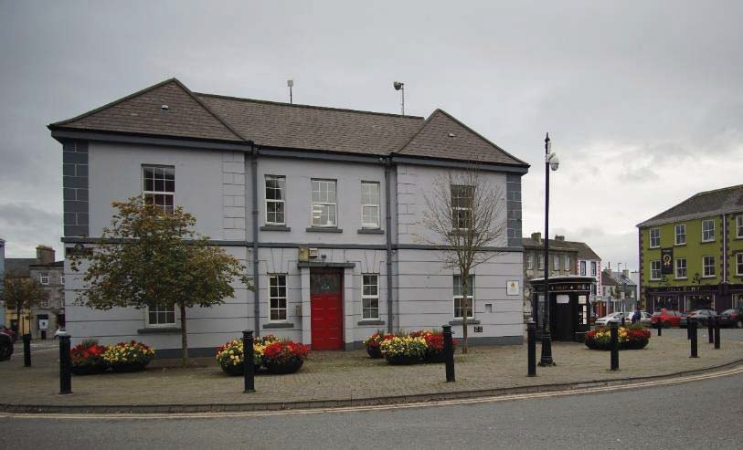
Many participants expressed their opinion that public toilets are often removed too easily due to the actions of a minority, to the detriment of the majority.
The public toilet is situated on Market Square. Market Square is hard to get to for pedestrians, because of difficulty crossing the road.

ACTION 8:
Improve the access to the existing public toilet by creating a safe pedestrian crossing to Market Square.

Lead Stakeholder: Clare County Council

Action 9 Rainwater Pipes discharging onto footpaths

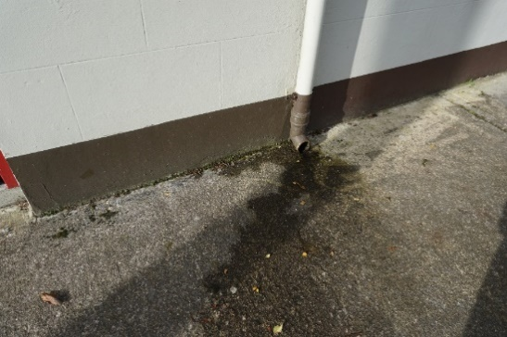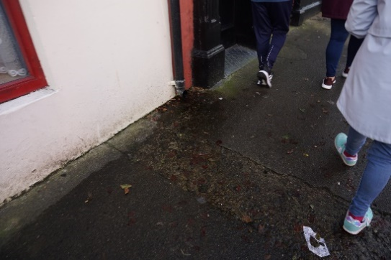
Several rainwater downpipes discharge direct to the public footpaths. In winter, the water freezes, and the blackspot areas become unwalkable and dangerous.
Photos highlighting an example of downpipe discharge onto the public footpath causing additional problems for older people and people with mobility issues. (Toler Street)

ACTION 9

Identify the blackspot areas for rain-water pipes discharging onto the footpath and liaise with relevant stakeholders to repair the faulty downpipes.
Lead Stakeholder: Clare County Council

Action 10 Dog-fouling
Dog Fouling, while minimal on Route 2, was more prevalent on Route 1. The issue of Dog Fouling is a serious public health issue. Considering the demographic analysis of Kilrush, with 22% of the population of Kilrush registered as having some form of disability, the incidences of Dog Fouling on the day of the audits were not acceptable.
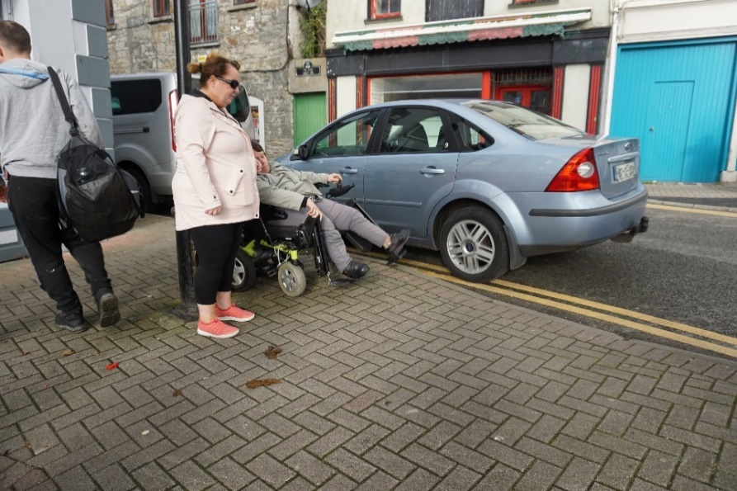
Photo of example of dog-fouling encountered on the day of the walkability audit in Kilrush.
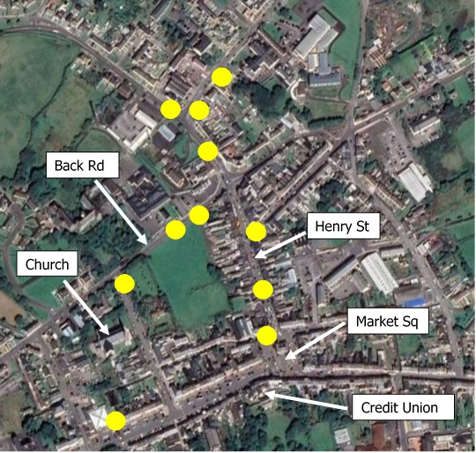
The cluster map above highlights examples of where dog fouling was encountered on the routes.

ACTION 10:

Identify the blackspot areas for dog-fouling and liaise with local authority regarding possible remedies, for example a local awareness campaign.

Lead Stakeholders: Clare County Towns.Council, Kilrush Tidy

Conclusions

This walkability audit highlights several actions that are clearly needed to improve the walkability of Kilrush, including:

• | Action 1: Improve the provision of safe, accessible pedestrian crossing points, including pedestrian crossing(s) to access Market Square.
• | Action 2: Provide dropped kerbs and tactile paving at pedestrian crossing points and design a priority list for footpath repair works in conjunction with the relevant stakeholders.
• | Action 3: Provide public seating at appropriate locations in the town.
• | Action 4: Investigate the possibility of additional age-friendly and additional accessible parking spaces in Kilrush and provide in more dispersed locations such as Henry Street and Toler Street. Investigate how parking for business deliveries can be better catered for in the town. This should include engagement at a local level on appropriate locations for age-friendly and accessible spaces and spaces for deliveries.
• | Action 5: Undertake an audit of poorly located utility boxes and poles to see if any can be relocated.
• | Action 6: Continue to work with businesses in relation to on-street signage and other clutter and create an awareness of the negative impact they can have for pedestrians. Liaise with Local Authority and Service Providers to highlight the impact of temporary works in Kilrush.
• | Action 7: Investigate the potential of an urban re-design to improve the public realm at this Market Square with the relevant stakeholders, including the provision of facilities at the bus-stop.
• | Action 8: Improve the access to the existing public toilet by creating a safe pedestrian crossing to Market Square, this action is linked to Action 1 above.
• | Action 9: Identify the blackspot areas for rain-water pipes discharging onto the footpath and liaise with relevant stakeholders to repair the faulty downpipes.
• | Action 10: Identify the blackspot areas for dog-fouling and liaise with local authority  regarding possible remedies, for example a local awareness campaign or making dog waste bags available in local shops.

Recommendations

- Housing:

The map of County Clare shown at the beginning of this report illustrates the older demographic of the population living in the town of Kilrush and the surrounding area. Any proposed new housing developments should take account of universal design principals in their design.

In line with the national policy document ‘Housing Options for an Ageing Population’ (2019), this will ensure that older people and people living with disabilities, will have greater choice by developing a range of housing options that are suited to their needs, so they can plan ahead and, insofar as possible, choose the right home for them.

Existing examples of Age Friendly Housing developments in County Clare are:

  - Glór Na Srútha, Clonlara, Co. Clare
    - Referenced in the national Policy document; Housing Options for an Ageing Population
    - This scheme was designed with a view to helping people to stay in their homes longer. Lifetime adaptability, efficiency of technology, sustainability, accessibility, and adaptability to address changing life circumstances were all key components in the scheme design and consideration.

  - An Cluinín Retirement Village, Kilmaley, Co. Clare
    - 24 single independent living houses with help from an outreach service when required. In addition, a Day Centre was built which caters for 110 older people in the immediate locality and a Health Centre which accommodates the public health nurses & General Practitioner service.
    - The houses form a retirement village in the centre of Kilmaley village, located adjacent to the Catholic Church and within walking distance of the local shop and post office.
    - With the assistance of these services this has created a safe and secure environment for the residents, in a quiet and modern environment surrounded by beautiful countryside.

- Feasibility Study
It is recommended that a feasibility study of the town be carried out to include a public realm enhancement and movement plan for both Market Square and Francis Street. This should

include full mobility planning, modelling and analysis of traffic count data. The scope of the study should include hard and soft landscaping and urban design as part of a wider strategy for the town. The strategy would identify a series of projects along Francis Street, including the Marina Park and the Market Square area.
Such a study would allow for the future leveraging of funding from the Rural Regeneration and Development Fund (RRDF) as well as tourism funding available through Failte Ireland.

- Rural Regeneration and Development Fund (RRDF)
If a feasibility study of Kilrush and its environs were to be carried out and a wider strategic plan was developed, the RRDF fund should be considered in the context of addressing any major development plans of Kilrush in the future.
The purpose of this fund is to support job creation in rural areas, address de-population of rural communities and support improvements in our towns and villages with a population of less than 10,000, and outlying areas.
This walkability audit is submitted to Clare County Council, by Age Friendly Ireland and the Centre for Excellence in Universal Design at the National Disability Authority, in conjunction with the residents of Kilrush who participated in the audit and provided feedback on the difficulties that they experience in Kilrush on an everyday basis.
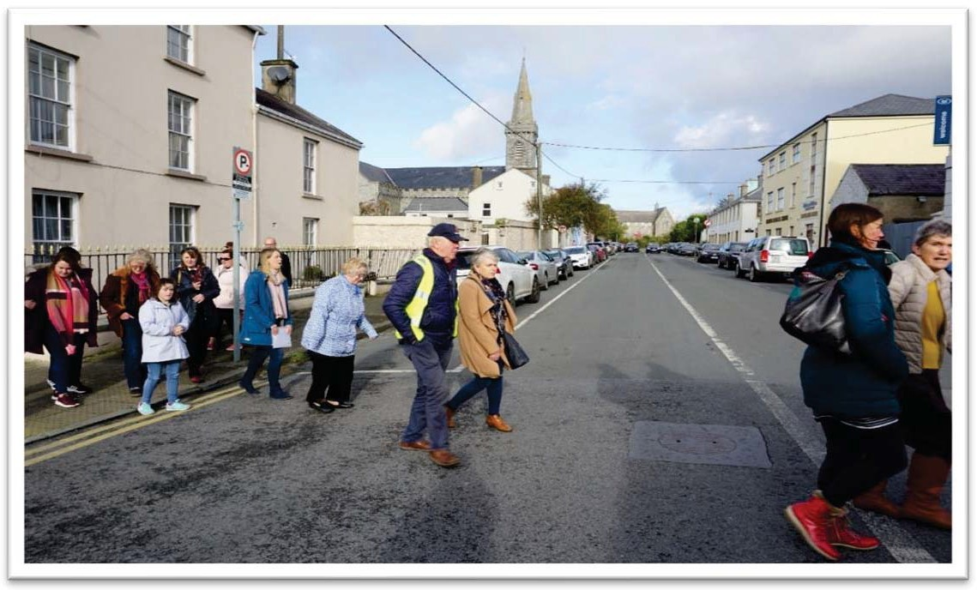
Public participation is an essential element of any future improvement in the walkability of Kilrush. The participants enjoyed the participation and were vocal and positive in their observations and comments.

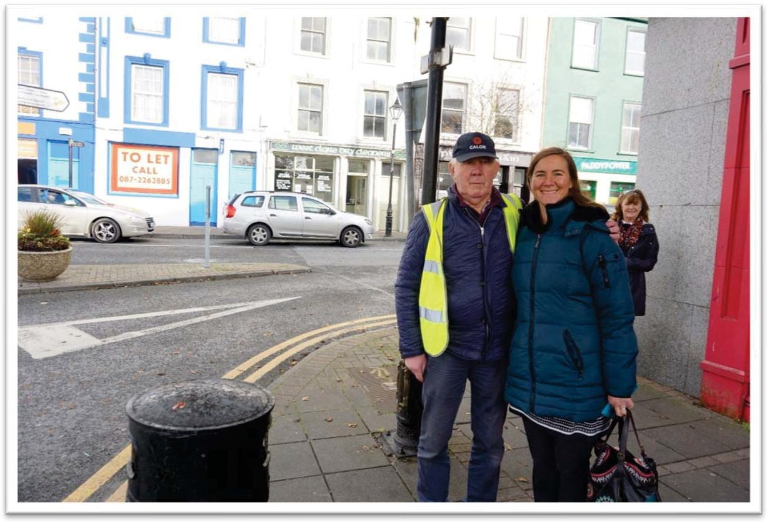
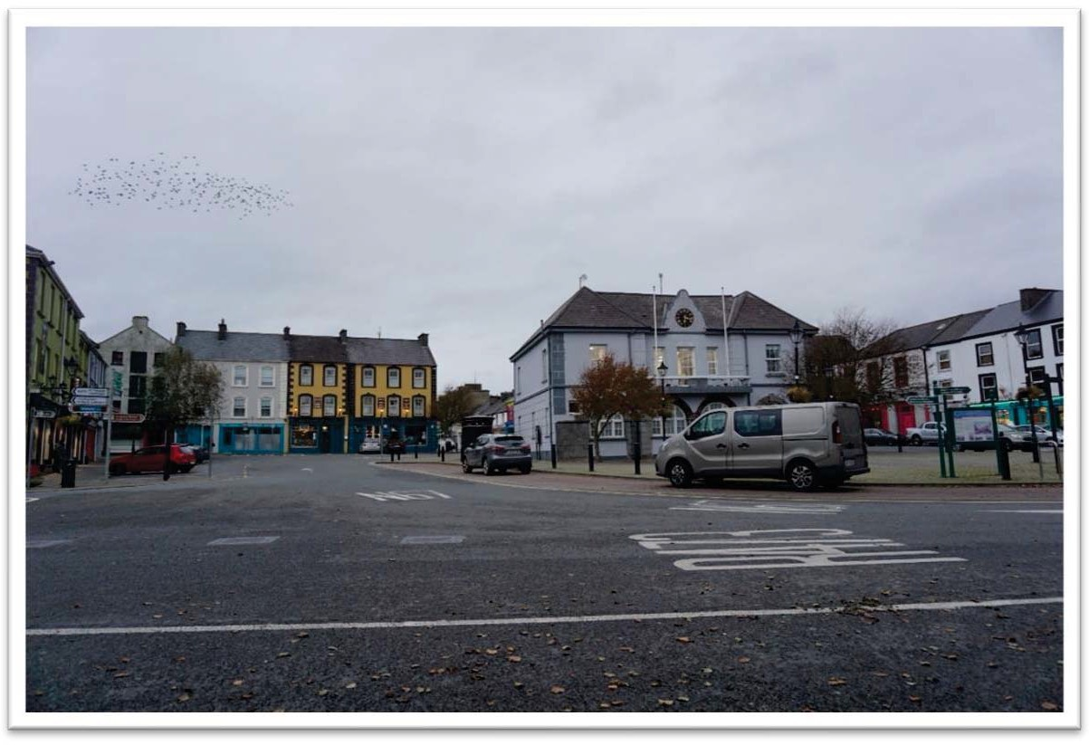

Market Square at dusk.

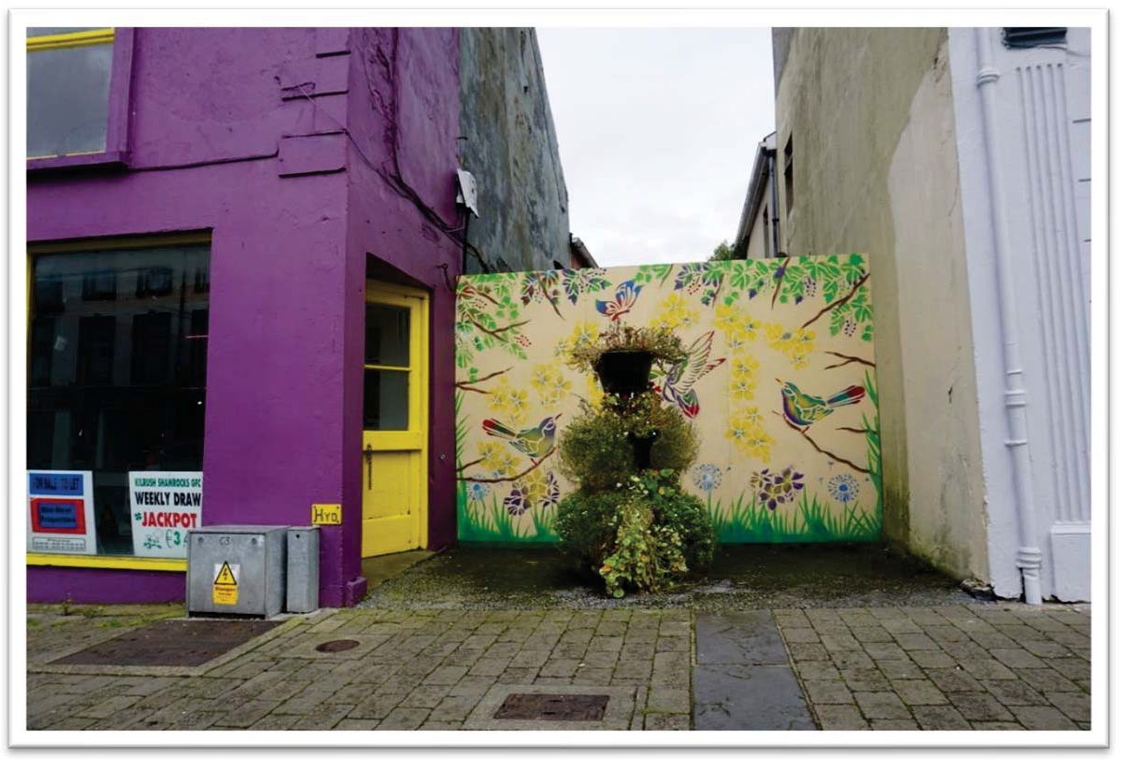

All towns and villages need to be visually interesting!

Quotations from Participants

“I love living in Kilrush, it is a great town, but it has been left behind for years, we really need to do it up!”

“Market Square is such a waste; it could be great with just some small changes”

“The town is a difficult place for wheelchair users to get around, the wide footpaths are used for parking and business owners tend to leave their signs out, sometimes I think they just don’t realise and worst still – they don’t care”

“I can’t see why there can’t be a proper Bus Shelter outside Bourke’s – there is plenty of room”

“I can’t get across at Market Square, I have to wait until cars fully stop before I walk across, sometimes people beep me to move faster – but I can’t go any faster!”

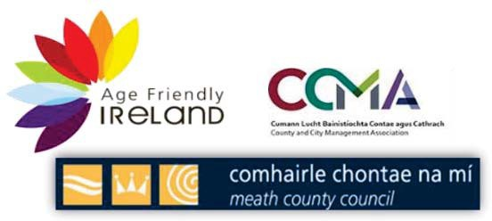
For further information;
Age Friendly Ireland
Meath County Council,
Buvinda House, Navan, Co. Meath
E: rleavy@meathcoco.ie

