Universal Design Guidelines for Changing Places Toilets

June 2024

Centre for Excellence in Universal Design
Creating an environment that can be used by all people, regardless of their age, size, disability, or ability.
The National Disability Authority’s Centre for Excellence in Universal Design has a statutory role to promote the achievement of excellence in universal design in:
- the design of the built and external environment
- product/service design
- information and communications technologies (ICT)
- the development and promotion of standards
- education and professional development
- raising awareness of universal design
More information and updates on the website at: www.universaldesign.ie

Contents
Foreword 7
1 Acknowledgements 9
2 Statement on Language 10
3 Introduction and Context 11
3.1 Objectives 11
3.2 What is a Changing Places Toilet? 11
3.3 Who uses Changing Places Toilets? 12
3.4 Estimated Number of Users of Changing Places Toilets 13
3.5 Benefits from Providing Changing Places Toilets 13
3.6 The difference between Changing Places Toilets and wheelchair accessible unisex WCs 13
3.7 National Building Regulations Requirements 15
3.8 Universal Design 15
3.9 United Nations Convention on the Rights of Persons with Disabilities 16
4 Key Considerations Overview 18
4.1 Provision 18
4.2 Location 18
4.3 Design and Installation 18
4.4 Management and Maintenance 18
5 Provision 19
5.1 Changing Places Toilets – Extending the Range of Users 19
5.2 Minimum Requirements for the provision of a Changing Places Toilet 19
5.3 Taking a Universal Design Approach - Going Beyond Minimum Requirements 20
5.4 Improving the Access and Use of Existing Buildings 21
5.5 Planning and Building Control 22
6 Location 23
6.1 Consider Location at Early Design Stages 23
6.2 Maximising Access and Use 23
6.3 Accessibility and Security 23
6.4 Location in Existing Buildings 24
6.5 Signage and Wayfinding 24
7 Design and Installation 26
7.1 Approach 26
7.2 Size and Space 26
7.3 Doors to Changing Places Toilets 30
7.4 WC Pan 31
7.5 Changing Bench 35
7.6 Washbasin 39
7.7 Mirrors 41
7.8 Soap Dispenser 42
7.9 Hand Drying 42
7.10 Wide Paper Roll Dispenser 43
7.11 Hoist System 43
7.12 Privacy Screen 45
7.13 Waste Disposal Bins 46
7.14 Ventilation 47
7.15 Sanitary Towel Dispenser 47
7.16 Emergency Assistance Alarm System 47
7.17 Lighting 48
7.18 Heating 48
7.19 Shower 49
7.20 Accessories 50
7.21 Signage 50
7.22 Flooring and Surface Finishes 51
8 Management and Maintenance 53
8.1 Pre-Visit Information 53
8.2 Information During Visit 55
8.3 Managing Accessibility and Security 56
8.4 Staff Training 57
8.5 Routine Monitoring and Maintenance 57
8.6 Health and Safety 60

Foreword
I am delighted to welcome publication of the ‘Universal Design Guidelines for Changing Places Toilets’, by the Centre for Excellence in Universal Design at the National Disability Authority. The UN Convention on the Rights of Persons with Disabilities, which was ratified by Ireland in 2018 sets out that disabled people have the right to accessibility in the built environment and the right to equal participation. A lack of suitable toilet facilities greatly restricts the everyday lives of some disabled people and their families. Research by the National Disability Authority indicates that between 17,100 to 37,700 people as well as their assistants, will benefit from the provision of Changing Places Toilets.
The introduction of new building regulations Part M 2022 requiring a Changing Places Toilet to be provided in certain buildings was an important step towards improving community participation and social inclusion for disabled people. These Universal Design Guidelines for Changing Places Toilets will complement implementation of the building regulations by providing additional guidance on good practice, as well as management and maintenance issues which are outside the scope of the building regulations.
As set out in the European Accessibility Act, ‘accessibility should be achieved by the systematic removal and prevention of barriers, preferably through a universal design or ‘design for all’ approach, which contributes to ensuring access for persons with disabilities on an equal basis with others’. I hope that these guidelines will be widely used by clients, designers, and facilities managers as new Changing Places Toilets are installed around Ireland.
Anne Rabbitte T.D.
Minister of State at the Department of Children, Equality, Disability, Integration and Youth
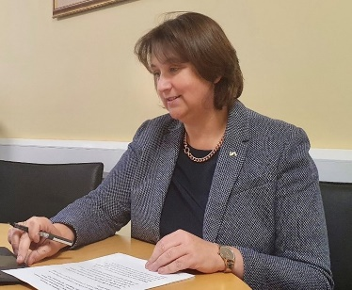

Acknowledgements
The Centre for Excellence in Universal Design at the National Disability Authority (NDA) commissioned O’Herlihy Access Consultancy to develop these guidelines.
The NDA would like to acknowledge and thank the members of the Technical Advisory Group which advised on the development of these guidelines:
Technical Advisory Group
- Aaron Daly, Changing Places Ireland
- Helge Koester, the Royal Institute of the Architects of Ireland
- Paul McDermott, Department of Housing, Local Government and Heritage
- Aoife McNicholl, Independent Living Movement Ireland
- Mairéad Phelan, Local Government Management Association
- Karen Smith, Changing Places Ireland
We also thank those individuals and organisations who attended the consultation workshop in June 2023 and responded to the public consultation in January 2024.

Statement on Language
In these guidelines, the terms ‘people/persons with disabilities’ and ‘disabled people’ are used interchangeably. The term ‘disabled people’ is recognised by many within the disability rights movement in Ireland to align with the social model and human rights approach of disability, as it is considered to acknowledge the fact that people with an impairment are disabled by barriers in the environment and society. However, we also recognise that others prefer the term ‘people/persons with disabilities’ because of the inherent understanding in the term that they are first and foremost human beings entitled to human rights. This also reflects the language used in the United Nations Convention on the Rights of Persons with Disabilities (UNCRPD). We recognise that many people with an intellectual disability, people with a mental health difficulty or psycho-social disability prefer person-first language. We also recognise that some people don’t identify with either term.
Refer to the NDA advice paper on disability language and terminology for further information.

Introduction and Context

Objectives
These guidelines are aimed at designers, building managers and owners of facilities as well as clients, industry professionals and disability stakeholders. The purpose of this document is to:
- provide good practice guidance on the location of Changing Places Toilets, having regard to the use and operation of a building
- provide good practice guidance on the provision and design of Changing Places Toilets
- provide good practice guidance on managing and maintaining Changing Places Toilets
- complement implementation of the Building Regulations (Part M Amendment) Regulations 2022, which make provision for Changing Places Toilets, having regard to the use and size of a building
The minimum requirements for the provision of Changing Places Toilets in certain buildings are set out in the Building Regulations (Part M Amendment) Regulations 2022 and the associated Technical Guidance Document M 2022 (TGD M 2022).
While the Part M requirements may be regarded as a statutory minimum level of provision, the accompanying technical guidance states that ‘those involved in the design and construction of buildings should also have regard to the design philosophy of Universal Design and consider making additional provisions where practicable and appropriate.’
A Universal Design approach recognises and extends beyond minimum requirements. These guidelines include a range of good practice recommendations that in some cases go beyond the minimum requirements of the Building Regulations.

What is a Changing Places Toilet?
A Changing Places Toilet is an accessible sanitary facility with a toilet, hoist, basin, adult-sized changing bench, and optional shower with adequate space for use by persons with a range of abilities who may require assistance (Technical Guidance Document M, 2022). For guidance on where Changing Places Toilets should be provided, refer to Section 5 of this document.
Image 1 A simulated image of a Changing Places Toilet

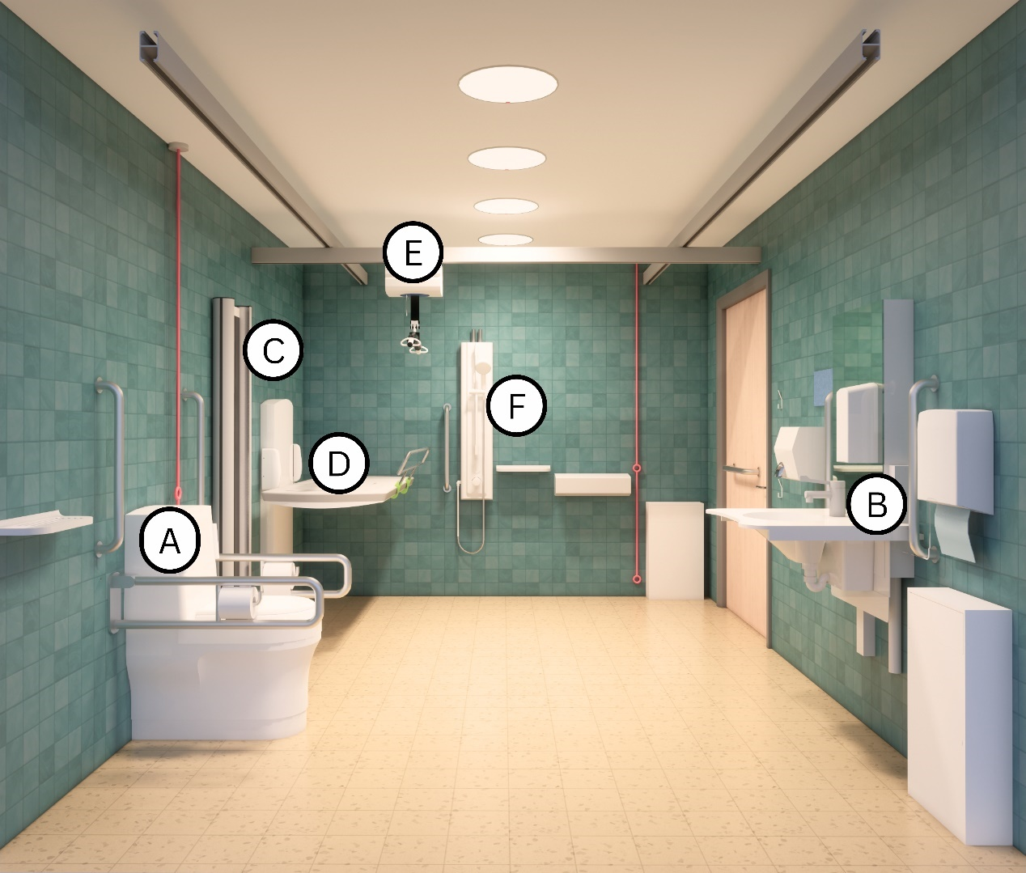

Key

- WC pan with space on both sides for assistance to be provided.
- Height-adjustable washbasin.
- Privacy screen.
- Height-adjustable changing bench.
- Full room cover overhead tracked hoist system.
- Optional shower.

Who uses Changing Places Toilets?
Changing places toilets offer larger sanitary facilities that address the needs of people for whom other sanitary accommodation is inadequate. They enable people with complex care needs to take part in everyday activities such as travel, shopping, family days out or attending a sporting or cultural event. This includes people using larger motorised wheelchairs. In addition, some neurodiverse people may also benefit from Changing Places Toilets as there is more space provided, and excessive noise can be avoided.

Estimated Number of Users of Changing Places Toilets
According to research carried out by the NDA between 17,100 to 37,700 or 1 in 291 to 1 in 132 people in Ireland are estimated to be potential users of Changing Places Toilets.

Benefits from Providing Changing Places Toilets
There are many benefits from providing Changing Place Toilets. These include:
- Increased participation in society:
Providing access to a Changing Places Toilet benefits a disabled person by preventing exclusion from society and promoting community engagement and participation. It also benefits family members and personal assistants/carers, who may assist the disabled person.
- Improved hygiene and dignity for end-users:
Changing Places Toilets prevent people from having to use the floor of toilets as a space to change, which is inadequate, unsafe, undignified, and unsanitary.
- Business benefits:
Organisations that provide Changing Places Toilets can benefit from a wider range of people visiting their business and increased customer satisfaction.

The difference between Changing Places Toilets and wheelchair accessible unisex WCs
A Changing Places Toilet is not a replacement for a wheelchair accessible unisex WC designed for independent use. It is an additional facility to address the needs of people for whom other sanitary accommodation is inadequate. Changing Places Toilets are different to wheelchair accessible unisex WCs in many ways:
- Changing Places Toilets are designed to allow Personal Assistants/Carers to assist someone in the room, whereas standard wheelchair accessible unisex WCs are designed for independent use
- Changing Places Toilets offer other functions beyond that provided in a wheelchair accessible unisex WC, such as providing equipment and space to change clothing, attend to personal care, and in some instances showering
- In a Changing Places Toilet both the washbasin and the WC pan are arranged differently in comparison to a wheelchair accessible unisex WC:
  - The WC pan in a Changing Places Toilet is in a peninsular arrangement (which allows space on both sides of the WC pan for wheelchair transfers or assistance from both sides of the WC pan), whereas in a wheelchair accessible unisex WC, the WC pan is in a corner arrangement (refer to Image 2 and Image 3)
  - The washbasin is not as close to the WC pan in a Changing Places Toilet as it is in a wheelchair accessible unisex WC
Image 2 WC Pan in a Changing Places Toilet with space on both sides for wheelchair transfers or for assistance to be provided (peninsular arrangement)
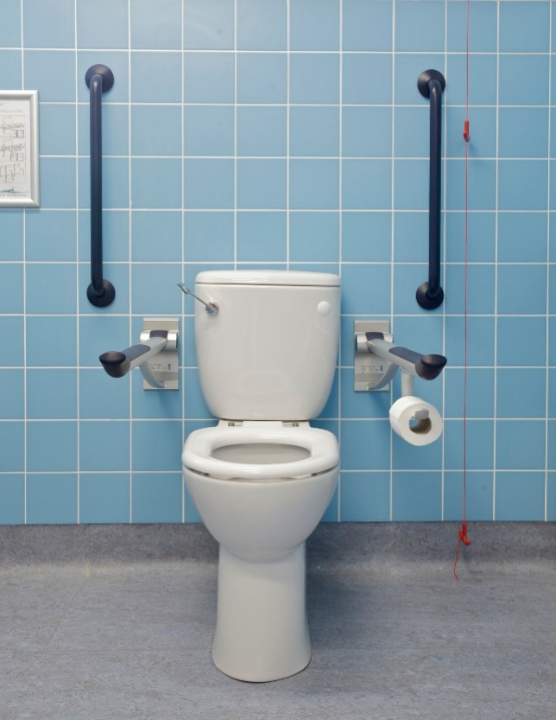
Image 3 Wheelchair Accessible Unisex WC with corner WC pan arrangement and washbasin within reach of the WC pan
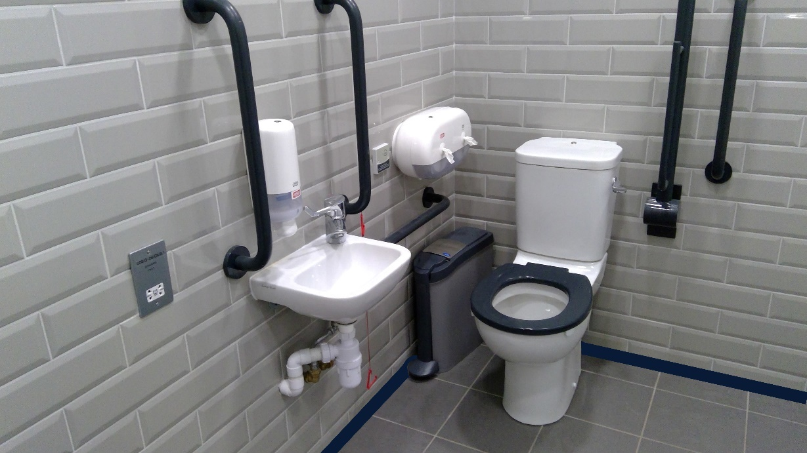

National Building Regulations Requirements
In 2022, Part M of the Building Regulations was amended by the Minister of State for Housing, Local Government and Heritage to make provision for Changing Places Toilets in certain buildings.
The Building Regulations (Part M Amendment) Regulations 2022 were accompanied by a revised Technical Guidance Document M Access and Use 2022 (TGD M 2022).
M4 of the Second Schedule of the Building Regulations 2022 states: ‘where sanitary facilities are provided in a building, or in a building that is to be extended, adequate provision shall be made for people to access and use a Changing Places Toilet, having regard to the use and size of the building’.
TGD M 2022 provides guidance on the minimum provisions for Changing Places Toilets to meet the requirements of Part M of the Building Regulations.
Where works are carried out in accordance with the guidance in TGD M 2022, this will, prima facie, indicate compliance with Part M of the Second Schedule to the Building Regulations (as amended). However, the adoption of an approach other than that outlined in the guidance is not precluded provided that the relevant requirements of the Regulations are complied with.
TGD M 2022 does not include guidance on management or maintenance of Changing Places Toilets facilities, as this is outside the scope of the Building Regulations. However, it is acknowledged that management and maintenance are important functions and contribute to the ongoing accessibility of the building.

Universal Design

What is Universal Design?
Universal Design is the design and composition of an environment so that it can be accessed, understood, and used to the greatest extent possible by all people regardless of their age, size, ability, or disability.
An environment (or any building, product, or service in that environment) should be designed to meet the needs of all people who wish to use it. This is not a special requirement, for the benefit of only a minority of the population. It is a fundamental condition of good design. If an environment is accessible, usable, convenient and a pleasure to use, everyone benefits. By considering the diverse needs and abilities of all throughout the design process, Universal Design creates products, services and environments that meet peoples' needs. Simply put, Universal Design is good design.
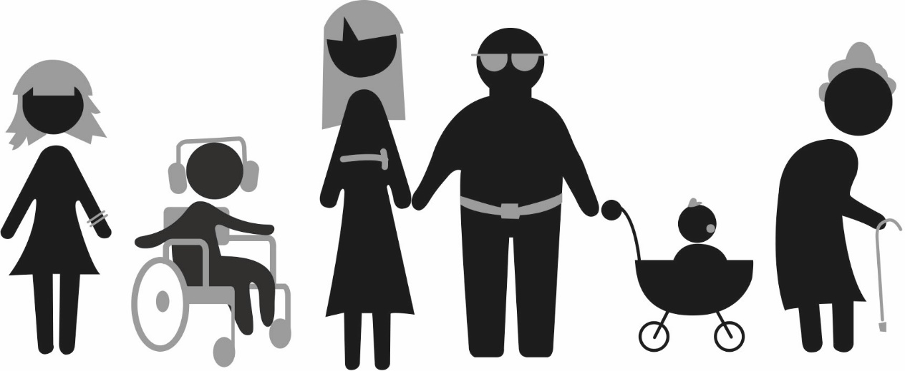
For more information on Universal Design, refer to the Centre for Excellence in Universal Design

User Involvement in the Design Process
A Universal Design approach involves users in the design process from an early stage. It prioritises the involvement of users with the most diverse abilities and characteristics to the greatest extent possible. A Universal Design approach recognises and extends beyond the minimum requirements of the Building Regulations. When planning to provide a Changing Places Toilet, it is always beneficial to engage with end-users and relevant organisations at an early stage, to ensure that the facility will meet the needs and preferences of end-users, as well as the minimum requirements of the Building Regulations.
There are a range of users that could be consulted including:
- Disabled Persons Organisations
- Older Persons Organisations
- Employee Resource Groups (where a Changing Places Toilet is being provided in a workplace)
Changing Places Ireland and the access officer in the relevant local authority may be able to provide contact information for local organisations.

United Nations Convention on the Rights of Persons with Disabilities

UNCRPD and Universal Design
Ireland ratified the UN Convention on the Rights of Persons with Disabilities (UNCRPD) in 2018. Under Article 4(1)(f) of the Convention, Ireland commits to undertake or promote the development of universally designed facilities, which should require the minimum possible adaptation and the least cost to meet the specific needs of a person with disabilities, and to promote their availability and use, and to promote Universal Design in the development of standards and guidelines.

UNCRPD and the Participation of Disabled People in Decision Making
Under Article 4(3), the Convention also outlines obligations on Government for how they include disabled people in the development, implementation and monitoring of policies and legislation and other decision-making processes. It applies at the local, national, and international level. The NDA guidelines 'Participation Matters: Guidelines on implementing the obligation to meaningfully engage with disabled people in public decision making' are a practical resource to support public officials at national and local level to meaningfully consult with and actively involve disabled people and their representative organisations in policy development and other decision-making processes to meet obligations set out under the UNCRPD.

Key Considerations Overview

Provision
Changing Places Toilets are an additional and separate requirement to the provision of a unisex wheelchair accessible WC.
Provide a Changing Places Toilet where required by the Building Regulations (Part M Amendment) Regulations 2022 and Technical Guidance Document M 2022 (TGD M 2022).
In addition, consider providing a Changing Places Toilet in buildings and public spaces where they are not required by the Building Regulations, to maximise access and use for all.

Location
Ideally, locate a Changing Places Toilet adjacent to other sanitary facilities.
Consider the location at early design stages to ensure it allows for convenient access.
Consider the availability of accessible parking in relation to the location of a Changing Places Toilet.

Design and Installation
Ensure that the design and installation meet the minimum requirements of the Building Regulations.
Engage with end-users to identify and respond to their key needs and preferences.
Pay attention to detail in the design, equipment and finishes specified in a Changing Places Toilet.

Management and Maintenance
Provide pre-visit information and well-designed signage to enable people to easily locate and use a Changing Places Toilet.
Enable end-users to gain access easily without having to overcome complex security arrangements.
Train staff on management procedures for the facility.

Provision

Changing Places Toilets – Extending the Range of Users
Providing a Changing Places Toilet extends the range of users of a building by enabling access and use to people who would otherwise be excluded from using the building, because of a lack of toilet facilities to meet their needs.
It is important to identify whether a Changing Places Toilet is required in a building and to consider whether more than one Changing Places Toilet should be provided. This section refers to the minimum requirements set out in Table 1 of Technical Guidance Document M 2022, as well as good practice.

Minimum Requirements for the provision of a Changing Places Toilet

Technical Guidance Document M 2022
From the 1st of January 2024, subject to transitional arrangements, the Building Regulations (Part M Amendment) Regulations 2022 require Changing Places Toilets to be provided in certain buildings, having regard to their use and size.
Table 1 of Technical Guidance Document M (TGD M) 2022 sets out fourteen relevant building uses and associated size criteria relating to the provision of a Changing Places Toilet. At least one Changing Places Toilet should be provided in the buildings with the relevant use listed in Table 1 of TGD M 2022, having regard to the use and size of the building.

Minimum Requirements for Mixed-Use Buildings
In some mixed-use buildings, there may be a number of relevant building uses that exceed the size criteria in Table 1 of TGD M 2022.
Under the provisions of TGD M 2022, it is adequate to provide a single Changing Places Toilet in such a building if it is suitably located, having regard to the operation and use patterns of all the relevant building uses.
For example, it may be located adjacent to other sanitary facilities that are open to users of all the relevant building uses and available for use at the same time as those other sanitary facilities.
If the building layout or management arrangements do not facilitate access to the Changing Places Toilet for users of each relevant building use, the provision of more than one Changing Places Toilet in the building may be necessary to meet the requirements of the Building Regulations for each relevant building use.
For example, in a mixed-use building comprising a shopping centre and cinema, where the sizes of both uses exceed the criteria in Table 1 of TGD M 2022, access to a shared Changing Places Toilet should be available from when the shopping centre opens until the cinema closes. Alternatively, a separate Changing Places Toilet should be provided for each use to ensure access to a Changing Places Toilet is provided for users of both the shopping centre and cinema throughout their respective opening hours.

Minimum Requirements for Outdoor Amenities used for Assembly and Recreation
Table 1 of TGD M 2022 also includes provisions for a Changing Places Toilet as part of sanitary facilities associated with outdoor amenities used for assembly, recreation, or entertainment such as zoos, amusement parks and theme parks.
For these amenities, the provision is linked to the capacity of the outdoor amenity and the distance from another building within the same amenity containing a Changing Places Toilet.
A Changing Places Toilet is required in a building or part of a building containing sanitary facilities where the capacity of the outdoor amenity is more than 2,000 people (excluding staff) unless there is another building containing a Changing Places Toilet within 250 metres. This distance is measured as a straight line between buildings, rather than as a travel distance.

Taking a Universal Design Approach - Going Beyond Minimum Requirements
Consideration should be given to providing Changing Places Toilets in buildings and public spaces where they are not required in TGD M 2022, to maximise access and use for all. For example:
- providing a Changing Places Toilet in a building where the use is not a relevant building use in Table 1 of TGD M
- providing a Changing Places Toilet in a building that is smaller than the size criteria set out in Table 1 of TGD M
- providing a Changing Place Toilet in an existing building
- providing more than one Changing Places Toilet in a large single-use building
- in a theatre, providing a Changing Places Toilet backstage for performers as well as one for use by members of the audience
- In a stadium, providing more than one Changing Places Toilet, depending on circulation routes and the distance a user might have to travel from one part of the stadium to another
An analysis of the building use, building capacity, and end-user experience should be taken into consideration to inform the provision of Changing Places Toilets, where they are not required in TGD M 2022. For example, a university may carry out an analysis of its existing buildings to identify suitable locations for the installation of Changing Places Toilets on campus, taking into account the location of key student facilities with high use, capacity, user feedback, management arrangements such as opening hours, travel distances, arrival points and accessible routes on the campus.
Section 25 of the Disability Act may apply to some existing public buildings, see Section 5.4.1.

Improving the Access and Use of Existing Buildings
Many organisations are committed to improving the overall access and use of their facilities to improve the visitor experience for everyone. Organisations should review their diversity and inclusion initiatives and access audit findings and identify if Changing Places Toilets should be provided within their existing facilities.

Section 25 of the Disability Act 2005
Under Section 25 of the Disability Act, public buildings shall be brought into compliance with any amendment of Part M, not later than 10 years after the commencement of the amendment. Part M Building Regulations (Part M Amendment) Regulations 2022 commenced on 1 January 2023.
The definition of a public building set out in Section 25 of the Disability Act is ‘a building, or that part of a building, to which members of the public generally have access and which is occupied, managed or controlled by a public body’.
Public bodies should be aware of their obligations under Section 25 of the Disability Act 2005, as this may result in a Changing Places Toilet being required in some existing public buildings.
For example, Table 1 of TGD M 2022 includes provision for a Changing Places Toilet to be provided in an office building where the relevant floor area is greater than 250 m², where the office is occupied, managed or controlled by a public body, to which members of the public generally have access and where sanitary facilities are provided for use by the public.

Planning and Building Control
The provision of Changing Places Toilets may require planning permission and will need to meet the requirements of the Building Regulations and Building Control Regulations (for example submission of a Disability Access Certificate application). When considering installing a Changing Places Toilet, professional advice should be obtained from a competent person in the early stages of a project to ensure that all works will meet the requirements of planning and building control legislation.

Location
When installing a Changing Places Toilet, it is important to ensure that it is easy to locate, access and exit safely. Guidance on the location of Changing Places Toilets within a building is provided below.

Consider Location at Early Design Stages
The location of a Changing Places Toilet should be considered at an early stage in the design process to help ensure adequate space is provided and that it is conveniently located to minimise security arrangements and with an accessible approach route.
Integrating Changing Places Toilet requirements into specifications and the design brief for projects is one way to ensure these considerations are addressed at an early stage in the design process.

Maximising Access and Use
Changing Places Toilets should be conveniently located to maximise access and use for all building users. There are several factors to be considered to optimise the location of a Changing Places Toilet.
Ideally a Changing Places Toilet should be located:
- adjacent to other sanitary facilities, having regard to the operation and use patterns of the building or outdoor amenity
- in proximity to designated accessible parking or set down areas
- to minimise the distance a disabled person has to travel from the arrival point
- to allow for security and management arrangements that enable ease of access (refer to Section 6.3 below)
For example, a Changing Places Toilet within a school that is used after hours for community events and sporting activities should be located so that it is readily available for use during all opening times.

Accessibility and Security
All toilets should, wherever possible, be freely accessed to preserve the dignity and privacy of users. Some people need to use toilets more frequently than others, and some with a greater sense of urgency. Having to locate a key or member of staff will delay access, which is inconvenient and may cause unnecessary discomfort. It should be easy for users to access a Changing Places Toilet, without having to overcome complex security arrangements.
The location of a Changing Places Toilet should be selected to minimise the security arrangements necessary to access the Changing Places Toilet and to facilitate that a Changing Places Toilet remains unlocked during standard opening times. A Changing Places Toilet that is in a staffed facility should be kept unlocked when not in use.
In some cases, it may be necessary to lock a Changing Places Toilet, for example in remote locations to prevent un-authorised access. For further information on managing access into Changing Places Toilets and the provision of security arrangements refer to Section 8.3.

Location in Existing Buildings
Where a Changing Places Toilet is being installed in an existing building, it should be conveniently located within easy access of the entrance of the building, or alternatively adjacent to other sanitary facilities in the building. The route leading to the Changing Places Toilet should be easy for everyone to use. This may require alterations to existing corridors and doors along the route leading to the Changing Places Toilet. For example, doors along the route to a Changing Places Toilet may need to be widened and/or held open.
TGD M 2022 includes specific provisions relating to the installation of a Changing Places Toilet in an existing building.

Signage and Wayfinding
Signage needs to be carefully designed and positioned to allow users to easily find a Changing Places Toilet. For guidance on signage to sanitary facilities, refer to Section 5.10.13 of Building for Everyone: A Universal Design Approach, Booklet 5, Sanitary Facilities.
Signage within the Changing Places Toilet is described in Section 8.
Maps and guides are important elements of wayfinding as described in Section 8.1.2.3 on pre-visit information.
Image 4 Example of signage at a Changing Places Toilet provided at an outdoor amenity.
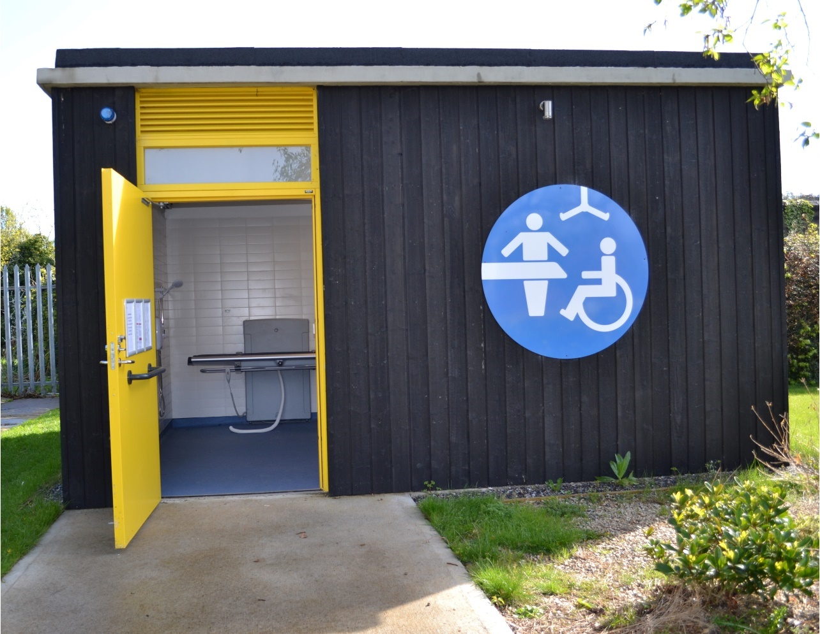
Design Features
- Clear, large, visually contrasting signage is provided.
- Visual contrast is provided between the entrance door and external wall and ground.

Design and Installation
The design and installation of a Changing Places Toilet should meet the minimum requirements of the Building Regulations.
Careful consideration and attention to detail in relation to the design, equipment and finishes specified in a Changing Places Toilet is required. In particular, the size of the equipment provided in a Changing Places Toilet can impact on the clear circulation space and subsequently the overall size of the room.
This section provides technical guidance on the design of Changing Places Toilets, taking a Universal Design approach.

Approach
Careful planning and design should ensure that approach routes leading to a Changing Places Toilet accommodate a wide range of users, in new and existing buildings. Internal doors should provide a minimum clear effective width of 850mm, although a greater width is preferred where practical. Where there are doors with door closers on the approach route, hold-open devices should be provided where possible, to maximise ease of access.
Any Changing Places Toilet door opening towards a corridor which is a major access route, or an escape route should be recessed so that when fully open, it does not project into the corridor space.
A clear unobstructed space of 1800mm by 1800mm minimum should be provided directly outside the door to the Changing Places Toilet. This will facilitate users to easily enter the Changing Places Toilet or to turn around if the Changing Places Toilet is already occupied.

Size and Space
The minimum overall dimensions and arrangement of equipment, circulation spaces, grab rails and other fittings within a Changing Places Toilet are shown in Figure 1. Figure 1 is the standard layout from TGD M 2022, which positions the door on the longer wall of the Changing Places Toilet. The minimum size of the Changing Places Toilet in this example is 4200mm by 3000mm.
A wheelchair turning space, free from obstruction, of 1800mm by 2000mm minimum should be provided immediately inside the door, clear of the door swing.
Refer to Section 7.18 for guidance on heating, which can impact on the clear space in a Changing Places Toilet.
Figure 1 Changing Places Toilet Plan, as per Technical Guidance Document M 2022.
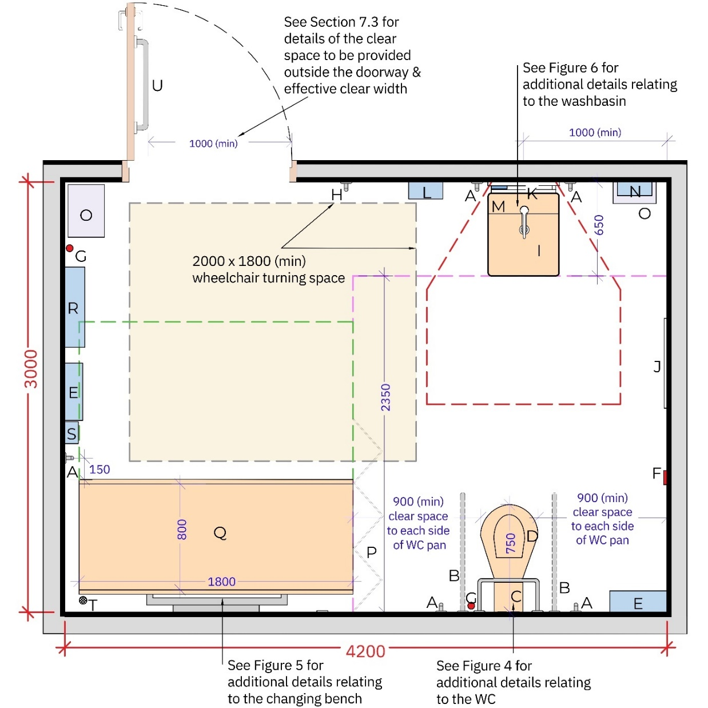

Key
- Vertical grabrail ∅ diameter 35mm
- Drop-down rail ∅ diameter 35mm
- Padded back rest
- WC pan
- Personal care shelf
- Alarm reset button
- Alarm pull cord
- Clothes hooks
- Height-adjustable washbasin
- Full length mirror
- Mirror above basin
- Automatic hand dryer

Note: All dimensions in millimetres

- Soap dispenser
- Paper towel dispenser
- Disposal bin
- Privacy screen
- Height-adjustable changing bench
- Wide paper roll dispenser
- Optional showering unit with minimum 2000mm hose
- Floor drain (when showering unit is provided)
- Long horizontal grabrail

TGD M 2022 allows a more flexible approach to the room size and layout in an existing building once the wheelchair turning space inside the door and adequate space allowance around each piece of equipment is provided. Figure 2 illustrates the circulation space required around each piece of equipment.
Figure 2 Wheelchair turning space and circulation space required around equipment in new and existing buildings.
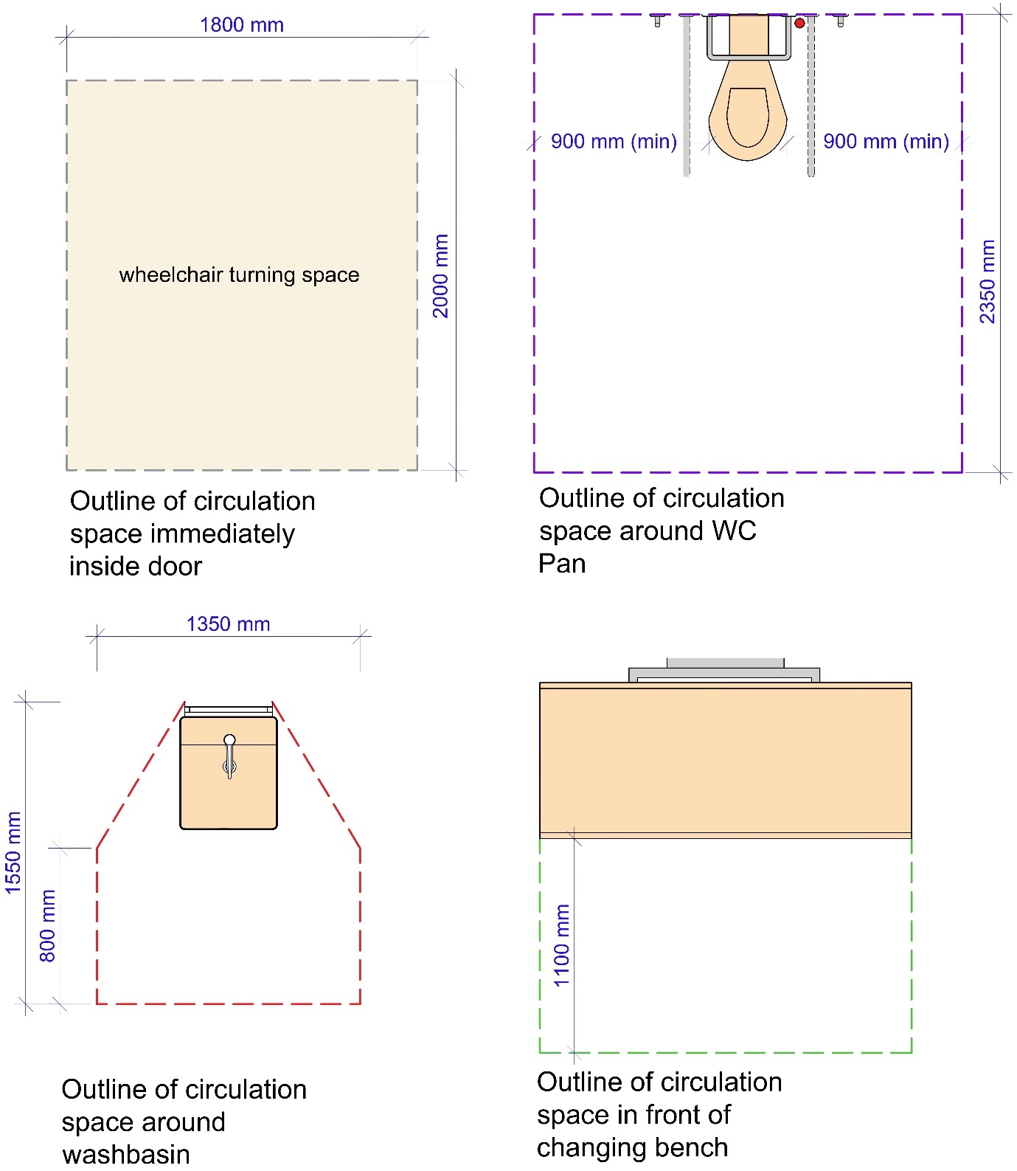

Figure 3 below indicates a layout with the door on the shorter wall of the Changing Places Toilet, entering between the WC pan and wash basin. In this example, a wash basin with an overall depth (including bracket) of 650mm is shown. In order to provide the wheelchair turning space of 2000mm by 1800mm directly inside the door, the room needs to be a minimum 3200mm wide. Figure 3 does not demonstrate prima facie compliance with Part M of the Second Schedule to the Building Regulations (as amended).

Figure 3 Alternative Layout of a Changing Places Toilet
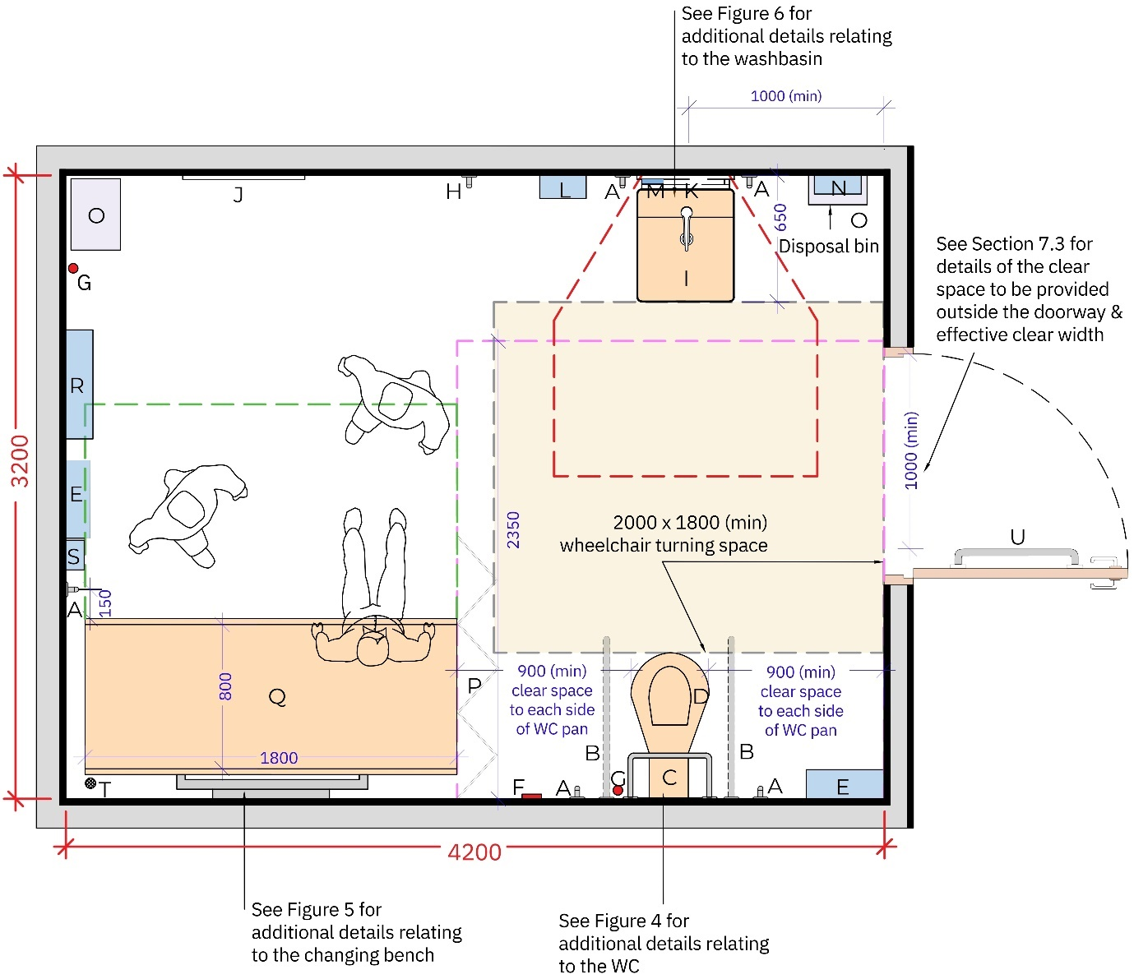

Key
- Vertical grabrail ∅ diameter 35mm
- Drop-down rail ∅ diameter 35mm
- Padded back rest
- WC pan
- Personal care shelf
- Alarm reset button
- Alarm pull cord
- Clothes hooks
- Height-adjustable washbasin
- Full length mirror
- Mirror above basin
- Automatic hand dryer

Note: All dimensions in millimetres

- Soap dispenser
- Paper towel dispenser
- Disposal bin
- Privacy screen
- Height-adjustable changing bench
- Wide paper roll dispenser
- Optional showering unit with minimum 2000mm hose
- Floor drain (when showering unit is provided)
- Long horizontal grabrail

Doors to Changing Places Toilets
A self-closing device should not be fitted to the door of a Changing Places Toilet unless the door is an accessible power-operated door or a fire door.
If a manually operated door is provided, the door handle should be a light action lever lock. The door handle should be operable with a closed fist.
The privacy bolt or lock should incorporate a visual indicator to display whether the Changing Places Toilet is vacant or occupied.
A minimum of 1000mm effective clear width is required on the Changing Places Toilet door. This is to accommodate large, wheeled mobility devices.
There should be an unobstructed space of at least 600mm on the pull side of the door between the leading edge of the door (when it opens towards you) and a return wall unless the door is opened by remote automatic control.
Doors to Changing Places Toilets should have an emergency release mechanism for example, lifting off hinges or a lock which can be opened from the outside.
If a manual outward opening door is provided, it should be fitted with a 600mm long horizontal rail 900mm above floor level.
Provision of an outward-opening door allows for maximum wheelchair circulation space inside the facility and is the preferred option, as an outward opening door can be opened easily in an emergency if a person has fallen against the door inside the room. Outward opening doors on major access routes and escape routes should be recessed so that when fully open, they do not project into the corridor space. The depth of the recess should not be less than the width of the door leaf.
Automatic doors should be provided, where possible, because opening a door while guiding a wheelchair can be difficult. Controls for automatic doors should be easy to use and should contrast visually with their background. For further guidance on automatic doors, refer to ‘Section 2.6.6 of Building for Everyone: A Universal Design Approach, Booklet 2, Entrances and horizontal circulation’.
Should sliding doors be provided, the guidance on sliding doors in ‘Section 5.10.3 of Building for Everyone: A Universal Design Approach, Booklet 5, Sanitary Facilities’ should be followed.
Acoustic privacy should be considered in a Changing Places Toilet, as it enhances the dignity and privacy of the people using the facilities. Doors should be designed with acoustic properties to enable speech privacy. Speech privacy means that when conversations are taking place, listeners may hear sounds, but cannot make out what the speakers are saying.

WC Pan
A peninsular WC layout should be provided with a clear circulation space provided around the pan. The space either side of the WC pan is to allow for Personal Assistants/Carers to assist on both sides of the WC pan. Refer to Figure 4 for the clear space required in front of and on each side of the WC pan. A distance of 750mm should be provided from the back wall to the front of the WC pan.
Wall-mounted drop-down support rails and vertical grab rails should be provided on both sides of the WC pan. The top edge of the drop-down rails should be 680mm high above floor level. Refer to Figure 4 for the location of wall-mounted drop-down support rails and vertical grab rails on both sides of the WC pan.
A toilet paper dispenser should be provided on at least one of the drop-down support rails and preferably on both drop-down support rails. Wherever possible, dropdown support rails should be height-adjustable as this offers greater flexibility.
Vertical rails should be a minimum of 600mm in length.
Image 5 A simulated image of a peninsular WC pan arrangement. 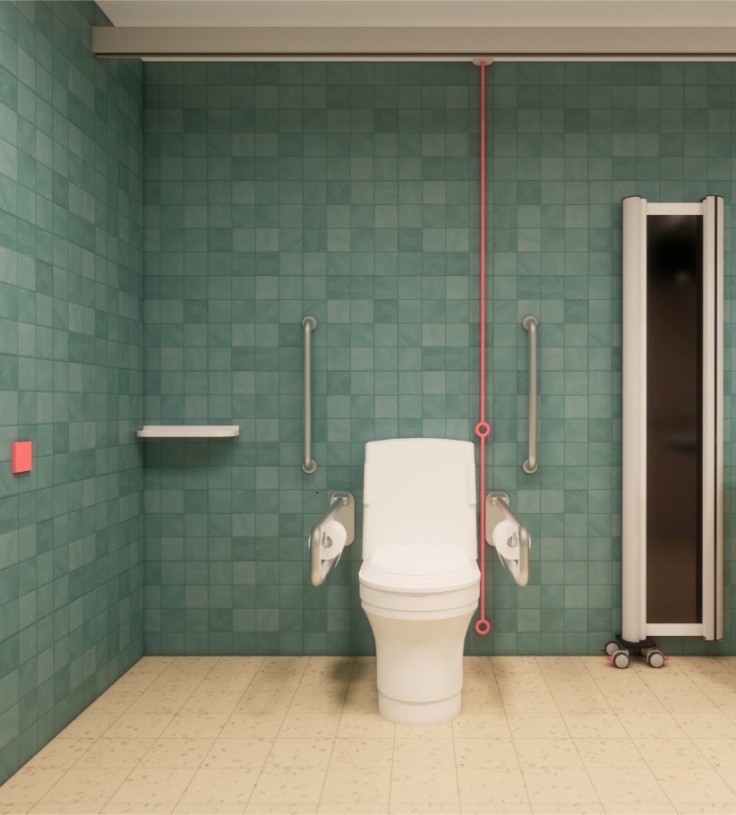
The WC pan should have a seat height of 480mm above floor level. In some building types for example day centres, health-care settings, or schools a different height WC pan may be preferred.
Where high- or low-level cisterns or concealed cisterns are provided, a rail with a padded back rest should be provided. Where a flat topped close-coupled cistern is used, the cistern should be adequate to also act as a back rest.
Providing a separate colostomy shelf is preferred to using the WC cistern as a shelf. This is to ensure that a hygienic and safe space is provided for personal care items, which can include not only colostomy care items, but also sanitary pads, wipes, hygiene products, incontinence wear and personal protective equipment (PPE). Refer to Section 7.20 for further guidance on the provision of shelves.

The following additional provisions should be considered in consultation with users:
- A height-adjustable WC pan:
A height-adjustable WC pan offers flexibility in use. People of shorter stature may prefer a lower WC pan height. Others may prefer a higher WC pan height for example to make the movement from sitting to standing easier.
- An automatic ‘wash and dry’ WC pan:
An automatic ‘wash and dry' WC pan removes the need to wipe after toileting and may be preferred by users for a number of reasons including cultural preferences, enhanced dignity in care or limited reach-range to wipe.
Image 6 Example of a height-adjustable WC pan, courtesy of Pressalit
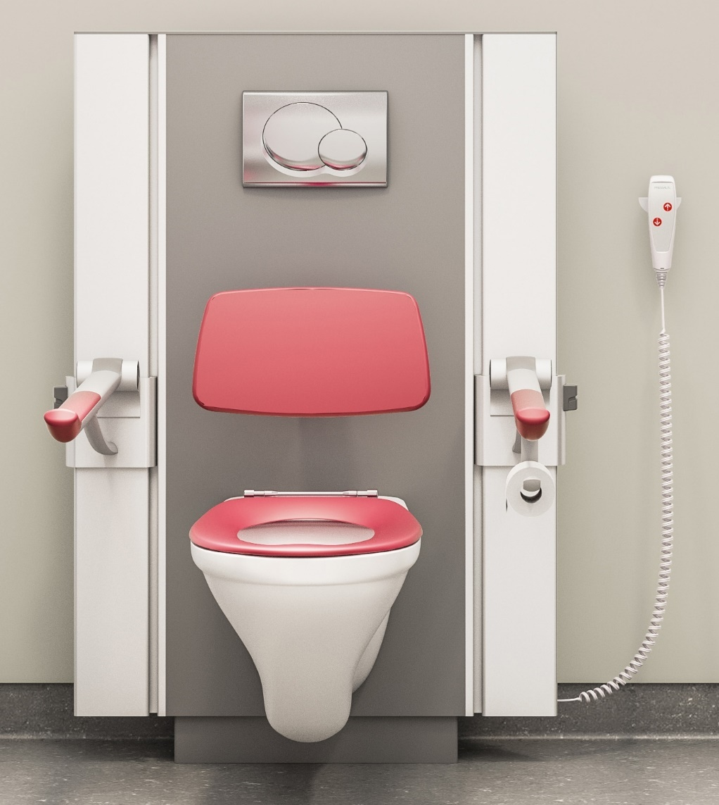

Figure 4 Changing Places Toilet WC Pan Circulation Space and Fittings
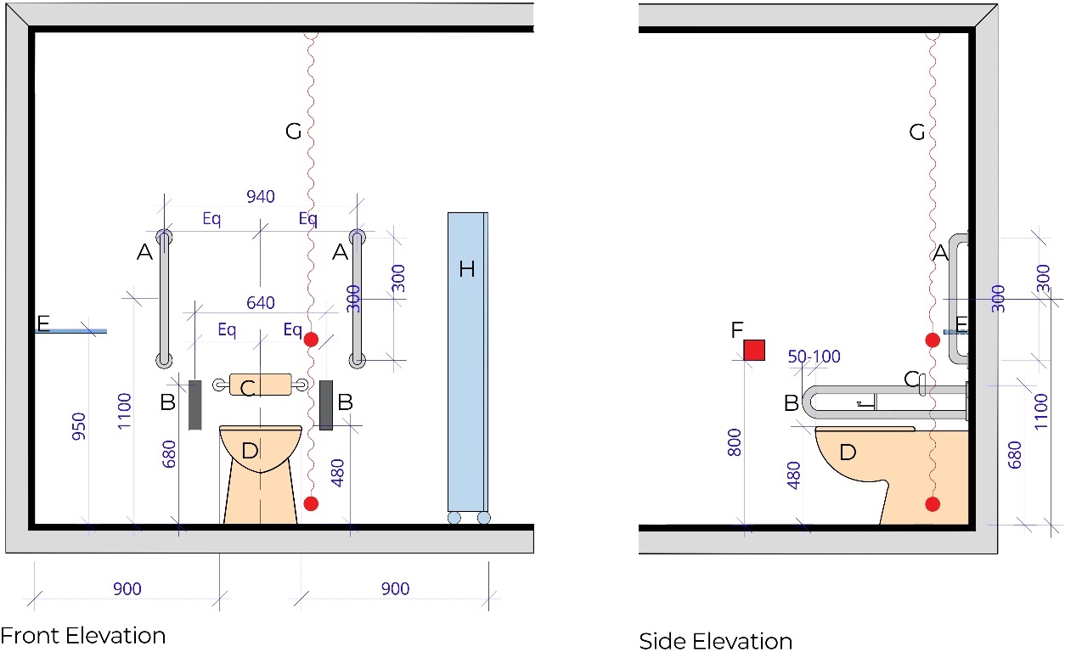

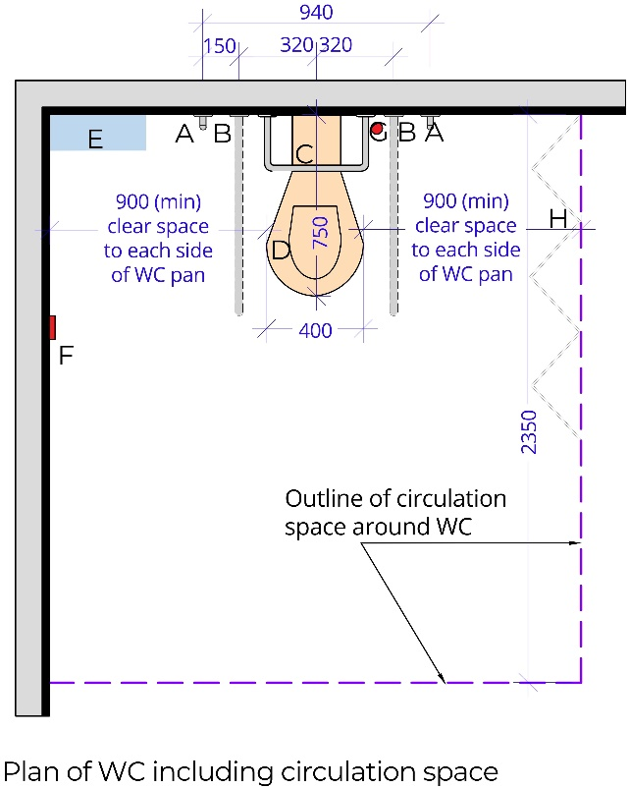
Key
- Vertical grab rail ∅ diameter 35mm
- Drop down rail ∅ diameter 35mm
- Padded back rest
- WC pan
- Personal care shelf
- Alarm reset button
- Alarm pull cord
- Privacy screen
Eq. Equal distance

Note: All dimensions in millimetres.

Changing Bench

Wall-mounted Changing Bench
The minimum provisions of TGD M 2022 require a wall-mounted adult-sized, height-adjustable, changing bench, with a clear unobstructed circulation space in front of the changing bench as per Figure 2 and Figure 5.
The height-adjustable changing bench should have a changing surface which is a minimum of 1800mm in length by 800mm wide with a minimum certified weight capacity of 200kg. The height adjustment mechanism for wall-mounted benches should be mains powered and include a pressure sensitive safety override that will prevent the changing bench from lowering if there is any obstruction underneath.
The changing bench should have a minimum range of height adjustment from 450mm to 900mm above floor level.
It should have retractable side safety rails along the long edge(s) that can be folded up or down. Instructions should be provided on how to adjust the rails and the height of the changing bench.
Where a shower facility is being provided, a suitable changing bench should be provided with provision for wastewater disposal.
A vertical grab rail should be provided 150mm from the front edge of the changing bench at the available wall side as per Figure 5.
Changing bench material should be comfortable, easily wipeable and non-porous to support infection control. For example, some changing benches are padded for cushioning effect and some products have adjustable surfaces/inclined backs to prop a person’s head and/or back on the bench which can assist with dressing.
Downlighters are not to be fitted directly above the last 600mm of the head or foot of the changing bench.
Providing a wall-mounted changing bench will ensure that the bench cannot be removed from the Changing Places Toilet and will be the most suitable option in most public buildings.

Freestanding Changing Bench
A freestanding bench can be moved and enables a user to be assisted by two or more people either side of the bench, whereas a wall-hung bench enables people to be assisted on one side of the bench only. In some cases, for example in a day centre with staff who are familiar with the equipment, a freestanding changing bench may be preferred to a wall-mounted version. Providing a freestanding changing bench should be informed by stakeholder engagement and consultation with end-users.
A freestanding changing bench, in lieu of a wall-mounted changing bench, will not prima facie, indicate compliance with Part M of the Second Schedule to the Building Regulations (as amended).

Figure 5 Changing Places Toilet Changing Bench and Fittings
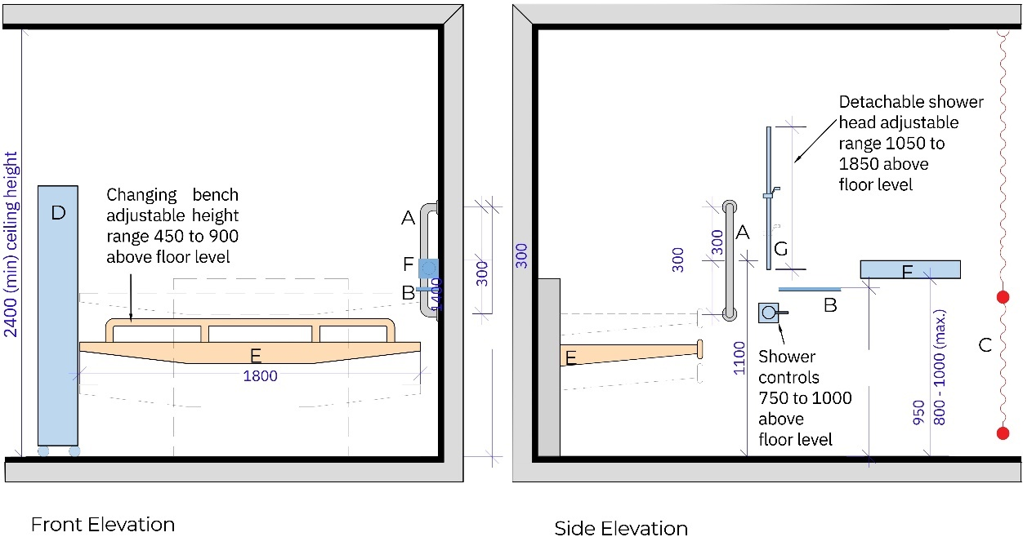
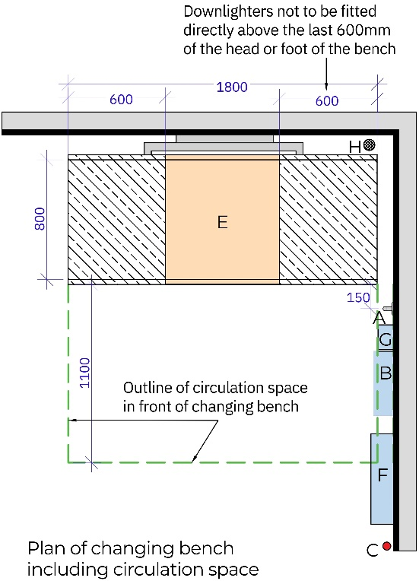
Key
- Vertical grabrail ∅ diameter 35mm
- Personal belongings shelf
- Alarm pull cord
- Privacy screen
- Height-adjustable changing bench
- Wide paper roll dispenser
- Optional showering unit with minimum 2000mm hose
- Floor drain (when showering unit is provided)
Note: All dimensions in millimetres.
Image 7 Example of a wall-mounted height-adjustable changing bench.
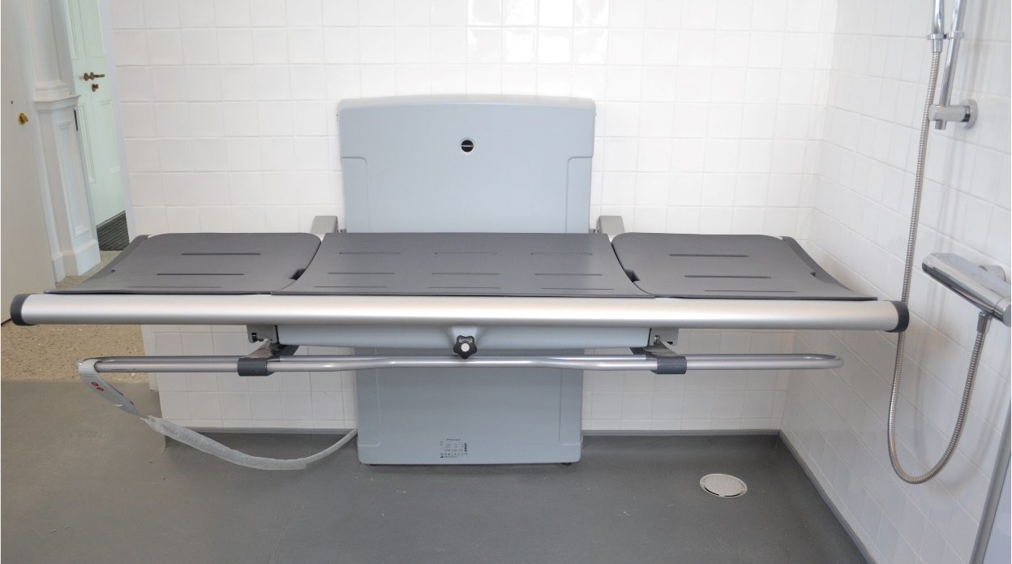

Image 8 A person using a hoist, being transferred onto a wall-hung changing bench by two assistants.
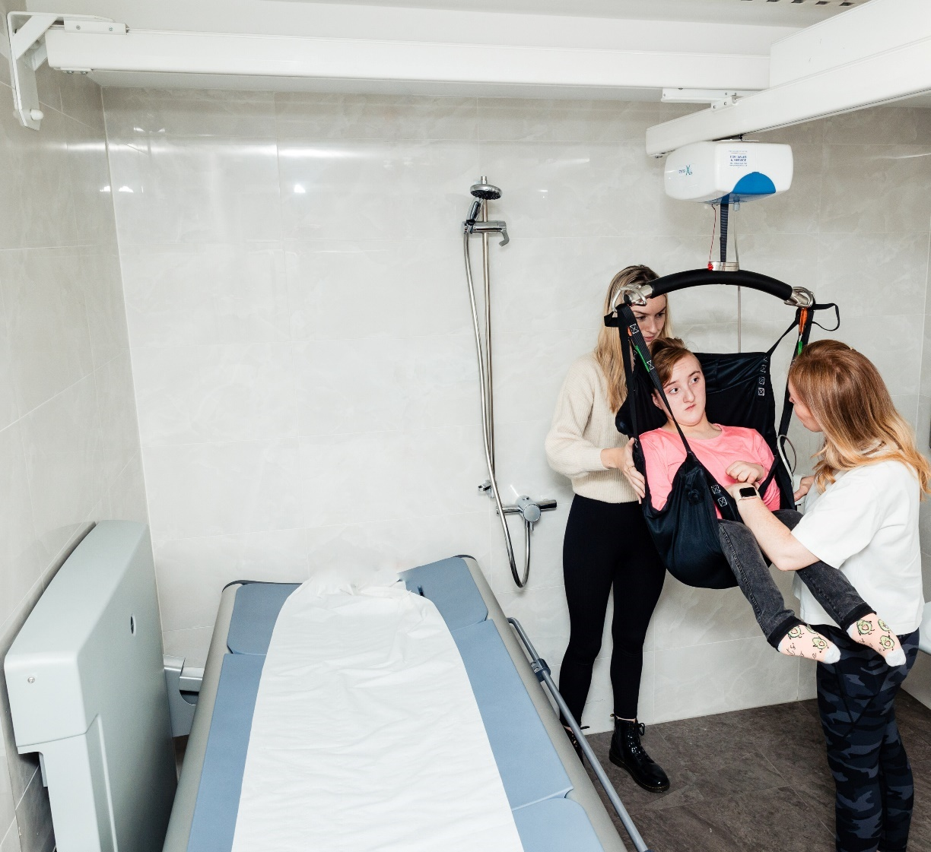

Washbasin
To cater for both standing and seated users, a power-operated, height-adjustable washbasin should be provided. Refer to Figure 6 for the clear circulation space required around the washbasin. The circulation space around the washbasin begins at each side of the washbasin where the washbasin abuts the wall.
An electronically height-adjustable range of 600mm to 850mm above floor level should be provided and the knee recess under the basin should be free of obstructions. The height-adjustment mechanism should include a pressure sensitive safety override that will prevent the washbasin from lowering if there is any obstruction underneath.
A minimum washbasin size of approximately 500mm wide by 450mm deep is required, to enable people to have a full body wash, or to wash personal care equipment. The drawings in these guidelines show an indicative overall washbasin depth of 650mm, which includes the washbasin and its height-adjustable bracket. Should the installed washbasin and bracket be deeper than this, the overall width of the room will need to increase, in order to maintain the 2350mm deep clear circulation space at the WC pan.
Vertical grabrails should be provided adjacent to the washbasin to provide support and allow a person to stabilise themselves at the washbasin. They may be used by some people to pull themselves up to standing. The top fixings for both handrails should be 1400mm above floor level. Refer to Figure 6 for further details on the location of vertical grab rails on both sides of the washbasin.
The washbasin should have a power-operated height-adjustable control that is visually contrasting. If controls of the washbasin have a remote control, there should be a bracket to hang the remote control. This is typically attached to the washbasin or can be a wall-hung bracket adjacent to the washbasin.
An automatically controlled tap or a tap capable of being operable with a closed fist, such as a long lever tap, should be provided. The washbasin and tap should visually contrast with the background on which they are seen.
There should be waterproof, wall-mounted instructions for operating the washbasin, which are easy to understand, using suitable pictograms.
Figure 6 Changing Places Toilet Washbasin and Fittings
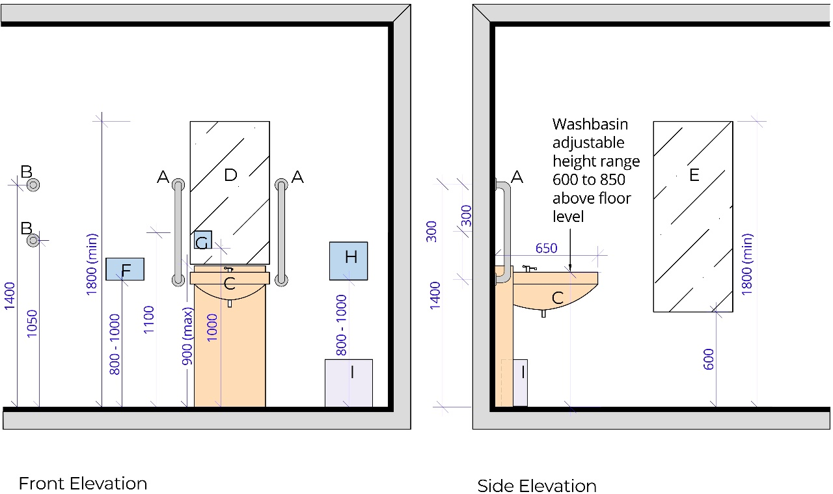
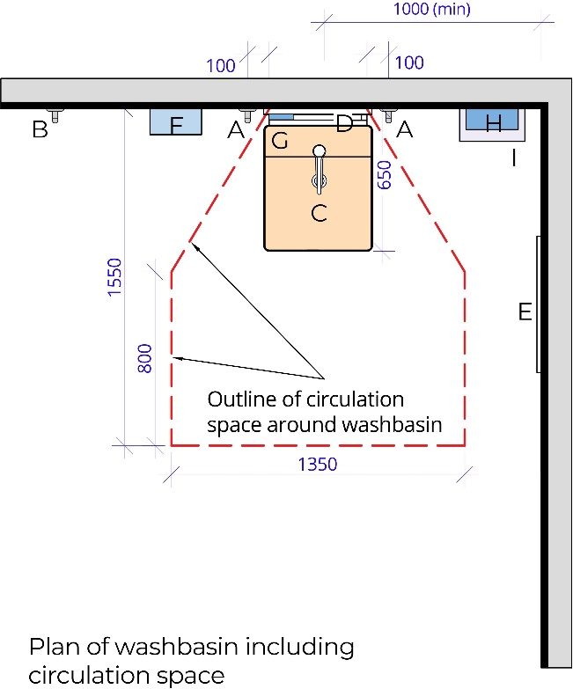
Key
              - Vertical grabrail ∅ diameter 35mm
              - Clothes hooks
              - Height-adjustable washbasin
              - Mirror above washbasin
              - Full-length mirror
              - Automatic hand dryer
              - Soap dispenser
              - Paper towel dispenser
              - Disposal bin

Note: All dimensions in millimetres.

Image 9 Example of a height-adjustable washbasin, courtesy of Kildare County Council
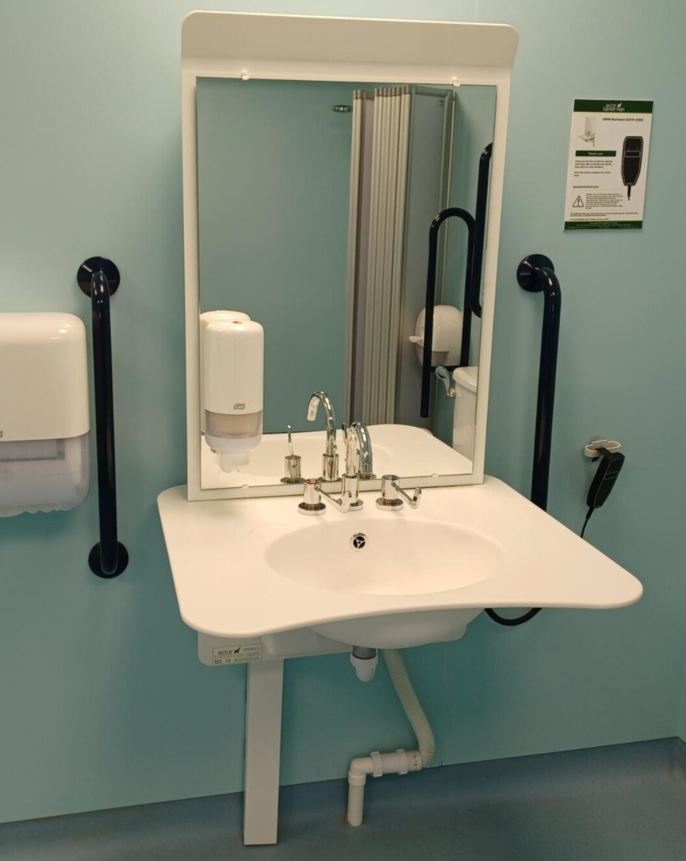

Mirrors
A mirror should be installed over the washbasin with the lower end of the mirror at maximum 900mm above floor level. The mirror should have an overall length of at least 900mm. Some height-adjustable washbasins have an integrated mirror installed above the washbasin, which allows the height of both the mirror and washbasin to adjust simultaneously.
A wall-mounted full-length mirror with unobstructed access should also be provided in a Changing Places Toilet, to enable both seated and standing users to view themselves. The full-length mirror should be at least 600mm wide and should be positioned with its lower edge at 600mm above floor level, extending to at least 1800mm from floor level. A mirror should not extend to floor level as it can be susceptible to damage by wheelchair footrests. Additionally, a mirror which extends to floor level can create a false impression of being a door or wall opening.
A minimum gap of 300mm should be provided between the mirror and the corner of the room, to allow for ease of use for all users.

Soap Dispenser
A soap dispenser should be positioned directly above the washbasin. If a wall-mounted mirror is provided, a soap dispenser should have its lower edge at 1000mm above floor level, to allow for a sufficient gap to be maintained when the wash basin is at its highest position (850mm) and for easy operation by seated and standing users. If a height-adjustable washbasin with an integrated mirror is installed, a soap-dispenser mounted on the mirror will move simultaneously with the height-adjustable washbasin.
An automated sensor soap dispenser should be provided as it requires low physical effort. Alternatively, the soap dispenser should be easy to operate with one hand.
Pump dispensers which require fine motor movement and force should not be installed.
Whilst hand sanitiser is not a requirement, it is good practice to provide it for hand hygiene. It should be dispensed by the same low-effort mechanism as the soap dispenser.

Hand Drying
A hand dryer and a paper towel dispenser should be provided in a Changing Places Toilet. Providing both options provides flexibility in use, for example those who are sensitive to noise or direct heat may have a preference to use paper towels.
Low noise hand dryers should be provided with a maximum noise level of 70 decibels. Louder hand dryers can cause discomfort for people who have noise sensitivity. The hand dryer should function by either a motion sensor or a push button which can be activated by a closed fist.
The hand dryer should be provided near the washbasin with the lower edge positioned 800mm to 1000mm above floor level. The design of the hand dryer should not require hands to be inserted from the top of the dryer.
There should be sufficient space in front of the hand dryer for a wheelchair user to wheel up to it as per Figure 1, Figure 3 and Figure 6.
The paper towel dispenser should be wall-mounted close to the washbasin with the lower edge positioned 800mm to 1000mm above floor level. The paper towel dispenser should be easy to operate with one hand.
Both the paper towel dispenser and hand dryer should visually contrast against the background they are seen on.

Wide Paper Roll Dispenser
A wall-mounted dispenser with a wide paper roll should be provided, adjacent to the head of the changing-bench.
The underside of the wall-mounted paper roll dispenser should be positioned 800 to 1000mm above floor level.
Where possible, avoid locating the wall-mounted paper roll dispenser too close to where a shower is provided.

Hoist System
A continuous charging full-ceiling coverage track should be provided within the Changing Places Toilet that conforms to ‘I.S. EN ISO 10535:2021 Hoists for the transfer of persons: Requirements and test methods’. Ceiling mounted mechanical and electrical fittings should not obstruct the moving rail of the overhead hoist.
Image 10 Example of a user being hoisted within a Changing Places Toilet.
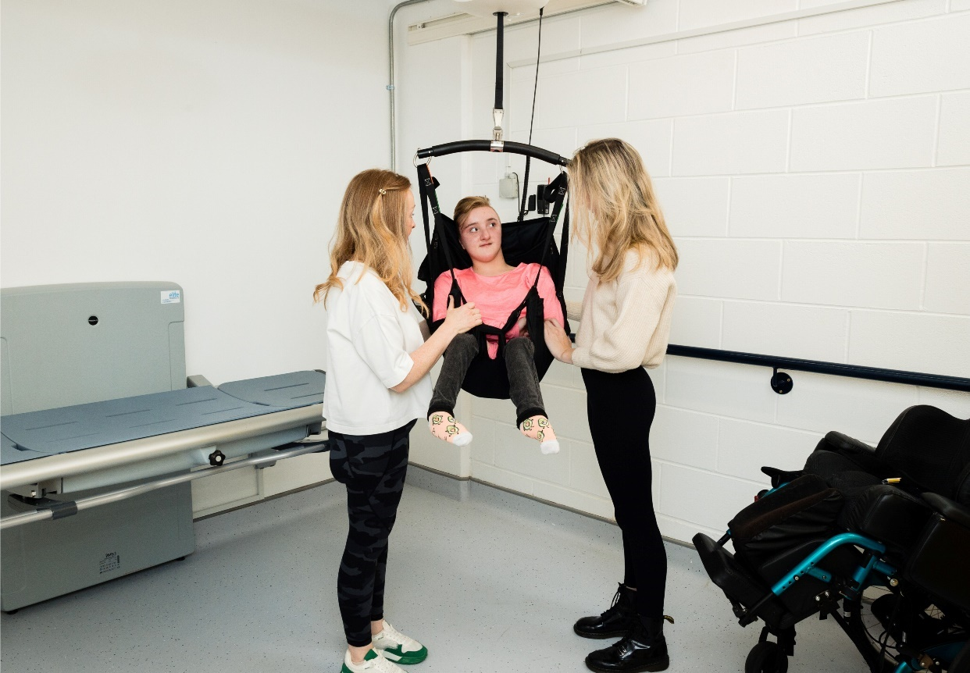
The room structure and hoist system should be capable of supporting a safe working load of not less than 200kg. The hoist, the washbasin and the changing bench should have the same lifting load to prevent a mismatch of safe lifting loads.
A Changing Places Toilet is not suitable for Bariatric use where the turning space and load-bearing capabilities are required to be considerably more onerous. It is necessary to obtain specialist advice for such use.
A minimum clear ceiling height of 2400mm should be provided. This is to accommodate the ceiling hoist space whilst providing clear headroom between the hoist track/rails and the floor level, which should be no less than 2100mm.
The hoist spreader bar should be capable of extending from the hoist down to no more than 300mm from the floor level to facilitate a person being lifted from ground level if required in an emergency.
This type of track system is typically a H-frame, and it should provide full room cover.
The handset controls for the hoist should visually contrast against the background on which they are seen.
Clear and visual hoist instructions should be provided for the hoist attachment, control, and use.
Hoist signage should include the following:
- Safety features such as maximum load weight, production certification such as CE markings, date of last service (typically provided on a sticker by an equipment service engineer)
The following additional hoist provisions should be considered in consultation with users:
- Hoist Attachment – a spreader bar attachment:
Some wheelchair users may have different types of slings (loop and clipped) which can be accommodated for with different hoist attachments such as a spreader bar.
- Hoist Attachment – a weighing scales attachment:
Some wheelchair users find it difficult to record their weight at home, and this hoist attachment could be of benefit.

Privacy Screen
A privacy screen is typically a wall-mounted folding screen or a retractable roller screen on castors, that can be pulled out, to give dignity to the user in a Changing Places Toilet.

Wall-mounted Privacy Screen
The minimum provisions of TGD M 2022 require a wall-mounted privacy screen. It offers extra privacy for users of Changing Places Toilets when using the changing bench or WC pan whilst not obstructing the space to the side of the WC when it is retracted.
Privacy screens should have an extended length of not less than 1750mm. The screen should have a surface that is easy to clean and dry.
Providing a wall-mounted privacy screen will ensure that it cannot be removed from the Changing Places Toilet and will be the most suitable option in most public buildings.

Freestanding Privacy Screen
A freestanding privacy screen can offer more flexibility than a wall-mounted one, as it can be positioned in different areas of the room. In some cases, for example in a day centre with staff who are familiar with the equipment, a freestanding privacy screen may be preferred to a wall-mounted version. Providing a freestanding privacy screen should be informed by stakeholder engagement and consultation with end-users. If a freestanding privacy screen is provided, it should have a sturdy castor base that can carry the weight of the privacy screen when moving, and prevent it from tipping over.
A freestanding privacy screen, in lieu of a wall-mounted privacy screen, will not prima facie, indicate compliance with Part M of the Second Schedule to the Building Regulations (as amended).

Image 11 Example of a wall-mounted privacy screen in the extended position.
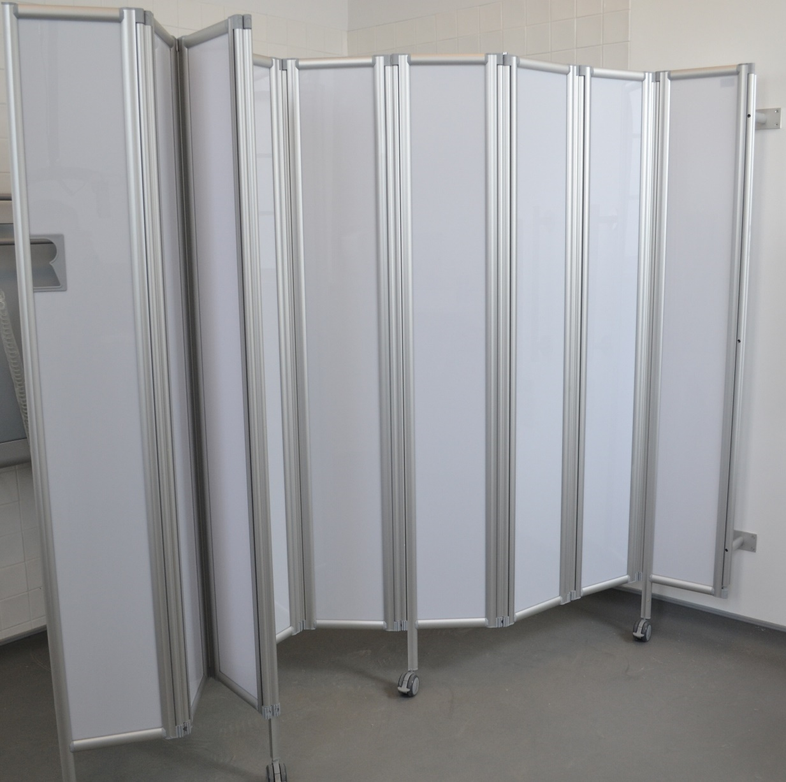

Waste Disposal Bins
Two bins should be provided in a Changing Places Toilet, one for general refuse and one for sanitary/offensive waste. Sanitary/offensive waste is non-infectious, non-clinical, non-hazardous waste that contains bodily fluids, secretions, or excretions.
The bin provided for sanitary/offensive waste should be large enough for the following:
- Personal protective equipment (PPE) such as gloves, aprons, and masks
- Incontinence wear products such as incontinence pads, chair protection sheets, catheters, penile sheaths, stoma bags and urinary drainage bags
The bins should, where practicable, be recessed into the wall to avoid being an obstacle.
Some users including wheelchair users may not be able to use pedal-bins. Hands-free bins are good for infection control as they prevent people from touching the top of the bin. Automated or infrared sensor bins are accessible and operate on low power usage. They require infrequent battery changes.

Ventilation
Adequate ventilation should be provided to ensure the room has sufficient fresh air, and to remove moisture after showering, if applicable. Supplementary natural ventilation (for example windows) may also be beneficial.
If a ventilation extract fan is provided, it should be as quiet as possible in operation as the noise can cause distress to some people and can be a barrier to communication.
Placement of heating, ventilation and air conditioning fans should be considered so the airflow is not blowing air on top of a user. For example, avoid locating the fans over the changing bench and WC where a user can be positioned for long periods of time.

Sanitary Towel Dispenser
The provision of a sanitary towel dispenser should be considered. If provided, the controls and dispensing drawer should be positioned at a height between 750mm and 1200mm above floor level. The dispenser should be located no less than 500mm from an internal corner.

Emergency Assistance Alarm System
An emergency alarm with two pull cords should be provided within the Changing Places Toilet. This will allow the user or Personal Assistant/Carer to call for help if needed. These need to be carefully positioned to avoid obstructing the operation of the overhead hoist.
The two alarm pull cords should have two red 50mm diameter bangles, one at 100 mm above floor level and the other at 800mm to 1000mm above floor level. This allows for the cord to be reachable by a person who has fallen to the floor, as well as someone seated or standing. For positioning of the two alarm pull cords refer to Figure 1, Figure 3 and Figure 4.
A reset button should be provided in the position shown in Figure 1, Figure 4 and Figure 3. The lower end of the reset button should be located 800mm above floor level.
There should be visual and audible indicators at a central control point to alert staff that an emergency call has been activated. Additionally, there should be a visual and audible indicator provided directly outside the Changing Places Toilet so it can be seen and heard by people to give assistance. The sound should be distinguishable from the fire alarm sound.
Ensure that early planning takes place to ensure the alarms are fully integrated into the overall operational strategy for the facility (for example the alerts are sent to staffed areas and that staff are provided with training on how to assist).
Instructions on what to do in the event of triggering the emergency alarm and the information about emergency assistance process should be provided on clear signage.

Lighting
Timed lighting should not be used in a Changing Places Toilet.
Down lighters should not be installed within 600mm of the ends of the changing bench within the areas where a person lying on the table will be looking directly towards the ceiling.
Lighting should be positioned to avoid creating shadows, glare, and reflections. Ceiling lights and other mechanical fittings should be shallow or recessed and positioned away from the ceiling track to avoid causing a hoist obstruction.
Lighting should be suitable for a ‘wet room’ environment.
The lux levels when the lighting is fully on should be between 200 and 300 lux, measured at floor level. Lighting should be evenly distributed throughout the room.
Ultraviolet light should be avoided in Changing Places Toilets as it reduces lighting levels and visual contrast.
The provision of lighting that allows for variable lighting levels in the room should be considered, as it may benefit some neurodiverse people.

Heating
Changing Places Toilets need to be adequately heated to maintain a comfortable temperature for users of the space. People using the facilities who may be undressed for longer periods of time whilst changing or showering within the room will require a suitably heated space.
Consider underfloor heating in the design as it will provide consistent temperature throughout.
If heat emitters such as radiators are installed, they should not project into or restrict the minimum clear wheelchair turning space or the circulation spaces beside the WC, washbasin or changing bench. They should not be located near the changing bench where a person could touch it and it could cause an injury. Any heat emitters should either be screened or have their exposed surfaces kept at a temperature below 43° Celsius.

Shower
The main benefit of installing a shower in a Changing Places Toilet is to allow people to wash after using the WC or whilst getting changed at the facility, for example at a leisure centre or swimming pool.
A shower is not required in all Changing Places Toilets. A shower is required in a Changing Places Toilet where sanitary facilities combining showers and WCs are provided for use by people other than staff, for example in sports and leisure centres.
The provision of a shower in a Changing Places Toilet in other facilities where it is not required should be informed by user consultation and consideration of the nature and use of the building.
Where a shower is provided, the shower controls should be easy to use and capable of being operated with a closed fist, for example with a lever handle operation. The markings on the shower control should be logical and clear. The shower control should be located within the range of 750 to 1000mm above floor level.
The shower rail should be located adjacent to the changing bench. A vertical mounting bar and adjustable bracket should be provided to allow for the shower head to be mounted in the range of 1050 to 1850mm. The showerhead should be detachable and mounted on a flexible hose. The hose should be at least 2m long to allow for use on the changing bench. The temperature of the water should be adjustable, and the shower thermostat should have a maximum temperature of 40 degrees Celsius.
When installing a shower into a Changing Places Toilet, the changing bench should have a water collection tray with an integral wastewater outlet, plug and hose. The floor should be self-draining and the gradient for the shower drain should be 1:50 or less steep. The position of the shower drain should be co-ordinated with the position of the hose outlet on the changing bench and to avoid the hose causing an obstruction when the changing bench is folded up. Any drainage grating should be designed to not pose the risk of castor wheel, cane, or wheelchairs becoming caught.
A Changing Places Toilet with a shower will need regular cleaning as wet floors may prevent people from using it. The changing bench also needs to be dried before dressing, and therefore users should be reminded to bring their own towels.

Accessories
A colostomy changing shelf should be provided near the WC pan and another shelf should be provided near the changing bench to allow Personal Assistants / Carers to easily reach items such as catheters, pads, PPE, colostomy items and other personal care items. Shelving should not be positioned in such a way as to impede Personal Assistants/Carers being able to safely operate the hoist or attend to the person on the changing bench. The location of the shelves is represented in Figure 1, Figure 3, Figure 4 and Figure 5.
The shelf dimensions are 125mm to 150mm deep by 400mm minimum wide with its surface 950mm above floor level.
A minimum of two clothing hooks should also be provided at 1050mm and 1400mm above floor level. For placement of all accessories refer to Figure 1, Figure 3 and Figure 6.

Signage
Signage should be provided at the entrance of the Changing Places Toilet to indicate the location of the nearest accessible unisex WC and any baby changing facilities. It is also useful to provide information on the appropriate use of the Changing Places Toilet, for example in Image 12 below.
Image 12 Example of door signage indicating the function and use of a Changing Places Toilet
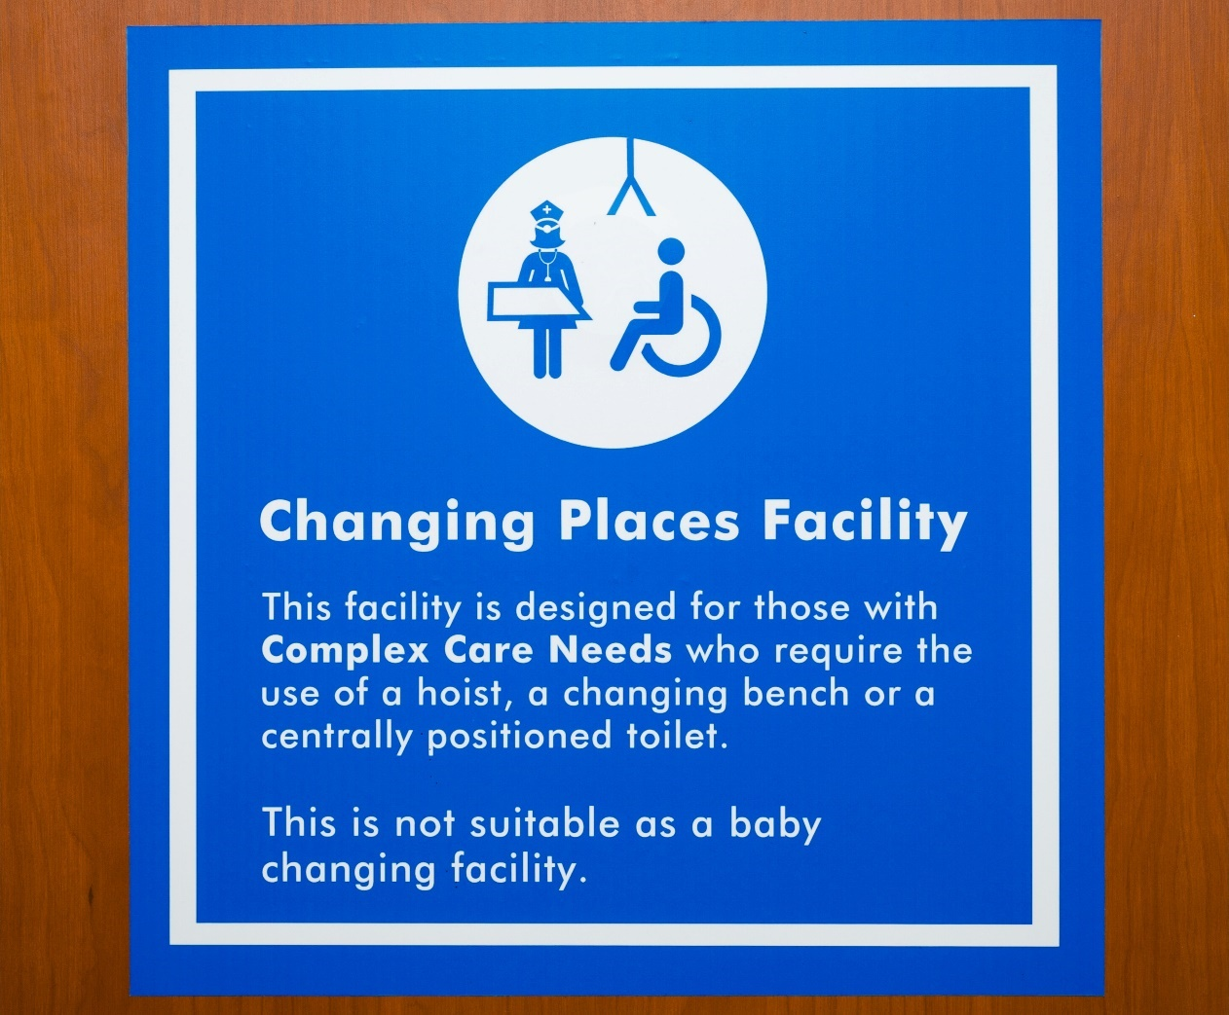
Accessible signage that includes instructions on how to safely operate the changing bench, overhead hoist and height-adjustable washbasin should be provided in a Changing Places Toilet.
Information should also be provided on who to contact should the facility need to be maintained or cleaned.
Providing Braille signs on taps, hand dryers and on the WC pan near the flush should also be considered.
Refer to Section 6.5 for further information on signage.

Flooring and Surface Finishes
The floor surface should be step free, level, and slip resistant, especially when wet. The slip resistance of the flooring in Changing Places Toilets should maintain a minimum Pendulum Test Value (PTV) of 36+ in final use conditions.
The surface finish of the floor should contrast visually with the surrounding surfaces (walls and door) within the Changing Places Toilet.
Matt surface finishes should be used throughout to avoid glare.
Careful use of colour should be incorporated into the design. Strong contrasting busy patterns should be avoided on walls and floors where visual acuity is critical, such as in a transfer area where grabrails are located. They can cause confusion, particularly for people who are blind and partially sighted and people who are neurodiverse.
Finishes should be selected to ensure the aesthetics, look and feel of the room make it inviting and user friendly.
If artwork is provided it should be carefully located so that it does not compete with signage and instructions. Large wall murals and floor to ceiling artwork should be avoided as they can cause confusion for some people with dementia.

Management and Maintenance
This section provides good practice guidance on managing and maintaining Changing Places Toilets.
It includes guidance on the importance of pre-visit information to inform users that a Changing Places Toilet is available and to provide them with information about the facility. It provides details on the importance of registering a Changing Places Toilet on the Changing Places Ireland website and how to provide information for users during their visit.
The section also recognises the importance of Universal Design in the day-to-day operations of a building and provides details on managing accessibility and security, staff training, routine monitoring and maintenance and health and safety.

Pre-Visit Information
Organisations providing a new Changing Places Toilet should promote the facility to raise awareness within the community. Pre-visit information allows people to plan their journey in advance. It is widely recognised that providing pre-visit information enhances the overall visit experience for everyone. It is particularly important for disabled people and their Personal Assistants/Carers to have pre-visit information, as it cannot always be assumed that sanitary facilities to meet their needs will be available.

Registration of Changing Places Toilets
A national voluntary register of Changing Places Toilets is maintained by Changing Places Ireland. A national map of Changing Places Toilets locations is provided on their website as well as a link to each Changing Places Toilet. Registering a Changing Places Toilet on this website allows end-users to identify where Changing Places Toilets and ‘step-down’ facilities are provided throughout the country and it provides detailed pre-visit information on the design and equipment in place at each of the Changing Places Toilets. A Changing Places Toilet should be registered on this website as it ensures all information is available in one location. The website is very beneficial as it provides direct links to individual websites and facility contacts for each Changing Places Toilet.
To voluntarily register a Changing Places Toilet, contact Changing Places Ireland.

Checklist of Pre-visit Information
Pre-visit information is typically provided on a website and should include the information in the checklist below.

Appointed Person to Manage and Maintain the Facility
- Contact person’s name, number, and e-mail
- Explicitly state wait-time to return call/email
- Contact person should be reachable for the duration when the facility is open

Appointed Person in Case of Emergency
- Contact person’s name, number, and e-mail
- Explicitly state wait-time to return call/email
- Contact person should be reachable for the duration when the facility is open

Details about the Changing Places Toilet
- Location of the Changing Places Toilet
- Opening hours
- Methods of access, for example, is the facility unlocked, locked by a key, or is there another method of opening including information on any security arrangements
- Car-parking spaces and approach routes, distance to the facility from accessible parking spaces and the opening hours of parking
- Photographs of the Changing Places Toilet, the approach to the facility and its equipment
- Description of the facility and equipment in place including the size of the room
- Specifications on the equipment including the load weight capacity and style of hoist and changing bench and what type of slings are compatible with the hoist
- Downloadable instructions for using the hoist, changing bench, washbasin etc.
- Reminder to users to bring own sling(s), and towels if there is a shower facility
- Any unique functions of the facility, for example option to switch off the hand dryer and availability of extra attachments for the hoist and where to retrieve them
- A post-visit evaluation form
Include the Changing Places Toilet in the social story of the building, if there is one to download for visitors. A social story is a social learning tool that supports the safe and meaningful exchange of information between parents, professionals, and people with autism of all ages.
It is also recommended that members of the local community are made aware of the availability of Changing Places Toilets, for example by making printed maps and guides available at reception areas in local buildings such as public libraries and community facilities. This will create an awareness among the community about the facility and will promote the use of the Changing Places Toilet.

Pre-visit Information for Existing ‘Step-Down Facilities’
In Ireland, there are a number of existing sanitary facilities that were installed prior to the publication of the Building Regulations (Part M Amendment) Regulations 2022 that meet some but not all of the requirements for a Changing Places Toilet. For example, the room might be smaller than the recommended size, it might be missing some essential equipment, or the equipment may not meet minimum requirements such as the load/weight capacity of a hoist or changing bench. Some of these facilities are referred to as ‘step-down’ facilities.
Where an existing facility does not meet all the requirements for a Changing Places Toilet, pre-visit information should clearly indicate the size of the room, as well as specifications and equipment that are in place, so that users can assess in advance whether it will be accessible to them.

Information During Visit
Information about the Changing Places Toilet at the venue, including good signage to make it easy to find, will enhance the overall visitor experience. Information should be made available as part of the overall accessible visitor handbook and at reception areas as well as key information points around the building or facility.
Information on Changing Places Toilets should be provided at events and festivals also. Where mobile Changing Places Toilets are provided at events, sufficient information for eventgoers should be provided to ensure an inclusive visitor experience. An information checklist is provided below:

Information at and inside the Changing Places Toilet
- Well-designed signage and wayfinding to locate the Changing Places Toilet
- Opening hours, security and how to gain access to the Changing Places Toilet (unlocked, key, or other). Refer to Section 8.3 Accessibility and Security for further information
- Instructions for all equipment that is operable by switches and controls and what types of slings are compatible with the hoist
- Contact details for facility management, operational emergencies and in the event of accidents, including a protocol of who to contact in the event of the room or equipment needing maintenance or repairs
- Cleaning schedule – showing the last time the facility was cleaned

Managing Accessibility and Security
As outlined in Section 6.3, it is important that disabled people can easily gain access to a Changing Places Toilet without having to overcome complex security arrangements or depend on security staff to open the facility. Ideally, a Changing Places Toilet should be left unlocked when not in use as this makes it easy for disabled people to access and use.
For safety and security purposes, on-site security staff and the use of external closed-circuit TV can be a way of monitoring the use of the Changing Places Toilet. Attention to obligations pursuant to data protection law is necessary when installing CCTV. For further information refer to The Data Protection Commission.
Where a Changing Places Toilet is locked for security reasons, the following measures should be in place:
- A management strategy with arrangements to ensure that user access is available as and when it is needed. This strategy should consider that some users may require urgent access to a Changing Places Toilet
- Staff training, see Section 8.4
- Accurate pre-visit information on any security arrangements in place should be promoted and provided. If a door lock is required to prevent un-authorised access, information should be provided in advance about the type of lock and key in use (for example a Radar or Abloy universal key) and where to go upon arrival to obtain the key to the Changing Places Toilet
- Gathering feedback from end-users, making any necessary improvements regularly and ensuring access is well maintained
- Security arrangements for users to easily gain access to the Changing Places Toilet including for example the:
  - provision of a universal key system: Where a universal key system, for example a ‘Radar’ or ‘Abloy’ universal key, is in place for Changing Places Toilets, guidance on where to obtain a key should be displayed at information points and at customer services desks to facilitate visitors/customers who do not possess a universal key.
  - provision of complementary keys, where there are regular users of the centre or facility wherever the Changing Places Toilet is located.
  - identification of complimentary systems to a door lock. For example, alternative ways of gaining access to the Changing Places Toilet (fob access; keypad code; access via mobile phone, utilising new technologies).
  - provision of an accessible intercom at the entrance to the Changing Places Toilet as a way for people to contact building management to gain access to the Changing Places Toilet. The design of the intercom should be accessible to all users.

Staff Training
When installing a new Changing Places Toilet, training should take place for staff to inform them of the benefits and management procedures for the facility (for example, the diversity of potential users of a Changing Places Toilet, operation of equipment, suitable cleaning products, troubleshooting, sling compatibility with the hoist). Staff training should include awareness that that some users may not be wheelchair users and some users may have non-visible disabilities.
Information on the Changing Places Toilet should also be provided as part of regular on-going Disability Awareness Training to ensure that all staff are aware of the accessibility issues faced by disabled people, and know the relevant management procedure of the building, for example, staff are aware of where the key is stored for the accessible or Changing Places Toilet, if applicable.
Manual handling training is a requirement for people transferring disabled users/people with disabilities. Staff should be trained to understand that they should not assist in transferring of users or helping users within the Changing Places Toilet (unless the staff member is a Carer or Personal Assistant to the user). This is to prevent accidents, and the risk of injury. Staff should be trained to record any maintenance or operations issues in a comprehensive log and how to escalate issues to management.

Routine Monitoring and Maintenance
Maintaining a Changing Places Toilet is an important requirement to ensure that it is always fully accessible and usable. On-going routine monitoring and maintenance will be required. Testing of equipment needs to take place regularly. Processes and procedures should be put in place to ensure the Changing Places Toilet is clean at all times and floor is dried after use of shower.

Maintaining Equipment
Testing, servicing, and maintenance of equipment (for example, servicing of the hoist) should take place on an on-going basis in line with manufacturers’ recommendations, relevant European and international standards, and the requirements of the Safety, Health and Welfare at Work (General Application) Regulations 2007.
Processes should be in place to maintain the integrity of equipment by a system of ongoing monitoring. This is to ensure detection of deterioration of equipment in sufficient time to allow remedial measures to be taken. The facility management team should have a policy and procedure for regular servicing of equipment, for example a contracted service agreement with a product supplier company which includes information on the frequency of servicing. Up-to-date equipment service and inspection records should be maintained. The timing of routine tests and servicing should be carefully planned to minimise disruption to building occupants and to ensure that access to the Changing Places Toilet facility is not unnecessarily prevented.
Procedures should be in place to facilitate the prompt repair or replacement of equipment within the Changing Places Toilet.
It would be beneficial to seek feedback from users when new equipment is required within the Changing Places Toilet.

Cleaning
As with all sanitary facilities, Changing Places Toilets should be cleaned regularly to ensure a safe and pleasant environment for everyone to use. All cleaning personnel and contractors should be aware of the key requirements to maintain within the Changing Places Toilet. Routine inspections should be carried out by the facility management team to ensure the facilities are clean. Information about cleaning methods and materials for the Changing Places Toilet should be retained in the building manual.
To ensure that the Changing Places Toilet is kept clean, staff/contractors should be trained on the following standard operating procedures:
- How the Changing Places Toilet and equipment should be cleaned, and demonstrations should be provided to relevant staff
- What cleaning agents should be used within the Changing Places Toilet (for example, the cleaning agent used for cleaning the Changing Bench might be different to that of the cleaning agent for the floor)
- The frequency of when the facility and the equipment is cleaned
- How to record who cleaned, what was cleaned and when (date and time) it was cleaned
- How to report issues in cleaning or maintenance
- What PPE to wear when cleaning the Changing Places Toilet and how to dispose of cleaning waste and PPE
- How to dispose of different types of refuse waste within the Changing Places Toilet (for example, disposal of PPE and incontinence pads)

Routine Maintenance and Checks
Changing Places Toilets require regular effective maintenance to ensure they function correctly and meet the needs of the end-user. Routine maintenance checks should take place when cleaning is being undertaken and check the following:
- The door is easy to open, and locks and handles are operational
- The continuous charging hoist is working
- The changing bench is fully operational
- The washbasin is fully operational, and taps are in working order
- The WC pan has been flushed and is clean
- The floor is dried after shower use
- The grabrails are firmly secured and the drop-down rails are fully operational
- Sufficient stock of toilet paper, paper towels, paper rolls and PPE (if supplied)
- The storage and function of any extra equipment such as spreader bars (for the ceiling hoist) that is in place
- Lighting is fully operational and not flickering etc.
- Cleaning supplies or equipment is not stored or obstructing circulation space in the Changing Places Toilet
- Signage and instructions– ensure all information provided is up-to date, accessible and clearly legible
- Assistance alarms are correctly positioned and fully operational
- Heating is fully operational
- Good ventilation is maintained throughout
- Fire alarms are tested regularly in line with legislative requirements and good practice

Health and Safety

Evacuation Planning
Changing Places Toilets can be located within a building or as a stand-alone facility located in a public space. Whether located in a building or as a stand-alone facility, careful planning is required to ensure safe evacuation for everyone. This may require policies and procedures to be developed.
When identifying the location of the Changing Places Toilet in a new or existing building consider procedures and routes for emergency evacuation at the design stage.
For further guidance on evacuation planning, refer to ‘Section 8.5 of Building for Everyone: A Universal Design Approach, Booklet 8, Building Management’, and the NDA Planning and Management Guide ‘Safe Evacuation for All’.

Risk Assessments
The aim of a risk assessment is to reduce the risk of injury and illness associated with the use of the Changing Places Toilet and to ensure the health and safety of users.
A risk is the likelihood that somebody will be harmed by a hazard and how serious the harm might be. When considering risk, consider the number of people at risk from the hazard.
Risk assessments should be completed during the design stage and before opening a public Changing Places Toilet. The assessments should be based on the access and use requirement of the building where the Changing Places Toilet is provided and managing risk. For example, public parks may have a greater incidence of risk activity compared to a school or museum with a much lower risk.
Areas to consider as part of the risk assessment could include vandalism, staff responsibilities, anti-social behaviour and loitering, unauthorised entry and forced break-ins, theft, misuse of the facility and its equipment, use of slings and staffing issues.

Lárionad Foirfeachta
i nDearadh Uilíoch
Údarás Náisiúnta Míchumais
25 Bóthar Chluaidh
Baile Átha Cliath 4
Teileafón (01) 608 0400
Facs (01) 660 9935
www.nda.ie
www.universaldesign.ie

Centre for Excellence
in Universal Design
National Disability Authority
25 Clyde Road
Dublin 4
Telephone (01) 608 0400
Fax (01) 660 9935
www.nda.ie
www.universaldesign.ie

See Technical Guidance Document M 2022 Section 1.4.3.6 (b)(i)
Prima facie’ is a legal term, translated as ‘on the face of it’ in the National Adult Literacy Agency’s (NALA) document 'A Plain English Guide to Legal Terms', from Latin.
A Changing Places Toilet may be required in some existing public buildings, under Section 25 of the Disability, see Section 5.4.1
The height-adjustable basin and bench must be CE marked in compliance with relevant EU Directives and standards e.g., Directive 2006/42/EC of the European Parliament and of the Council of 17 May 2006 on machinery and amending Directive 95/16/EC (recast). They should be installed in accordance with the manufacturer’s instructions and positioned to avoid entrapment or injury.
The height-adjustable basin and bench must be CE marked in compliance with relevant EU Directives and standards e.g., Directive 2006/42/EC of the European Parliament and of the Council of 17 May 2006 on machinery and amending Directive 95/16/EC (recast). They should be installed in accordance with the manufacturer’s instructions and positioned to avoid entrapment or injury.
The main benefit of this system is that charging the hoist motor unit can take place anywhere along the rail as the charging connections are located within the track.
Non-visible disabilities include a wide range of disabilities. These are not limited to, but may include: mental health conditions, including anxiety, depression, schizophrenia, personality disorders, obsessive compulsive disorder; autism and Asperger’s syndrome; visual impairments or restricted vision; hearing loss; sensory and processing difficulties; cognitive impairment, including dementia, traumatic brain injury, or learning disabilities; non-visible health conditions, including diabetes, chronic pain or fatigue, respiratory conditions, incontinence.

