These technical guidelines for the Universal Design of In-Home Displays were developed by Dolmen (www.dolmen.ie) on behalf of the Centre for Excellence in Universal Design at the National Disability Authority, Ireland.

Table of Contents
- Introduction 3
  - Approach 4
  - In-Home Displays 5
  - Universal Design 6
- Introduction to the Technical Guidelines 10
  - Who are the Guidelines for? 10
  - What do the Guidelines cover? 10
  - Design, Development and Procurement 11
- Physical Interface 12
  - Handling of the In-Home Display 12
  - In-Home Display Shape and Weight 14
  - Button Design 16
- Screen Interface Design 27
  - General Guidance 27
  - In-Home Display Screen Information 27
  - Text and Visual Display 39
- Tactile, Audio and Visual Considerations 46
  - General Guidance 46
  - Feedback, Alarms and Response 46
  - Verbal and Auditory Communication 47
  - Volume and Sound Control 48
  - Tactile Markings 49
- Installation and Power 52
  - General Guidance 52
  - Setup and Installation 52
  - Powering and Connection 54
  - Additional Design Guidance 56
- Terms and Definitions 58
- Standards Referenced 60
- Bibliography 61
- Annex 1 63
- Annex 2 66
- Annex 3 67

Introduction
This document presents technical guidelines for the Universal Design of In-Home Displays. These guidelines have been developed following a Literature Review, Usability Testing and Stakeholder Consultations. The aim of these guidelines is to provide developers, designers, manufacturers and regulators of In-Home Displays with technical guidance on the Universal Design of In-Home Displays. This will help ensure that the In-Home Displays can be accessed, understood and used to the greatest extent possible by all energy customers regardless of their age, size, ability or disability.
In 2012, the Commission for Energy Regulation (CER) announced the planned deployment of electricity and gas smart meters across Ireland between 2016 and 2019.1 As part of this smart meter rollout, all household customers will receive an In-Home Display capable of displaying near real-time information on their energy consumption.
In order for In-Home Displays to be successfully adopted as a tool to reduce energy consumption, they should be easy to access, understand and use by all household customers. This is aligned with Section 3 of the European Communities (Internal Market in Electricity and Gas) (Consumer Protection) Regulations of 2011, which states that distribution system operators and suppliers shall apply the principles of Universal Design to all products offered or provided to final customers.2
The smart meter rollout has been driven by legislation and initiatives, such as ‘Europe 2020’, which sets out targets including the reduction of both energy consumption levels and greenhouse emissions by 20% (from 1990 levels) by 2020.3 The benefit of undertaking this activity in Ireland is twofold; firstly it will help meet the criteria set by the European Commission to reduce energy consumption and greenhouse emission levels. Secondly, In-Home Displays will provide Irish householders with the knowledge and information to become more energy aware and efficient (by knowing how much energy they are consuming and what it is costing them). In-Home Displays are proven to change customer’s behaviour in increasing energy efficiency.

1 The Commission for Energy Regulation, (2012). CER/12/213: ‘National Smart Metering
Programme (NSMP)’. Information Paper. Dublin: The Commission for Energy Regulation.
2 European Communities (Internal Market in Electricity and Gas) (Consumer Protection) Regulations of 2011, Section 3.
3 European Commission. ‘Europe 2020’. Available from: [http://ec.europa.eu/europe2020/europe- 2020-in-anutshell/targets/index_en.htm]. [Accessed 25/1/13].

Approach
The research undertaken showed that there is very little technical guidance in place to guide the development of In-Home Displays in line with Universal Design principles.
Many of the In-Home Display products currently on the market can be difficult to use and are often ‘only as usable as the least usable part’.4 In 2012, ConsumerFocus (UK) published a ‘usability good practice guidance’ document to inform manufacturers, companies and other organisations involved in the design and development of
In-Home Displays.5 However, overall there is currently little technical guidance available for designers, manufacturers or procurement agencies specifically on the Universal Design of In-Home Displays.
It is intended that these technical guidelines will be a resource for manufacturers, designers, developers and regulators of In-Home Displays. The content provided in this document is based on international standards, guidelines and best practice.
The implementation of these technical guidelines should ensure that In-Home Displays are easy to access, understand and use by the broad range of people who will use them to manage their energy budgets. In Ireland this will range from young to older people, many of whom will have specific needs and difficulties.
The approach taken in the development of these guidelines has a strong focus on the technical specifications required to produce a product that is accessible, understandable and usable by all. These guidelines have been designed to allow the designer / manufacturer scope to produce a product of high design quality and enhanced usability, without restricting the innovative design and functionality of
In-Home Displays.

4 Jacobs, Caroline, and Harnett, Mark (2011). Getting to grips with smart displays ‘An expert appraisal of the usability of in-home energy displays’. London: ConsumerFocus.
5 Ricability (2012). Smart Meter In-Home Display Design: Usability good practice guidance. London: ConsumerFocus.

In-Home Displays
An In-Home Display is a product that presents both real-time and past energy usage information. It provides the user with information on the amount of energy used and how much the energy costs. These products vary in their level of functionality, with more sophisticated products providing features such as information on charge rates for specific energy suppliers and having the ability to turn on and off appliances (such as heating remotely).
In-Home Displays can be used in two ways:
- In-Home Displays can be used in conjunction with a smart meter to communicate and display the information from the smart meter (such as energy usage and cost). Smart meters are typically electricity and gas meters that gather energy consumption data, which is communicated remotely to the energy supplier for monitoring and billing purposes
- In-Home Displays can also be designed for use with systems that do not have a smart meter. In this case a sensor is placed between the power meter and the fuse box to provide the consumer with energy consumption and cost information
As part of the smart meter rollout in Ireland between 2016 and 2019, all household customers will receive an In-Home Display capable of displaying near real-time information on their energy consumption.6 The basic functionality of the mandated
In-Home Display will be determined by the Commission for Energy Regulation (CER) in collaboration with energy stakeholders. However typical information provided by an In-Home Display includes:7
- Real-time energy usage in kilowatts / kilowatt hours
- Real-time usage in monetary cost
- Historical data in monetary cost (for example, cost per day, week or month)
- Historical data on energy consumption (for example, energy usage per day, week or month in kilowatts / kilowatt hours)
- Ambient feedback that allows consumers to easily distinguish between high and low levels of energy usage

6 The Commission for Energy Regulation, (2012). CER/12/213: ‘National Smart Metering
Programme (NSMP)’. Information Paper. Dublin: The Commission for Energy Regulation.
7 Ofgem (2011). ‘Smart Metering Implementation Programme – Response to Prospectus Consultation’. London: Department of Energy and Climate Change and the Office of Gas and Electricity Markets.

Universal Design
Section 3 of the European Communities (Internal Market in Electricity and Gas) (Consumer Protection) Regulations of 2011, states that distribution system operators and suppliers shall apply the principles of Universal Design to:8
- all products and services offered or provided to final customers, and
- communications with final customers.

The Disability Act (2005) is designed to progress and support the participation of people with disabilities in everyday life. It establishes a statutory basis for supporting the provision of disability specific services and improving access to mainstream public services. Based on the definition provided in the Irish Disability Act (2005), Universal Design in this context is about ensuring that In-Home Displays can be accessed, understood and used to the greatest practicable extent by household customers of any age, size, ability or disability.

Based on the definition outlined in Part 6 of the Disability Act (2005), Universal Design:9
- means the design and composition of an environment so that it may be accessed, understood and used -
  - to the greatest practicable extent,
  - in the most independent and natural manner possible,
  - in the widest possible range of situations, and
  - without the need for adaptation, modification, assistive devices or specialised solutions,
by any persons of any age or size or having any particular physical, sensory, mental health or intellectual ability or disability,
and
- means, in relation to electronic systems, any electronics-based process of creating products, services or systems so that they may be used by any person.
By applying Universal Design principles, organisations can achieve products and services that are usable by all persons, to the greatest extent possible, ideally without the need for adaption or specialised design. Where this is not possible, In-Home Displays should be adaptable to the specific needs of different users by ensuring that the product is compatible with assistive technology products and services.

8 European Communities (Internal Market in Electricity and Gas) (Consumer Protection) Regulations of 2011, Section 3.
9 Irish Statute Book. Disability Act 2005. Available from: [http://www.irishstatutebook.ie/2005/en/act/pub/0014/index.html]. [Accessed: 26/11/12].

While some elements of Universal Design can add significant costs, the majority of Universal Design guidance does not add any additional cost when included in the initial design thinking process, during the research and development (R&D) stage. Universal Design is often just the application of good design principles which make the product easier, safer and more comfortable to use.

Principles and Guidelines of Universal Design
In 1997, the Centre for Universal Design (North Carolina State University) developed a set of 7 Principles and 29 Guidelines which provide guidance on the general application of Universal Design when designing and procuring products and services.10
Each of the 7 principles of Universal Design has four or five descriptive guidelines.11 These principles and guidelines are used to examine existing designs, guide the design process and act as a source of information on designing more usable products and environments.
The 7 principles of Universal Design are:12
- Principle 1: Equitable use: The design is useful and marketable to people with diverse abilities
- Principle 2: Flexibility in use: The design accommodates a wide range of individual preferences and abilities
- Principle 3: Simple and intuitive use: Use of the design is easy to understand, regardless of the user’s experience, knowledge, language skills or current concentration level
- Principle 4: Perceptible information: The design communicates necessary information effectively to the user, regardless of ambient conditions or the user’s sensory abilities
- Principle 5: Tolerance for error: The design minimises hazards and adverse consequences of accidental or unintended actions
- Principle 6: Low physical effort: The design can be used effectively and comfortably and with a minimum of fatigue
- Principle 7: Size and space for approach and use: Appropriate size and space is provided for approach, reach, manipulation, and use regardless of user’s body size, posture, or mobility

10 North Carolina State University (1997). ‘7 Principles and 29 Guidelines of Universal Design’. USA: Centre for Universal Design.
11 Please see Annex 1 for further information.
12 North Carolina State University (1997). ‘7 Principles and 29 Guidelines of Universal Design’. USA: Centre for Universal Design.

Usability is the ‘extent to which a product can be used by specified users to achieve specified goals with effectiveness, efficiency and satisfaction in a specified context of use’; as defined by ISO 9241-11.13
Although using different terminology, the principles of Universal Design correspond with the best practice attributes of ‘Usability’. The relationship and overlap between Usability and Universal Design have been illustrated in Table 1 below.

13 European Committee for Standardization (1998). ISO 9241-11:1998 ‘Ergonomic requirements for office work with visual display terminals (VDTs) - Part 11 Guidance on usability’. Brussels: European Committee for Standardization.

Table 1: Relationship between the quality attributes of Usability and the principles of Universal Design

Quality attributes of Usability14,15 | Corresponding Universal Design Principles16,17
Satisfaction  The comfort and acceptability of the work system to its users and other people affected by its use | Universal Design Principle 1: Equitable Use  The design is useful and marketable to people with diverse abilities  Universal Design Principle 6: Low Physical Effort  The design can be used efficiently and comfortably and with a minimum of fatigue
Efficiency  The resources expended in relation to the accuracy and completeness of goals achieved | Universal Design Principle 2: Flexibility in Use  The design accommodates a wide range of individual preferences and abilities
Learnability  The ease of use to accomplish basic tasks the first time the user encounters the design | Universal Design Principle 3: Simple and Intuitive Use  Use of design is easy to understand, regardless of the user’s experience, knowledge, language skills or current concentration level
Memorability  After a period of not using the In-Home Display, how easy can the user establish proficiency | Universal Design Principle 3: Simple and Intuitive Use  Use of design is easy to understand, regardless of the user’s experience, knowledge, language skills or current concentration level
Effective  The accuracy and completeness with which users can achieve specified goals in particular environments | Universal Design Principle 4: Perceptible Information  The design communicates necessary information effectively to the user, regardless of ambient conditions or the user’s sensory abilities
Errors  How many errors do users make, the severity of these errors, and the ease of recovering from the errors | Universal Design Principle 5: Tolerance for Error  The design minimises hazards and adverse consequences of accidental or unintended actions

14 Usability 101: Introduction to Usability. Available from:
[http://www.nngroup.com/articles/usability-101-introduction-to-usability/]. [Accessed on: 21/1/13].
15 European Committee for Standardization (1998). ISO 9241-11:1998 ‘Ergonomic requirements for office work with visual display terminals (VDTs) - Part 11 Guidance on usability’. Brussels: European Committee for Standardization.
16 North Carolina State University (1997). ‘7 Principles and 29 Guidelines of Universal Design’. USA: Centre for Universal Design.
17 National Standards Authority of Ireland (2012). SWiFT 9:2012: ‘Universal Design for Energy Suppliers’. Dublin: NSAI.

Introduction to the Technical Guidelines

Who are the Guidelines for?
These technical guidelines for the Universal Design of In-Home Displays will guide industry leaders, stakeholders, manufacturers, designers and procurement agencies.

What do the Guidelines cover?
Technical guidance has been provided to address the following Universal Design considerations:

Physical interface
  - Handling of the In-Home Display
  - In-Home Display shape and weight
  - Button design

Screen interface design
  - In-Home Display screen information
  - Text and visual display

Tactile, audio and visual considerations
  - Feedback, alarms and responses
  - Verbal and auditory communication
  - Volume and sound control
  - Tactile markings

Installation and power
  - Setup and installation
These guidelines are primarily focused around specific problematic functional aspects relating to the anthropometric, ergonomic and the graphic user interface of an
In-Home Display. The content of this document was informed by a three stage research process undertaken on behalf of the Centre for Excellence in Universal Design, which is part of the National Disability Authority.18 The guidance is aligned with the Universal Design principles and guidelines and has been supported with technical specifications where appropriate and available.
This guidance document provides an overview of good practice Universal Design considerations for the design and procurement of In-Home Displays. However, designers and manufacturers should additionally ensure that the In-Home Displays conform to the relevant health and safety, and industry standard requirements.

18 This included a Literature Review, Usability Testing and Stakeholder Consultations. See the
NDA’s ‘Research Report’ on the Universal Design of In-Home Displays for further information.

Design, Development and Procurement
In-Home Displays should be easy to use, with information easy to find and understand, in order to drive behavioural change. This can result in an increase in energy efficiency in addition to personal savings for the household customer.
It is critical that the end user plays an integral and central part in the design and selection of the In-Home Displays. This will help ensure that the In-Home Displays developed or selected will engage the consumer and motivate them to actively start using their In-Home Display to monitor, measure and manage their energy usage more effectively.
Universal Design should be a key criterion throughout the tendering process for In-Home Display procurement, design and development.

Physical Interface
Technical guidance has been provided in relation to the following areas of the In-Home Display’s physical interface:
- Handling of the In-Home Display
- In-Home Display shape and weight
- Button design
This section provides guidance on the physical design of the In-Home Display, to ensure maximum comfort, efficiency, safety and ease of use.

Handling of the In-Home Display
There should be flexibility in use (Universal Design Principle 2)19 in the design of the In-Home Display to accommodate different user behaviours. Research undertaken on behalf of the Centre for Excellence in Universal Design (part of the National Disability Authority) identified that the In-Home Display should provide the household customer with the option of mounting the In-Home Display on a wall, allow for portable use (walking between rooms) as well as use in a static location.20
The following design considerations should be addressed in relation to the handling and use of In-Home Displays:
- Where handheld and used portably, the design of the In-Home Display should be capable of being held comfortably in one hand and operated with the other. The In-Home Display should accommodate both right and left-handed use
- Where the product is wall mounted, it should be operable using one hand (either right or left hand). This is to allow for operation by people with limited use of one hand (for example, a mother holding a baby)
- Where the product is being used on a flat surface, the In-Home Display should not slip or move when the user is interacting with the product’s interface (for example, when pressing buttons) and should be operable using one hand (either the right or left hand)
- The In-Home Display should be robustly designed
- The In-Home Display should not require a high degree of dexterity or force to operate the product features

19 North Carolina State University (1997). ‘7 Principles and 29 Guidelines of Universal Design’. USA: Centre for Universal Design.
20 See the ‘Research Report’ on the Universal Design of In-Home Displays for additional information.

Product handling
      - Design features, such as textured grips, can help to reduce slipping. The use of distinct textures should also be incorporated on touch-points to clearly illustrate how to hold the In-Home Display.
Reference: ISO/IEC Guide 71: 2001, 8.18.1

      - The In-Home Display should be capable of being operated using either hand and should avoid requiring simultaneous use of both hands.
Reference: ISO 9241-20: 2008, 7.5.3 and ISO 9241-410: 2008, C.2.2.5

      - Physical force required to open and close product features should not exceed 30% of the applicable physical strength of a 5th percentile woman.21
Reference: ISO/TR 22411: 2008, 8.12.1

      - The In-Home Display should withstand a drop from a height of 1,000mm ± 10mm onto a 13mm thick hardwood.
Reference: EN 60950-1: 2006, 4.2.6 for test setup
Note: Damages to the finish of the In-Home Display including cracks, dents, and chips are acceptable as long as the damage does not affect the safety of the device (such as electrocution from exposed wires).

21 This is recommended good practice where the appropriate force values can be located or determined.

In-Home Display Shape and Weight
Ergonomic considerations should be applied to ensure that In-Home Displays are designed for maximum comfort and ease of use, in addition to related safety issues. This section focuses on the force and strength required to operate an In-Home Display.

Shape and Weight
3.2.1.1 Based on values for simliar products and controls, the recommended width of a hand-held In-Home Display should be within the range of 15mm to 35mm.22
Reference: EN 894-3: 2000, Table 3.

3.2.1.2 To reduce discomfort or risk of injury when using the In-Home Display the surface should be free from sharp points or edges.
Reference: ISO/TR 22411: 2008, 8.18.2
For example ISO 9241-5 recommends that sharp edges and corners have a minimum radius of 2mm. The application of this in relation to the design of the In-Home Display is illustrated below (see Figure 1).

Figure 1: Recommended radii on corners and edges.
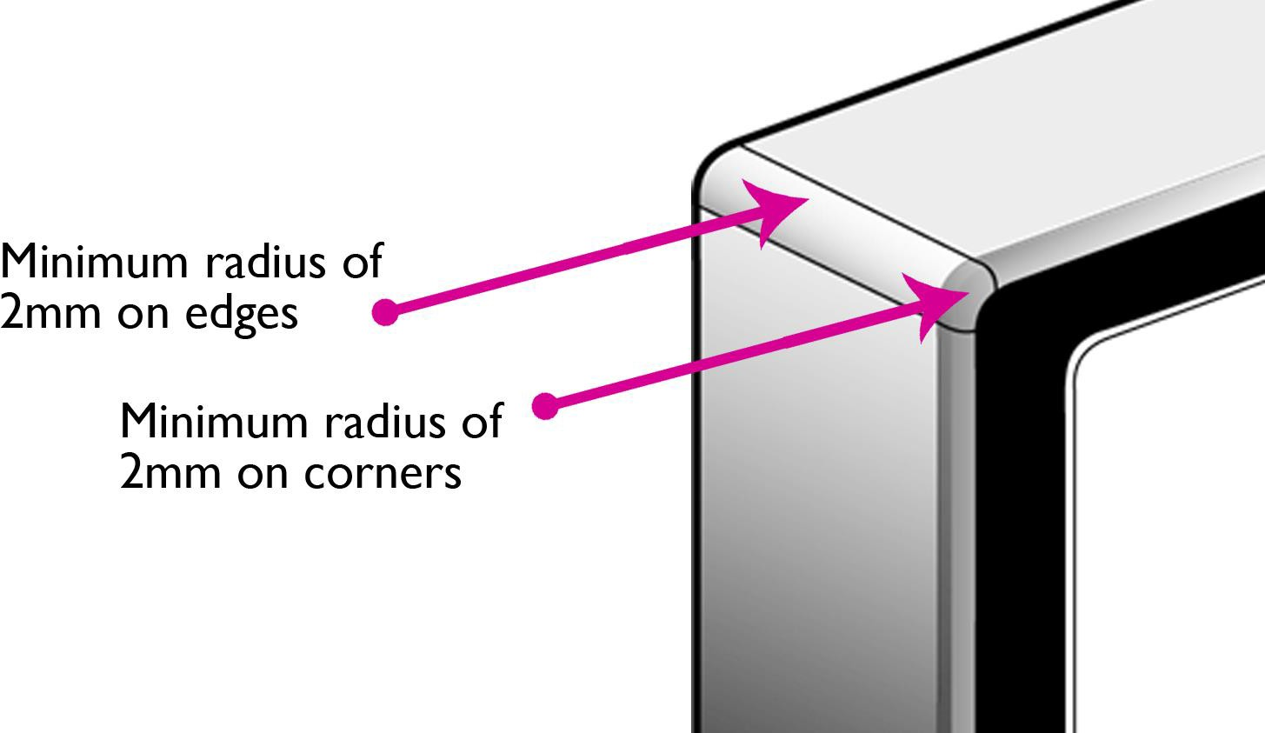

22 Note: As specified in EN 894-3:2000, Table 3; this value is based on the recommended dimensions for a manual control actuator when using a clench grip where force is being applied by a user’s finger.

3.2.1.3 The strength required for the In-Home Display to be handled easily with one or both hands should not exceed 30% of the applicable physical strength of a 5th percentile woman.23
Reference: ISO/TR 22411: 2008, 8.12.1.
3.2.1.4 The In-Home Display should avoid requiring the user to hold a static position for a period of time. If held over a prolonged period of time, the In-Home Displays may cause fatigue and discomfort if the product is too heavy or too large.

Reference: ISO 9241-20: 2008, 7.1.9
For example, if a user has to outstretch his/her arm for an extended period of time to operate the product it could cause discomfort.
For further information please see Annex 2.

23 This is recommended good practice where the appropriate force values can be located or determined.

Button Design
The In-Home Display’s controls should be simple and intuitive to use, provide information easily perceived by users, allow tolerance for error and require low physical effort (see Universal Design principles and guidelines for further information).24 The size, shape, texture, position and responsiveness of the In-Home Display controls are crucial in ensuring the product is easy to use and easy to understand by all users.
Through research carried out for the Centre for Excellence in Universal Design, a general preference was identified for physical buttons rather than touchscreen interfaces or dials.25 This was a particularly important consideration for older people who have difficulties with dexterity or precision.
The Usability Testing identified that older people who were deaf or who had hearing difficulties had a particular preference for large, well-spaced physical buttons which provided tactile feedback to enhance ease of use.
Key findings from the Usability Testing identified that:
- Where labelled, the button’s description, font, text, size and colour contrast should make it easy to read and intuitive to use
- The sequential layout and positioning of buttons enhances the In-Home Display’s ease of use
- The positioning of the buttons should enable the In-Home Display to be operated with one hand (accommodating both right and left-handed users), without the need to simultaneously use both hands
- The layout of buttons should prevent the need for the user to reach across the screen to operate key buttons, while requiring a clear view of the screen
Technical guidance has been provided in relation to the following seven areas of button design:
- Button layout
- Button size and spacing
- Button labels
- Button operation
- Feedback and response
- Forces and displacement
- Tolerance for error

24 North Carolina State University (1997). ‘7 Principles and 29 Guidelines of Universal Design’. USA: Centre for Universal Design.
25 See the ‘Research Report’ on the Universal Design of In-Home Displays for further information.

Button layout
      - The buttons should be laid out so that they correspond with the information and content they control.
Reference: ISO/TR 22411: 2008, 8.3.3
An example of this is the positioning of buttons on an Automated Teller Machine (ATM) (see Figure 2). The buttons are located next to the options provided. Additionally arrows are provided on the screen interface that links the options to their respective buttons. This is considered a good button and interface layout as it is easy to identify the correct button for the desired option.

Figure 2: Good example of a screen interface layout of an A.T.M.
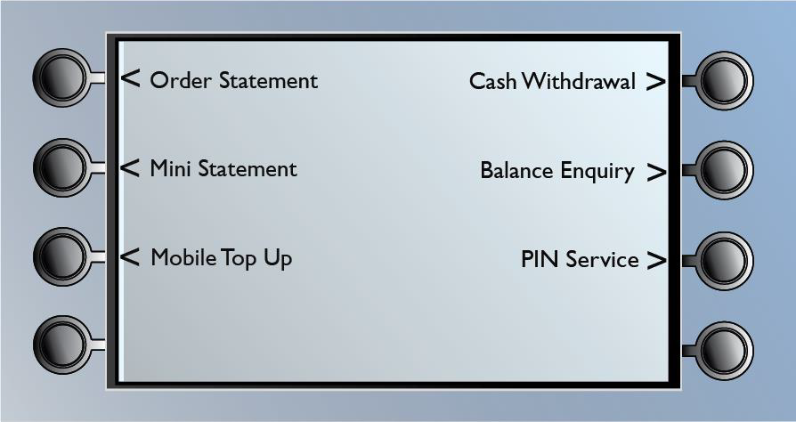

      - Buttons should be grouped and arranged in hierarchical order or in a sequence which will aid recognition and use.
Reference: ISO/TR 22411: 2008, 8.3.1.2

      - To increase effectiveness, where required, buttons should be positioned close enough to be operated in quick succession. The buttons however should not be so close that they risk being activated inadvertently.
Reference: ISO 1503: 2008, 4.4.1

      - Buttons should be placed so they can be easily seen and operated by the user whether standing or seated.
Reference: ISO/TR 22411: 2008, 8.3.1.2

      - Where possible and applicable, the number of buttons required to use the In-Home Display should be limited to avoid over complexity and confusion. See Figure 3 below.
Reference: ISO/TR 22411: 2008, 8.3.1.2

Figure 3: A good example of button layout.
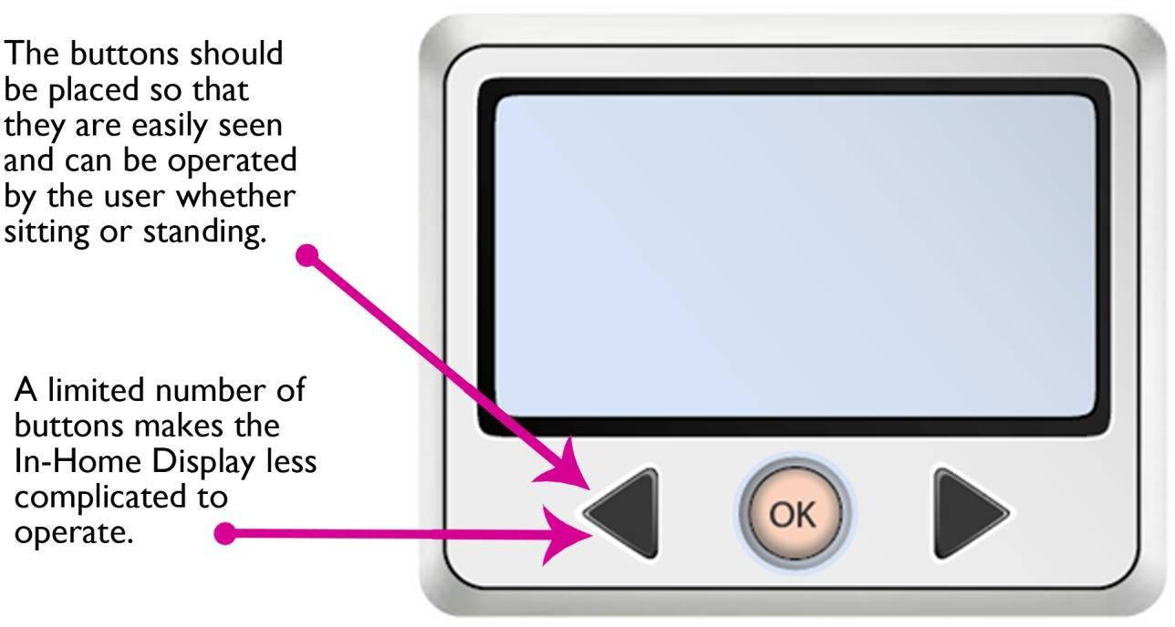

      - If the In-Home Display contains a numeric keypad, a layout similar to a telephone should be used rather than the layout used on a calculator.26
Additional considerations to help aid the location of buttons include:
        - Providing buttons with tactile markings. For example, tactile markings on particular keys can be used to aid identification and navigation among a group of buttons, such as the number ‘5’ key on a keypad
        - Providing sufficient contrast between the buttons and the surface of the In-Home Display. For example, illuminating the keys to aid contrast
For further information:
- See section 4.3: ‘Text and Visual Display’ for information on using colour and contrast
- See section 5.5: ‘Tactile Markings’ for information on providing tactile markings on groups of buttons

26 National Disability Authority. ‘Building for Everyone: A Universal Design Approach – Facilities in Buildings’. Available from: [http://www.universaldesign.ie/files/bfe/BfE-6-facilities.pdf]. [Accessed: 1/8/13].

Button size and spacing

Physical button size
      - Based on the findings from the Usability Testing, the recommended minimum diameter / width of physical buttons should be 10mm or greater. The Usability Testing also identified that physical buttons should protrude in depth from the surface of the In-Home Display to increase usability.
Reference: EN 894-3: 2000, 8.127

Figure 4: Minimum width and diameter of a physical button.
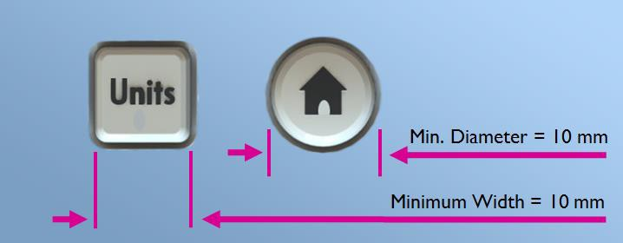

27 Note: EN 894- 3: 2000 states that the buttons should have a minimum diameter / width of 7mm. However based on Usability Testing performed as part of the development of these guidelines, it is recommended that the buttons exceed this requirement to enhance ease of use. This guideline recommends having a minimum diameter / width of 10mm.

Touchscreen button size
      - The minimum touchscreen button diameter / width should be greater than the size of the 95th percentile male distal (digit 2) joint breadth.
Based on data from ISO 7250-2: 2010, the minimum touchscreen button diameter/width should be greater than 21mm (based on data from the Netherlands for the 95th percentile male index finger breadth). See Figure 5 below.
Reference: ISO 9241-410: 2008, J.2.2.1 and ISO 7250-2: 2010, 4.3.6

Figure 5: Recommended width of a touch screen button.
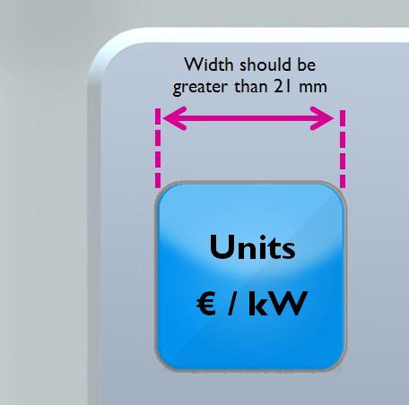

Note: The size of touchscreen buttons should be increased if parallax results in a reduction in effectiveness occurring due to the user’s viewing angle.
Reference: ISO 9241-410: 2008, J.2.2.1

Button spacing
      - Spacing between adjacent buttons should be at least 2.5mm.28
The figure below illustrates the minimum spacing for two adjacent square buttons and two adjacent circular buttons.

Figure 6: Minimum spacing between adjacent touchscreen buttons.
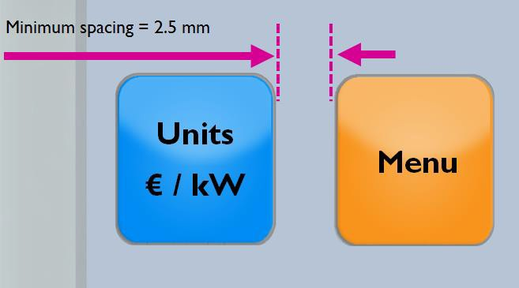

Figure 7: Minimum spacing between adjacent physical buttons.
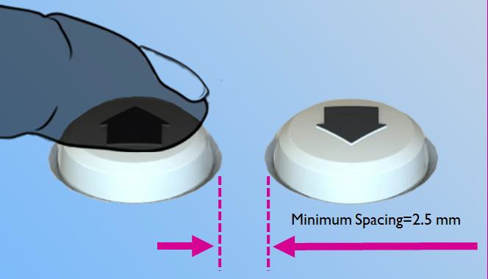

28 National Disability Authority, ‘Guidelines for Public Access Terminals Accessibility‘. Available from: [http://www.universaldesign.ie/useandapply/ict/itaccessibilityguidelines/publicaccessterminals/guideli nes/priority-2/2-1]. [Accessed 16/1/13].

Button labels
      - The print on button labels should remain intact throughout the life of the In-Home Display. The print should not degrade or rub off after prolonged use.
Reference: ISO/TR 22411: 2008, 8.12.8

      - Rough surfaces and / or markings on buttons should be provided to make them easier to identify. For example, tactile marking on the number ‘5’ key on a numeric keypad can help users to identify buttons and navigate the keypad layout.
Reference: ISO/IEC Guide 71: 2001, 8.18.1

See section 4.3 on ‘Text and Visual Display’ for further information.

Button operation
      - Buttons should be capable of being operated using either hand and should avoid requiring simultaneous use of both hands.
Reference: ISO 9241-20: 2008, 7.5.3 and ISO 9241-410: 2008, C.2.2.5

      - Buttons should be designed to be operated by users with limited dexterity. For example, push buttons are preferable to dials for users with dexterity difficulties (see Figure 8).
Reference: ISO/TR 22411: 2008, 9.3.1.1

      - The shape of the button should help the user identify and activate the button. This can be achieved by protruding the button high enough from the face of the In-Home Display so the user can fully depress the button comfortably. Buttons should protrude at least one mm above the In-Home Display housing, and preferably have a slight concave.29
Reference: ISO 9241-410: 2008, H.2.2.3.5

29 National Disability Authority. ‘Building for Everyone: A Universal Design Approach – Facilities in Buildings’. Available from: [http://www.universaldesign.ie/files/bfe/BfE-6-facilities.pdf]. [Accessed: 1/8/13].

Figure 8: Push buttons that protrude from the surface of the In-Home Display make it easier to identify and detect.
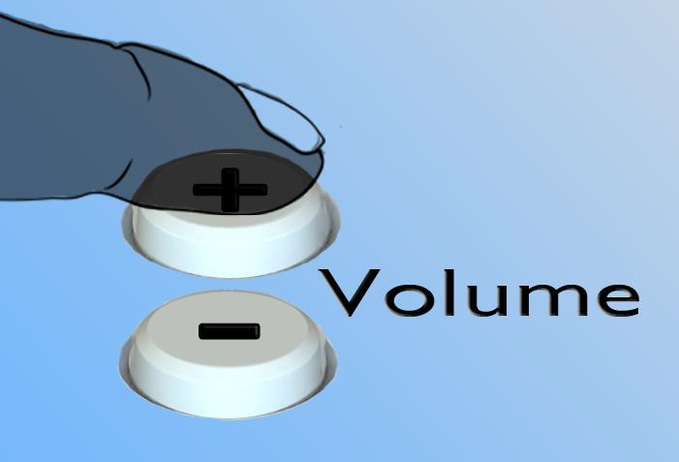
      - In-Home Display buttons with double or multiple functions should be avoided.
For example, a button that is used to navigate through the interface should not be used to activate the settings mode.
Reference: ISO/TR 22411: 2008, 8.3.1.2

      - The In-Home Display should be easy to switch on and off either by a physical control or by a software command.
Reference: ISO 9241-20: 2008, 9.5.3

Feedback and response
      - Buttons should provide tactile feedback. This can be achieved using a pressure point typically found on a keyboard.
Reference: ISO/TR 22411: 2008, 8.12.3.1

      - Using the specification for similar interactive products, push buttons that provide tactile feedback should move downwards within a range of 0.5 mm and 6 mm when pressed. See Figure 9.
Reference: ISO 9241-410: 2008, G.2.2.3.6

Figure 9: Downward movement of a push button.
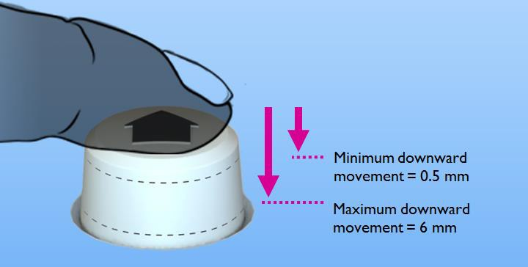
      - Tactile feedback should be directed towards at least two senses, to make it more effective for a wider range of people. For example, providing tactile and auditory feedback when a button is pressed.
Reference: ISO/TR 22411: 2008, 8.12.3.1

Forces and Displacement (Physical Buttons)
3.3.6.1 A minimum force is required so the user does not inadvertently activate the buttons on the In-Home Display.
Using the specification for similar interactive products, push buttons should have an activation force within the range of 0.5N and 1.5 N.
Reference: ISO 9241-410: 2008, G.2.2.3.5

Error Tolerance
Guidance on safeguarding features from inadvertent use:
      - Important controls should be positioned in a location which prevents the button from inadvertently being activated.
Reference: ISO 9355-3: 2006, 5.3.
Example 1: An infrequently used control should be positioned in a recess or surrounded with a collar.
Example 2: A commonly used control, should be highlighted through colour, form or texture, and positioned clear of any other buttons.

      - The user should be unable to activate the same button more than once within a two second period. This delay will prevent inadvertent button activation.
Reference: Draft EN 301 549: 2013 V1.0.0, 5.6

      - The location of the In-Home Display’s on and off switch should be easy to locate and access, but not in a location where it can be activated accidentally.
Reference: ISO 9241-20: 2008, 9.5.3
A poor example would be locating the on/off switch on the top corner of the In-Home Display, where the finger may rest. This is a bad location as it would be at risk of unintentional activation.

      - If the user makes a mistake when using the In-Home Display, they should be able to correct their actions by returning to the previous step prior to undertaking the action.
Where the action is irreversible the In-Home Display should provide the user with a warning or require the user to confirm the action.
This warning should be provided using two or more methods (such as through audio and visual means).
Reference: ISO 9241-20: 2008, 7.3.4 and ISO 9241-20: 2008, 9.1.7

Screen Interface Design

General Guidance
The In-Home Display’s interface should be simple and intuitive to operate (see Universal Design Principle 3). This will be driven by the sequential and logical layout of information on the screen, the provision of cues or instructions to guide users when necessary, and the ease of identifying and finding information through intuitive navigation.
The In-Home Display screen should be easy to see and read. Considerations for the In-Home Display’s interface design should include character size and how information is presented (whether digital or analogue). People perceive and understand information in different ways. Therefore, in line with Universal Design guideline 4a, different modes of communication (pictorial, verbal or tactile) should be used for the redundant presentation of essential information, to ensure that the information is communicated effectively to the user. For example, the use of colour, icons and a verbal description could be used to help understanding.
Feedback through visual, auditory and tactile channels should be considered as both a tool for operating the In-Home Displays, but additionally in providing visual information in alternative formats to increase accessibility, particularly for users who have visual difficulties.
This section provides guidance relating to the interaction between users and the In-Home Display screen interface, as well as text and visual display guidance.

In-Home Display Screen Information
The In-Home Display should be easy to operate from the first time it is used. The screen information should be intuitive. It should allow the user to access, identify and locate information easily, by providing logical navigation sequences and presenting information in a consistent fashion.
The design of the In-Home Display should ensure flexibility in use (Universal Design Principle 2) to take into account the varied needs and abilities of the users. For example, the In-Home Display should provide adaptability to the user’s pace by providing the option of additional time when the user is completing a time allocated task.
Additionally where there is a large amount of information to remember in operating the In-Home Display, it is important that instructions or prompts are provided to make the product easier to use.

Technical guidance has been provided in relation to the following areas of In-Home Display screen information:
  - Screen interaction, feedback and response
  - Layout of screen information
  - Screen Display

Screen interaction, feedback and response
4.2.1.1 If a user is required to complete a task within a limited period of time, an option should be available for the user to change or turn off the time requirement.
Reference: ISO 9241-20: 2008, 7.5.7
For example, if a customer has to input a prepayment top-up code within a limited amount of time, the customer should be able to change or turn off the time requirement if they require additional time.

4.2.1.2 The In-Home Display’s default settings should accommodate the slowest user for completion time of tasks. To accommodate the slowest user, it is recommended to allow up to 10 times the amount of time that it takes the average user to complete the task.30
Reference: ISO/TR 22411: 2008, 8.10.3

4.2.1.3 A prompt should be provided to request additional time to complete a task if more time is required.
For example, if a prepayment top-up code must be input within a certain time frame, an option should be provided to allow the user additional time to complete the task. See Figure 10 below.
Reference: ISO/TR 22411: 2008, 8.10.3

30 National Disability Authority, ‘Guidelines for Public Access Terminals Accessibility‘. Available from: [http://www.universaldesign.ie/useandapply/ict/itaccessibilityguidelines/publicaccessterminals/guideli nes/priority-2/2-1]. [Accessed 16/1/13].

Figure 10: Interface displaying the option of additional time to complete a task.
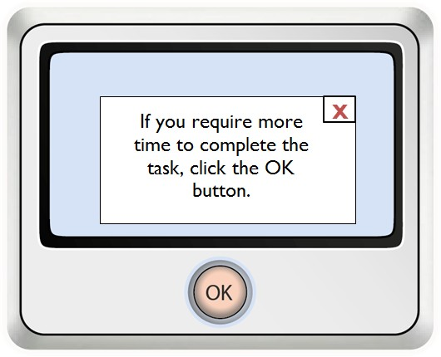

4.2.1.4 If the user is faster than the system a ‘wait message’ should be displayed (an example of which is illustrated in Figure 11 below). This should be communicated using at least two senses to increase accessibility
Reference: ISO/TR 22411: 2008, 8.10.3

Figure 11: Interface displaying a loading icon.
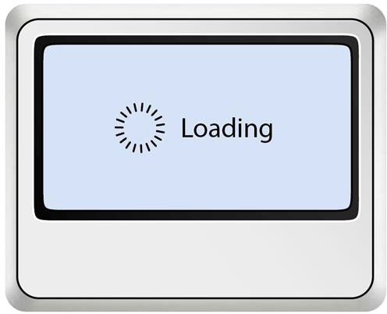

4.2.1.5 Users should be allowed to pause and continue long voice messages or instructions using a single action.
Reference: ISO/TR 22411: 2008, 8.10.3

4.2.1.6 The In-Home Display should provide visual cues, reminders and use memory aids where appropriate to guide tasks that users may have difficulty memorising.
Reference: ISO/TR 22411: 2008, 8.17.2

4.2.1.7 Tasks (such as finding the weekly energy consumption information) should be designed so the user can perform the task using simple steps, instead of fewer but more complex steps.
Reference: ISO/TR 22411, 8.17.2

4.2.1.8 The In-Home Display should provide feedback and on-screen information that helps the user to understand the current status of the In-Home Display. Feedback should be used to help minimise the need to use an instruction manual or other information sources.
Reference: ISO 9241-20: 2008, 7.6.6, ISO/TR 22411: 2008,
8.17.2 and 8.17.4

4.2.1.9 The In-Home Display should provide feedback after each action is undertaken by the user, particularly when undertaking a multi-step procedure.
For example, the screen should immediately react in response to a button being pressed. This will help the user keep track of their position in the process.
Reference: ISO/TR 22411: 2008, 8.17.4

4.2.1.10 The user should be able to gain more information about an action or a feature.
For example, by providing a help/information icon, the user can learn more about a step or feature (such as gaining more information on how monthly energy usage is measured).
Reference: ISO/TR 22411: 2008, 8.17.4

4.2.1.11 The In-Home Display should provide consistent feedback. Reference: ISO/TR 22411: 2008, 8.17.4

Layout of screen information
4.2.2.1 Slight changes of values on the digital displays (such as for real-time kilowatt (kW) readings) should not change faster than twice per second.
Reference: EN 894-2: 2000, 4.2.5

4.2.2.2 The In-Home Display operation should reduce the amount of information the user is required to memorise so they can perform a task.
Reference: ISO/TR 22411: 2008, 8.17.2

4.2.2.3 Interface layouts should be identical if they are showing similar data, but are using different units of measurement. This equally applies where interface layouts are showing similar units of measurement (such as Euro) but different values.
Reference: ISO 9241-12: 1998, 5.4.1
For example, Figure 12 below illustrates current and weekly energy costs. In the first image the decimal place is close to the Euro sign. However, in the second image, the decimal place has moved two places away from the Euro sign. The inconsistent location of the decimal place can cause misunderstanding of the reading.

Figure 12: Poor example of inconsistent data display. Display showing the real time cost and the average cost per week, but with inconsistent placement of the decimal point.
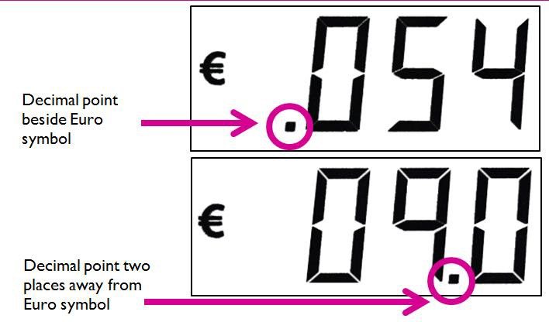

Figure 13 shows two displays showing the average cost ‘per day’ and average cost per ‘week’. Note the text to notify the user that the display is showing average per ‘week’ is not in the same location as text that notifies the user that they are looking at the average ‘per day’. This makes the information more difficult to interpret by the user.

Figure 13: Poor example of text location. Display showing the average cost per day and average cost per week, with ‘week’ and ‘per day’ placed in different locations.
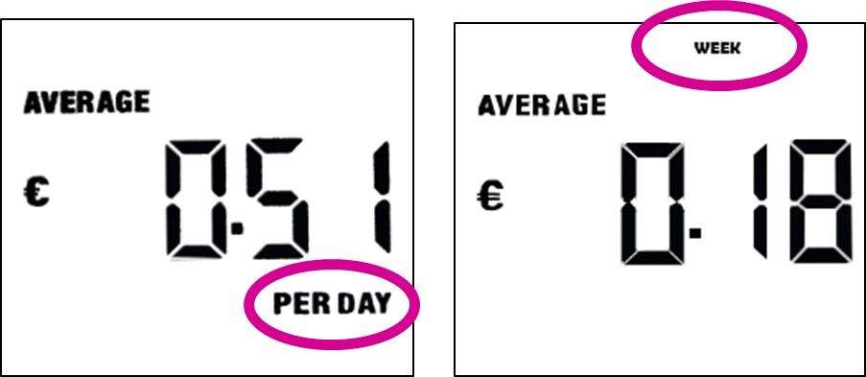

      - Whenever presenting changing or moving information, it should be possible for the user to pause or stop the changing information.
Reference: ISO 9241-20: 2008, 7.6.8

      - For graphs or charts that display time, it is recommended that time is situated on the horizontal axis (x-axis).
Reference: ISO 1503: 2008, 4.5.4.9

      - Past events (such as the energy cost for the previous day/week) should be placed to the left of the most recent energy cost readings (for example, the current day’s reading).
Reference: ISO 1503: 2008, 4.5.4.9

Screen display
The following guidance should be applied to the design of the screen display:
4.2.3.1 Frequencies of flashing text and video screens that may cause visually induced seizures should be avoided. The frequency range should be within 2Hz to 60Hz.31
Reference: ISO 9241-20: 2008, 7.2.12

4.2.3.2 Sequences of three or more flashes of an image per second should be avoided.
Reference: ISO/TR 22411: 2008, 8.2.6

4.2.3.3 To reduce the possibility of a visually induced seizure, transitions to and from a saturated red should be avoided.
Reference: ISO/TR 22411: 2008, 8.2.6

4.2.3.4 A minimum of a 5 by 7 (width-to-height) character matrix should be used for displaying upper case letters and numbers.
Reference: ISO 9241-303: 2008, 5.5.8

4.2.3.5 For continuous reading, a minimum 7 by 9 (width-to-height) character matrix should be used to display upper case letters and numbers (see Figure 14 below).
Reference: ISO 9241-303: 2008, 5.5.8

Figure 14: 7 by 9 dot matrix example.

31 National Disability Authority, ‘Guidelines for Public Access Terminals Accessibility‘. Available from: [http://www.universaldesign.ie/useandapply/ict/itaccessibilityguidelines/publicaccessterminals/guideli nes/priority-2/2-1]. [Accessed 16/1/13].

4.2.3.6 Seven segment displays (commonly used in LED and LCD screens and illustrated in Figure 15 below) are only suitable for displaying numbers. This is to avoid confusing letters such as B with 8.
Reference: EN 894-2: 2000, 4.2.1

Figure 15: Seven segment display.

For more information on contrast and colour combinations see section 4.3.4 ‘Contrast and colour combinations’.

Analogue and digital displays
In-Home Displays can present information using analogue or digital displays. The advantages and disadvantages of the two types of displays are detailed below:
  - Digital Displays: If acquiring a value, such as current energy usage from the In-Home Display, it is recommended that a digital display is used. Digital displays communicate using only numbers; as such they are very good at communicating information accurately. Digital displays however are not particularly effective at communicating relative values, such as today’s energy usage compared to budgeted energy usage.
  - Analogue Displays: If monitoring changes in value over a period of time, it is recommended that an analogue display is used. Analogue displays are very good at communicating relative values, such as today’s energy usage compared to budgeted energy usage.

The following guidelines (4.2.4.1 – 4.2.4.3) are specific to analogue displays:
4.2.4.1 To indicate an increase in value in analogue displays, pointers should move upwards, move to the right or move clockwise, illustrated in Figure 16 below.
Reference: ISO 9355-2: 1999, 4.2.3

Figure 16: Increasing analogue displays.
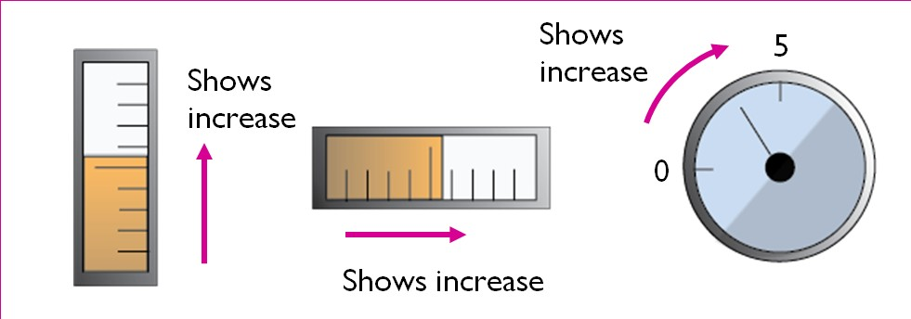

4.2.4.2 To indicate a decrease in value, pointers should move downwards, move to the left or move anti-clockwise, illustrated in Figure 17 below.
Reference: ISO 9355-2: 1999, 4.2.3

Figure 17: Decreasing analogue displays
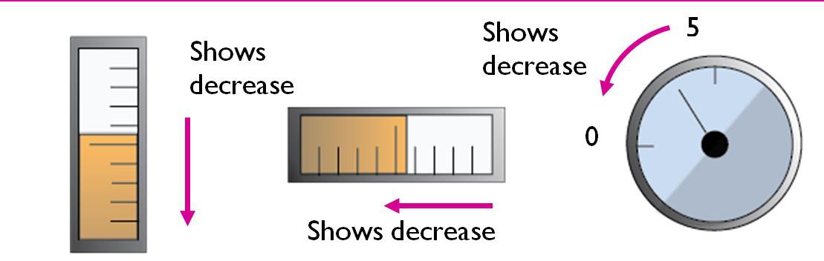

4.2.4.3 Analogue displays should not have more than three levels of graduation marks. Commonly used graduations include major, intermediate and minor graduations.
Recommended dimensions for graduations in normal lighting environments and from a reading distance of 700mm are:
    - Major graduation: Height 4.9mm, Width 0.3mm
    - Intermediate graduation: Height 3.7mm, Width 0.3mm
    - Minor graduation: Height 2.4mm, Width 0.3mm
Reference: ISO 9355-2: 1999, 4.2.4

Figure 18: Recommended scale for major, intermediate and minor graduations for high/normal illumination levels from a 700mm reading distance.

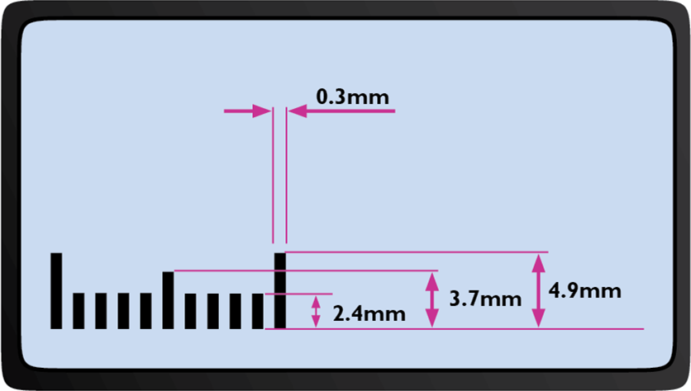

Text and Visual Display
The In-Home Display should maximise the legibility of essential information so that it is easy to see, read and interpret.32 Ease of use is directly influenced by how information is presented; ranging from the use of language and colour contrast, to the choice of font and text size.
Technical guidance has been provided in relation to the following areas of text and visual display:
  - Icons and images
  - Text format
  - Font and emphasis
  - Contrast and colour combinations
  - Font sizes

Icons and images
Where icons or images are used to communicate information, the following considerations should be applied.
4.3.1.1 Where possible, information should be provided using icons or images to help the user understand the information being communicated.
Reference: ISO 9241-20: 2008, 7.6.5

4.3.1.2 The user should be easily able to relate and associate the image of the icon with its function. For example, the home icon is a common icon across a range of electronic devices that is used to return to the default screen (see Figure 19 below).
Reference: ISO 9241-303: 2008, 5.7.2

Figure 19: Home Icon.

32 Universal Design Principle 4: Perceptible Information. Source: North Carolina State University (1997). ‘7 Principles and 29 Guidelines of Universal Design’. USA: Centre for Universal Design.

4.3.1.3 If colour is used to communicate information, the coloured information should be accompanied with a non-colour method of conveying the same information (such as figures, letters and tactile markings).
Reference: ISO/TR 22411: 2008, 8.5.1
For example, if colour is used to identify tariff charges where red represents a high tariff rate, it should also be provided in a text format.

Text format
4.3.2.1 Dates should be presented in the format of dd mth yyyy (day month year). For example, 12 July 2014.
Reference: NSAI, SWiFT 9: 2012, F.2.11

4.3.2.2 Technical terms should be replaced with more common and simple alternatives. If specialised terms, uncommon abbreviations and/or acronyms are required, clearly explain what they mean.
For example, during the Usability Testing, few participants understood the meaning of kilowatt (kW).
Reference: NSAI, SWiFT 9: 2012, F.2.2 and F.2.5

4.3.2.3 Group digits in threes from the right and place a comma to separate each group (for example, 1,567).
Reference: NSAI, SWiFT 9: 2012, F.3.10.1

4.3.2.4 Write percentages using digits and the percentage symbol (for example, 64 %).
Reference: NSAI, SWiFT 9: 2012, F.3.10.2

Font and emphasis
The following considerations should be applied to the text display to maximise legibility:

4.3.3.1 The use of a san-serif font is recommended when using a low resolution display.
Reference: ISO/TR 22411: 2008, 8.6.3

4.3.3.2 If a serif font is used, ensure that the font doesn’t affect the legibility of the text.
Reference: ISO/TR 22411: 2008, 8.6.3

4.3.3.3 Italics, underlining and other decorative styles should be avoided.
Reference: NSAI, SWiFT 9: 2012, F.3.5

4.3.3.4 Emphasise the most important information by using bold or increasing the font size of the text.
Reference: NSAI, SWiFT 9: 2012, F.3.5

4.3.3.5 Do not use BLOCK CAPITALS as it makes the words difficult to read.
Reference: NSAI, SWiFT 9: 2012, F.3.5

Figure 20: Examples of san-serif, serif, underline, italic and bold font styles.
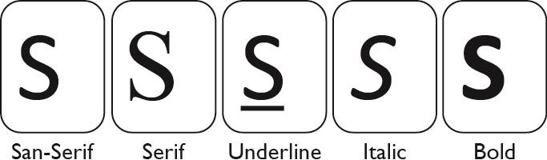

Contrast and colour combinations
When using colour, the following considerations should be applied to maximise legibility:

4.3.4.1 A maximum of six colours should be used if colour discrimination is required for visual searching.
Reference: ISO 9241-303: 2008, 5.7.6.2
For example, if the user is required to push the blue button in undertaking a task, limit the number of coloured buttons.

4.3.4.2 Colour combinations should be considered carefully. Reference: ISO/TR 22411: 2008, 9.2.1.1
For example, bluish lights in the short-wavelength range of 400 nm to 500 nm can appear darker to people as they age. Care should be taken when using blue in this range to ensure than it can be distinguishable from colours such as black that may surround it.
See Figures 21 and 22 below for examples of good colour contrast combined against a black and white background.

Figure: 21. Distinctive colours for letters on a white background.

Figure: 22. Distinctive colours for letters on a black background.

4.3.4.3 For light-emitting (active) displays, the foreground to background luminance should have a recommended contrast ratio of 6:1.
Reference: EN 894-2: 2000, 4.2

The following guidelines are relevant to the use of colour combinations, especially for people with difficulties seeing and differentiating colour (such as colour blindness).
4.3.4.4 When using colour to provide information, information should also be provided using non-colour methods.
Reference: ISO/TR 22411: 2008, 8.5.1

4.3.4.5 Combinations such as red and green should be avoided, as they can be difficult to differentiate for people with colour blindness.
Reference: ISO/TR 22411: 2008, 8.5.2

Character Sizes
Numerous variables are considered in this section in relation to the character size to be used on an In-Home Display, including guidance on viewing from different distances, guidance from Draft EN 301 54933 and findings from the Usability Testing. Sections 4.3.5.1 to 4.3.5.3 below apply to the use of character (letter, number or symbol) sizes for the In-Home Display, where it is not possible for the user to adjust the character size.

4.3.5.1 Legibility of the In-Home Display is affected by factors such as the viewing distance, the luminance levels of the In-Home Display screen and the user’s visual abilities. The character size should be increased when visual acuity is assumed to be decreased. The guidelines in this section relating to character size are based on viewing the In-Home Display at arm’s reach. It is recommended that the height of characters should be increased if the In-Home Display is expected to be viewed from greater distances (such as across a room).
Reference: ISO/TR 22411: 2008, 9.2

33 Draft EN 301 549 (V 1.0.0): 2013. Human Factors (HF); Accessibility requirements for public procurement of ICT products and services in Europe.

4.3.5.2 The recommended minimum character height for information that is intended to be legible at arm’s reach (823mm) is 10mm (illustrated in Figure 23 below). See Annex 3 for character size calculations.
Reference: Draft EN 301 549 (V1.0.0): 2013, 5.1.5

Figure 23: Recommended minimum character height of 10mm.

4.3.5.3 Based on the Usability Testing,34 a minimum character height of 20mm should be considered, particularly for important information that is intended to be legible at arm’s reach (such as current energy usage).

Figure 24: Recommended minimum character height of 20mm.
Note 1: The above dimensions are based on perpendicular viewing of the display. Alternatively, If the user is looking at an angle the text height should be increased.
Note 2: Arm reach of 823mm was referenced as the viewing distance based on the shoulder to grip distance of the 95th percentile male from the Netherlands.35
4.3.5.4 Font size should have a recommended width-to-height ratio within the range of 0.7:1 and 0.9:1 for optimum legibility.
Reference: ISO 9241-303: 2011, 5.5.7

34 National Disability Authority (2013). Research Report for the Universal Design of In-Home Displays. Section 3.2. Dublin: National Disability Authority.
35 National Disability Authority (not yet published). ‘Size data and methods for Universal Design in Ireland’. Dublin: National Disability Authority.

4.3.5.5 Font stroke width should be between 10% and 17% of the character height.
Reference: ISO 9241-303: 2011, 5.5.6

4.3.5.6 Spacing between characters should be in the range of 20-50% of the width of the character.
Reference: EN 894-2: 2000, 4.2.1

4.3.5.7 Spacing between words should be in the range of 1-1.5 times the width of a character.
Reference: EN 894-2: 2000, 4.2.1

Tactile, Audio and Visual Considerations

General Guidance
The In-Home Display should communicate information effectively to the user regardless of the user’s sensory abilities. This is of particular importance when
providing reminders, cues, feedback and error management to help the user perform a task.
Therefore to increase accessibility it is important that the redundant presentation of essential information is communicated through different senses, such as audio, visual and tactile.36 An example of this is if the user has visual difficulties or is blind, it is particularly important that information is accessible through alternative senses, either through an audio function on the In-Home Display or through interoperability with assistive technology systems (such as text-to-speech software).
Technical guidance has been provided in relation to the following areas of tactile, audio and visual considerations:
  - Feedback alarms and responses
  - Verbal and auditory communication
  - Volume and sound control
  - Tactile markings

Feedback, Alarms and Response
The In-Home Display should provide feedback, alarms and responses to enhance ease of use in undertaking tasks and communicating with the user. Considerations for feedback, alarms and responses are detailed below.
    - The In-Home Display should provide cues, feedback and on-screen information that helps the user understand the current status of the In-Home Display. Where possible, the feedback provided should support two or more senses.
Reference: ISO 9241-20: 2008, 7.6.6, and ISO/TR 22411: 2008,
8.17.2
Example 1: If a button is pressed, tactile and auditory feedback should be provided.
Example 2: If the replaceable battery power is running low, the
In-Home Display should provide both a visual and auditory alarm to warn the user.

36 (in line with Universal Design Principle 4)

    - The In-Home Display should provide consistent feedback.
For example, if the increase volume button is pressed and an
on-screen animation pops up to show the volume level, then the same action should happen when decreasing the volume.
Reference: ISO/TR 22411:2008, 8.17.4

    - In-Home Display alarms and warnings that are presented in auditory form should also be highlighted using visual cues.
For example, a warning tone (beep) to indicate that the In-Home Display’s battery level is low, should be supported by an onscreen message.
Reference: ISO 9241-20: 2008, 7.3.4

    - When attracting the user’s attention, the blink rate of lights on the In-Home Display should be in the range of 1 Hz and 3 Hz, and have a duty cycle of 50%.
Reference: ISO 9241-303: 2011, 5.6.3
For example, the flashing light used to indicate low battery power should be in the range of 1 Hz and 3 Hz, and have a duty cycle of 50%.

    - Blink rate where readability is required, should be in the range of
0.33 Hz and 1 Hz, and have a duty cycle of 70%. Reference: ISO 9241-303: 2011, 5.6.3
For example, a flashing visual prompt can be used to guide the user in undertaking the next step in a multi-step process.

Verbal and Auditory Communication
Where auditory or verbal communication is a feature of the In-Home Display, the following considerations should be applied:
    - Where verbal instructions are provided, they should be communicated at a speaking rate of 140-170 words per minute. However it should be noted that people who are blind may prefer faster speech rates.
Reference: ISO/TR 22411: 2008, 8.7.4.5

    - The recommended frequency range to be used for speech instructions is between 300Hz and 3400Hz.
Reference: ISO/TR 22411: 2008, 9.2.2.4

    - The In-Home Display’s audio output should not cause harm to hearing. Guidance for sound levels and the comfort level for users who are approximately one metre away from the source are detailed below:
      - Very loud 78 dB
      - Loud 72 dB
      - Raised 66 dB
      - Normal 60 dB
      - Relaxed 54 dB
Reference: ISO 9241-20: 2008, 7.3.1 and ISO 9921: 2003, Table A.1

    - For maximum effect, sounds that use multiple frequencies should be used. Human hearing is most sensitive to hearing signals in the range of 500Hz to 3,000 Hz.
For example, A multiple frequency authorisation sound could be used to acknowledge that the user has input the correct code when topping up using the prepayment function.
Reference: ISO 9355-2: 1999, 5.1

    - If the In-Home Display provides audio warnings and/or instructions, a 3.5mm standard mono audio port should be provided for connecting to assistive listening equipment.
Reference: ADA Standards for Accessible Design: 2010, 706.2

    - To overcome background environment noise and increase simple speech information, the In-Home Display should be capable of exceeding the environment noise by 15db (A-weighted).
Reference: ISO/TR 22411: 2008 9.2.2.5

Volume and Sound Control
Where sound is provided, the following guidance should be applied:
    - Users should be able to pause and continue long voice messages or instructions.37
    - To adjust the In-Home Display’s volume, buttons directed upwards or right should be used to increase volume and buttons directed downwards or left should be used to decrease volume, as illustrated in Figure 25 below.
Reference: ISO 1503: 2008, 4.4.3

Figure 25: Volume push buttons.
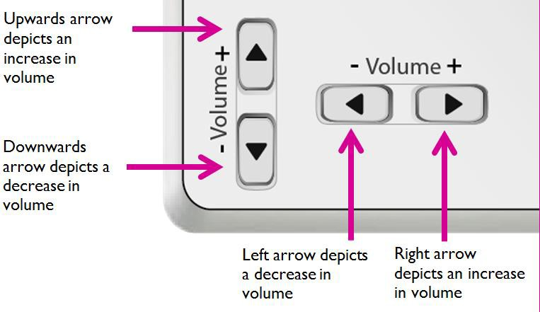

Tactile Markings
Tactile markings (such as Braille, dots and bars) are a convenient method to communicate location, perceived shape and function, and information. It is recommended that tactile markings are used along with another form of communication, such as visual labels.
For further information see ISO/TR 22411: 2008, 8.2.2.1

37 US Department of Transportation Federal Aviation Administration. ‘Human Factors Design Standard’. Available from: [http://hf.tc.faa.gov/hfds/download.htm]. [Accessed 09/5/13].

Tactile markings: dots and bars overview
Using tactile dots or bars on grouped buttons:
    - If there is an odd number of buttons in a row, it is best to place the tactile dot / bar on the middle button.
Reference: ISO/TR 22411: 2008, 8.2.2.1
For example if there are five buttons in a row, the tactile dot / bar should be placed on the middle / third button.

    - For numbered key pads, the tactile dot / bar should be placed on the number 5 key. See Figure 26 below.
Reference: ES 201 381 V1.1.1: 1998, 5.2

Figure 26: 12 button keypad with a tactile bar on the number ‘5’ button.
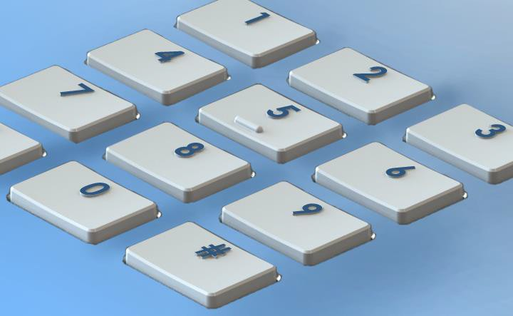

    - If there is an even number of buttons in a row, it is best to place the tactile dot / bar to the centre left button.
Reference: ISO/TR 22411: 2008, 8.2.2.1
For example if there are four buttons in a row, the tactile dot / bar should be placed on the second button (see Figure 27 below).

Figure 27: Four buttons in a row with a tactile bar on the second button.
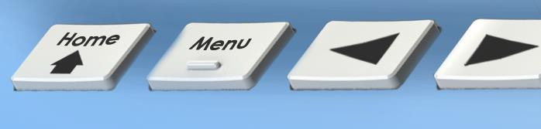

    - Dots should have a height of 0.6mm (± 0.2mm) and a diameter of 1.5mm (+/- 0.2mm).
Reference: ES 201 381 V1.1.1: 1998, 5.3

    - Bars should have a height of 0.6mm (± 0.2mm), a width of 0.5mm (± 0.1mm) and a length of 4.0mm (+/- 1.0mm).
Reference: ES 201 381 V1.1.1:1998, 6.2

Tactile markings: Braille
    - Based on ISO/TR 22411:2008 (country dependant):
      - Braille should have 2.13mm to 3.17mm spacing between dots Reference: ISO/TR 22411: 2008, 8.2.2.1, Table 1.
      - Braille should have 3.13mm to 4.05mm spacing between characters.
Reference: ISO/TR 22411: 2008, 8.2.2.1, Table 1.
      - Braille should have interline spacing of 4.87mm to 9.17mm. Reference: ISO/TR 22411: 2008, 8.2.2.1, Table 1.
      - Braille heights can be 0.4mm +/- 0.1mm or 0.7mm to 1.3mm Reference: ISO/TR 22411: 2008, 8.2.2.1, Table 1.

Tactile markings: Raised symbols and letters
    - When using raised lines and letters, it is best to use a triangular shaped cross section. Edges however should be rounded and relatively smooth.
Reference: ISO/TR 22411: 2008, 8.2.2.1

Installation and Power

General Guidance
The stakeholder consultation research identified the need for an ‘out of the box’ solution which requires minimal actions for the initial set-up and maintenance. Where the product is being installed by either the household customer or by the energy supplier, guidance should be provided in relation to the positioning of an In-Home Display (if being wall mounted) ensuring that it is positioned close to eye-height, with ease of access and in an environment that is well lit.
While methods of powering the In-Home Display varies between manufacturers, it is important that where replaceable batteries are required, the process of accessing and changing batteries is easy to undertake for all users, particularly those with limited dexterity. Additionally standard input and output connections should be positioned in a location that is easy to access.
Technical guidance has been provided in relation to the following areas of installation and power:
  - Setup and installation
  - Powering and connection
  - Additional design guidance

Setup and Installation
The In-Home Display should be easy to set-up and maintain. An out of the box solution should ideally be provided which requires minimal set up actions to be undertaken.
While the In-Home Display should accommodate both free-standing and
wall-mounted positioning, specific guidance should be supplied on the installation (mounting on a wall) of the In-Home Display.
The In-Home Display should be positioned close to eye-level or at a height appropriate for multiple users. It should be located in a well-lit environment to ensure ease of interaction and accessibility by all users. Additionally the product should be easy to both mount and remove from a wall.

Setup and installation
Considerations for the setup and maintenance of In-Home Displays are as follows:
6.2.1.1 Minimal actions should be required to install the In-Home Display for the first time. If the user is expected to install the In-Home Display, the activities necessary to complete this task should be achievable by the widest possible range of users.
Reference: ISO 9241-20: 2008 9.5.2

6.2.1.2 There should be minimal set up and maintenance required by the user to operate the In-Home Display.
For example, this can be achieved by pre-loading the In-Home Display with default settings or providing a company representative to install and set up the In-Home Display.
Reference: ISO 9241-20: 2008, 8.3

Wall Mounting
Guidance for the wall-mounting installation of an In-Home Displays is as follows:
6.2.2.1 The product should be easy to both mount and remove from a wall.

6.2.2.2 If the In-Home Display is wall mounted, a surface on the In-Home Display should be provided to support the user’s
hand whilst using the In-Home Display. This will help the user use the In-Home Display more accurately.
Reference: ISO/TR 22411: 2008, 9.3.1.1

6.2.2.3 Sufficient wall mountings should be capable of withstanding a downward force (through the centre of gravity of the
In-Home Display) of at least three times the weight of the
In-Home Display but not less than 50N for a duration of one minute.
Reference: IEC 60950-1:2005, 4.2.10

  - Powering and Connection
There are a variety of options available to power the In-Home Displays, the most common of which are: rechargeable batteries, replaceable batteries and mains powered units. In order to allow for portable use, it is recommended that the
In-Home Display should have the option of being a wireless unit.
Where replaceable batteries are utilised, the battery cover and the method of changing batteries should be designed for ease of use, particularly for users with visual or dexterity difficulties.
Standard input and output connection points should be incorporated in the In-Home Display design. These should be easy to access and identify without requiring visual access, and should not require fine motor control to engage.
These input connection points can also be used to connect the In-Home Display with assistive technology devices.

Guidelines for adapters
6.3.1.1 Connecting and disconnecting equipment should be easy, logical and physically possible.
Reference: ISO 9241-20: 2008 9.5.5
For example, connection points on the face or sides of the In-Home Display are easier to access than on the back of the In-Home Display.

6.3.1.2 The In-Home Display should use an industry standard input or output connection point or an industry standard commercially available adapter.
Reference: Draft EN 301 549 (V1.0.0): 2013, 8.1.1

6.3.1.3 The user should be able to connect the adaptor and connectors correctly without requiring vision. This can be achieved using tactile markings on the body of the parts to ensure they are in the correct orientation.
Reference: ISO/TR 22411: 2008, 8.11.2
For example, some mobile phone charger connectors have a tactile marker on one side so the user knows which side of the connector should be facing upwards when connected to a mobile phone.

6.3.1.4 The connector and related parts should not require the user to twist, pinch, or grasp the part tightly. The force required plugging in or plugging out the connector or related parts should be less than 2N.38

6.3.1.5 Plugging in the adaptor and related cables should not require fine motor control and should not require high dexterity. If fine motor control is required, there should be a way to compensate.
For example, unidirectional car keys.
Reference: ISO 9241-20: 2008 7.5.5 and ISO 9241-20: 2008,
7.5.6.

Guidelines when using batteries
Because there are multiple ways to open and access batteries, the following guidelines are relatively broad to cover as many different methods as possible:
6.3.2.1 The strength required to open the cover of the In-Home Display and remove the batteries should not exceed 30% of the applicable physical strength of a 5th percentile woman.39
Reference: ISO/TR 22411: 2008, 8.12.1

6.3.2.2 The method to open and close the battery cover should be easy to reach and easy to grip.
Reference: ISO/TR 22411: 2008, 8.12.3.1

6.3.2.3 Opening or closing methods that require simultaneous actions should be avoided.
For example, battery covers that are required to be pressed and pushed simultaneously to open should be avoided.
Reference: ISO/TR 22411: 2008, 8.12.3.1

38 Nordic Cooperation on Disability. ‘Nordic Guidelines for Computer Accessibility, 2nd Edition’. Available from: [http://trace.wisc.edu/docs/nordic_guidelines/nordic_guidelines.htm]. [Accessed 02/5/13].
39 This is recommended good practice where the appropriate force values can be located or determined.

6.3.2.4 Appropriate shapes, sizes and surface finishes should be provided to help the user access, remove and replace the batteries.
Reference: ISO/TR 22411: 2008, 8.17.4

6.3.2.5 Tactile dots or other affordances should be provided to indicate the optimum place for the user to place their finger when opening or closing the battery cover.
Reference: ISO/TR 22411: 2008, 8.17.4

6.3.2.6 Labels should be provided on the battery cover to communicate how to open the battery cover and perform other related tasks.
Reference: ISO/TR 22411: 2008, 8.17.4

Additional Design Guidance

Instruction manuals and user guidance
      - Accessible user guidance should be provided to support the use of the In-Home Display in relation to the product and service.
Reference: ISO 9241-20: 2008 9.1.3
For example, accessible on-line guidance and/or printed instructions should be provided on the intended use of the In-Home Display.

      - Information on the accessibility of the In-Home Display should be provided in a range of formats. This information should be accessible to the widest range of users possible.
Reference: ISO 9241-20: 2008 9.4.1

      - To increase accessibility, instruction manuals should be spiral bound so they can be opened out flat.40

40 National Standards Authority of Ireland (2012). SWiFT 9:2012: ‘Universal Design for Energy Suppliers’. Dublin: NSAI.

Viewing angle
6.4.2.1 An adjustable viewing angle should be available whether the In-Home Display is wall-mounted or free standing.

Terms and Definitions

Accessibility
Extent to which products, systems, services, environments and facilities can be used by people from a population with the widest range of characteristics and capabilities to achieve a specified goal in a specified context of use.
Note 1: Context of use includes direct use or use supported by assistive technologies Note 2: Adapted from ISO/TR 22411:2008, definition 3.6
[Source: ISO 26800: 2011, 3.1]

Assistive Technology / Assistive device
Any product (including devices, equipment, instruments and software), especially produced or generally available, used by or for people with disability.
  - For participation;
  - To protect, support, measure or substitute for body functions/structures and activities; or
  - To prevent impairments, activity limitations or participation restrictions. [Source: ISO 9999: 2011, 2.3]

Ergonomics
Ergonomics is the design of environments, products and services to suit the needs and abilities of the user.

Household Customer / User
Customer(s) who purchase natural gas or electricity for their own use at a domestic dwelling.
Note: In the context of this document the term dwelling refers to a house, flat or other place or residence.
[Source: NSAI, SWiFT 9: 2012]

Icon
Graphic displayed on the screen of a visual display that represents a function of the computer system.
[Source: ISO/IEC 11581-1:2000, 4.7]

In-Home Display
An In-Home Display is a product that presents both real-time and past energy usage information. It provides the user with information on the amount of energy used and how much the energy costs. These products vary in their level of functionality, with more sophisticated products providing features such as information on charge rates for specific energy suppliers and having the ability to turn on and off appliances (such as heating remotely).

Smart Meter
Smart meters are typically electricity and gas meters that gather energy consumption data. This information is communicated remotely to the energy supplier for monitoring and billing purposes.

User Interface
All components of an interactive system (software or hardware) that provide information and controls for the user to accomplish specific tasks with the interactive system.
[Source: ISO 9241-110: 2006, 3.9]

Usability
Extent to which a product can be used by specific users to achieve specified goals with effectiveness, efficiency and satisfaction in a specified context of use.
[Source: ISO 9241-11: 1998, 3.1]

Universal Design
- means the design and composition of an environment so that it may be accessed, understood and used -
  - to the greatest practicable extent,
  - in the most independent and natural manner possible,
  - in the widest possible range of situations, and
  - without the need for adaptation, modification, assistive devices or specialised solutions,
by persons of any age or size or having any particular physical, sensory, mental health or intellectual ability or disability,
and
- means, in relation to electronic systems, any electronics-based process of creating products, services or systems so that they may be used by any person.
[Source: Disability Act 2005]

Standards Referenced
  - 2010 ADA Standards for Accessible Design
  - ISO/IEC Guide 71: 2001: Guidelines for standards developers to address the needs of older persons and persons with disabilities
  - ISO/TR 22411: 2008: Ergonomics data and guidelines for the application of ISO/IEC Guide 71 to products and services to address the needs of older persons and persons with disabilities
  - ISO 1503: 2008: Spatial orientation and direction of movement - Ergonomic requirements
  - ISO 7250-2: 2010: Basic human body measurements for technogical design - Part 2: Statistical summaries of body measurements from individual ISO populations.
  - ISO 9241-20: 2008: Ergonomics of human-system interaction - Part 20: Accessibility guidelines for information/communication technology (ICT) equipment and services
  - ISO 9241-303: 2011: Ergonomics of human-system interaction - Part 303: Requirements for electronic visual displays
  - ISO 9241-410: 2008: Ergonomics of human-system interaction- Part 410: Design criteria for physical input devices
  - ISO 9355-2: 1999: Ergonomic requirements for the design of displays and control actuators - Part 2: Displays
  - ISO 9355-3: 2006: Ergonomic requirements for the design of displays and control actuators - Part 3: Control actuators
  - ISO 9921: 2003: Ergonomics - Assessment of speech communication
  - ISO 11683: 1997: Packaging -Tactile warnings of danger - Requirements
  - EN 60950-1: 2006: Information technology equipment - Safety Part 1: General requirements
  - ISO 9999: 2011: Assistive products for persons with disability - Classification and terminology
  - ISO 26800: 2011: Ergonomics - General approach, principles and concepts
  - EN 894-2: 2000: Safety of machinery- Ergonomics requirements for the design of displays and control actuators: Part 2, Displays
  - EN 894-3: 2000: Safety of machinery- Ergonomics requirements for the design of displays and control actuators: Part 3, Controls
  - ES 201 381: 1998 V1.1.1: Human Factors (HF); Telecommunications keypads and keyboards; Tactile identifiers
  - Draft EN 301 549: 2013 V 1.0.0: Human Factors (HF); Accessibility requirements for public procurement of ICT products and services in Europe

Bibliography
- ‘Designing for muscular strength of various populations’. Available from: [http://www.dtic.mil/dtic/tr/fulltext/u2/a011537.pdf]. [Accessed 1/5/13].
- European Commission. ‘Europe 2020’. Available from: [http://ec.europa.eu/europe2020/europe-2020-in- anutshell/targets/index_en.htm]. [Accessed 25/1/13].
- European Committee for Standardization (1998). ISO 9241-11:1998
‘Ergonomic requirements for office work with visual display terminals (VDTs) - Part 11 Guidance on usability’. Brussels: European Committee for Standardization
- European Communities (Internal Market in Electricity and Gas) (Consumer Protection) Regulations of 2011, Section 3.
- Irish Statute Book. ‘Disability Act 2005’. Available from: [http://www.irishstatutebook.ie/2005/en/act/pub/0014/index.html]. [Accessed: 26/11/12].
- Jacobs, Caroline, and Harnett, Mark (2011). Getting to grips with smart displays ‘An expert appraisal of the usability of in-home energy displays’. London: ConsumerFocus.
- Kahn, J.F & Monod, H. (1989). Fatigue induced by static work, ‘Ergonomics - The Official Journal of the Institute for Ergonomics and Human Factors’, 32 (7) page 839-846.
- National Disability Authority (2013). Research Report for the Universal Design of In-Home Displays. Dublin: National Disability Authority.
- National Disability Authority (not yet published). ‘Size data and methods for Universal Design in Ireland’. Dublin: National Disability Authority.
- National Disability Authority, ‘Guidelines for Public Access Terminals Accessibility‘. Available from:
[http://www.universaldesign.ie/useandapply/ict/itaccessibilityguidelines/publicacc essterminals/guidelines/priority-2/2-1]. [Accessed 16/1/13].
- National Disability Authority. ‘Building for Everyone: A Universal Design Approach – Facilities in Buildings’. Available from: [http://www.universaldesign.ie/files/bfe/BfE-6-facilities.pdf]. [Accessed: 1/8/13].
- National Standards Authority of Ireland (2012). SWiFT 9:2012: ‘Universal Design for Energy Suppliers’. Dublin: NSAI.
- Nordic Cooperation on Disability. ‘Nordic Guidelines for Computer Accessibility, 2nd Edition’. Available from: [http://trace.wisc.edu/docs/nordic_guidelines/nordic_guidelines.htm]. [Accessed 02/5/13].

- North Carolina State University (1997). ‘7 Principles and 29 Guidelines of Universal Design’. USA: Centre for Universal Design.
- Ofgem (2011). ‘Smart Metering Implementation Programme – Response to
Prospectus Consultation’. London: Department of Energy and Climate Change and the Office of Gas and Electricity Markets.
- Ricability (2012). Smart Meter In-Home Display Design: Usability good practice guidance. London: ConsumerFocus.
- The Commission for Energy Regulation, (2012). CER/12/213: ‘National Smart Metering Programme (NSMP)’. Information Paper. Dublin: The Commission for Energy Regulation.
- The Commission for Energy Regulation, (2012). Decision on the National Rollout of Electricity and Gas Smart Metering, Dublin: The Commission for Energy Regulation.
- US Department of Transportation Federal Aviation Administration. ‘Human Factors Design Standard’. Available from: [http://hf.tc.faa.gov/hfds/download.htm]. [Accessed 09/5/13].
- Usability 101: Introduction to Usability. Available from: [http://www.nngroup.com/articles/usability-101-introduction-to-usability/]. [Accessed on: 21/1/13].

Annex 1
  - Universal Design Principles and Guidelines
The 7 principles of Universal Design as relating to In-Home Displays:41

Principle 1: Equitable use
The design of the In-Home Display should be useful and marketable to people with diverse abilities.
Guidelines:
- Provide the same means of use for all users: identical whenever possible; equivalent when not
- Avoid segregating or stigmatizing any users
- Provisions for privacy, security, and safety should be equally available to all users
- Make the design appealing to all users

Principle 2: Flexibility in use
The design of the In-Home Display should accommodate a wide range of individual preferences and abilities.
Guidelines:
- Provide choice in methods of use
- Accommodate right or left-handed access and use
- Facilitate the user's accuracy and precision
- Provide adaptability to the user's pace

Principle 3: Simple and intuitive use
Use of the design should be easy to understand, regardless of the user’s experience, knowledge, language skills, or current concentration level.
Guidelines:
- Eliminate unnecessary complexity
- Be consistent with user expectations and intuition
- Accommodate a wide range of literacy and language skills
- Arrange information consistent with its importance
- Provide effective prompting and feedback during and after task completion

41 North Carolina State University (1997). ‘7 Principles and 29 Guidelines of Universal Design’. USA: Centre for Universal Design.

Principle 4: Perceptible Information
The design of the In-Home Display should communicate necessary information effectively to the user, regardless of ambient conditions or the user's sensory abilities.
Guidelines:
- Use different modes (pictorial, verbal, tactile) for redundant presentation of essential information
- Provide adequate contrast between essential information and its surroundings
- Maximise ‘legibility’ of essential information
- Differentiate elements in ways that can be described (i.e., make it easy to give instructions or directions)
- Provide compatibility with a variety of techniques or devices used by people with sensory limitations

Principle 5: Tolerance for Error
The design of the In-Home Display should minimise hazards and the adverse consequences of accidental or unintended actions.
Guidelines:
- Arrange elements to minimise hazards and errors: most used elements, most accessible; hazardous elements eliminated, isolated, or shielded
- Provide warnings of hazards and errors
- Provide fail safe features
- Discourage unconscious action in tasks that require vigilance

Principle 6: Low Physical Effort
The design of the In-Home Display should be used efficiently and comfortably and with minimum of fatigue.
Guidelines:
- Allow user to maintain a neutral body position
- Use reasonable operating forces
- Minimise repetitive actions
- Minimise sustained physical effort

Principle 7: Size and Space for Approach and Use
Appropriate size and space is provided for approach, reach, manipulation, and use of the In-Home Display regardless of user's body size, posture, or mobility.
Guidelines:
- Provide a clear line of sight to important elements for any seated or standing user
- Make reach to all components comfortable for any seated or standing user
- Accommodate variations in hand and grip size
- Provide adequate space for the use of assistive devices or personal assistance

Annex 2
It is recommended that the strength required to hold the In-Home Display should be below a range of 15-20% of the Maximum Voluntary Contraction (%MVC).42 This strength requirement however is dependent on the position the user has to take in order to use the In-Home Display. For example, due to the extra effort it requires to pump blood to elevated muscles, if a user has to raise their arms above their heart for a period of time they will experience fatigue and discomfort faster than if their arms were below their heart.43
Figure A2.1, provides a chart plotting the ‘endurance time as a function of partial strength requirement’. The chart below illustrates the nonlinear relationship between the strength required to undertake a task and the period of time during which this strength can be maintained. Or in other words, endurance versus the strength required to perform a task / percentage of maximum voluntary contraction (maximum strength). The chart is based on the Rohmert formula, to determine a person’s ability to maintain a static force.

Figure A2.1: Endurance versus strength.44
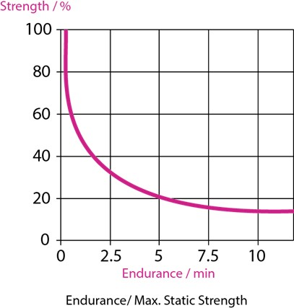

42 Kahn, J.F & Monod, H. (1989). Fatigue induced by static work, ‘Ergonomics - The Official Journal of the Institute for Ergonomics and Human Factors’, 32 (7) page 839-846.
43 Kahn, J.F & Monod, H. (1989). Fatigue induced by static work, ‘Ergonomics - The Official Journal of the Institute for Ergonomics and Human Factors’, 32 (7) page 839-846.
44 ‘Designing for muscular strength of various populations’. Available from: [http://www.dtic.mil/dtic/tr/fulltext/u2/a011537.pdf]. [Accessed 1/5/13].

Annex 3

Calculations for recommended character heights where text size cannot be enlarged.
‘Where any functionality of ICT is closed to the text enlargement features of platform or assistive technology, the ICT shall provide a mode of operation where the text and images of text necessary for all functionality is displayed in such a way that a non-accented capital ‘H’ subtends an angle of at least 0,7 degrees at a viewing distance specified by the supplier’.
The subtended angle, in degrees may be calculated from:
Ψ = (180 x H) / (π x D)
Where:
  - Ψ is the subtended angle in degrees
  - H is the height of the text
  - D is the viewing distance
  - D and H are expressed in the same units (Source: Draft EN 301 549 (V 1.0.0): 2013, 5.1.5)
For the purpose of this calculation a viewing distance of 823mm is used. This is based on the shoulder to grip distance of the 95th percentile male.45 This calculation identifies that the recommended character height is 10mm, based on a minimum subtended angle of 0,7 degrees.
The calculation undertaken was as follows:
Ψ = (180 x H)/ (π x D)
0,7 degrees = (180 x H)/ (π x 823mm) 0.7 𝑥 (π x 823mm) = H

180
H = 10mm

45 National Disability Authority (not yet published). ‘Size data and methods for Universal Design in Ireland’. Dublin: National Disability Authority.

Figure A3.1: Recommended minimum character height at a viewing distance of 823mm.
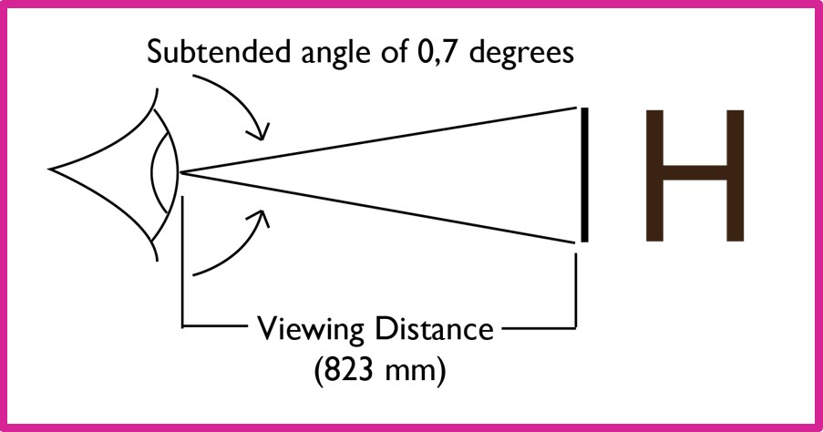

Centre for Excellence in Universal Design
National Disability Authority 25 Clyde Road, Dublin 4
Telephone (01) 608 0400
Fax (01) 660 9935

www.nda.ie
Universal Design is the design of a building or place, products, services or information / communication technologies so that they can be accessed, understood and used to the greatest extent possible by all people, regardless of their age, size, ability or disability.

