

Universal Design

Data for considering body size and shape

## Steps to Using the Data

## Ask, “How will users interact with the designed object?”

1. Ask, “How will body size and shape affect the interactions?”
2. Find the relevant dimensions in the figures here.
3. Use the minimum and maximum values as a guide to the range in body size and shape your design might encounter globally.
4. Consider this variability in your Universal Design. Incorporating adjustability or offering multiple sizes might be helpful.
5. Can you reimagine your design so that limitations due to user size, shape and capability are irrelevant?

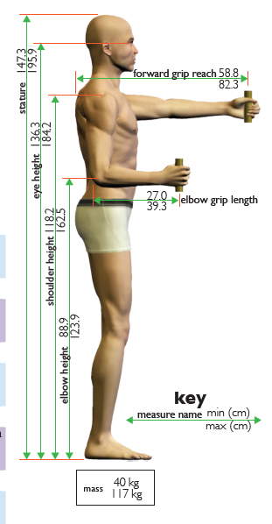

The max value for each measure is the largest 95th percentile value, male or female, in published global data. The min value is the smallest 5th percentile value in the published global data. The design range (Large minus Small) is useful in knowing how much adjustability is required for those products or workspaces where adjustability is possible.

Male manakin sitting down and facing forward depicting eight selected body size values. Dimension lines depict how measurements are taken on the human body. Refer to table 1 in the report “Size Data for Universal Design in Ireland – Part 3.”

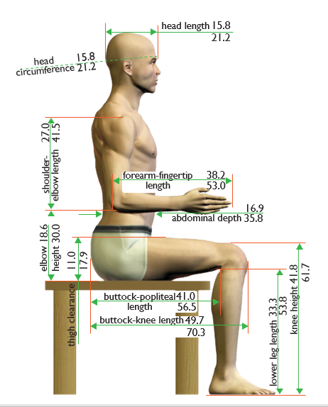

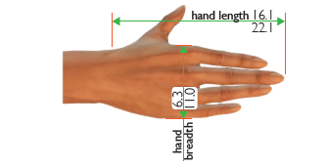

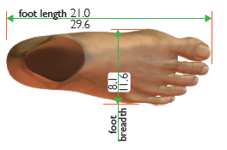

## Background

Successful Universal Design results in products and environments that are effective for all users, regardless of their age, capability, or body size. Consequently, identifying the range in body size and shape of potential users is one important step in Universal Design. The international literature identifies certain parts of the world as being characterized by both larger and smaller body sizes. Both are needed to define a design range that will accommodate as many people as possible. Although an individual might be characterized by thousands of dimensions, collecting these data for large populations is a painstaking process. Instead, most studies focus on the body dimensions most critical for design and other activities. This primer contains design ranges for 29 of the most commonly used dimensions. Typically, the largest values came from the US or Netherlands, and the smallest values from one or more Asian countries and southern Europe. Additional information is available in an NDA Technical Report. [1]

**Sources**

* Korean Agency for Technology and Standards, 2004
* Daanen & Robinette, 2001
* HQL Laboratory, 2007
* Thai Industrial Standards Institute (TISI), 2001
* Fubini et al., 1993
* Harrison & Robinette, 2002

1. Parkinson, M., Bradtmiller, M., and Garneau, C. (2012) “Size Data for Universal Design in Ireland Part 3: Size Data for Universal Design in Ireland”. Report prepared for Centre for Excellence in Universal Design National Disability Authority 25 Clyde Road Dublin 4 Ireland.