

Universal Design

An overview to considering body size and shape

## Anthropometry

Anthropometry means "the measure of man". Specifically, it refers to the study of body size and shape, although it is sometimes used casually to refer to Anthropometric Data.

## Anthropometric Data

These data represent the body size and shape of individuals. Anthropometric data can assist the designer in quantifying some kinds of variability exhibited by potential users of their design. Unfortunately, data specific to a particular population of target users can be difficult to obtain.

| Dimension | Small (cm) | Large (cm) | Design Range (cm) |
| --- | --- | --- | --- |
| Abdominal Depth, Sitting | 16.9 | 35.8 | 18.9 |
| Buttock-Knee Length | 49.7 | 70.3 | 20.6 |
| Buttock-Popliteal Length | 41 | 56.5 | 15.5 |
| Elbow Grip Length | 27 | 39.3 | 12.3 |
| Elbow Height | 88.9 | 123.9 | 35 |
| Elbow Height, Sitting | 18.6 | 30 | 11.4 |
| Elbow-Elbow Breadth | 32.2 | 57.1 | 24.9 |
| Eye Height | 136.3 | 184.2 | 47.9 |

## Manikins

Manikins are representations of the human form. They can be purely mathematical, entirely visual, or somewhere in between. Manikins rendered in Computer-aided Design systems are becoming more prevalent for design and are called Digital Human Models (DHMs).

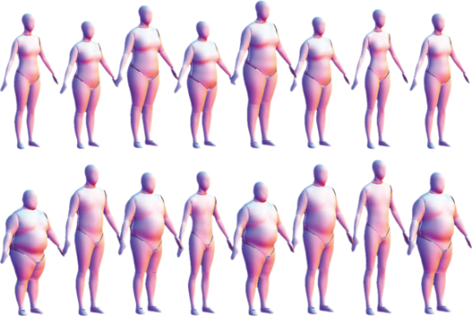

## The Myth of the “Average” Person

There is no “average” or “ideal” person. Two individuals of average height, for example, might have very different arm lengths, leg lengths, and capabilities. Those conducting Universal Design seek to consider human variability in their work and produce designs that work equally well for everyone.

## Proportionality Constants

A tall individual is likely to have longer legs than a shorter individual. Yet, the ratio of leg length to stature might be close to the same for both. The ratio of arms, legs and other body parts to stature varies just as other anthropometric characteristics vary. The so-called Proportionality Constant is the average ratio of one body dimension to another across a population. These average proportions have been tabulated and are sometimes used by designers to estimate the specific body dimensions (for example, leg length) when only general measures like stature are available. But this is not a good practice for many reasons. In particular, these ratios vary across race/ethnicity and are only accurate for “average” individuals, neglecting those whose ratios differ from the mean.

# Statistics

Statistics are numerical descriptions of data. In Universal Design, statistics can help to quantify the variability in body size and shape that a target user population might exhibit. A good designer considers more than just the average individual, looking at the full range of user characteristics.

## Distributions

The frequency of response for some kinds of data (for example, test scores) for a large population often creates a “bell-shaped” curve. This is called a Normal or Gaussian distribution. The distribution of some measures of anthropometry within a population, particularly measures of length (for example, stature or leg length), can be approximated as normal distributions. Note that some measures, such as mass and some measures of breadth (for example, seated hip breadth), are known to not be normally distributed within a population.

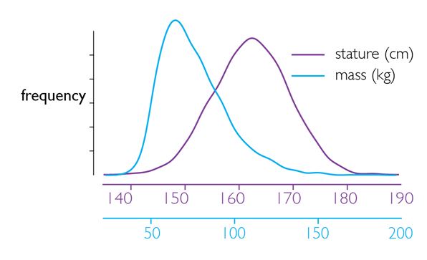

## Extremes

Individuals that are average on some measure that is normally distributed are near the middle of the distribution of values for that measure. A person with more extreme values is said to be in the distributions tail. Those conducting Universal Design are particularly conscientious of individuals who, due to their body size or capability, are in the tail of some distribution.

Graph showing sample Extremes data: x-axis representing frequency, y-axis representing stature in centimetres

## Percentiles

It is often helpful to know the range of anthropometric data associated with a particular measure like arm length or leg length. One way to quantify this is through percentiles. For a particular population, the nth-percentile value of a measure is the value at which n% is below that value and 100% - n% is above it. The figure below shows stature for 100 women, arranged from shortest to tallest. The “5th-percentile stature” lies between the 5th and 6th values. A person that is nth-percentile on one measure (for example, 5th-percentile stature) will have body dimensions of many other percentiles (for example, 15th-percentile leg length or 73rd-percentile hip breadth) and it is unlikely that two people will have the same combination on all measures.

Graph showing sample Percentiles data; x-axis representing statures in centimetres, y-axis representing percentile values

## Other Factors

Most anthropometric data are collected in ideal conditions and from individuals wearing minimal clothing. This provides an accurate measure of body size and shape, but ignores the effects of factors like clothing, footwear, and protective equipment. These can affect not just the size of the individuals within the population, but their ability to perform particular tasks. Likewise, anthropometric data are capable of predicting some elements of human performance, but ignore others. Developing an effective strategy for quantifying and including these factors is an important skill in Universal Design.