Universal Design
Body size and shape: User testing
Conducting User Testing
Design is an iterative process in which concepts are developed, tested, and refined. Changes to the concept during each iteration can be minor or substantial. User testing can be used at the beginning of an iteration to guide development, near the end to assess a potential final design, or both. Regardless of when testing occurs, the overall objectives are the same: identify how users interact with the design and their satisfaction with the interaction. Body size and shape is a good predictor of some of the interaction, but the rest will be left to preference. For example, two people of the same size and shape may not have the same preferred seat height on a bicycle. User testing can help to quantify both this variation and overall satisfaction with a design. Potential users involved in a user study are called participants.
Selecting Participants
- Identify the intended users of the design.
- Identify how users will interact with a design and the body dimensions that are likely to affect user fit.
- Recruit study participants from the target user population.
- Make sure that the range of variability in user characteristics (for example, relevant body dimensions) is represented.
- Recruit additional participants that represent the extremes of the user variability (oversampling)
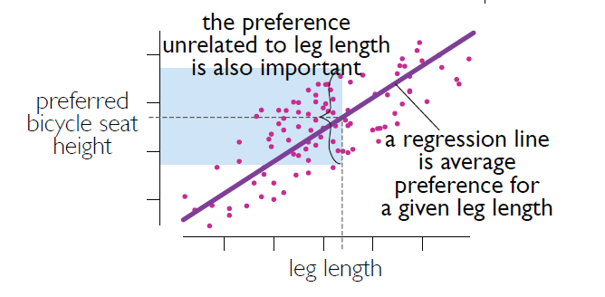
Representative Populations
User studies are often conducted with a convenience sample of family, friends, co-workers, or randomly selected individuals from the general population. This is not good design since none of these is representative of the actual target user population. Designers should be deliberate in their selection of participants. They need to represent the full range of variability exhibited by likely users. Since a random sampling of target users will result in many participants with similar anthropometry in the sample, a procedure called oversampling of the tails is used. In this, additional individuals with characteristics (for example, leg length, stature, mass) at the minimum and maximum boundaries are recruited. This ensures that multiple individuals represent user needs (for example, body sizes) in this critical portion of the design space.
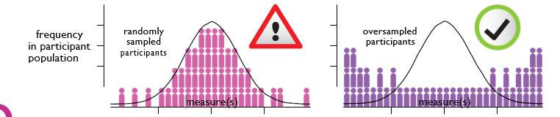
Protecting Participants
When conducting user studies, it is important that participants are protected from physical and emotional risks. This can also include safeguards like preserving the anonymity of participants, ensuring that those conducting the study are not in a position to influence participation, and that the benefits associated with the study outweigh the risks. Most governments, large companies, and academic institutions have an Institutional Review Board (IRB) tasked with preserving the ethics associated with user testing. They advocate for participants and approve and monitor studies. If your organization has an IRB, be sure to obtain their approval prior to initiating a study. If they do not, consider partnering with an institution that does or finding an independent IRB.

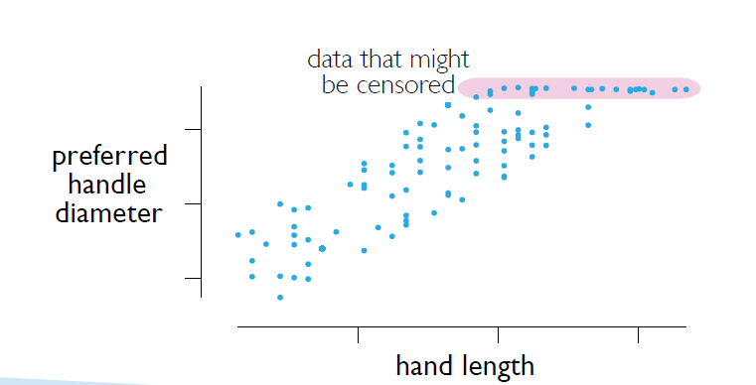

Steps in User Study
- Determine the type of results desired (for example, qualitative versus quantitative).
- Prepare the prototype. When adjustability or sizing is used, ensure that responses will be censored.
- Prepare the script that will introduce participants to the prototype and testing procedure.
- Following the script precisely, conduct the study. Randomize initial conditions and do not allow one participant to influence the next.
- Consider the results individually and collectively. Examine the range of responses not just the average. Evaluate “conclusions”.
- Improve the design concept; consider adjustability and sizing to improve accommodation.
- Can the design be re imagined so that limitations due to user size, shape, and capability are irrelevant?

Censoring
When prototypes incorporate adjustability or sizing, it is important that potential user responses not be limited by the prototype. The condition where a participant is constrained by the prototype from achieving their desired configuration is called censoring. For example, participants might be involved in a study where they select their preferred handle diameter from a finite set of choices. If the range of choices does not include handles of sufficiently large diameter, some participants might be forced to select a smaller size. This prevents the designer from obtaining a true understanding of the relationship between body size and shape and performance of the candidate design.

