Research Report

Universal Design of In-Home Displays

The National Disability Authority has commissioned and funded this research. Responsibility for the research (including any errors or omissions) remains with Dolmen (www.dolmen.ie). The views and opinions contained in this report are those of the authors and do not necessarily reflect the views or opinions of the National Disability Authority.

Acknowledgements
The research in this document has been undertaken by Dolmen (www.dolmen.ie) for the Centre for Excellence in Universal Design (part of the National Disability Authority).

Dolmen, the Centre for Excellence in Universal Design and the National Disability Authority wish to thank the following for their assistance and valuable contribution in undertaking this research:
- Acquired Brain Injury Ireland
- Age and Opportunity
- Bord Gáis
- Centre for Independent Living (CIL)
- Commission for Energy Regulation (CER)
- Consumer Energy Display Industry Group (CEDIG)
- DeafHear
- Department of Communication, Energy and Natural Resources
- Disability Access Officer UCD
- Disability Federation of Ireland
- Dublin City University
- Eco-eye
- Efergy
- EirGrid
- Electricity Supply Board (ESB)
- Enable Ireland
- Energia
- Green Energy Options Limited
- Irish Wheelchair Association (IWA)
- Little People of Ireland (LPI)
- Multiple Sclerosis Ireland (MS Ireland)
- National Council for the Blind of Ireland (NCBI)
- Prepaypower
- Sustainable Energy Authority of Ireland (SEAI)

Executive Summary

Introduction
In 2012, the Commission for Energy Regulation (CER) announced the planned deployment of electricity and gas smart meters across Ireland between 2016 and 2019.1 As part of this smart meter rollout, all household customers will receive an In-Home Display capable of displaying near real-time energy usage information. This smart meter rollout has been driven by initiatives and legislation, such as ‘Europe 2020’, which sets out targets including the reduction of both energy consumption levels and greenhouse emissions by 20% (from 1990 levels) by 2020.2
Research undertaken by the CER demonstrates the financial gain that can be achieved by household customers through reducing their energy usage.
However, with the exception of the research undertaken by ConsumerFocus (UK), there has been a lack of in-depth research undertaken on the Usability and Universal Design of In-Home Displays. This research is important to help ensure that the greatest number of consumers will be able to interact successfully with the In-Home Displays to achieve these economic gains
The importance of undertaking this research project is therefore to provide designers, manufacturers, suppliers and procurers with Universal Design technical guidance. This will help ensure that the mandated In-Home Displays can be accessed, used and understood by all household customers, to the greatest practicable extent, without the need for adaption or specialised design.

Research
A three stage research strategy was undertaken to inform the development of the Technical Guidelines for the Universal Design of In-Home Displays. The three stage research process consisted of the following:
- A Literature Review
- Usability Testing
- Stakeholder Consultations

1 Commission for Energy Regulation, (2012). CER/12/213: ‘National Smart Metering Programme (NSMP). Information Paper’. Dublin: The Commission for Energy Regulation.
2 European Commission. ‘Europe 2020’. Available from: [http://ec.europa.eu/europe2020/europe-2020-in-a-nutshell/targets/index_en.htm]. [Accessed 25/1/13].

It is important to clarify that the purpose of this research was not about deciding which In-Home Display was best; rather, the purpose of this research was to study the individual attributes, features and functionality of the
In-Home Displays and to identify how these attributes impacted on Usability. Many of these attributes are common across a wide range of interactive products and are not limited solely to In-Home Displays.
The three stages of research are outlined below.

Literature Review
The Literature Review was undertaken from an international perspective, focused on learning from countries that have undertaken or are currently undertaking a rollout of smart meters. Specific focus was placed on countries that have mandated the inclusion of In-Home Displays alongside smart meters.
Research was additionally undertaken to explore the role Universal Design plays in the design and manufacture of In-Home Displays internationally and how it has been applied to the design of products from comparable sectors.

Usability Testing
Usability Testing was undertaken with a diverse sample of 22 participants using four In-Home Displays. The VAST™ testing process explored three streams of data: physiological, observational and post-testing qualitative interviews. These data streams were used to determine problems and positive experiences that end users experienced using In-Home Displays that are currently on the market.

Stakeholder Consultations
The Stakeholder Consultations involved one-to-one interviews with 20 energy stakeholders and end users to gain insight and input on the design of In-Home Displays.
A round-table workshop was also undertaken with energy suppliers, regulatory bodies and organisations representing end users with specific difficulties. The aim of this workshop was to gain insight, input and feedback on the development of the Technical Guidelines in a discussion format.

Key Research Findings
The research undertaken identified three main design considerations to be addressed in relation to the design of In-Home Displays. These were:
- Ergonomic design: The ergonomic design relates to the product’s physical design and the physical interaction between the user and the In-Home Display. Design considerations relating to ergonomic design are focused on the comfort, efficiency, safety and use of the In-Home Displays
- Screen interface design: The screen interface design relates to how the user interacts with the In-Home Display
- Installation and power: The installation and power section relates to the interaction between the user and the In-Home Display when choosing an environment to install the In-Home Display, setting up the In-Home Display, changing batteries, and using a power adaptor
Key findings from the research are addressed under the three headings below.

Ergonomic Design
Through the three stage research process the following ergonomic design considerations were identified. These have been addressed under the following four headings:
- Button design
  - Large, well-spaced, physical buttons that provide tactile feedback are preferred to touchscreen interfaces
  - Physical buttons should have a minimum width / diameter of 10mm
  - Touchscreen buttons should have a minimum width / diameter of 21mm
  - Physical buttons should be easy to detect and identify

- Button positioning
  - Buttons used frequently should be located on the front plane of the In-Home Display for ease of identification. If additional buttons with more advanced functionality are required, they should be located on the side of the In-Home Display
  - Buttons should be arranged in a hierarchical order. Illogical sequences of button operations are more difficult to remember
  - Buttons should be positioned so that they can be operated using either the right or left hand
  - Buttons required to perform common tasks should be grouped together
  - A spacing of at least 2.5mm should be provided between adjacent buttons
- Button operation
  - Button operations that require a button to be pressed and held for a prolonged period of time should be avoided
  - A delay in time between activating the same button should be provided to cater for inadvertent button activation
  - Too much functionality or a variety of functionality in one button should be avoided
- In-Home Display design
  - The In-Home Display design should have the option of being both wall mounted or portable
  - The In-Home Display design should be designed to withstand a drop test
  - The In-Home Display design should be wireless (or have the option of being wireless) to allow for moving to different locations and being handheld
  - The In-Home Display design should be aesthetically pleasing. Aesthetics are an important consideration and will influence where the In-Home Display is located. Aesthetics also influence the level and frequency that the householder interacts with the product
  - The In-Home Display design should avoid providing too many buttons

Screen Interface design
The In-Home Display should be easy to operate from the first time it is used. The screen interface design should allow for flexibility in use to take into account the varied needs and abilities of the users.
Through the three stages of research the following screen interface design considerations were identified. These have been addressed under the following headings:
- Layout:
  - The In-Home Display should have a familiar layout. The screen interface should have a recognisable layout with legible cues that are sufficient in size and colour contrast to help users find information
  - The In-Home Display should have a clear, uncluttered presentation of key information
  - The In-Home Display should have a consistent interface design and layout (particularly in the placement of text, numbers, symbols and decimal points)
- Functionality:
  - The In-Home Display’s general functionality should be simple to operate. It was suggested that there could be different levels of information for users with different technological experience and needs
  - The In-Home Display should provide information in both digital and analogue formats. This is to accommodate peoples’ preferences for information to be conveyed in different ways.
When providing information using a digital display or an analogue display, it is important to consider how values and symbols are portrayed, specifically relating to unit symbols (such as, €)
- Text and Visuals:
  - Familiar features should be used. Familiarity of the feature is more important than the location of the feature
  - Where contemporary symbols or logos are used, they should be accompanied by text

- Feedback:
  - The In-Home Display should provide prompt and legible feedback to aid understanding. Difficulties were experienced in the Usability Testing where there was a prolonged time delay between the time a button was pressed and the time the system responded
- Legibility:
  - The In-Home Display should provide adequate height and spacing of the numbers and text. In-Home Displays which had small text size and spacing resulted in poor reading accuracy in the Usability Testing
  - The In-Home Display should provide an easy to read screen size. The Usability Testing identified that a screen size of approximately 20mm x 70mm was too small. 64% of participants in the Usability Testing identified that a screen size of approximately 70mm x 150mm as being a good size screen for legibility
- Screen contrast and resolution:
  - The In-Home Display should prevent glare by avoiding the use of materials with glossy surfaces
  - The In-Home Display should provide acceptable colour contrast
  - The In-Home Display should provide good screen resolution so similar shaped numbers and letters can be differentiated
  - The In-Home Display should provide backlighting that can be adjusted for environments with poor lighting
- Tolerance for error:
  - The In-Home Display should provide an obvious method to escape from an error if the wrong button is pressed
  - The In-Home Display should provide a quick help guide on the product housing to assist participants who may be confused about which button to press
  - The In-Home Display should provide a feature/function to automatically return to the default screen after a period of time. This function should be designed to accommodate the slowest user

Installation and Power:
The design considerations for the installation and powering of the In-Home Displays identified through the three stages of research are as follows:
- Installation:
  - The In-Home Display should be an out of the box solution. The In-Home Display should automatically connect to the smart meter while protecting the user’s information
  - The In-Home Display should be simple to mount on the wall. It should also be easy to remove from the wall
  - To ensure ease of use for the end user, guidance should be provided for wall-mounting the In-Home Display (such as, in an accessible location and close to eye-level)
- Accessibility of batteries:
  - The In-Home Display should provide an easy method to access and change replaceable batteries. This is a particularly important consideration for users with dexterity problems, such as arthritis
- Compatibility with Assistive Technology:
  - If the In-Home Display cannot be designed to accommodate all users, compatibility with assistive technologies (such as infrared devices) is required
  - If the In-Home Display cannot be designed to accommodate all users, the information from the In-Home Displays should be provided through a smart phone or computer (as most assistive technology tools can be accessed through these products)

Development of Technical Guidelines
The three stage research process was undertaken to inform the development of Technical Guidelines for the Universal Design of In-Home Displays.
The outcome of this research is a collective set of design considerations for the design and development of In-Home Displays. These design considerations are focused on making the In-Home Displays easy to access, understand and use for all household customers. The design considerations are aligned with the principles and guidelines of Universal Design, and are supported through technical specifications identified from best practice sources.
The Technical Guidelines will provide specific technical guidance on the Universal Design of In-Home Displays for designers, manufacturers and procurement agencies.

Table of Contents

- Introduction 3
  - Overview 3
  - Irish Smart Meter Strategy 4
    - In-Home Displays 4
  - Universal Design 6
    - Principles and Guidelines of Universal Design 8
- Methodology 9
  - Research Methodology 9
- Research Strategy, Scope and Findings 10
  - Literature Review 10
    - Literature Review Methodology 10
    - Literature Review Scope and Purpose 11
    - Design Considerations for the Development of Technical Guidelines 18
    - Key Findings 29
  - Usability Testing Overview 32
    - Introduction to Usability Testing and Universal Design 32
    - Usability Testing Methodology 35
    - Usability Testing Findings 43
  - Stakeholder Consultations 68
    - Stakeholder Methodology 68
    - Stakeholder Consultations Scope, Purpose and Findings 70
    - Stakeholder Consultation Findings 74
- Discussion 76
  - Research Discussions and Recommendations 76
    - Universal Design 76
    - Cost of Universal Design 76
    - Interoperability with Assistive Technology 77
    - In-Home Display Information 77
- Conclusions and Recommendations 78
  - Development of Technical Guidelines 78
    - Guidance for the Development of Technical Guidelines 78
- Bibliography 87
- Terms and Definitions 91
- Annex 1 93
- Annex 2 93

Introduction

Overview
In 2012, the Commission for Energy Regulation (CER) announced the planned deployment of electricity and gas smart meters across Ireland between 2016 and 2019.3 As part of this smart meter rollout, all household customers will receive an In-Home Display capable of displaying near real-time information on their energy consumption.
In order for In-Home Displays to be successfully adopted as a tool to reduce energy consumption, they should be easy to access, understand and use by all household customers. This is aligned with Section 3 of the European Communities (Internal Market in Electricity and Gas) (Consumer Protection) Regulations of 2011, which states that distribution system operators and suppliers shall apply the principles of Universal Design to all products offered or provided to final customers.4
The Centre for Excellence in Universal Design (part of the National Disability Authority) identified the need for a practical resource for designers and manufacturers to support the application of Universal Design principles in the design of In-Home Displays.
This Research Report presents the key findings from a Literature Review, Usability Testing and Stakeholder Consultations. It additionally outlines the recommendations for the development of Technical Guidelines on the Universal Design of In-Home Displays.
The Technical Guidelines will promote good design practices, developed from best practice research. These guidelines will provide technical specifications, outlining good practice on which the In-Home Displays can be built. The Technical Guidelines are not designed to restrict or constrain the design of the In-Home Display, but rather to identify good design practice that can help designers and manufacturers to develop products that are easier to access, understand and use for all their customers.

3 Commission for Energy Regulation, (2012). CER/12/213: ‘National Smart Metering Programme (NSMP). Information Paper’. Dublin: The Commission for Energy Regulation.
4 European Communities (Internal Market in Electricity and Gas) (Consumer Protection) Regulations of 2011, Section 3.

Irish Smart Meter Strategy
The smart meter rollout has been driven by initiatives and legislation, such as ‘Europe 2020’, which sets out targets including the reduction of both energy consumption levels and greenhouse emissions by 20% (from 1990 levels) by 2020.5
Over the past decade smart meters have been gradually rolled out internationally, driven by improved technology, environmental considerations and the need to change and inform consumers’ behaviour. Following cost benefit analyses, the United Kingdom (UK), Victorian Province in Australia and Ireland have mandated the inclusion of In-Home Displays in their smart meter implementation.6,7,8
The benefit of mandating In-Home Displays alongside smart meters in Ireland is twofold; firstly it will assist in meeting the criteria set by the European Commission in reducing energy consumption and greenhouse emission levels. Secondly, In-Home Displays will provide Irish householders with the knowledge and information to become more energy aware and efficient (by knowing how much energy they are consuming and what it is costing them).

In-Home Displays
An In-Home Display is a product that presents both real-time and past energy usage information. It provides the user with information on the amount of energy used and how much the energy costs. These products vary in their level of functionality, with more sophisticated products providing features such as information on charge rates for specific energy suppliers and having the ability to turn on and off appliances (such as heating remotely).
In-Home Displays can be used in two ways:
      - In-Home Displays can be used in conjunction with a smart meter to communicate and display the information from the smart meter (such as energy usage and cost). Smart meters are typically electricity and gas meters that gather energy consumption data, which is communicated remotely to the energy supplier for monitoring and billing purposes

5 European Commission. ‘Europe 2020’. Available from: [http://ec.europa.eu/europe2020/europe-2020-in-a-nutshell/targets/index_en.htm]. [Accessed 25/1/13].
6 Department of Energy and Climate Change (2012). ‘Smart meter roll-out for the domestic sector (GB)’. London: Department of Energy and Climate Change.
7 Accenture Pty Ltd for Department of Primary Industries, (2011). ‘Department of Primary Industries IHD Inclusion into ESI scheme’. Accenture.
8 The Commission for Energy Regulation. (2012), ‘Decision on the National Rollout of Electricity and Gas Smart Metering’. Dublin: The Commission for Energy Regulation.

      - In-Home Displays can also be designed for use with systems that do not have a smart meter. In this case a sensor is placed between the power meter and the fuse box to provide the consumer with energy consumption and cost information
As part of the smart meter rollout in Ireland between 2016 and 2019, all household customers will receive an In-Home Display capable of displaying near real-time information on their energy consumption.9 The basic functionality of the mandated In-Home Display will be determined by the Commission for Energy Regulation (CER) in collaboration with energy stakeholders. However typical information provided by an In-Home Display includes:10
      - Real-time energy usage in kilowatts / kilowatt hours
      - Real-time usage in monetary cost
      - Historical data in monetary cost (for example, cost per day, week or month)
      - Historical data on energy consumption (for example, energy usage per day, week or month in kilowatts / kilowatt hours)
      - Ambient feedback that allows consumers to easily distinguish between high and low levels of energy usage

9 The Commission for Energy Regulation, (2012). CER/12/213: ‘National Smart Metering Programme (NSMP)’. Information Paper. Dublin: The Commission for Energy Regulation.
10 Ofgem (2011). ‘Smart Metering Implementation Programme – Response to Prospectus Consultation’. London: Department of Energy and Climate Change and the Office of Gas and Electricity Markets.

Universal Design
Section 3 of the European Communities (Internal Market in Electricity and Gas) (Consumer Protection) Regulations of 2011, states that distribution system operators and suppliers shall apply the principles of Universal Design to:11
- all products and services offered or provided to final customers, and
- communications with final customers.

The Disability Act (2005) is designed to progress and support the participation of people with disabilities in everyday life. It establishes a statutory basis for supporting the provision of disability specific services and improving access to mainstream public services. Based on the definition provided in the Irish Disability Act (2005), Universal Design in this context is about ensuring that
In-Home Displays can be accessed, understood and used to the greatest practicable extent by household customers of any age, size, ability or disability.

Based on the definition outlined in Part 6 of the Disability Act (2005), Universal Design:12
- means the design and composition of an environment so that it may be accessed, understood and used -
  - to the greatest practicable extent,
  - in the most independent and natural manner possible,
  - in the widest possible range of situations, and
  - without the need for adaptation, modification, assistive devices or specialised solutions,
by any persons of any age or size or having any particular physical, sensory, mental health or intellectual ability or disability,
and
- means, in relation to electronic systems, any electronics-based process of creating products, services or systems so that they may be used by any person.

11 European Communities (Internal Market in Electricity and Gas) (Consumer Protection) Regulations of 2011, Section 3.
12 Irish Statute Book. Disability Act 2005. Available from: [http://www.irishstatutebook.ie/2005/en/act/pub/0014/index.html]. [Accessed: 26/11/12].

The International Classification of Functioning, Disability and Health (ICF) reinforces the need for the Universal Design of In-Home Displays by emphasising that every person can experience a decrease in health during their lifetime and thereby experience some degree of disability. Focus is therefore placed on the fact that disability is not something that only happens to a minority of people.13
By applying Universal Design principles and guidelines, organisations can produce products and services that are accessible, understandable and usable by all household customers, to the greatest practicable extent, without the need for adaption or specialised design.
Where this is not possible, In-Home Displays should be adaptable to the specific needs of users by ensuring that the product is compatible with assistive technology products and services.

13 World Health Organisation. ‘International Classification of Functioning, Disability and Health (ICF)’. Available from: [http://www.who.int/classifications/icf/en/]. [Accessed: 26/11/12].

Principles and Guidelines of Universal Design
In 1997, the Centre for Universal Design (North Carolina State University) developed a set of 7 principles and 29 guidelines which provide guidance on the general application of Universal Design when designing and procuring products and services.14
Each of the 7 principles of Universal Design has four or five descriptive guidelines.15 These principles and guidelines are used to examine existing designs, guide the design process and act as a source of information on designing more usable products and environments.
The 7 principles of Universal Design are:16,17
      - Principle 1: Equitable use: The design is useful and marketable to people with diverse abilities
      - Principle 2: Flexibility in use: The design accommodates a wide range of individual preferences and abilities
      - Principle 3: Simple and intuitive use: Use of the design is easy to understand, regardless of the user’s experience, knowledge, language skills, or current concentration level
      - Principle 4: Perceptible information: The design communicates necessary information effectively to the user, regardless of ambient conditions or the user’s sensory abilities
      - Principle 5: Tolerance for error: The design minimises hazards and adverse consequences of accidental or unintended actions
      - Principle 6: Low physical effort: The design can be used effectively and comfortably and with a minimum of fatigue
      - Principle 7: Size and space for approach and use: Appropriate size and space is provided for approach, reach, manipulation, and use regardless of the user’s body size, posture, or mobility

14 North Carolina State University (1997). ‘7 Principles and 29 Guidelines of Universal Design’. USA: Centre for Universal Design.
15 Please see Annex 1 for further information.
16 National Standards Authority of Ireland (2012). SWiFT 9:2012 ‘Universal Design for Energy Suppliers’. Dublin: NSAI.
17 North Carolina State University (1997), ‘7 Principles and 29 Guidelines of Universal Design’. USA: Centre for Universal Design.

Methodology

Research Methodology
A three stage research strategy was undertaken to guide the development of the Technical Guidelines. The three stage research process consisted of the following:
- Literature Review: The Literature Review was undertaken from an international perspective, focused on learning from countries that have undertaken or are currently undertaking a rollout of smart meters. Specific focus was placed on countries that have mandated the inclusion of In-Home Displays alongside smart meters.
Research was additionally undertaken to explore the role Universal Design plays in the design and manufacture of In-Home Displays internationally and additionally how it has been applied to products from comparable sectors.
- Usability Testing: The Usability Testing was undertaken with a diverse sample of 22 participants using four In-Home Displays. The VAST™ testing process explored three streams of data: physiological, observational and post-testing qualitative interviews. These data streams were used to determine problems and positive experiences that end users experienced using In-Home Displays that are currently on the market.
- Stakeholder Consultation: The Stakeholder Consultation involved one-to-one interviews with 20 energy stakeholders and end users to gain insight and input on the design of In-Home Displays.
A round-table workshop was also undertaken with energy suppliers, regulatory bodies and organisations representing end users with specific difficulties. The aim of this workshop was to gain insight, input and feedback on the development of the Technical Guidelines in a discussion format.
The focus of this three stage research process was to inform the development of the Technical Guidelines for the Universal Design of In-Home Displays.

Research Strategy, Scope and Findings

Literature Review

Literature Review Methodology
The Literature Review focused on identifying international good practice in the Universal Design of In-Home Displays.
The Literature Review was undertaken to:
- Explore the international rollout of smart meters. Specific focus was placed on countries which have mandated the inclusion of In-Home Displays as part of their smart meter rollout. Research was undertaken into countries including the United Kingdom, the United States (California and Central Arizona), Italy, Sweden, South Korea and Australia (Victoria Province)
- Explore the role of Universal Design in the design and manufacture of In-Home Displays internationally
- Identify best practice Universal Design considerations applied to products in comparable sectors
- Identify and explore In-Home Display life cycle, costs and trends
This Literature Review draws on a range of government and private sector information, as well as proprietary databases, such as the International Organization for Standardization (ISO), National Standards Authority of Ireland (NSAI), Datamonitor, Frost & Sullivan and BCC Research. Search Engines used as part of the research strategy included Google (advanced search), Google Scholar and Google Trends.
Keywords, synonyms and related terms used for the Literature Review included: In-Home Displays, smart meters, home energy displays, water and energy displays, energy monitors, smart displays, Universal Design, accessible design, inclusive design, design for all, interface design, user interface design (UID), energy management information systems (EMIS) and home energy management systems (HEMS).
The Literature Review was completed in November 2012.

Literature Review Scope and Purpose

Smart Meters and In-Home Displays
The global market for In-Home Displays was worth an estimated $118.3 million in 2011. The size of the market is expected to increase rapidly over the next five years, reaching $405.5 million by 2017.18 This significant increase in the
In-Home Display market is due to strong national investment from countries around the world.
The ‘European Initiative on Smart Cities’ provides support to cities and regions to reduce greenhouse gas emissions by 40% by 2020, through sustainable usage and production of energy.19 This initiative focuses on smart meters, calling for their deployment before 2020.
Italy is considered a world leader in smart metering. Over 85% of Italian homes have smart meters installed. Italy’s progress is the result of a programme begun in 2001 by its main utility company, Enel.20

Smart Meter and In-Home Display Rollout
Research was undertaken into the different stages of international rollout of smart meters on a large scale basis in countries, including the UK, Italy, Sweden, the US (California and Central Arizona), South Korea and Australia (Victoria).
Of these, specific focus of the Literature Review was placed on Victoria in Australia and the UK who have also mandated the inclusion of In-Home Displays in their smart meter implementation.
A study by Accenture on behalf of the Victorian Government in Australia identified that monitoring electricity consumption with the use of an In-Home Display saved householders between $77.6 and $102.5 (AUS) a year through a 6.6% reduction in energy consumption.21

18 BCC Research (2012). ‘Energy Management Information Systems: Global Markets’. Wellesley: BCC Research.
19 European Initiative on Smart Cities. Available from: [http://setis.ec.europa.eu/about- setis/technology-roadmap/european-initiative-on-smart-cities]. [Accessed: 26/11/12].
20 Wood, Lisa (2011). ‘The Future of Home Automation: Emerging trends and technologies for smart home energy, entertainment, security and health’. London: Datamonitor.
21 Accenture Pty Ltd for Department of Primary Industries, (2011). ‘Department of Primary Industries IHD Inclusion into ESI scheme’. Victoria: Accenture.

The Literature Review identified that many countries and suppliers have undertaken pilot programs and trials using smart meters and In-Home Displays; however the subsequent findings from the majority of these reports are focused primarily on energy savings rather than the usability and Universal Design of the In-Home Displays.
Overall it was found that internationally Universal Design principles have typically not been applied in a structured and consistent way in the design of In-Home Displays. However, certain design features and functions have been integrated into In-Home Displays currently on the market, which make the products more accessible and easier to use by end users. This however is determined by the manufacturers and designers rather than through the regulated application of Universal Design, and is the exception rather than the rule.

Smart Meter Rollout in Ireland
In Ireland, the Commission for Energy Regulation (CER) published a ‘Smart metering information paper’ (CER/11/080) in 2011 which outlined their findings from: their customer behavioural trials (CER/11/080a), technology trial findings report (CER/11/080b), and their cost-benefit analysis report (CER/11/080c).22
The behavioural trials, completed in 2011, (CER/11/080a) consisted of a representative sample of over 5,000 residential participants and 650 Irish SMEs. The study used four different methods to communicate energy usage to the consumer. The residential customer behaviour trial identified that using a bimonthly bill, energy statement and an In-Home Display could lead to a reduction of 11.3% peak time (17:00-19:00) energy usage.23

22 Commission for Energy Regulation, (2011). Smart Metering Information Paper 4 (CER 11080). ‘Results of Electricity Cost-Benefit Analysis, Customer Behaviour Trials and Technology Trials’. Dublin: The Commission for Energy Regulation.
23 Commission for Energy Regulation, (2011). ‘Electricity Smart Metering Customer Behaviour Trials Findings Report’. CER/11/080a. Dublin: The Commission for Energy Regulation.

The CER’s 'Decision on the national rollout of electricity and gas smart metering' (CER 12092) outlined several key energy policy related decisions, including:24
- Rolling out electricity and gas smart metering to all electricity and gas residential and business consumers25
- Mandating the rollout of In-Home Display devices to all electricity consumers
- Mandating time of use electricity tariffs for all electricity consumers
- Enabling broader and easier access to prepayment services for electricity and gas consumers

Water meters
The Irish government is undertaking a national rollout of 1.05 million water meters with installation between July 2013 and late 2016.26 It is expected that from 2014 consumers will be charged for water use.
In Ireland the water meter rollout is being regulated by the CER.27 The opportunity this presents is in the synergy between the smart meter (electricity and gas) rollout and the water meter rollout. The CER’s ‘Consultation on the proposed national rollout of electricity and gas smart metering’ (2011) outlined that:28
‘The CER will continue to review any potential synergies that may exist between the required energy smart metering infrastructure and water metering. However, at this stage the high level design will proceed on the basis that water metering is not included.’

Multi-utility In-Home Displays
The most commonly seen multi-utility In-Home Displays are dual fuel, which incorporate electricity and gas. However, increasingly there is additional focus on including information on water usage and renewable energy.

24 Commission for Energy Regulation (2012). ‘Decision on the National Rollout of Electricity and Gas’. Dublin: CER.
25 Please note: electricity smart metering will be supplied to all electricity customers on non-interval meters and gas smart metering will be supplied to consumers in the G4 meter category.
26 Independent.ie. ‘Water meter roll out will be delayed until 2016’. Available from: [http://www.independent.ie/business/irish/water-meter-rollout-will-be-delayed-until-2016- 28821600.html]. [Accessed: 8/5/13].
27 Community and Local Government Environment (2012). ‘Reform of the water sector in Ireland’. Position Paper. Ireland: ENVIRON.
28 The Commission for Energy Regulation (2011). ‘Consultation on the proposed national rollout of electricity and gas smart metering’. Consultation Paper CER 11191. Dublin: CER.

In-Home Display manufacturers in the UK and the US have incorporated functions to allow In-Home Displays to provide information on electricity, gas and water. This is being driven by partnerships within the relevant sectors to meet the growing needs and demands of the market.
An example of this is Landis + Gyr’s ‘ecoMeter’ (see Figure 1) which allows the user to view the current and historical data relating to their electricity, gas, heat and water usage.29

Figure 1: Usability considerations on Landis + Gyr’s ‘ecoMeter’.
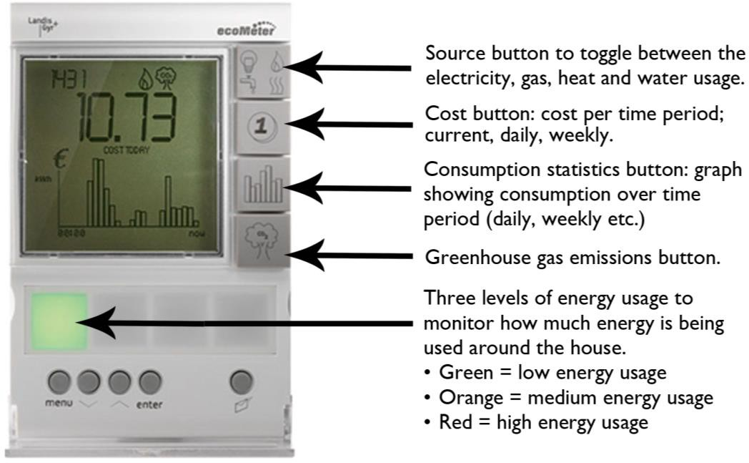
Source: Landis + Gyr’s ‘ecoMeter’30

While there isn’t a need for minimum functionality of In-Home Displays to display information on micro-generation; this could be a desirable ‘extra’, which could be packaged as part of micro-generation services provided by energy suppliers.31, 32

29 Landis+Gyr’s ‘EcoMeter’ In-Home Display. Available from: [http://www.za.landisgyr.com/product/landisgyr-p350-ecometer/]. [Accessed: 8/5/13].
30 Landis+Gyr’ ‘EcoMeter’ In-Home Display. Available from: [http://www.za.landisgyr.com/product/landisgyr-p350-ecometer/]. [Accessed: 8/5/13].
31 ConsumerFocus (2010). ‘Response to Smart Metering Implementation Programme: In-Home Display’. London: Consumer Focus.
32 Note: Micro-generation is the generation of zero or low-carbon heat and power by individuals, small businesses and communities to meet their own needs. Micro-generation is dominated by three areas: solar, wind and hydroelectric power. (IWEA, 2013).

Monitoring Energy Usage
In-Home Displays are just one method to display energy consumption information; other methods include web-based interfaces, interactive monitors and energy orbs (which communicate changes in pricing and demand by glowing different colours).
Web-based interfaces track home energy usage by connecting to the smart meter and displaying real-time energy-use data for the customer online.
Energy orbs monitor the energy grid and a home’s energy consumption. Energy orbs typically change colour to inform the householder on their energy consumption rates. The light pulses red when energy costs are high and glows green when they’re lower (see Figure 2).

Figure 2: The Energy Orb.
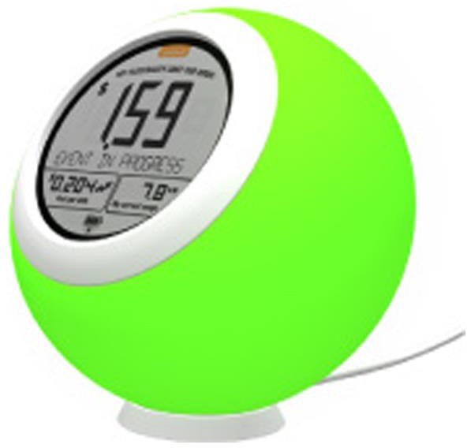
Source: Ambient Device’s ‘Energy Orb’33

In-Home Displays are constantly evolving to enable more complex functionality; this provides the customer with additional knowledge and control over their spending behaviour.

33 Ambient. ‘The Energy Orb’. Available from: [http://www.ambientdevices.com/about/about- the-company]. [Accessed: 20/12/12].

Irish Demographics
The Universal Design Technical Guidelines for In-Home Displays provide guidance on the design and procurement of In-Home Displays to meet the needs of all customers. Energy customers are diverse; from their size and age, their level of education and literacy levels, to their varied range of experience using computers and digital interfaces. Additionally many household customers have specific needs ranging from difficulties with movement, to sensory and cognitive difficulties, which may impact how they will access, understand and use In-Home Displays.
The 2011 Irish Census identified that the number of older people (over the age of 65) increased by 14% since the previous census. Alongside this rapidly increasing figure, the Irish Census (2011) also identified that 13% of people in Ireland have some type of long term difficulty, a statistic which increases significantly with age (see Figure 3 below). This is supported by the finding that over 75% of the female population over the age of 85 years have some type of long term difficulty.34
Figure 3 illustrates that many disabilities increase significantly with age. Examples of difficulties that increase with age includes: blindness and vision difficulties, deafness and hearing difficulties, learning difficulties and physical difficulties.

Figure 3: Type of disability by age group (2011).
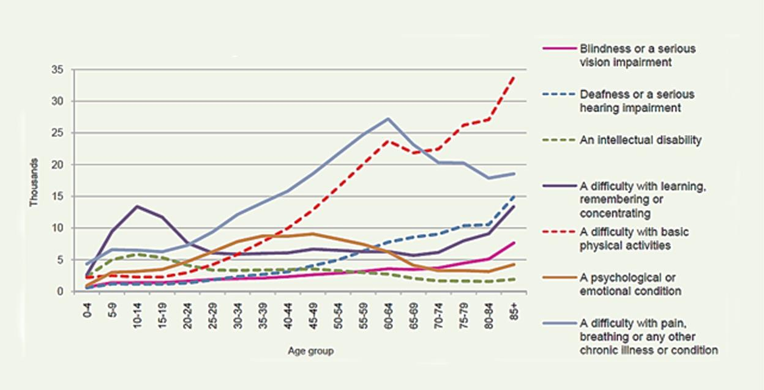
Source: Central Statistics Office 'Our Bill of Health’ (2012)35

34 Central Statistics Office (2012). 'Our Bill of Health’ Profile 8. Dublin: The Stationary Office.
35 Central Statistics Office (2012). 'Our Bill of Health’ Profile 8. Dublin: The Stationary Office.

The ‘Type of disability by age group’ chart illustrates that considerations in relation to physical, visual, hearing, learning and remembering difficulties are very important in addressing the needs of older people. Addressing these design considerations will help make products more usable, functional and understandable for all customers. Considerations relating to this market also include their varied experience of using technology products, which reinforces the need for user-friendly designs.

Universal Design of In-Home Displays
In 2012, ConsumerFocus (UK) published a ‘Usability good practice guidance’ document to inform manufacturers, companies and other organisations involved in the design and manufacture of In-Home Displays.36 However there is currently little technical guidance available for designers or procurement agencies specifically on the Universal Design of In-Home Displays.
The National Disability Authority (NDA) has emphasised the need to put in place technical guidance on the Universal Design of In-Home Displays, so that In-Home Displays can be accessed, understood and used by household customers regardless of age, size, ability or disability in line with the Disability Act 2005.37 With the pending national rollout of In-Home Displays from 2016, this guidance will help ensure that manufacturers, designers and procurers of
In-Home Displays have a resource available that will provide them with technical guidance.
From both a short and long term perspective it is important that the household customer successfully engages with the product as a tool to reduce energy consumption and greenhouse gas emission levels. It is therefore critical that the In-Home Display provided to the household customer is easy to access, understand and use.

36 Ricability, (2012). Smart Meter In-Home Display Design: ‘Usability good practice guidance’. UK: ConsumerFocus.
37 Irish Statute Book. Disability Act 2005. Available from: [http://www.irishstatutebook.ie/2005/en/act/pub/0014/index.html]. [Accessed 26/11/12].

Assistive Technology
The Irish Disability Act’s (2005) definition of Universal Design refers to assistive technology as follows:38
Universal Design is the design and composition of an environment39 so that it may be accessed, understood and used without the need for adaptation, modification, assistive devices or specialised solutions, by persons of any age or size or having any particular physical, sensory, mental health or intellectual ability or disability.
However, where required, the In-Home Display should provide compatibility with a variety of techniques or devices used by people with sensory limitations (in line with Universal Design guideline 4d).40
This can be achieved by making the product adaptable to different users by having standardised interfaces that are compatible with assistive technology products or services for people with specific needs or difficulties.

Design Considerations for the Development of Technical Guidelines
The Literature Review identified three main design considerations to be addressed in relation to the design of In-Home Displays. These were:
- Ergonomic design: The ergonomic design relates to the product’s physical design and the physical interaction between the user and the In-Home Display
- Screen interface design: The screen interface design relates to how the user interacts with the In-Home Display. The screen interface design can provide information to the user through visual, auditory or tactile means
- Installation and power: The installation and power section relates to the interaction between the user and the In-Home Display when choosing an environment to install the In-Home Display, setting up the In-Home Display, changing batteries, and using a power adaptor
The remainder of the Literature Review is set out under the three headings below.

38 Irish Statute Book. Disability Act 2005. Available from: [http://www.irishstatutebook.ie/2005/en/act/pub/0014/index.html].[Accessed 26/11/12].
39 Note: Part 6 of the Disability Act 2005 states that: ‘environment’, in relation to any area, means any buildings and any public places in that area and any products used, services provided and systems (including electronic systems) available for operation in that area.
40 North Carolina State University (1997). ‘7 Principles and 29 Guidelines of Universal Design’. Centre for Universal Design, USA.

Ergonomic Design
The Literature Review on the ergonomic design of In-Home Displays related to the product’s physical design. It specifically focused on design considerations that would increase the product’s comfort, efficiency, safety, and ease of use.
A key feature that affects usability is the product’s buttons or controls (physical or touchscreen). Research on the ergonomic design of In-Home Displays was addressed under the following headings:
- Button design
- Button positioning
- Button size and spacing

Button Design
As part of the Literature Review, research was undertaken into the button design of comparable products. A study undertaken on mobile phones by the Communications Consumer Panel (2011) identified that the majority of participants (both ‘disabled’ and ‘non-disabled’) found tactile keys easier to use than touchscreen keys.41 The study found that touchscreens resulted in more errors, as the screens tested could be under or over-sensitive.
The study identified that younger and more frequent users preferred phones with sensitive buttons, while ‘older and disabled users’ preferred buttons that required more force to activate.
The ‘Nordic Guidelines for Computer Accessibility’ recommend that no operation of a control should require more power than 2 Newton (N).42

Button positioning
Research on mobile phones by the Communications Consumer Panel (2011) found that the location of the buttons on mobile phones appeared to be important. Older participants disliked buttons on the side or back of the phone because they could be activated accidently.

41 Communications Consumer Panel (2011). ‘Making Phones easier to use: views from consumers’. London: Communications Consumer Panel.
42 ‘Nordic Guidelines for Computer Accessibility’. Available from: [http://trace.wisc.edu/docs/nordic_guidelines/nordic_guidelines.htm]. [Accessed 29/5/13].

Older participants found buttons on the sides of phones (such as the on/off button) difficult to use because they were not easily identifiable by sight or touch.43 However, younger and more frequent users preferred to have keys on the side as it allowed them to have quick access to advanced features such as photos.44

Button size and spacing
Findings from the ‘Touchscreen performance by individuals with and without motor control disabilities’ report undertaken by Chen et al (2012) identified the following:45
- There was a 22% decrease in errors by participants with motor control disabilities as the button size increased from 20mm to 25 mm. There was a further 15% decrease in errors as the button size was increased from 25mm to 30mm
- There was an 84% decrease in ‘misses’46 from participants (with and without motor control disabilities) when the button size on a touch screen was increased from 10mm to 30mm. The majority of both groups preferred a gap of 3mm between the buttons. This is in line with the guidance provided by the National Disability Authority’s ‘Guidelines for Public Access Terminals Accessibility’ which identified that spacing between adjacent buttons should be greater than 2.5mm47
- With a button size of over 20mm, the time to complete a task (enter a code) was consistent. The interface used for the testing is illustrated in Figure 4 below

43 Communications Consumer Panel (2011). ‘Making Phones easier to use: views from consumers’. London: Communications Consumer Panel.
44 Communications Consumer Panel (2011). ‘Making Phones easier to use: views from consumers’. London: Communications Consumer Panel.
45 Chen, et al. (2012), ‘Touch screen performance by individuals with and without motor control disabilities’, Applied Ergonomics, 44 (2), pp. 297-302.
46 Note: A miss was defined as a touch that landed outside of the intended button area and did not result in button activation.
47 National Disability Authority. ‘Guidelines for public access terminals’. Available from: [http://universaldesign.ie/useandapply/ict/itaccessibilityguidelines/publicaccessterminals/guid elines/priority-1/1-3]. [Accessed 16/1/13].

Figure: 4. Touchscreen layout used for undertaking set tasks (for example entering a four digit code).
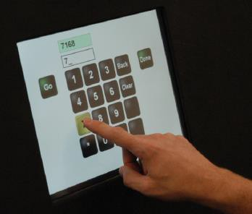
Source: Chen, et al. 201248
The study ‘Performance and touch characteristics of disabled and non-disabled participants during a reciprocal tapping task using touchscreen technology’ undertaken by Irwin and Sesto (2012), found that participants with motor control difficulties kept their finger on the button 2.3 times longer.49 This can lead to inadvertent activation of the button.
Recommendations for reducing key repeat (inadvertently pressing the same key more than once) can be found in the draft European Standard EN 301 549, which recommends that the delay between pressing the same button ‘shall be adjustable to at least two seconds.’50

Screen Interface Design
The screen interface design is the interaction between the user and the
In-Home Display. Research on screen interface design has been addressed below under the following headings:
- In-Home Display design and communication
- Information communicated through In-Home Displays
- Auditory considerations
- Visual design considerations
- Screen interface navigation

48 Chen et al. (2012). ‘Touch screen performance by individuals with and without motor control disabilities’, Applied Ergonomics. 44 (2). pp. 297-302.
49 Irwin, Curt B., and Mary E. Sesto (2012). ‘Performance and touch characteristics of disabled and non-disabled participants during a reciprocal tapping task using touch screen technology’, Applied Ergonomics. 43 (6), pp. 1038-1043.
50 European Committee for Standardization (2012). Draft EN 301 549 (v1.0.0 (2013-02)) ‘Accessibility requirements for public procurement of ICT products and services in Europe.’ Brussels: European Committee for Standardization.

In-Home Display Design and Communication
In-Home Displays should convey information in an easily and rapidly understood fashion, as end users may be actively engaged in other domestic tasks simultaneously. This can be achieved through the visual design of the display component (for example, using a graph), or by contextualising the information from the norm by highlighting important changes that require attention (for example, a display turns red when at peak energy cost rate).51
The UK Government’s ‘Smart metering equipment technical specifications’ have developed specifications for In-Home Displays. They propose that information about cumulative energy consumption and money related to tariff price and payment be provided in numerical form (in pounds and pence as well as in kilowatts and kilowatt hours) for both gas and electricity. Additionally the level of energy consumption should be provided in ambient form to indicate the level as low, medium or high.52

In-Home Display Screen Information
‘Prioritise simplicity’. 53 The ConsumerFocus research report ‘Getting to grips with smart displays’ identified that the In-Home Display’s interface should provide clear, uncluttered presentation of key information.54 The Research Perspective Report (2008) identified that the default/home screen should contain the information that appeals to the majority. This should include core options (such as total cost and current cost displays) which are pre-set.55

51 Chiang, Teresa (2012). ‘A laboratory test of the efficacy of energy display interface design’. Bath: Elsevier.
52 Ofgem (2011). ‘Smart Metering Implementation Programme – Response to Prospectus Consultation’. London: Department of Energy and Climate Change and the Office of Gas and Electricity Markets.
53 Anderson, Will and White, Vicki (2009). Centre for Sustainable Energy. ‘Exploring consumer preferences for home energy display functionality’. UK: Energy Saving Trust.
54 Jacobs, Caroline, and Mark Harnett (2011). Getting to grips with smart displays: ‘Research review’. London: ConsumerFocus.
55 The Research Perspective (2008). Smart Meter Trial. ‘IHD and Consumption report: Insight from Dundalk 2020.’ Dublin: The Research Perspective.

The ConsumerFocus report ‘Response to Smart Metering Implementation Programme: In-Home Display’ suggested that the key information on the default screen should include as a minimum:56
- Usage information cost (displayed in pounds and pence)
- Indication of what fuel is being used (electricity/gas)
- Ambient feedback
- A mixture of verbal and numerical information, and graphics/images/other
- Signal strength
There is an on-going discussion on what information should be displayed; whether kilowatts or Euro have more impact. Anderson and White (2009) argued that ‘Watts, kilowatts and especially kilowatt-hours will never be universally understood or accepted as units of energy consumption. Money offers a straightforward alternative for both rate of consumption and historic consumption.’57
The ConsumerFocus report ‘Response to smart metering implementation programme: In-Home Display’ welcomed the presentation of information on usage in ‘pounds and pence’ (UK), as this has been demonstrated to be more meaningful to consumers than kWhs, helping people understand how their consumption translates in actual expenditure.58

56 ConsumerFocus (2010). ‘Response to Smart Metering Implementation Programme: In- Home Display’. London: Consumer Focus.
57 Anderson, Will and White, Vicki. (2009) Centre for Sustainable Energy. ‘Exploring consumer preferences for home energy display functionality’. UK: Energy Saving Trust.
58 ConsumerFocus (2010). ‘Response to Smart Metering Implementation Programme: In- Home Display’. London: Consumer Focus.

Information communicated through In-Home Displays
The CER have recommended that the following information should be provided as part of the smart meter roll-out:
- Time-of-Use Pricing: The CER’s proposed smart meter roll-out includes mandating ‘time-of-use’ electricity tariffs for all electricity customers.59 As smart meters record electricity usage over short intervals, it will enable suppliers to charge varying prices to electricity customers.
The provision of this information would assist in shifting electricity consumption from peak times (for example, 17.00-19.00), when more power stations are required, to cheaper times. This will be undertaken by offering lower electricity prices at off-peak times. This approach will seek to encourage customers to move electricity consumption to cheaper
off-peak times, thereby reducing their electricity bills60
- Dual Fuel Information: The mandated In-Home Displays that will be rolled-out nationally will be capable of displaying electricity and gas information for dual fuel consumers61
- Prepayment Information: It was also recommended by the CER that prepayment services should be provided as standard with smart metering. This will enable energy consumers to be able to automatically change between prepay and bill pay options62

59 Commission for Energy Regulation (2012). ‘Decision on the National Rollout of Electricity and Gas’. Dublin: CER.
60 Commission for Energy Regulation (2011). ‘CER plans national roll-out of energy smart meters in Ireland’. Dublin: CER.
61 Commission for Energy Regulation (2012). ‘Decision on the National Rollout of Electricity and Gas’. Dublin: CER.
62 Commission for Energy Regulation (2011). ‘CER plans national roll-out of energy smart meters in Ireland’. Dublin: CER.

Auditory Considerations
As identified in the Literature Review, where audio is used as a mode of communication, the following guidance should be considered.
Auditory outputs, such as speech should be communicated using a mechanism built into or provided with the In-Home Display or by using a personal headset that is capable of being connected through a 3.5mm audio jack or industry standard connection.63
Where audio communication is provided through speakers, volume control should be provided. Draft European Standard EN 301 549 (v1.0.0) provides the following guidance in relation to volume control: 64
- For private listening, the In-Home Display should provide at least one way of controlling the volume that doesn’t require vision
- For speaker volume, an incremental volume control should be provided with output amplification up to a level of at least 65 dBA
- A function that resets the volume to a level of 65 dBA or less after each use should be provided, unless specified for personal use

Visual Design Considerations
Draft European Standard EN 301 549 (v1.0.0), states that ICT shall not use colour coding as the only means of visually conveying information, prompting a response, indicating an action or distinguishing a visual element.65 This is additionally outlined in Universal Design Guideline 4a, ‘Use different modes (pictorial, verbal, tactile) for redundant presentation of essential information.’66

63 European Committee for Standardization (2012). Draft EN 301 549 (v1.0.0 (2013-02)) ‘Accessibility requirements for public procurement of ICT products and services in Europe.’ Brussels: European Committee for Standardization.
64 European Committee for Standardization (2012). Draft EN 301 549 (v1.0.0 (2013-02)) ‘Accessibility requirements for public procurement of ICT products and services in Europe.’ Brussels: European Committee for Standardization.
65 European Committee for Standardization (2012). Draft EN 301 549 (v1.0.0 (2013-02)) ‘Accessibility requirements for public procurement of ICT products and services in Europe.’ Brussels: European Committee for Standardization.
66 National Standards Authority of Ireland (2012). SWiFT 9:2012. ‘Universal Design for Energy Suppliers’. Dublin: NSAI.

This is further supported by Literature Review findings on comparable products. A study on ‘Cross-modal warnings for orienting attention in older drivers with and without attention impairments’, undertaken by Lee et al (2012), identified that using multiple forms of feedback (specifically auditory and auditory/ haptic cues) provide an effective means of drawing attention to critical events for drivers (including drivers with attention impairments).67 This study was conducted using a simulator cab, with stimuli projected on a large screen in front of the cab. Posner task software was then interfaced with equipment in the vehicle to present warnings (for example, using the speakers mounted on the dashboard).
In the study ‘Investigating user’s intuitive interactions with complex artefacts’, Blackler et al (2010) demonstrated that being familiar with the appearance of a feature (such as a button) increases a person’s ability to use the feature quicker and more intuitively.68
In the study it appeared that participants could find a feature that had a familiar appearance in an unexpected location but the participants were unable to find a feature with an unfamiliar appearance that was in a familiar location.69 The study recommended that where contemporary symbols are used, text should be provided with the symbols.
In the study ‘Improving the usability and learnability of a home electric appliance’, Imaia et al (2010)70 demonstrated a learning curve that users have when learning how to use new electric home appliances. It was identified that users have an initial period of discovery to identify the features most useful to them. After this period the number of features used regularly is significantly reduced. The study found that to aid understanding, the use of quick feedback and text is required when trying to understand a new device.

67 Lees, Monica N. et al (2012). ‘Cross-modal warnings for orienting attention in older drivers with and without attention impairments,’ Applied Ergonomics. 43 (4), pp 768 -776.
68 Blackler et al. (2010). ‘Investigating users’ intuitive interaction with complex artefacts’, Applied Ergonomics, 41 (1), pp. 72-92.
69 Blackler et al. (2010). ‘Investigating users’ intuitive interaction with complex artefacts’, Applied Ergonomics, 41 (1), pp. 72-92.
70 Imaia, et al. (2010) ‘Improving the usability and learnability of a home electric Improving the usability and learnability of a home electric’, Journal of Engineering Design, 21 (2/3), pp. 173-187.

Screen Interface Navigation
The ‘IHD and Consumption report: Insight from Dundalk 2020’ report found that the settings were too complex in both of the In-Home Displays trialled, as they required multiple button presses to cycle through options. Based on this finding a recommendation was made for a menu system to be used instead.71
The Centre for Sustainable Energy’s report, ‘Exploring consumer preferences for home energy display functionality’ (2009), recommended that the display should offer the following options through interaction (by pressing a single button):72
- Spend in last seven days, day by day
- Spend in last complete week
- Spend in last complete month
- Spend in last complete quarter
The Communications Consumer Panel (2011) conducted a study on mobile phones, which identified that short, simple and logical menus would be useful for users who find navigating a phone difficult. However they noted that limiting easy access to a larger range of phone options may be a disadvantage to other users.73
One method of promoting usability for both ‘disabled’ and ‘non-disabled’ users is proposed by Shneiderman (2003) in his report ‘Promoting universal usability with multi-layer interface design’. He proposes the use of multi-layered interfaces that start with a limited amount of features for the novice user. As the user becomes more advanced and willing to explore new features he/she can move up levels into move advanced interfaces with added functionality.74

71 The Research Perspective (2008). Smart Meter Trial. ‘IHD and Consumption report: Insight from Dundalk 2020.’ Dublin: The Research Perspective.
72 Anderson, Will and White, Vicki. (2009) Centre for Sustainable Energy. ‘Exploring consumer preferences for home energy display functionality’. UK: Energy Saving Trust.
73 Communications Consumer Panel (2011). ‘Making Phones easier to use: views from consumers’. London: Communications Consumer Panel.
74 Shneiderman, Ben (2003). ‘Promoting Universal Usability with Multi-Layer Interface Design.’ Proceedings of the 2003 conferences on universal usability. New York.

Installation and Power
The Literature Review identified the following design considerations in relation to the installation and powering of In-Home Displays.
- The In-Home Display should be capable of deleting data stored on the In-Home Display should the consumer relocate75
- The In-Home Display should be mains-powered.76 The Sustainable Energy Report ‘Exploring consumer preferences for home energy display functionality’ recommended that the display should also have an internal battery to enable mobility in the home77
- The In-Home Display should have a minimum life expectancy of five years78
- The design of the In-Home Displays should assist the user in removing and replacing battery covers and plugging in power adapters79
- The In-Home Display should be installed in a location in the home/office that prevents glare on the screen of the product80
- The In-Home Display should be installed in a location in the home/office that has adequate lighting levels. If this is not achievable, backlighting functions should be provided. Where possible this function should be adjustable.
It was found that none of the devices tested in the ConsumerFocus ‘Expert appraisal of the usability of in-home energy displays’ (2011) had a designated backlight button81

75 Ofgem (2011). Smart Metering Implementation Programme. ‘Response to Prospectus Consultation’. London: Department of Energy and Climate Change and the Office of Gas and Electricity Markets.
76 Jacobs, Caroline, and Harnett, Mark (2011). Getting to grips with smart displays ‘An expert appraisal of the usability of in-home energy displays’. London: Consumer Focus.
77 Anderson, Will and White, Vicki. (2009) Centre for Sustainable Energy. ‘Exploring consumer preferences for home energy display functionality’. UK: Energy Saving Trust.
78 Victorian Government Energy Initiative (2012). Energy Saver Initiative (C/12/123445). Available online: [https://www.veet.vic.gov.au/Public/Pub.aspx?id=266]. [Accessed 14/11/12].
79 Jacobs, Caroline, and Harnett, Mark (2011). Getting to grips with smart displays ‘An expert appraisal of the usability of in-home energy displays’. London: Consumer Focus.
80 Jacobs, Caroline, and Harnett, Mark (2011). Getting to grips with smart displays ‘An expert appraisal of the usability of in-home energy displays’. London: Consumer Focus.
81 Jacobs, Caroline, and Harnett, Mark (2011). Getting to grips with smart displays ‘An expert appraisal of the usability of in-home energy displays’. London: Consumer Focus.

- The In-Home Display should provide flexible handling and mounting options; such as wall mounting, free standing and portable use.82 This is supported by the Energy Saving Trust study which identified that ‘mobility is valued, but for a limited period’.83
Initially participants valued being able to move around their homes with their displays, discovering the impact of switching on different appliances. After this initial period, the majority of people were satisfied with leaving the display in a prominent position in their home84

Key Findings
The Literature Review identified three main design considerations to be addressed in relation to the design of In-Home Displays. These were:
- Ergonomic design: Ergonomic design relates to the product’s physical design and the physical interaction between the user and the In-Home Display.
The Literature Review on the ergonomic design of In-Home Displays and products from comparable sectors identified the following design considerations:
  - Frequently used buttons should be positioned to allow for ease of access
  - Buttons (such as on/off button) should be positioned to prevent inadvertent activation
  - Physical buttons which provided tactile feedback were identified as being easier to use than touchscreen buttons for the majority of end users

82 The Research Perspective (2008). Smart Meter Trial. ‘IHD and Consumption report: Insight from Dundalk 2020.’ Dublin: The Research Perspective.
83 Anderson, Will and White, Vicki (2009). Centre for Sustainable Energy. ‘Exploring consumer preferences for home energy display functionality’. UK: Energy Saving Trust.
84 Anderson, Will and White, Vicki (2009). Centre for Sustainable Energy. ‘Exploring consumer preferences for home energy display functionality’. UK: Energy Saving Trust.

  - Button size affected the number of misses in using products.85, 86 There was an 84% decrease in misses from participants when the button size on a touchscreen was increased from 10mm to 30mm87 ISO 9241-9 suggests that the size of a touch sensitive area should be at least equal to the breadth of the index finger of the 95th percentile male, which is 2.28cm88
  - Buttons should prevent the user from inadvertently activating the same key more than once within a set time frame. A study undertaken by Irwin and Sesto (2012), identified that participants with motor control difficulties kept their finger on the button 2.3 times longer89
- Screen interface design: The screen interface design focused on the interaction between the user and the In-Home Display. Research on screen interface design for both In-Home Displays and products from comparable sectors identified the following design considerations:
  - Familiarity of a feature should be a priority over the features location on a product
  - Different modes of communication should be used to communicate important information
  - Prompt feedback should be provided to aid the user in using the product
  - Information should be displayed in a clear, uncluttered way
  - Where a menu system is provided it was suggested that a
multi-layered interface would be used-with limited features for novice users and more advanced features for experienced users

85 Note: A miss was defined as a touch that landed outside of the intended button area and did not result in button activation.
86 Chen, et al. (2012), ‘Touch screen performance by individuals with and without motor control disabilities’, Applied Ergonomics, 44 (2), pp. 297-302.
87 Chen, et al. (2012), ‘Touch screen performance by individuals with and without motor control disabilities’, Applied Ergonomics, 44 (2), pp. 297-302.
88 Chen, et al. (2012), ‘Touch screen performance by individuals with and without motor control disabilities’, Applied Ergonomics, 44 (2), pp. 297-302.
89 Irwin, Curt B., and Mary E. Sesto (2012). ‘Performance and touch characteristics of disabled and non-disabled participants during a reciprocal tapping task using touch screen technology’, Applied Ergonomics. 43 (6), pp. 1038-1043.

- Installation and power: Literature research on the In-Home Display’s installation and power identified the following design considerations:
  - Flexibility in use should be provided to allow the In-Home Display to be wall-mounted, free standing or hand-held
  - Ease of use should be addressed in operating the products features (such as removing the battery cover or plugging in the power adapters)

Usability Testing Overview

Introduction to Usability Testing and Universal Design
Usability is the ‘extent to which a product can be used by specified users to achieve specified goals with effectiveness, efficiency and satisfaction in a specified context of use’; as defined by ISO 9241-11.
The Usability measures identified by ISO 9241-11 are:90
- Effectiveness: the accuracy and completeness with which users can achieve specified goals in particular environments
- Efficiency: the resources expended in relation to the accuracy and completeness of goals achieved
- Satisfaction: the comfort and acceptability of the work system to its users and other people affected by its use
Jakob Nielsen, a renowned expert in evidence-based user experience, builds on this definition by describing Usability as a quality attribute that assesses how easy user interfaces are to use, as well as a method of improving ease-of-use during the design process. Nielsen defined Usability by five quality attributes:91
- Learnability: The ease of use to accomplish basic tasks the first time the user encounters the design
- Efficiency: When users have learned the design, the speed in which they can perform tasks
- Memorability: After a period of not using the product, how easy it is to re-establish proficiency
- Errors: How many errors do users make, the severity of these errors, and the ease of recovering from the errors
- Satisfaction: How pleasant is it to use the design?
Although there are more definitions and opinions on the definition of Usability it is proposed that the above reference terms provide a rigorous framework within which the Usability Testing of In-Home Displays fits.

90 European Committee for Standardization (1998). ISO 9241-11:1998 ‘Ergonomic requirements for office work with visual display terminals (VDTs) - Part 11 Guidance on usability’. Brussels: European Committee for Standardization.
91 Neilson Norman Group. ‘Usability 101: Introduction to Usability’. Available from: [http://www.nngroup.com/articles/usability-101-introduction-to-usability/].[Accessed on: 21/1/13].

Although using different terminology, there is a close interlink between the quality attributes of Usability and the principles of Universal Design. The relationship and overlap between Usability and Universal Design have been illustrated in Table 1 below.

Table 1: Relationship between the quality attributes of Usability and the principles of Universal Design

Quality attributes of Usability92,93 | Corresponding Universal Design Principles94,95
Satisfaction  The comfort and acceptability of the work system to its users and other people affected by its use | Universal Design principle 1: Equitable Use  The design is useful and marketable to people with diverse abilities  Universal Design principle 6: Low Physical Effort  The design can be used efficiently and comfortably and with a minimum of fatigue
Efficiency  The resources expended in relation to the accuracy and completeness of goals achieved | Universal Design principle 2: Flexibility in Use  The design accommodates a wide range of individual preferences and abilities
Learnability  The ease of use to accomplish basic tasks the first time the user encounters the design | Universal Design principle 3: Simple and Intuitive Use  Use of design is easy to understand, regardless of the user’s experience, knowledge, language skills or current concentration level
Memorability  After a period of not using the In-Home Display, how easy can the user establish proficiency | Universal Design principle 3: Simple and Intuitive Use  Use of design is easy to understand, regardless of the user’s experience, knowledge, language skills or current concentration level
Effective  The accuracy and completeness with which users can achieve specified goals in particular environments | Universal Design principle 4: Perceptible Information  The design communicates necessary information effectively to the user, regardless of ambient conditions or the user’s sensory abilities
Errors  How many errors do users make, the severity of these errors, and the ease of recovering from the errors | Universal Design principle 5: Tolerance for Error  The design minimises hazards and adverse consequences of accidental or unintended actions

92 Usability 101: Introduction to Usability. Available from: [http://www.nngroup.com/articles/usability-101-introduction-to-usability/]. [Accessed on: 21/1/13].
93 European Committee for Standardization (1998). ISO 9241-11:1998 ‘Ergonomic requirements for office work with visual display terminals (VDTs) - Part 11 Guidance on usability’. Brussels: European Committee for Standardization.
94 North Carolina State University (1997). ‘7 Principles and 29 Guidelines of Universal Design’. Centre for Universal Design, USA.
95 National Standards Authority of Ireland (2012). SWiFT 9:2012: Universal Design for Energy Suppliers, Dublin: NSAI.

Usability Testing Methodology
As part of the development of Technical Guidelines for the Universal Design of In-Home Displays, Usability Testing was undertaken with 22 participants to ensure that energy householders were at the centre of the technical guideline development process.
While 22 participants are not a representative sample, the approach developed was to test participants who have a diverse range of abilities. Focus was placed on testing the products with these participants in order to identify common difficulties. By identifying the needs of users with a diverse range of abilities, the subsequent recommendations based on these findings if implemented will help make In-Home Displays easier to access, understand and use by all household customers.
It is important to clarify that the purpose of this research was to identify attributes, features and functions that caused Usability problems when operating an In-Home Display. This testing was not about deciding which In-Home Display was best; rather, the purpose of this research was to study the individual attributes of the In-Home Displays and to identify how these attributes impacted on Usability. Many of these attributes, features and functions are common across a wide range of interactive products and are not limited solely to In-Home Displays.

Research Objective of Usability Testing
To identify what design attributes, features and functions make an In-Home Display easy to use, and what attributes cause difficulty.

Testing Process
The VAST™ (Vehicle Analysis and System Test) procedure was used in undertaking the Usability Testing. The VAST™ procedure was originally developed for in-car controls and displays but has been applied to many other small screen interface products.96 This procedure aims to eliminate subjectivity by focusing on physiological data. This helps ensure that all the participants’ experience of interacting with the In-Home Displays tested are comparable.

96 Design Hosting Software. ‘VAST™ Vehicle Analysis & System Test’. Available from: [http://www.dhs-ltd.com/wordpress/?p=104]. [Accessed 26/11/12].

The VAST™ testing procedure merges three data streams, specifically:97
- Physiological Monitoring: which measures the stress experienced by the body and the time taken to carry out the set tasks using the four products
- Observational Analysis: which looks at how the user behaved
- Qualitative Post-Test Interviews: which explores the user’s perception of the product, the user’s experience and their decision-making process
The VAST™ process (illustrated in Figure 5 below) merges these data streams to build a comprehensive inference model, identifying the difficulties (or lack of) which the users experienced when using the In-Home Displays. This was supported by an analysis by an expert panel to review the products’ features and design attributes. The focus of the expert review was based on common difficulties and issues identified through the Usability Testing and the Literature Review.

Figure 5: Usability Testing Process: Quantitative and Qualitative Testing.
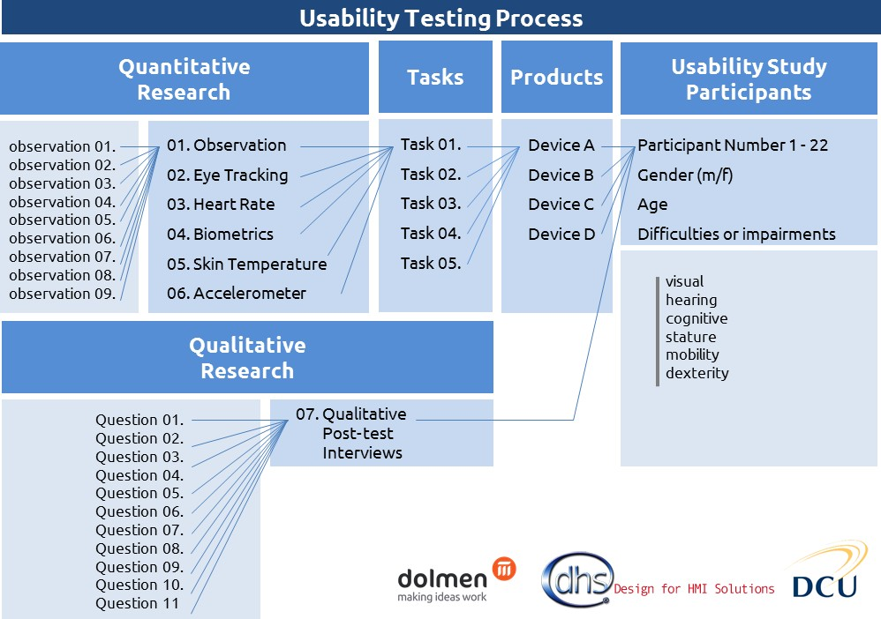

97 Please see Annex 2 for further information on the Usability Testing procedure.

The Usability Testing session comprised of:
- A Pre-briefing Session: The Usability Testing involved an initial training period. This approach was used to relax the participants, get them comfortable with the lab-based environment and the equipment they were wearing, and to familiarise them with the different In-Home Displays being tested.
- A Usability Testing Session: A set of five tasks were developed to test the Usability of the In-Home Displays. These were:
  - Task 1: To provide the real time energy reading in kilowatts
  - Task 2: To provide the real time energy reading in Euro
  - Task 3: To provide the daily energy reading in Euro
  - Task 4: To provide the weekly energy reading in Euro
  - Task 5: To return to the default display (real time energy usage in kilowatts)
These tasks were measured using quantitative physiological analysis. The physiological analysis undertaken, included measurement and analysis of the following:
  - Heart rate (ECG)
  - Arm movement
  - Breathing rate (per minute)
  - Galvanic skin response
  - Eye tracking
The aim of physiological monitoring was to:
  - Identify the time to completion (TtC) for the set tasks. These were then measured and benchmarked against the ‘norm’ times of completion
  - Explore, identify and analyse the physiological reaction the participant experiences when interacting with the In-Home Displays. This specifically relates to the stress experienced by the body, ranging from increased heart rate to perspiration
  - Identify the user’s level of confusion by tracking the movement of their eyes
  - Identify the user’s reaction when undertaking tasks (what they were looking at) using eye-tracking

Figure 6: Usability Testing.
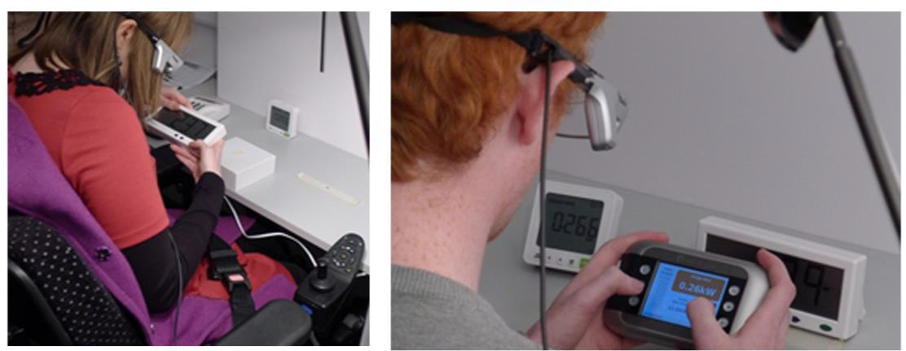

- Qualitative Post-Test Interview: A one-to-one interview was conducted with each participant in a designated interview room. A structured approach to the interview was undertaken to ensure that responses from all participants involved in the Usability Testing could be benchmarked. The interview questions were designed and developed to gain in-depth responses into the participant’s experience using the In-Home Displays.
Following the interviews the results were analysed and benchmarked to identify patterns, opportunities, insights and barriers experienced.

Figure: 7. Post-Usability Test Interviews
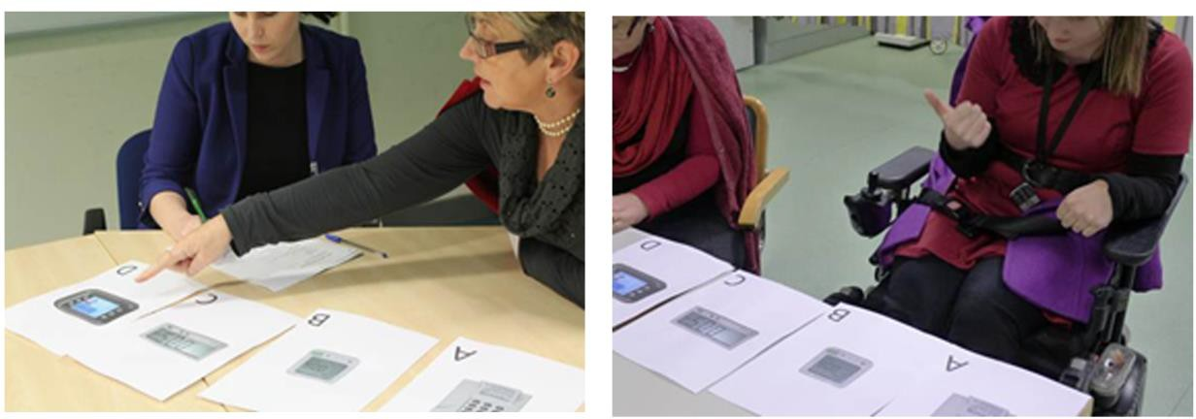

Group Sizes
It was determined that the In-Home Display Usability Testing would be focused on gaining insights, rather than undertaking a statistical analysis. This was based on the approach developed by Jacob Nielson and Tom Landauer, which identified that 85% of Usability problems are found using five participants when utilising a product with an average level of difficulty.98,99
When applying this approach, it is generally acceptable to use small group sizes of approximately five participants who share common attributes. Nielson determined that going above this maximum number, results in a smaller number of new insights.

Participant Selection
The Usability Testing was composed of small groups, with sample sizes of up to six participants categorised by age groups.100 This approach was used to identify Usability problems across as many user types as possible.
Four demographic groups of end users were identified to take part in the Usability Testing:
  - Group 1 consisted of six participants, male and female of different sizes, and range of abilities that were under 30 years of age
  - Group 2 consisted of six participants, male and female of different sizes, and range of abilities that were between 31 and 64 years of age
  - Group 3 consisted of six participants, male and female of different sizes, and range of abilities that were over 65 years of age
  - Group 4 was a benchmark group consisting of four participants of mixed gender, age, and of ‘average ability’
Dolmen with assistance from the Centre of Excellence in Universal Design (part of the National Disability Authority) identified a total of 22 participants (see Figure 8 below), nine women and the thirteen men with a range of abilities.101

98 Nielsen Norman Group. ‘How Many Test Users in a Usability Study?’, Available at: [http://www.nngroup.com/articles/how-many-test-users/]. [Accessed: 25/1/13].
99 Nielsen Norman Group. ‘Why You Only Need to Test with 5 Users’, Available at: [http://www.nngroup.com/articles/why-you-only-need-to-test-with-5-users/]. [Accessed: 25/1/13].
100 Please see Annex 2 for further detail on the participants involved in the study.
101 The list of people selected for the usability testing was developed with reference to CEN/CENELEC Guide 6, Guidelines for standards developers to address the needs of older persons and persons with disabilities.

Four of the participants (three male and one female) were selected to be part of a benchmark group. This benchmark group was composed of participants deemed to be of average ability. This group of participants were expected to perform the tasks the quickest and with the least number of errors.
The benchmark group helped to identify:
  - Problems with the product due to poor design that affected all users
  - Problems with the product that affected specific users or user groups

Figure 8: Participants range of abilities
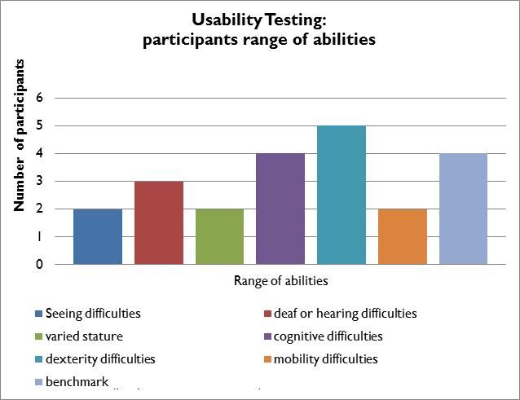

In-Home Display Selection
Due to the amount of time required to gain sufficient information and insights, and to limit participant fatigue, the Usability Testing was limited to four
In-Home Displays in the 90 minute testing session. Out of a market selection of over 20 In-Home Displays, four were selected which gave the greatest representation of the product types available. These were obtained through assistance from In-Home Display suppliers (both in Ireland and the UK) and the Consumer Energy Display Industry Group (CEDIG).

The In-Home Displays were selected for the Usability Testing based on their broad scope of design attributes, ergonomics and interface characteristics, including:
  - Screen display (colour vs. monochrome)
  - Navigation type (one button cyclical navigation vs. multi button operation)
  - Auditory function (auditory vs. non-auditory function)
  - Backlighting (backlit vs. non-backlit products)
  - Button characteristics (flush buttons vs. raised buttons, tactile buttons vs. non-tactile buttons, small vs. large buttons)
  - Button labelling (colours, logos, text and numbers)
  - Button layout (multi-plane vs. singular plane layout)
  - Screen size (large vs. small)
  - Screen text size (large vs. small)
The four products selected included two In-Home Displays from Irish suppliers; ESB Networks102 and PrePayPower103. The remaining In-Home Displays were obtained from UK suppliers, namely; Eco-Eye104 (Elite) and Efergy105 (e2 classic 2.0).

Figure 9: Four In-Home Displays used in the Usability Testing. 106
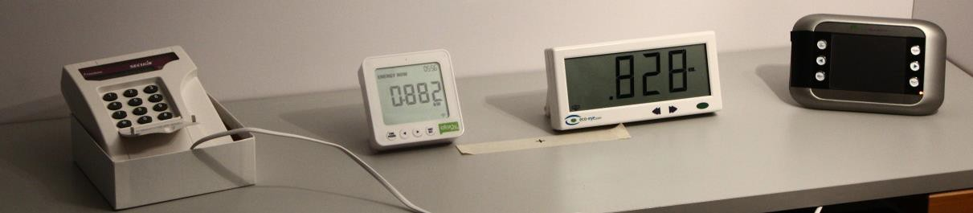

102 ESB In-Home Display. Available from: [http://www.seai.ie/Renewables/Smart_Grids/The_Smart_Grid_for_the_Consumer/Home
_Consumer/Home_Energy_Management_Systems/]. [Accessed 25/11/12].
103 For further information see: [http://www.prepaypower.ie/ ].
104 For further information see: [http://www.eco-eye.com/products-elite.html].
105 For further information see: [http://www.efergy.com/index.php/default/products-uk- 1/electricity-monitors/e2v2-wirelesssmonitor-uk.html].
106 Note: The ESB Network’s In-Home Display was a prototype device, and the PrePayPower product offered basic In-Home Display functions as part of a pre-payment service offering.

For the purpose of the Usability Testing the In-Home Displays were referred to as: Product A (PrePayPower), Product B (Efergy), Product C (Eco-Eye) and Product D (Elster AD100). This is illustrated in sequence from left to right in Figure 9 above.
Due to the time required to gain in-depth insight and information on the products tested, only four In-Home Displays with the widest variety of design attributes were selected for the Usability Testing. However, a fifth product, Produce E (Efergy Elite) was included in the Expert Review. The Efergy Elite consisted of a monochromatic, backlit, multi-line display with an array of function control buttons located on the top of the In-Home Display.
For further information on the products selected please see Annex 2.

Usability Testing Findings
The Usability attributes and Universal Design principles formed parameters within which the findings of the Usability Testing of In-Home Displays would fit. These were as follows:
  - ‘Satisfaction’ which is aligned with ‘Universal Design principle 1: Equitable use’ and ‘Universal Design principle 6: Low physical use’
  - ‘Efficiency’ which is aligned with ‘Universal Design principle 2: Flexibility in use’
  - ‘Learnability’ and ‘Memorability’ which are aligned with ‘Universal Design principle 3: Simple and intuitive use’
  - ‘Effectiveness’ which is aligned with ‘Universal Design principle 4: Perceptible information’
  - ‘Errors’ which is aligned with ‘Universal Design principle 5: Tolerance for error’
These Usability attributes were used to assemble the Usability Testing findings from data sources including: physiological data, observations, post-test interviews and expert reviews. The findings of the Usability Testing are set out below under these five headings:

Satisfaction
The Usability attribute ‘Satisfaction’ refers to the comfort and acceptability experienced by the users in relation to how the product works. This is aligned with ‘Universal Design principle 1: Equitable use’, which outlines that the design should be useful and marketable to people with diverse abilities and ‘Universal Design principle 6: Low physical use’, which outlines that the design should be capable of being used efficiently and comfortably and with a minimum of fatigue. Qualitative and quantitative research findings on ‘Satisfaction’ were focused on the desirability (primarily relating to aesthetic appeal) of the products, as well as the effort required to operate the products.

Purchasing decision (desirability)
In the post-testing qualitative interviews, the participants were asked which product they would purchase. 39% of participants identified that they would purchase Product C, while 30% of participants would purchase Product D (See Figure 10 below).

Figure 10: Participants’ purchase preference.
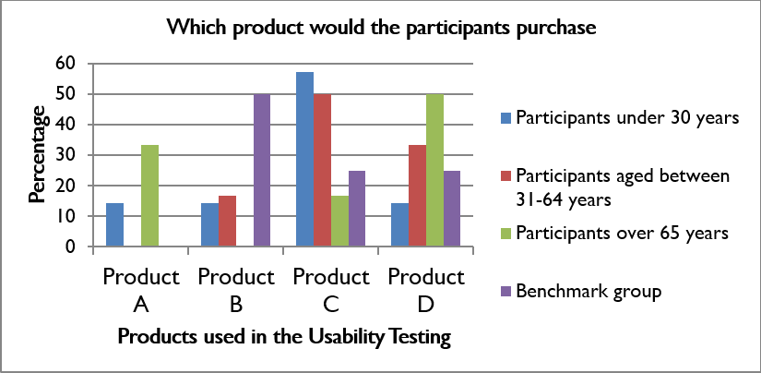

Product C, (Figure 11) which had ‘one’ button functionality, and a large screen and font size, was identified by 57% of participants under the age of 65 as their preferred purchase choice. In comparison only 17% of participants over the age of 65 had a preference for Product C.

Figure 11: Product C.
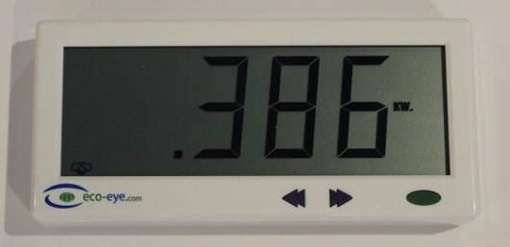
Product D (Figure 12) was identified as the second most preferred product for purchase by participants, with over 50% of participants over 65 years identifying it as their preferred purchase choice. A key consideration in their purchasing decision was influenced by the product’s aesthetic appeal. Product D was deemed to be the most aesthetically pleasing by all participants, significantly outperforming the other products (illustrated in Figure 13 below). Overall 57% of participants preferred the aesthetic design of Product D, in comparison to only 18% for Product C.

Figure 12: Product D.
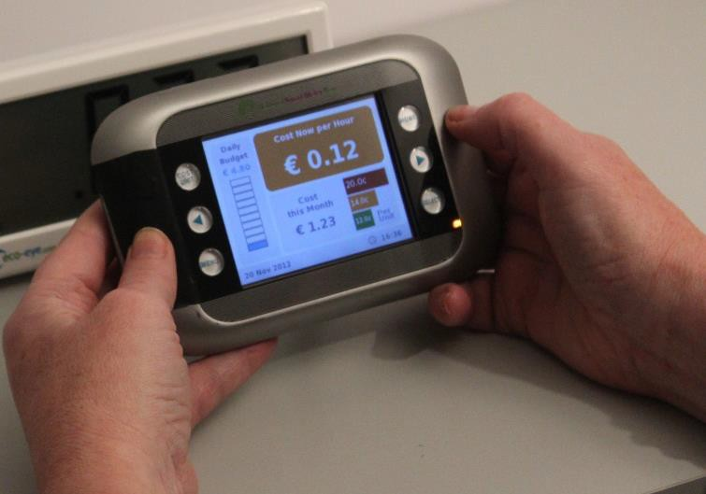

Figure 13: In-Home Display Aesthetic Design.
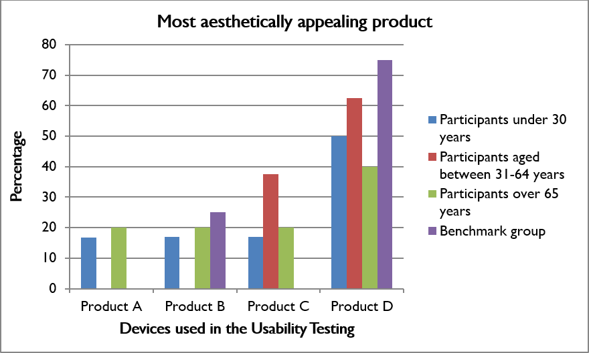
In contrast to its high rating for aesthetic design, Product D in post-test interviews was identified as the most difficult product to use and had one of the lowest reading accuracies and most errors among participants over the age of 65 (n = 6).

Key Findings
Based on qualitative research on ‘Satisfaction’, it was determined that Usability and aesthetics are equally important considerations for the participants in making a purchasing decision.

Efficiency
Efficiency refers to the resources put in place to assist accuracy and the ability of the user to successfully complete tasks. This is in line with ‘Universal Design principle 2: Flexibility in use’, which outlines that products should accommodate a wide range of individual preferences and abilities. The In-Home Display should provide choice in how the household customer uses the product, facilitating accuracy and precision and providing adaptability to the user’s pace.
Efficiency is addressed under the following headings:
  - Ability of the user to successfully complete tasks
  - Flexibility in use
  - Button positioning, detection and labelling

Ability of the user to successfully complete tasks
The 22 participants were set five tasks, which required identifying and finding information; it was found that out of 20 tasks per participant (five task per product, four products tested by each participant), participants under the age of 65 (n=16) successfully completed 83% of the tasks (n=340 tasks) without prompt or error. Participants over the age of 65 (n=6) however had a lower success rate of 71% (n=119 tasks). In this context ‘Efficiency’ is defined by the user’s ability to identify and find information in order to successfully complete a task.
When focusing on the ‘Efficiency’ of specific products, it was found that the participants had the highest success rate (of 94%) for completing the set tasks (n=109 tasks) using Product C; in comparison Product B had the lowest success rate (of 65%) for completing the set tasks (n=110 tasks).
The five tasks explored the efficiency of the user in identifying and finding information. Overall Product B had one of the highest scores for legibility (93% success rate) for all participants, which identifies that operating and navigating the In-Home Display to find the information was the key difficulty experienced by the participants in using this product.

Flexibility in use
The post-test qualitative interview identified that 82% of participants would mount their In-Home Display on a wall; while 18% of participants would like a portable product that could be moved between rooms.
With the exception of Product A, all the In-Home Displays could be handheld. The form of D and E (used in the Expert Review) were better suited and more comfortable to be handheld, due to their curved forms. Product E also had inbuilt rubber grips which provided guidance on how the product should be held, in addition to an anti-slip base (see Figure 14 below).

Figure 14: Product D and E.

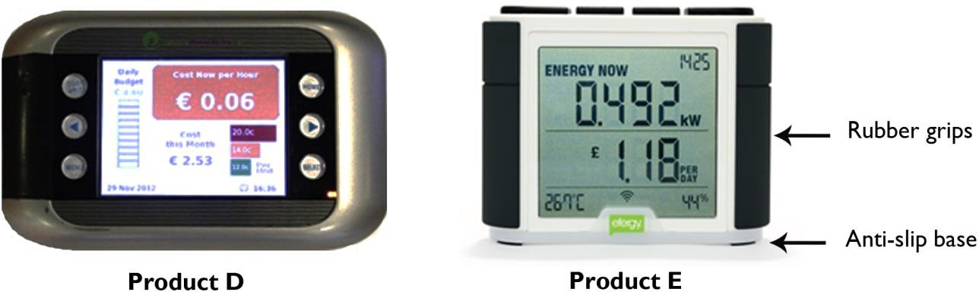

Button positioning, detection and labelling
An important consideration identified through the Usability Testing was the placement of buttons. The In-Home Display should provide flexibility in use to accommodate right or left-handed use.107
Participant 12108 identified that there was an issue using Product D if the user doesn’t have full use of both hands (this is additionally applicable to a mother carrying a baby or a user multi-tasking). When the participant operated the buttons located on the left side of the screen using her right hand, it resulted in restricted vision of a substantial part of the screen. This made completing the task much more difficult.
The Expert Review and Post-test Interviews additionally identified issues with the button positioning and detection in Product B. This was due to Product B’s positioning of the ‘function’ button on a different plane to the screen interface, which was identified as adding major complexity to its operation (see Figure 15). Where the product was not used frequently, this sequence of operation was less logical and intuitive to use.

107 North Carolina State University (1997). ‘7 Principles and 29 Guidelines of Universal Design’. Centre for Universal Design, USA.
108 Participant 12: female, aged 26 years, mobility difficulties.

Figure 15: An example of buttons arranged in an unfamiliar layout, where the function button is separated from the other controls.
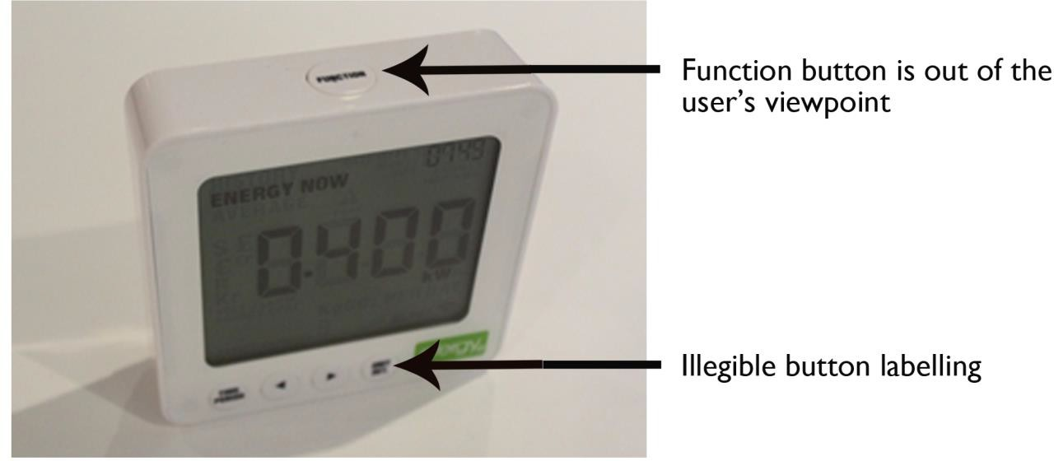
Additionally it was suggested that buttons on the face of Product B were too small and ‘the labelling on the buttons didn’t explain the function clearly’.109
The following design features and attributes affected the efficient use of the In-Home Displays:
  - Flush buttons added uncertainty to the buttons successful depression / activation
  - The size of text and lack of colour contrast on the screen interface additionally created issues for many of the products

Free-standing Displays
The Expert Review identified the following issues which should be considered in the design of freestanding In-Home Displays:
  - In Products B, C and D, access to the product’s support bracket (stand) is obtained using finger gaps and edge overlaps (see Figure 16 below). In general the products used in the Usability Testing incorporated minimal design considerations to enable ease of access. The potential issue this posed was that it would inhibit people with dexterity difficulties in accessing the support bracket.
Product D’s support bracket overall provided the best design considerations for ease of use in comparison to the other units. This was due to the support bracket’s positioning on the edge of the back of the In-Home Display, which made it easier to open
  - The Expert Review identified that the support bracket should be robust and durable to ensure an acceptable life span for this product

109 Participant 7: male, aged 25 years, tall stature.

Figure 16: Ease of accessing rear support brackets.
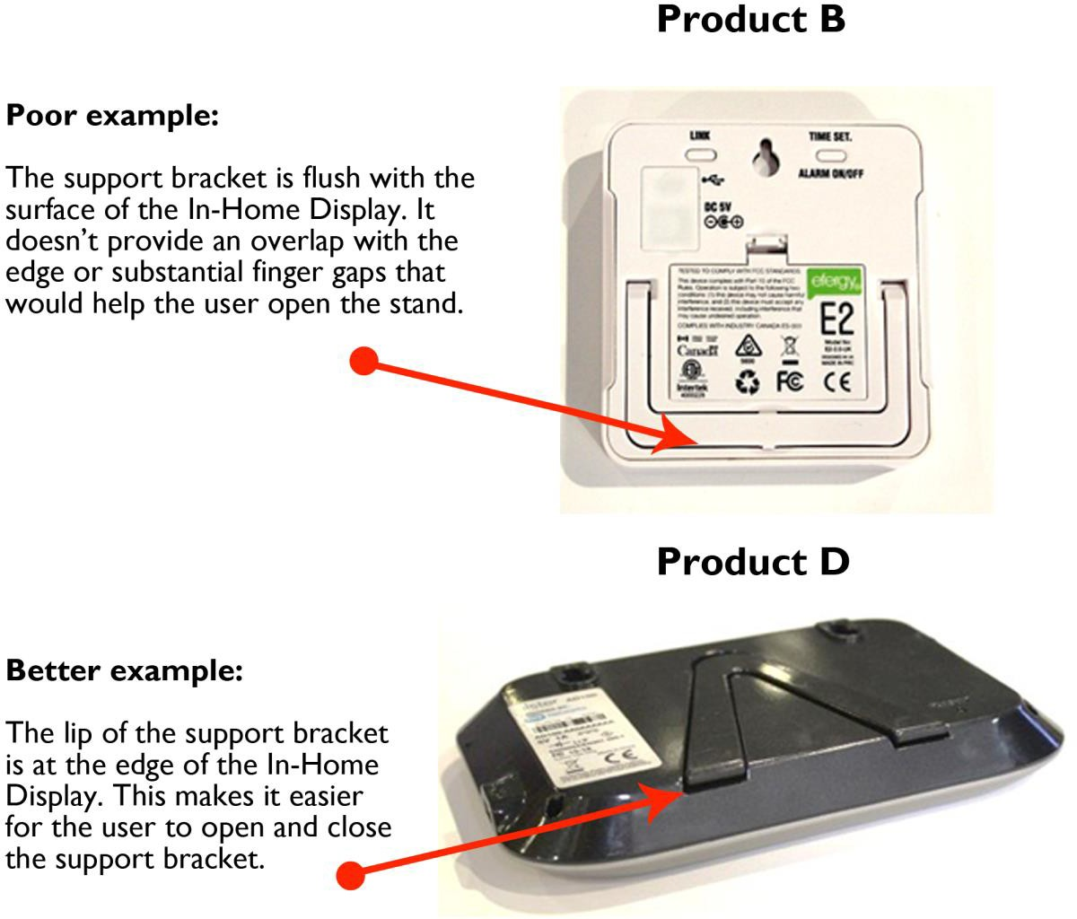

Key Findings:
In the context of Usability Testing ‘Efficiency’ is defined as the user’s ability to identify and find information in order to successfully complete a task.
Qualitative and quantitative research found that:
  - The participants had the highest success rate (94%) for completing the set tasks (n=109 tasks) using Product C without prompt from the facilitator or errors; in comparison Product B had the lowest success rate at completing tasks (n=110 tasks) of 65%. The five tasks explored the efficiency of the user in identifying and finding information
  - Overall Product B had one of the highest scores for legibility (93% success rate), which identifies that operating and navigating the In-Home Display to find the information was the key difficulty experienced by the participants in using this product (rather than difficulties with the legibility of the In-Home Display)

  - The In-Home Display should provide flexibility in use to accommodate right or left-handed use; this specifically relates to the positioning of buttons
Overall, the design features, functions and attributes of In-Home Displays which performed well:
  - Had buttons that could be operated using either the right or left hand
  - Had buttons positioned in a logical sequence to support ease of use
  - Had buttons that were easy to detect and identify
  - Had provided ease of access for features such as support brackets and battery covers
  - Had screen interfaces that were easy to operate and navigate
  - Were comfortable to hold and use
Design features, functions and attributes of In-Home Displays which were more difficult to use:
  - Had flush buttons which added uncertainty to its successful depression / activation
  - Had small sized labelling on buttons that were difficult to see and read
  - Had a lack of colour contrast between the text and background colour of the button

Learnability and Memorability
‘Learnability’ refers to ease of use in completing tasks the first time a product is interacted with. Similarly, ‘Memorability’ refers to the use of a product after a period of disuse and the ease of re-establishing proficiency. ‘Universal Design principle 3: Simple and intuitive use’, outlines that the design should be easy to understand, regardless of the user’s experience, language skills or current level of concentration.
The Usability Testing identified the following attributes which impact on the simple and intuitive use of the In-Home Display, these were:
  - Intuitive use
  - Learnability (repetition testing)
  - Ease of Use (time to complete tasks)

Intuitive Use
As illustrated in Figure 17 below, Product C was identified through qualitative post-test interviews as being the easiest product to use by over 50% of the participants over the age of 65, and 70% of the participants under 64 years of age.
According to the qualitative research undertaken, each age group identified ‘Product C’ as being easiest to use for the following reasons:
  - It had a simple interface, quick response time and ‘large screen which made it easy to use’
  - There was one main navigation button, so minimal information had to be remembered due to its cyclical functionality; ‘Once you did it once it was easy to operate’. The disadvantage of the cyclical function was that all the information had to be scrolled through when looking for specific information

Figure 17: The easiest product to use.
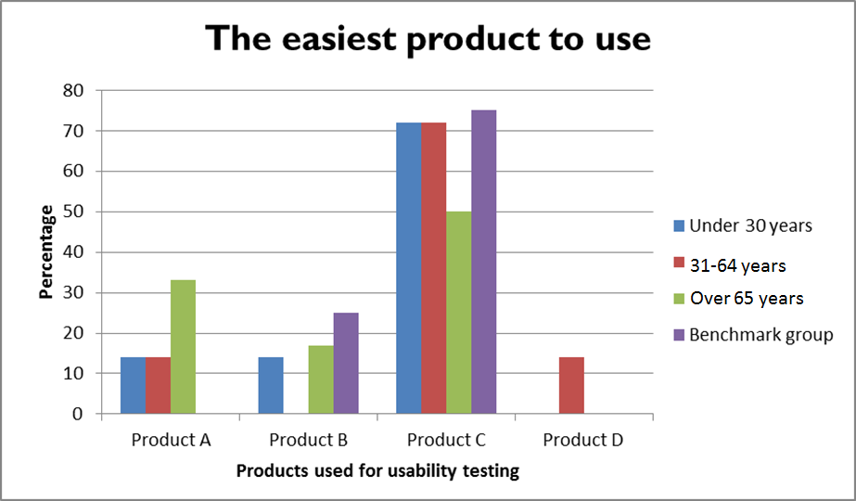
This was supported through quantitative research findings identified using the ’Tobii’ eye-track glasses. The eye track glasses were used to observe if the participants were able to identify and press the correct button within five seconds of being asked to attempt a task by the facilitator. Confusion was identified if the participant did not focus on the correct button before pressing a button or did not identify the correct button within a five second time frame and/or if the ‘gaze-points’ moved rapidly across the screen.
In the images below from the eye-track video, the ‘gaze-points’ that the participant is focusing on is identified by red dots.

Figure 18: Images from the eye-track video
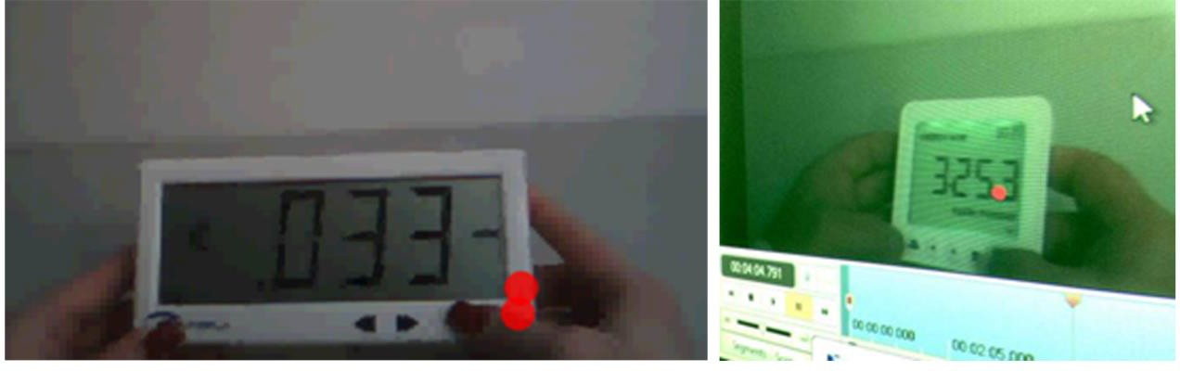

The ’Tobii’ eye-track glasses identified that when using Product C, the correct button was identified within five seconds for 100% of the tasks (n = 32 tasks), emphasising ease of use. In contrast, when using Product B, the participants (n=8)110 identified and selected the correct button within five seconds for only 50% of the tasks (n = 32 tasks). For tasks using Products A and D the correct button was identified within five seconds for 81% of the tasks (n = 32 tasks attempted on each product).
Overall there was no significant difference between the three age groups who pressed the incorrect button. It was found that:
  - In 27% of the tasks attempted (n = 93 tasks), participants in the over 65 year age group (n = 6) pressed the incorrect button
  - In 22% of the tasks attempted (n = 112 tasks), participants in the 31-64 age group (n = 7) pressed the incorrect button
  - In 20% of the tasks attempted (n = 144), participants in the under 30 age group (n = 9) pressed the incorrect button

Learnability (Repetition Testing)
Due to the participants low success rate (65%) at completing tasks using Product B without a fault or prompt by the testing facilitator (In contrast to Product C, which had a 94% task success rate), Product B was selected for further investigation through ‘repetition testing’ to discover if a selection of participants could learn though repeated use how to operate Product B. The participants were asked to repeat the test four times under the same conditions as the general testing. Seven participants were selected; three participants of average ability and four participants who had a range of difficulties.111
The results found that the ‘top’ participant of average ability (Participant 11)112 completed the set tasks with a 100% success rate during the repetition testing. The majority of the other participants improved consistently. Participant 18 in contrast, an 82 year old male who trained as a technician and ‘knew and felt comfortable with technology’, made a minimum of 40% errors (failed two of the five tasks) on each of the repeated tests, with no consistent improvement.

110 Participants were excluded due to problems encountered during the testing; the inaccuracies were caused chiefly by:
  - The participant not keeping the product within the scope of the camera in the glasses
  - The participant’s excessive head movement
  - Technical issues, such as the inability to calibrate the glasses before testing began
111 Note: Four Participants who had specific difficulties who took part in the Repetition Testing were: Participants 8, 9, 10 & 18
112 Note: Participant 11: female, 21 years, of ‘average ability’.

Figure 19: Four In-Home Displays used for the Usability Testing.
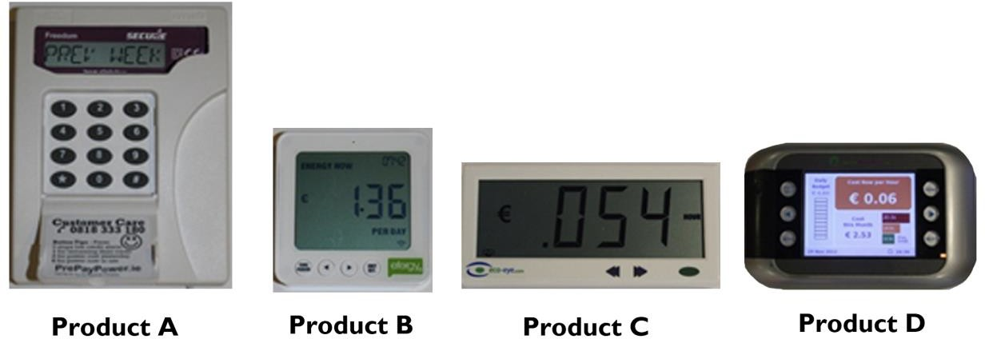
Ease of Use (time to complete tasks)
Compared to tasks 3,4 and 5, the time required to provide the real time reading from the default screen (task 1) and the time to change the units on the screen (task 2) were relatively low and consistent across all products. On average, this shows that these simple tasks were achievable by all the participants.
Overall the percentage of correct readings was similar for participants over the age of 65 years (illustrated in Figure 20). However Product D appeared to cause more difficulty for participants over the age of 65 than participants under the age of 65. Product D had the lowest success rate of 60% (n = 30 tasks) for participants over 65 years, while Product C had the highest task success rate of 83% (n = 30 tasks).

Figure 20: The percentage of tasks completed successfully by participants over 65 years of age (n = 6) without prompt from the facilitator or error.
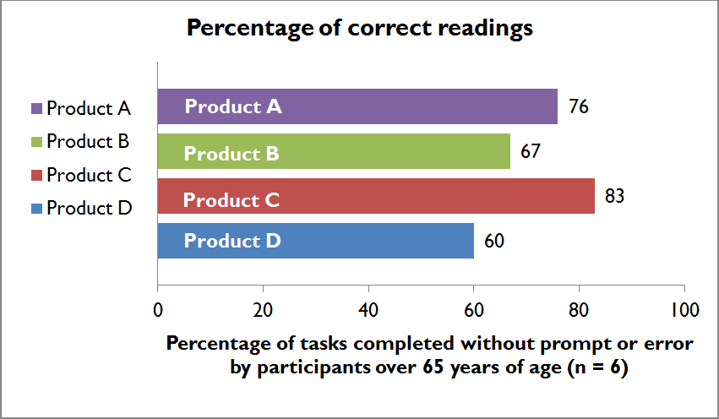
Time to completion was used to identify difficulty in performing a task. As most of the tasks (tasks 2-5) only required a maximum of two buttons presses, it can be presumed that the majority of a task’s time to completion was taken trying to identify the correct button(s) to press.
Comparing the different times to completion can identify which products caused the most problems for each participant and their respective age group.
When comparing time, it can be identified that Product D required the longest time to complete all five tasks. It took participants an average of 143 seconds to complete the five tasks. In comparison Product C was the fastest product to use with an average time of approximately 50 seconds.

The high times to complete tasks 3, 4, and 5, identified issues with navigating through information on some of the In-Home Displays. For example, participants using Product C for task 3, (to provide the daily energy reading in Euro) took on average 6.95 seconds. However, in comparison Product D, for the same task took participants on average 41.50 seconds to find the information, illustrated in Figure 21 below.

Figure 21. Mean time of completion for Products A, B, C and D.
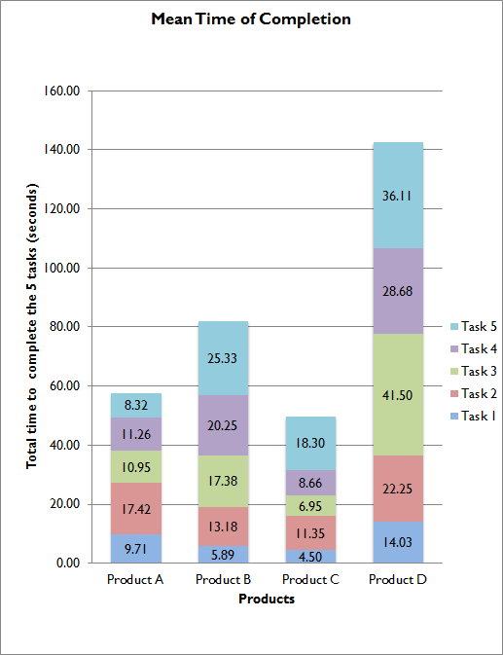

These times helped to identify what task and product features the participants were having difficulty with. For example, Task 5 required the participants to return to the default screen after navigating to the cost from the previous week. It took participants using Product A an average of 8.32 seconds to complete this task while it took participants using Product D an average of 36.11 seconds. The substantial difference in time to return to the default screen highlights a usability issue specifically linked to the ease of operating the product and finding information.

Key Findings
The following key findings were identified in relation to the simple and intuitive use of the In-Home Displays:
  - An issue with Usability was identified with Product B, where all age groups had an equally high percentage of tasks requiring prompts. Therefore it could be deemed that the product was not simple and intuitive to operate
  - When comparing times to completion, Product D required the longest time to complete all five tasks (an average of 143 seconds). In comparison Product C was the fastest product to use with an average time of approximately 50 seconds. Therefore it was substantially more difficult to undertake the tasks in question with Product D in comparison to Product C
  - The time to complete tasks (measured using the ‘Tobii’ eye-track glasses) identified that it took participants using Product A an average of 8.32 seconds to complete task 5, while it took participants using Product D an average of 36.11 seconds. The substantial difference in time it took to return to the default screen (task 5) highlights a Usability issue, specifically linked to the ease of operating the product and finding information
  - Task 1 and 2’s low time to completion was relatively consistent across all products. On average, this shows that simple tasks were achievable by all the participants
  - The ‘Tobii’ eye-track glasses identified that when using Product C, the correct button was identified within 5 seconds for 100% of the tasks (n = 32 tasks), which emphasised ease of use. In contrast, when using Product B, the participants (n = 8) identified and selected the correct button within 5 seconds for only 50% of the tasks (n = 32 tasks)

Overall, In-Home Displays which performed well:
  - Were quick to react after the user pressed a button
  - Had good sized screens which were easy to see and read
  - Were easy to navigate when looking for specific information; this was reflected in how quickly the user could find the required information
  - Were simple and intuitive to use
In-Home Displays which were more difficult to use:
  - Were complex to navigate when looking for specific information
  - Did not provide an easy way to return to the default home screen

Effectiveness
Effectiveness refers to the accuracy and completeness with which users can achieve specified goals in particular environments. This is aligned with ‘Universal Design principle 4: Perceptible information’, which outlines that the In-Home Display should communicate relevant information effectively to the user, regardless of ambient conditions or the user’s sensory abilities.
Effectiveness was addressed under the following headings:
  - Legibility: Providing correct readings
  - Legibility: Identifying information
  - Screen interface design
  - Audible feedback

Legibility: Providing correct readings
Overall, it was found that participants under the age of 65 (n = 16) had a 97% success rate (n = 320 readings) in giving correct readings from the products. However, participants over the age of 65 had a significantly lower success rate of 72% (n = 119 readings). (See Figure 22 below).

Figure 22: The percentage of correct readings provided by the participants after each attempted task.
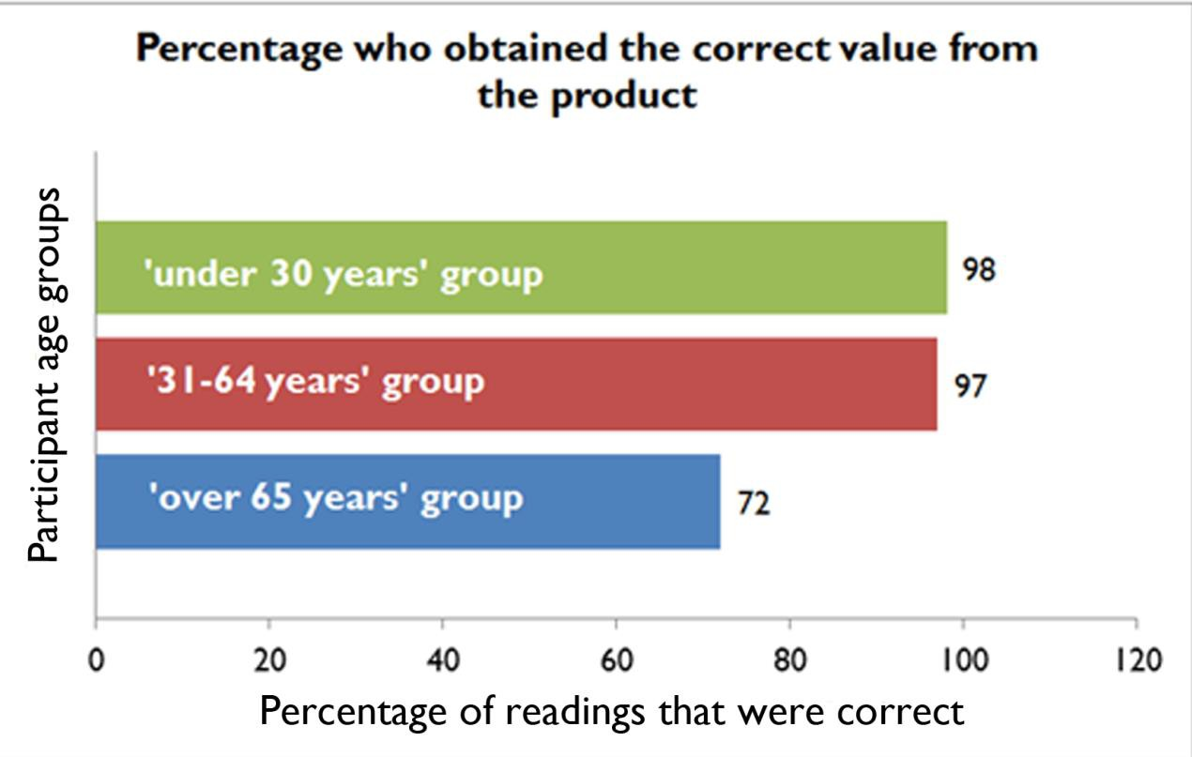

When comparing the legibility of the readings across the products for all the participants it was identified that Product B and Product C had the highest success rates of 93% (n = 110 readings for each Product) respectively. In comparison, while Product A and Product D had the lowest success rates of 88% (n = 109 readings) and 89% (n = 110 readings) respectively.
While the percentage of successful readings appears to be relatively high overall, when the legibility of the readings are isolated for participants over the age of 65 (n = 6) the success rates are significantly lower for most products (see Figure 23 below). Product B and Product C had the highest task success rate (n
= 30 readings) of 83% and 79% respectively. In contrast, Product A had the lowest task success rates of 59% (n = 29 readings) and Product D had a success rate of 62% (n = 30 readings).

Figure 23: The percentage of correct readings for each product provided by participants over 65 years of age.
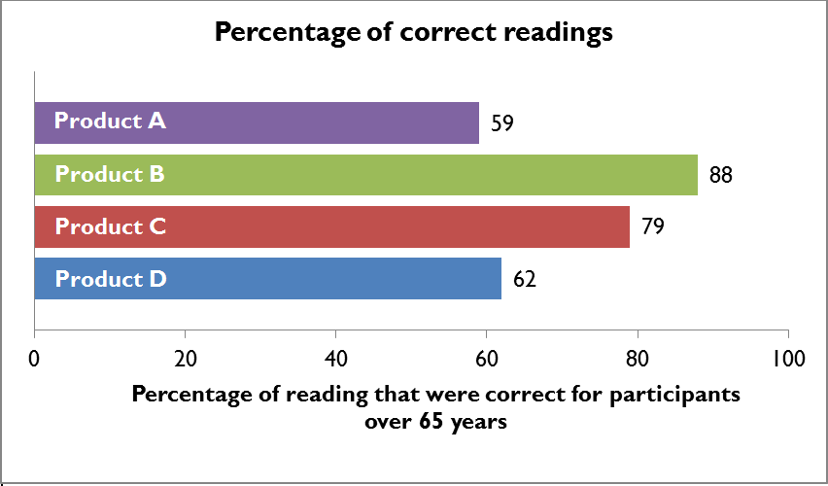
Percentage of readings that was correct for participants over 65 years of age
Legibility: Identifying information
As part of the set of tasks undertaken, the participants were asked if they could identify the numbers on the screen. This observation did not cover whether the values were correct or incorrect but simply that the participant could attempt to read the values. 21 of the 22 participants identified that the values on all the products were legible, however participant 4, (female, 85 years of age who had visual difficulties) found the values of Product A and Product D were illegible and was unable to attempt reading any of the values on the aforementioned products.

While Product B was identified as one of the most difficult products to operate, Product B received a 93% success rate for readings provided by participants. A key factor identified for this was Product B’s backlighting which made the product ‘easier to read’. However the exception for this was Participant 10 (male, 21 years) who was colour-blind. Due to the green backlighting of the product, the participant experienced great difficulty in reading the information on this product.

Figure 24: The four In-Home Displays used for the Usability Testing
Screen interface design
68% of participants had a preference for ‘the bigger the screen the better’. 64% of these participants mentioned Product C as having a good size screen. This compared with 21% of participants who had a preference for a screen size similar to that of Product D. It was suggested by some of the participants that the small screen on Product A was hard to read due to its small text size and seven segment screen display, which was deemed to be ‘old fashioned, like a calculator’ (for example, the Euro symbol was shown as E rather than €).
Product D was the only colour screen In-Home Display. While overall there was a preference (64%) for coloured screens, there was a general lack of understanding around the colours and time-of-use tariffs that were used.
Overall the general consensus by the participants was that while the information in Product D was useful, there was too much information on the screen.

Audible feedback
Product A was the only In-Home Display that made a sound when the buttons were pressed. However 82% of the participants were unaware in the Post-test Interviews that any of the products had made a noise.

Sound needs to be associated with an action, in the case of Product A the sound was keypad based and disassociated from the screen. So there was no obvious synchronisation between the action of pushing the key and the activity on the screen on which the participant was concentrating. For there to be a better recall, the auditory response needs to match a ‘roll over’ of obvious change of state visible on the screen.

Key Findings
In the context of the qualitative and quantitative research, ‘Effectiveness’ was primarily focused on the legibility of the information communicated using the In-Home Display. The following key findings were identified in relation to the effectiveness of the In-Home Display:
  - Product B was identified as one of the most difficult products to operate. However when legibility of readings were compared against the other products, participants received a score of 93% for providing correct readings using Product B. A key factor identified for this high score for legibility was Product B’s backlighting which made the product ‘easier to read’
  - Participants under the age of 65 (n = 16) had a 97% success rate (n=320 readings) in giving correct readings using the four In-Home Displays. However, participants over the age of 65 had a significantly lower success rate of 72% (n = 119 readings)
  - Product A was the only In-Home Display that made a sound when the buttons were pressed. However 82% of the participants were unaware in the Post-test Interview that any of the devices had made a noise.
Sound needs to be associated with an action; in the case of product A the sound was keypad based and disassociated from the screen. So there was no obvious synchronisation between the action of pushing the key and the activity on the screen on which the participant was concentrating.
Products that performed well had:
  - Adequate height and spacing of characters
  - Consistent interface design. For example, cues were consistently in the same location
  - A good sized screen which was easy to see and read
  - Good contrast between the text and the In-Home Display screen
  - A backlit display to increase contrast (see Figure 25)

Figure 25: Use of backlighting to increase contrast
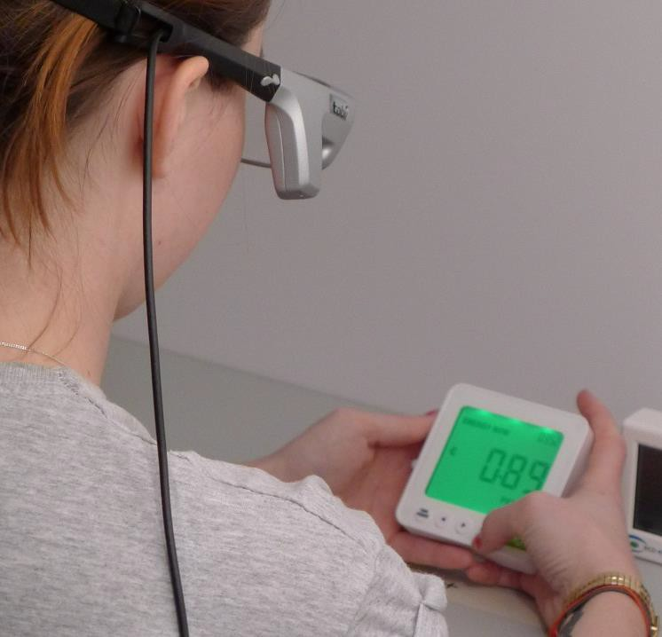
Products that performed poorly had:
  - Small character size and spacing, resulting in poor reading accuracy
  - A seven segment display (LCD) to display number, letters and symbols
  - Inconsistent interface layout. Note the change of location of the decimal place in Figure 26 below - this caused significant confusion for participants in the Usability Testing

Figure 26: Inconsistent User Interface
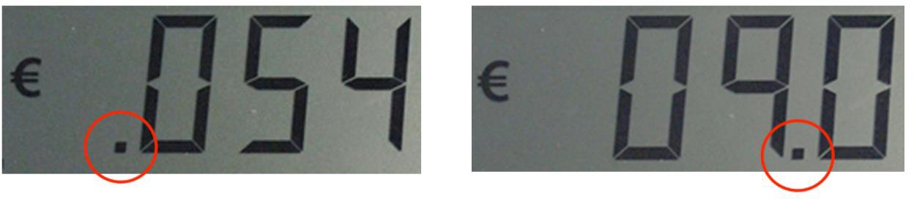

      - Errors
Errors refer to the number of mistakes the user makes, the severity of these mistakes and the ease of recovering from these mistakes. This is aligned with ‘Universal Design principle 5: Tolerance for errors’, which outlines that the design should minimise hazards and adverse consequences of accidental or unintended actions.
Errors were addressed under the following headings:
  - Ability to complete tasks without prompt or error
  - Errors caused by incorrect button pressing
  - Errors which the participants failed to recover from

Ability to complete tasks without prompt or error
It was found that participants over the age of 65 (n = 6) required the most prompts from the facilitator to help them complete the task. 39% of the tasks attempted (n=119 tasks) by participants over the age of 65 (n = 6) required a prompt / assistance by the facilitator. This is double the amount required by those in the under 65 age groups (n = 16).
Participants between the age of 31 and 64 (n = 9) required the least amount of prompts / assistance with only 12% of tasks attempted (n = 179 tasks) requiring a prompt. The under 30 age group faired a little worse with 19% of the tasks attempted (n = 133 tasks) requiring a prompt.
Participants over 65 years of age (n=6) using:
  - Product A required prompts for 34% of the tasks attempted (n = 29 tasks)
  - Product B required prompts for 53% of the tasks attempted (n = 30 tasks)
  - Product C required prompts for 20% of the tasks attempted (n = 30 tasks)
  - Product D required prompts for 50% of the tasks attempted (n = 30 tasks)
Comparing the variation between the different age groups for Product D it was found that 50% of the tasks attempted (n = 30 tasks) by participants over the age of 65 (n = 6) required a prompt. When compared to the tasks attempted by the younger age groups, it can be identified that participants in the 31-64 year age group (n = 9) required prompts for 16% of the tasks they attempted (n = 45 tasks) and participants under the age of 30 (n = 7) required prompts for 12% of the tasks they attempted (n = 33 tasks). The key finding therefore was that the success of undertaking tasks without prompts using Product D varied significantly across the three age groups.

It was found that 53% of the tasks attempted (n = 30 tasks) by participants over the age of 65 (n = 6) using Product B, required a prompt to complete the task. 25% of the tasks attempted (n = 44 tasks) by participants in the 31-64 age group (n = 9) required a prompt, whilst 39% of tasks attempted (n = 33 tasks) by participants in the under 30 age group (n = 7) required a prompt.

Errors
Errors are addressed below based on two sets of findings; the first relates to errors caused by pressing the incorrect buttons, while the second relates to errors which the participant failed to recover from, even when prompted by the facilitator.

Errors caused by incorrect button pressing
Through observational analysis it was identified that Product B had the highest percentage of incorrect button presses (43%) for the attempted tasks (n = 86 tasks). In comparison Product C has the lowest percentage of incorrect button presses (5%) for the attempted tasks (n = 88 tasks). (See Figure 27)

Figure 27: The percentages of tasks where an incorrect button press by participants of all ages was recorded.
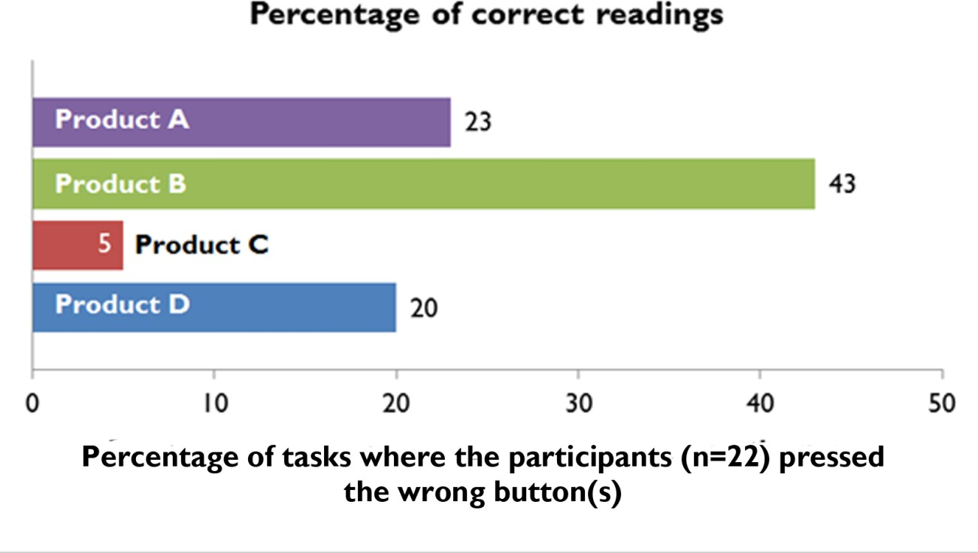

Product B was found to have the highest percentage of incorrect button presses (43%); the Expert Review and Post-test Interviews identified several reasons for this. The buttons were: flush with the body, had a small diameter, required a relatively high force to press and did not provide a feedback to confirm that the button was pressed. These factors made the product harder to use, particularly for people with below average dexterity.

Errors which the participants failed to recover from
‘Significant errors’ were identified as errors which the participant failed to recover from, even when prompted by the facilitator.
The information below identifies the number of attempted tasks where the participant got lost, requiring the task to be finished by the facilitator.
- Product A had no significant errors out of 109 attempted tasks
- Product B had 2 significant errors out of the 110 tasks attempted
- Product C had 1 significant errors out of the 110 tasks attempted
- Product D had 4 significant errors out of the 110 tasks attempted
While the values above may appear to be low, they are very significant as the participant was unable to correct their errors even when prompted by the facilitator.

Key Findings
Products that experienced a low level of ‘significant errors’ typically had the following characteristics:
- Provided an obvious method to escape from errors if the wrong button was pressed
- Provided a quick help guide on the product housing to guide participants in operating the In-Home Display
- Provided an automatic function that returns the user to the main menu after a period of time
Products that experienced a high level of ‘significant errors’ typically had the following characteristics:
- Provided too much functionality or a variety of functionality in one button
- Required pressing a button for a period of time to activate new functionality
- Provided a prolonged time delay between the time a button was pressed and the time taken for the system to respond
- Provided poor legibility for warnings and cues that were intended to aid the user (see Figure 28 below)

Figure 28: Illegible time delay icon
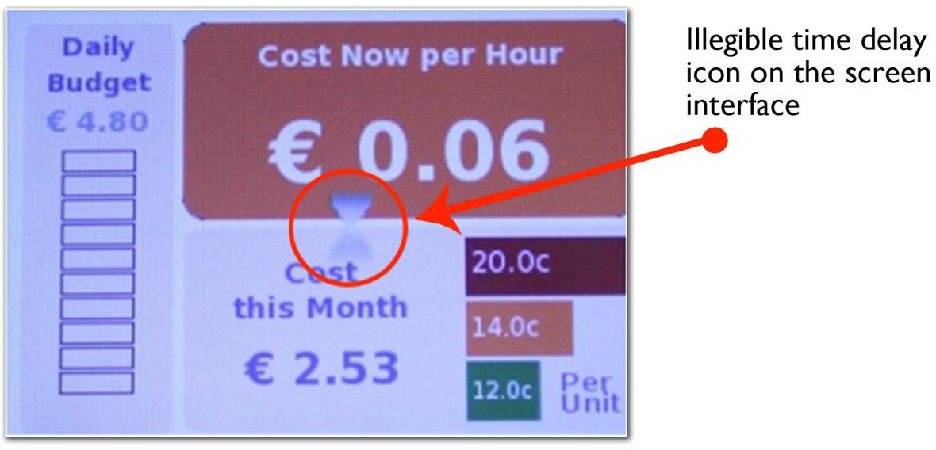

  - Stakeholder Consultation

Stakeholder Methodology
Stage three of the research was the Stakeholder Consultations which sought to identify key requirements, insights and feedback on the design of In-Home Displays, both from the perspective of energy stakeholders and end user group organisations (representing groups of people with specific needs).
The stakeholder consultation research was undertaken in two stages:
      - One-to-one Stakeholder Consultations
      - Round Table Workshop

Figure 29: Round Table Workshop
One-to One Stakeholder Consultations
One-to-one stakeholder interviews were undertaken with energy suppliers, energy regulatory bodies and end user group organisations representing members with specific needs or difficulties.
These stakeholder interviews were conducted between November 2012 and January 2013, prior to the undertaking of the ‘Round Table Workshop’. These one-to-one consultations were based on a set of semi-structured questions, undertaken both face-to-face and over the phone.
The Stakeholder Consultations were conducted with twenty participants, 11 of whom were key stakeholders in the energy sector and nine of whom were representatives of end user group organisations. The aim of these consultations were to gather requirements and input on the design and procurement of
In-Home Displays, which would guide the subsequent development of the technical guidelines.

Representatives from the following energy suppliers, regulatory bodies and end user group organisations were interviewed:
Energy stakeholders:
      - Bord Gáis
      - Commission for Energy Regulation (CER)
      - Consumer Energy Display Industry Group (CEDIG)
      - Department of Communication, Energy And Natural Resources
      - EirGrid
      - Electricity Supply Board (ESB)
      - Energia
      - Prepaypower
      - Sustainable Energy Authority of Ireland (SEAI)

End user group organisations:
      - Age and Opportunity
      - Centre for Independent Living (CIL)
      - DeafHear
      - Disability Access Officer UCD
      - Disability Federation of Ireland (DFI)
      - Irish Wheelchair Association (IWA)
      - Little People of Ireland (LPI)

Round Table Workshop
A roundtable workshop was held on the 11th January 2013 at the National Disability Authority, Dublin. This session provided an opportunity:
      - To present the findings of the Usability Testing
      - To discuss the requirements of the In-Home Displays with key stakeholders
      - To gain input and feedback on the development of the Technical Guidelines
This session was attended by five representatives from energy stakeholder groups, four representatives from end user group organisations, the Centre for Excellence in Universal Design’s In-Home Display project team and Dolmen’s team.

Representatives from the following energy suppliers, regulatory organisations and end user group organisations attended the Round Table Workshop:
Energy stakeholders:
      - Bord Gáis
      - Commission for Energy Regulation (CER)
      - Electricity Supply Board (ESB)
      - Sustainable Energy Authority of Ireland (SEAI)
End user group organisations:
      - Age and Opportunity
      - Centre for Independent Living (CIL)
      - Enable Ireland
      - Irish Wheelchair Association (IWA)

Stakeholder Consultations Scope, Purpose and Findings
The issues arising from the consultations with stakeholders related to general issues around the In-Home Display rollout as well as the detailed design of the In-Home Display; these are described below under the following headings:
      - Feedback on general issues
      - Ergonomic design
      - Interface screen design
      - Installation and power

Feedback on general issues
To be successful in increasing energy efficiency the stakeholders identified that the In-Home Display should be easy to use and understand. This is supported by findings from the Literature Review that identified a learning curve, whereby following an initial period of discovery, the number of features used frequently are reduced.113 Therefore, it is important that the information the In-Home Display communicates is easy to access and understand in order to change householders’ behaviour from the first time of use.

113 Imaia, et al. (2010). ‘Improving the usability and learnability of a home electric Improving the usability and learnability of a home electric’. Journal of Engineering Design, 21 (2/3). pp 173-187.

Similarly where use is infrequent, the controls should be intuitive to use and supported using simple cues and prompts. Additional consideration will need to be given on how information will transfer across a range of different technology platforms as more functionality is added to the In-Home Display over the short, medium and longer term.
An important consideration for the dual fuel In-Home Displays is the cost implications of integrating Universal Design considerations. The key question is how to get the most attractive and easy to use product within the cost margins. There may need to be trade-offs on features based on cost, but overall there was a consensus by the energy stakeholders on the importance of ensuring that the product is accessible, understandable and usable by all end users to the greatest extent possible in order for there to be a behavioural change in how energy is used.
Key stakeholders suggested that if the In-Home Display was designed to meet the needs of the over 65 age group, it could subsequently better meet the needs of all end users. This would significantly reduce follow on costs at a later stage (particularly relating to customer service costs). To do this, it was identified that the customer should be central to the design and development process by designers and manufacturers from the initial stages.
Feedback on the design considerations and procurement of In-Home Displays are addressed under the following three headings:
        - Ergonomic design
        - Interface screen design
        - Installation and power

Ergonomic Design
Feedback from the stakeholder consultation in relation to the ergonomic design of In-Home Displays, addressed a number of design features.
It was suggested that:
        - The In-Home Display should provide large, well-spaced, physical ‘press’ buttons that provide tactile feedback, rather than touch screen interfaces. There are several reasons for this, ranging from a familiarity perspective for the over 65 age group; a preference for tactile buttons by people who are deaf; to challenges of precise movement and dexterity by people with MS or in certain cases for people who use wheelchairs
        - The In-Home Display should be robust – with the ability to survive a drop test. The In-Home Display support bracket should also be designed robustly

        - The In-Home Display should have a ‘familiar’ design (similar aspects to products that the target market currently uses). Familiarity was identified as an important design trait; particularly for the over 65 age group, who are an increasingly dominant market sector and who will be an important market driver. Only 20% of this age group use the internet on a daily basis, and as such there is a risk that this group will not adopt this product if it is too complex to access information, understand and use
        - The In-Home Display should be aesthetically pleasing. Aesthetics are an important consideration and will influence where the In-Home Display is located (on display or hidden in a cupboard). Overall this will influence the level and frequency that the householder interacts with the product
        - The In-Home Display should be wireless (or have the option of being wireless) to allow for moving to different locations and being handheld
        - The In-Home Display should have the option of being either wall mounted or portable

Interface Screen Design
Feedback from the Stakeholder Consultations in relation to the In-Home Display screen design addressed a number of design considerations.
It was suggested that:
        - The In-Home Display should convey information simply. It was also suggested that the general functionality should be kept simple
        - There could be different levels of information that the end user could access. There was a suggestion of three levels of menus, based on similar assistive technology devices
        - The In-Home Display should display legible text, which is easy to read
        - The In-Home Display screen size should be capable of displaying information that is easy to read and see. In measureable terms, it was suggested that the screen should be bigger than a Nokia phone screen, but small enough that it will ‘blend in’ with the environment and other household products
        - The In-Home Display should convey information through both digital and analogue formats. People have preferences for information to be conveyed in different ways (digital or analogue)
        - The In-Home Display should provide good screen resolution
        - The In-Home Display should provide adjustable backlighting for poor lighting environments
        - The In-Home Display should provide a consistent screen layout (particularly in the placement of text and the consistent use of decimal places)
        - The In-Home Display’s layout should be easy to navigate

Information Communicated
It was suggested that the In-Home Display should provide the end user with the ability to:
        - Manage the household’s electricity and gas budget
        - Manage energy usage based on low and high tariffs
The energy stakeholders and end user groups suggested the following key information should be communicated through the In-Home Displays:
        - Cost savings (daily and weekly) resulting from increased energy efficiency
        - Comparable differences from their previous energy bill
        - The amount prepaid customers will need to top up by in the next week

Other information suggested for consideration included:
        - Weather forecasting information. For example what an impending cold spell would mean for energy usage based on previous years
        - Water heating costs
        - Ability to put boilers on timer and manage energy usage
        - Detailed overview of the householder’s energy usage

Power and Installation
It was suggested that the In-Home Display should be:
- An out of the box solution, that connects automatically to the smart meter while protecting the user’s information
- Simple to mount on the wall for self-installation. It should also be easy to remove from the wall
- Provided with batteries that are easy to access and change. It was suggested that batteries provided should be rechargeable
- Compatible with assistive technologies (such as infrared devices)
- Interoperable with smartphones and computers (as most assistive technology tools are built into these devices)
- Wall mounted in a location and at a level that will aid ease of use for the end user

Stakeholder Consultation Findings
The consultation with stakeholders recommended designing the In-Home Displays to meet the needs of participants over 65 years of age. It was felt that this would subsequently better meet the needs of all end users. Additionally focus was placed on the importance of making the customer central to the research and design process by all manufacturers and designers in the development of In-Home Displays. This would ensure that the In-Home Displays are aligned with the needs of the end users.
By applying Universal Design principles early in the design / procurement process, it should significantly reduce follow-on costs at a later stage (particularly relating to customer service, additional resources for on-going training and education on how to use the product). However to include these retrospectively could be very costly and significantly impact the on unit cost.

To be successful in increasing energy efficiency the stakeholders suggested that the product should be easy to use and understand, so that customers engage with it and use its functions frequently. When using a new product, customers typically have an initial period of discovery to identify the features most useful to them. After this period the numbers of features used regularly will be significantly reduced. Therefore it is important that the information is easy to access and understand in order to change the householder’s behaviour from the first time of use. It is also important that for infrequent use the controls are intuitive to use and supported by simple user prompts.

Discussion

Research Discussions and Recommendations
The research undertaken by the CER establishes clear benefits of In-Home Displays when combined with time-of-use tariffs to motivate change in energy usage.114 This research demonstrates the financial gain that can be immediately achieved by household customers in reducing their weekly budgets. However, with the exception of the research undertaken by ConsumerFocus (UK), there has been a lack of in-depth research undertaken on the Usability and Universal Design of In-Home Displays. This research is important to help ensure that the greatest number of consumers will be able to interact successfully with the
In-Home Displays to achieve these economic gains, even if the product is used infrequently.

Universal Design
Universal Design incorporates the suggestion in the Stakeholder Consultations that In-Home Displays should be designed to meet the needs of the older people. It was proposed that by meeting the needs of this market it would subsequently better meet the needs of all end users. However the author puts forward the argument that while this is a good concept, the main focus of Universal Design is to address the needs of all household customers, of any age, size, ability or disability.
Where Universal Design is successfully applied the In-Home Display should be easily accessed, understood and used by all household customers to the greatest practicable extent. If the In-Home Display is not easy to use, it is less likely to change the customer’s energy consumption, which is the overall objective of the smart meter rollout.

Cost of Universal Design
During the stakeholder consultations with energy suppliers and regulatory bodies, the constraints of the cost of the In-Home Displays became a very dominant issue. It was suggested that there would need to be a trade-off between Universal Design considerations and the cost of modifying existing In-Home Displays, in order to deliver on the allotted budget for these 2.2 million products (as part of the national rollout of smart meters).

114 Commission for Energy Regulation (2011). ‘CER plans national roll-out of energy smart meters in Ireland’. Dublin: CER.

There is a substantial benefit in integrating Universal Design from the outset of the design and development process. If a Universal Design approach is used early in the design stage, before any technical research and development, it should not significantly increase the development costs. However to include it retrospectively could be very costly and significantly impact the unit cost.
An important part of the Universal Design process is for designers, manufacturers and procurers to ensure that the consumers are proactively involved in the process of research, design and development of In-Home Displays; so that the end product is desirable, usable, accessible and easy to understand by all household customers.
This is essential to enable and drive change in household customer’s consumption behaviour and habits. Overall by making the customer central to the design and development of In-Home Displays, it should ensure that the end products are easy to use by all household customers. This in turn should support the achievements and the aims of the industry stakeholders in relation to the reduction in peak time and overall energy usage.

Interoperability with Assistive Technology
Using a Universal Design approach should reduce the need for specialised solutions (such as assistive technologies). However, Universal Design does include considerations for compatibility with assistive technology, for example how mainstream products can interoperate with it.

In-Home Display Information
Through the research process end users identified Euro per hour as their preferred default measurement of energy, as all household budgets are run that way. For example, most people think of their petrol budget for the week in Euro, not litres.

Conclusions and Recommendations

Development of Technical Guidelines

Guidance for the Development of Technical Guidelines
The three stage research strategy (composed of the Literature Review, Usability Testing and Stakeholder Consultations) was undertaken to inform the development of Technical Guidelines for the Universal Design of In-Home Displays. The Literature Review looked at international good practice in this area, including how Universal Design has been applied to products in comparable sectors. The Usability Testing identified Usability issues with design features of existing In-Home Displays when tested with people with a wide range of abilities. The consultation with industry stakeholders and end user representative groups identified key issues relating to the rollout of In-Home Displays and the requirements and needs of the stakeholders that should be addressed in the design of the In-Home Displays.
The outcome of this research is a collective set of design considerations for the design and development of In-Home Displays which are focused on making the products easily accessed, understood and used by all household customers.
These design considerations are aligned with the principles and guidelines of Universal Design, and supported through technical specifications identified from best practice sources.
The Technical Guidelines will provide specific technical guidance on the Universal Design of In-Home Displays for designers, manufacturers and procurement agencies.
The research identified three key categories under which the Technical Guidelines for the Universal Design of In-Home Displays will be developed, these are:
      - Ergonomic Design
      - Interface Screen Design
      - Power and Installation

Ergonomic Design
Guidance on the ergonomic design of In-Home Displays addresses considerations relating to the product’s physical design. These considerations ensure that In-Home Displays are designed for maximum comfort, efficiency, safety, and ease of use.

Through the three stages of research the following ergonomic design considerations were identified, which have been addressed under the following headings:
        - Button design:
          - Large, well-spaced, physical buttons that provide tactile feedback are preferred to touch screen interfaces
          - Physical buttons should have a minimum width / diameter of 10mm
          - Touch screen buttons should have a minimum width / diameter of 21mm
        - Button positioning:
          - Buttons used frequently should be located on the front plane of the In-Home Display for ease of identification. If additional buttons with advanced functionality are required, these should be located on the side of the In-Home Display
          - Buttons should be arranged in a hierarchical fashion. Illogical sequences of button operations are difficult to remember
          - Buttons required to perform common tasks should be grouped together
          - A spacing of at least 2.5mm should be provided between adjacent buttons
        - Button operation:
          - Button operations that require a button to be pressed and held for a prolonged period of time should be avoided
          - A delay in time between activating the same button should be provided to cater for inadvertent button activation
        - In-Home Display design:
          - Should have the option of being both wall mounted or portable
          - Should be designed to withstand a drop test
          - Should be wireless (or have the option of being wireless) to allow for moving to different locations and being handheld
          - Should be aesthetically pleasing. Aesthetics are an important consideration and will influence where the In-Home Display is located. Aesthetics also influence the level and frequency that the householder interacts with the product
          - Should avoid providing too many buttons

Additional resources to support Technical Guidelines
Based on the findings from the Literature Review, the following standards and literature were identified for use in the Technical Guidelines to expand on the design considerations identified. Referencing these standards and literature will provide widely accepted specifications that can be applied in the design of the In-Home Displays.
        - Draft EN 301 549: 2013 (V 1.0.0): Human Factors (HF); Accessibility requirements for public procurement of ICT products and services in Europe
        - ISO/IEC Guide 71: 2001: Guidelines for standards developers to address the needs of older persons and persons with disabilities
        - ISO/TR 22411: 2008: Ergonomics data and guidelines for the application of ISO/IEC Guide 71 to products and services to address the needs of older persons and persons with disabilities
        - ISO 1503: 2008: Spatial orientation and direction of movement - Ergonomic requirements
        - ISO 9241-20: 2008: Ergonomics of human-system interaction -Part 20: Accessibility guidelines for information/communication technology (ICT) equipment and services
        - ISO 9241-410: 2008: Ergonomics of human-system interaction- Part 410: Design criteria for physical input devices
        - ISO 9355-3: 2006: Ergonomic requirements for the design of displays and control actuators - Part 3: Control actuators
        - National Disability Authority. ‘Building for Everyone: A Universal Design Approach – Facilities in Buildings’. Available from: [http://www.universaldesign.ie/files/bfe/BfE-6-facilities.pdf]. [Accessed: 1/8/13].
        - National Disability Authority, ‘Guidelines for Public Access Terminals Accessibility‘. Available from: [http://www.universaldesign.ie/useandapply/ict/itaccessibilityguidelines/pub licaccessterminals/guidelines/priority-2/2-1]. [Accessed 16/1/13].
        - Nordic Cooperation on Disability. ‘Nordic Guidelines for Computer Accessibility, 2nd Edition’. Available from: [http://trace.wisc.edu/docs/nordic_guidelines/nordic_guidelines.htm]. [Accessed 02/5/13].

Interface Screen Design
The In-Home Display’s interface should be simple and intuitive to operate.115 This will be driven by the sequential and logical layout of information on the screen, the provision of cues or instructions to guide users where necessary, and ease of identifying and finding information through intuitive navigation.
The In-Home Display should be easy to operate from the first time it is used, allowing for flexibility in use to take into account the varied needs and abilities of the users.116 Additionally where there is a large amount of information or button sequences to remember, it is important that instructions or prompts are provided to enhance Usability of the product.
The In-Home Display screen should be easy to see and read; considerations for interface design include: font size, screen contrast, resolution and how information is presented (whether digital or analogue). People understand information in different ways. The In-Home Display should therefore provide different modes of communication for communicating essential information effectively to the user.117
When providing information visually, communication through auditory and tactile channels should also be considered. Providing information in alternative formats increases accessibility.
Through the three stages of research the following screen interface design considerations were identified. These have been addressed under the following headings:
        - Layout
        - Functionality
        - Text and visuals
        - Feedback
        - Legibility
        - Screen contrast and resolution
        - Tolerance for error

115 See Universal Design Principle 3, Annex 1 for further information. 116 See Universal Design Principle 2, Annex 1 for further information. 117 See Universal Design Principle 4, Annex 1 for further information.

Layout
        - The In-Home Display should have a familiar layout. The screen interface should have a recognisable layout with legible cues that are sufficient in size and colour contrast to help users find information
        - The In-Home Display should have a clear, uncluttered presentation of key information
        - The In-Home Display should have a consistent interface design and layout (particularly in the placement of text, numbers, symbols and decimal points)

Functionality
        - The In-Home Display’s general functionality should be simple to operate. It was suggested that there could be different levels of information for users with different technological experience and needs
        - The In-Home Display should provide information in both digital and analogue formats. This is to accommodate peoples’ preferences for information to be conveyed in different ways

Text and Visuals
        - Use familiar features; familiarity of the feature is more important than the location of the feature
        - Where contemporary symbols or logos are used, they should be accompanied by text

Feedback
        - The In-Home Display should provide prompt and legible feedback to aid understanding
        - Difficulties were experienced in the Usability Testing where there was a prolonged time delay between the time a button was pressed and the time the system responded

Legibility
        - The In-Home Display should provide adequate height and spacing of the numbers and text. In-Home Displays which had small text size and spacing resulted in poor reading accuracy in the Usability Testing
        - The In-Home Display’s screen size should be easy to read. The Usability Testing identified that a screen size of approximately 20mm x 70mm was too small. 64% of participants in the Usability Testing identified that a screen size of approximately 70mm x 150mm as being a good size screen for legibility

Screen contrast and resolution
        - The In-Home Display should prevent glare by avoiding the use of materials with glossy surfaces
        - The In-Home Display should provide acceptable colour contrast
        - The In-Home Display should provide good screen resolution so similar shaped numbers and letters can be differentiated
        - The In-Home Display should provide backlighting that can be adjusted for environments with poor lighting

Tolerance for error
        - The In-Home Display should provide an obvious method to escape from an error if the wrong button is pressed
        - The In-Home Display should provide a quick help guide on the product housing to assist participants who may be confused about which button to press
        - The In-Home Display should provide a feature/function to automatically return to the default screen after a period of time. This function should be designed to accommodate the slowest user

Additional resources to support Technical Guidelines
Based on the findings from the Literature Review, the following standards and literature were identified for use in the Technical Guidelines to expand on the design considerations identified. Referencing these standards and literature will provide widely accepted specifications that can be applied in the design of the In-Home Displays.
        - 2010 ADA Standards for Accessible Design
        - Draft EN 301 549: 2013 (V 1.0.0): Human Factors (HF); Accessibility requirements for public procurement of ICT products and services in Europe
        - EN 894-2: 2000: Safety of machinery- Ergonomics requirements for the design of displays and control actuators: Part 2, Displays
        - ES 201 381: 1998 V1.1.1: Human Factors (HF); Telecommunications keypads and keyboards; Tactile identifiers
        - ISO 11683: 1997: Packaging -Tactile warnings of danger - Requirements
        - ISO 1503: 2008: Spatial orientation and direction of movement - Ergonomic requirements
        - ISO 9241-20: 2008: Ergonomics of human-system interaction -Part 20: Accessibility guidelines for information/communication technology (ICT) equipment and services
        - ISO 9241-303: 2011: Ergonomics of human-system interaction - Part 303: Requirements for electronic visual displays
        - ISO 9355-2: 1999: Ergonomic requirements for the design of displays and control actuators - Part 2:Displays
        - ISO/TR 22411: 2008: Ergonomics data and guidelines for the application of ISO/IEC Guide 71 to products and services to address the needs of older persons and persons with disabilities
        - National Standards Authority of Ireland (2012). SWiFT 9:2012: ‘Universal Design for Energy Suppliers’. Dublin: NSAI.

Power and Installation
It is recommended that the user is provided with an ‘out of the box’ solution which from initial use requires minimal actions for set-up and maintenance.
Where the product is being installed by the user, guidance should be provided in relation to the positioning of the In-Home Display (if being wall mounted) to ensure that it is positioned close to eye-height, is easy to access and is located in an environment that is well lit.
While methods of powering the In-Home Displays varies between manufacturers, it is important that where replaceable batteries are required, the process of accessing and changing batteries is easy to undertake for users, specifically those with limited dexterity. Additionally standard input and output connections should be positioned in a location that is easily accessible and which does not required visual contact to identify.
Through the three stages of research the following power and installation considerations were identified:

Installation:
        - The In-Home Display should be an out of the box solution; that connects automatically to the smart meter while protecting the user’s information
        - The In-Home Display should be simple to mount on the wall. It should also be easy to remove from the wall
        - To ensure ease of use for the end user, guidance should be provided for wall-mounting the In-Home Display (such as, in an accessible location and close to eye-level)

Accessibility of batteries:
        - The In-Home Display should provide an easy method to access and change replaceable batteries. Changing replaceable batteries is an important consideration, particularly for users with dexterity problems, such as arthritis

Compatibility with Assistive Technology:
        - If the In-Home Display cannot be designed to accommodate all users, compatibility with assistive technologies (such as infrared devices) is required
        - If the In-Home Display cannot be designed to accommodate all users, information from the In-Home Displays should be provided through a smart phone or computer (as most assistive technology tools are accessible on these products)

Additional resources to support Technical Guidelines:
Based on the findings from the Literature Review, the following standards and literature will be used in the Technical Guidelines to expand on the topics identified. Referencing these standards and literature will provide widely accepted specifications that can be applied in the design of the In-Home Display.
        - 2010 ADA Standards for Accessible Design
        - Draft EN 301 549: 2013 (V 1.0.0): Human Factors (HF); Accessibility requirements for public procurement of ICT products and services in Europe
        - EN 894-2: 2000: Safety of machinery- Ergonomics requirements for the design of displays and control actuators: Part 2, Displays
        - ISO 9241-20: 2008: Ergonomics of human-system interaction -Part 20: Accessibility guidelines for information/communication technology (ICT) equipment and services
        - ISO/TR 22411: 2008: Ergonomics data and guidelines for the application of ISO/IEC Guide 71 to products and services to address the needs of older persons and persons with disabilities

Bibliography
        - Accenture Pty Ltd for Department of Primary Industries, (2011). ‘Department of Primary Industries IHD Inclusion into ESI scheme’. Accenture.
        - Ambient. ‘The Energy Orb’. Available from: [http://www.ambientdevices.com/about/about-the-company]. [Accessed: 20/12/12].
        - Anderson, Will and White, Vicki (2009). Centre for Sustainable Energy. ‘Exploring consumer preferences for home energy display functionality’. UK: Energy Saving Trust.
        - BCC Research (2012). ‘Energy Management Information Systems: Global Markets’. Wellesley: BCC Research.
        - Blackler, et al. (2010). ‘Investigating users’ intuitive interaction with complex artefacts’. Applied Ergonomics, 41 (1), pp 72-92.
        - Central Statistics Office (2012). 'Our Bill of Health’ Profile 8. Dublin: The Stationary Office.
        - Chen et al. (2012). ‘Touch screen performance by individuals with and without motor control disabilities’. Applied Ergonomics, 44 (2). Pp. 297- 302.
        - Chiang, Teresa (2012). ‘A laboratory test of the efficacy of energy display interface design’. Bath: Elsevier.
        - Commission for Energy Regulation (2011). ‘CER plans national roll-out of energy smart meters in Ireland’. Dublin: CER.
        - Commission for Energy Regulation (2011). ‘Consultation on the proposed national rollout of electricity and gas smart metering’. Consultation Paper CER11191. Dublin: CER.
        - Commission for Energy Regulation, (2011). ‘Electricity Smart Metering Customer Behaviour Trials Findings Report’. CER/11/080a. Dublin: The Commission for Energy Regulation.
        - Commission for Energy Regulation, (2011). Smart Metering Information Paper 4 (CER 11080). ‘Results of Electricity Cost-Benefit Analysis, Customer Behaviour Trials and Technology Trials’. Dublin: The Commission for Energy Regulation.
        - Commission for Energy Regulation, (2012). ‘Decision on the National Rollout of Electricity and Gas Smart Metering.’ Dublin: The Commission for Energy Regulation.
        - Commission for Energy Regulation, (2012). CER/12/213: ‘National Smart Metering Programme (NSMP)’. Information Paper. Dublin: The Commission for Energy Regulation.

        - Communications Consumer Panel (2011). ‘Making Phones easier to use: views from consumers’. London: Communications Consumer Panel.
        - Community and Local Government Environment (2012). ‘Reform of the water sector in Ireland’. Position Paper. Ireland: ENVIRON.
        - ConsumerFocus (2010). ‘Response to Smart Metering Implementation Programme: In-Home Display’. London: Consumer Focus.
        - Department of Energy and Climate Change (2012). ‘Smart meter roll-out for the domestic sector (GB)’. London: Department of Energy and Climate Change.
        - Design Hosting Software. ‘VAST™ Vehicle Analysis & System Test’. Available from: [http://www.dhs-ltd.com/wordpress/?p=104]. [Accessed 26/11/12].
        - ESB In-Home Display. Available from: [http://www.seai.ie/Renewables/Smart_Grids/The_Smart_Grid_for_the_ Consumer/Home_Consumer/Home_Energy_Management_Systems/]. [Accessed 25/11/12].
        - European Commission. ‘Europe 2020’. Available from: [http://ec.europa.eu/europe2020/europe-2020-in-a- nutshell/targets/index_en.htm]. [Accessed 25/1/13].
        - European Committee for Standardization (1998). ISO 9241-11:1998 ‘Ergonomic requirements for office work with visual display terminals (VDTs) - Part 11 Guidance on usability’. Brussels: European Committee for Standardization.
        - European Committee for Standardization (2012). Draft EN 301 549 (v1.0.0 (2013-02)) ‘Accessibility requirements for public procurement of ICT products and services in Europe.’ Brussels: European Committee for Standardization.
        - European Communities (Internal Market in Electricity and Gas) (Consumer Protection) Regulations of 2011, Section 3.
        - European initiative on Smart Cities. Available from: [http://setis.ec.europa.eu/about-setis/technology-roadmap/european- initiative-on-smart-cities]. [Accessed: 26/11/12].
        - Imaia, et al. (2010) ‘Improving the usability and learnability of a home electric Improving the usability and learnability of a home electric’, Journal of Engineering Design, 21 (2/3), pp 173-187
        - Independent.ie. ‘Water meter roll out will be delayed until 2016’. Available from: [http://www.independent.ie/business/irish/water-meter- rollout-will-be-delayed-until-2016-28821600.html]. [Accessed: 8/5/13].

        - Irish Statute Book. Disability Act 2005. Available from: [http://www.irishstatutebook.ie/2005/en/act/pub/0014/index.html]. [Accessed: 26/11/12].
        - Irwin, Curt B., and Mary E. Sesto (2012). ‘Performance and touch characteristics of disabled and non-disabled participants during a reciprocal tapping task using touch screen technology’. Applied Ergonomics. 43 (6), pp. 1038-1043.
        - Jacobs, Caroline, and Harnett, Mark (2011). Getting to grips with smart displays: ‘An expert appraisal of the usability of in-home energy displays’. London: ConsumerFocus.
        - Jacobs, Caroline, and Mark Harnett (2011).Getting to grips with smart displays ‘Research review’. London: ConsumerFocus.
        - Kennedy, S. (2007) Detecting changes in the respiratory status of ward patients. Nursing Standard. 21 (49), pp. 42-46.
        - Landis+Gyr’ ‘EcoMeter’ In-Home Display. Available from: [http://www.za.landisgyr.com/product/landisgyr-p350-ecometer/]. [Accessed: 8/5/13].
        - Lees, Monica N. et al (2012). ‘Cross-modal warnings for orienting attention in older drivers with and without attention impairments,’ Applied Ergonomics 43 (4), pp 768 -776.
        - McArdle, W. D., Katch, F.I., & Katch, V.L. (2010). Exercise Physiology: ‘Nutrition, Energy and Human Performance’, 7th edn, Baltimore: Point, Lippincott Williams & Wilkins.
        - National Standards Authority of Ireland (2012). SWiFT 9:2012. ‘Universal Design for Energy Suppliers’. Dublin: NSAI.
        - Neilson Norman Group. ‘Usability 101: Introduction to Usability’. Available from: [http://www.nngroup.com/articles/usability-101- introduction-to-usability/]. [Accessed on: 21/1/13].
        - Nielsen Norman Group. ‘How Many Test Users in a Usability Study?’, Available at: [http://www.nngroup.com/articles/how-many-test-users/]. [Accessed 25/1/13].
        - Nielsen Norman Group. ‘Why You Only Need to Test with 5 Users’, Available at: [http://www.nngroup.com/articles/why-you-only-need-to- test-with-5-users/]. [Accessed: 25/1/13].
        - ‘Nordic Guidelines for Computer Accessibility’. Available from: [http://trace.wisc.edu/docs/nordic_guidelines/nordic_guidelines.htm]. [Accessed 29/5/13].
        - North Carolina State University (1997). ‘7 Principles and 29 Guidelines of Universal Design’. Centre for Universal Design, USA.

        - Ofgem (2011). Smart Metering Implementation Programme. ‘Response to Prospectus Consultation’. London: Department of Energy and Climate Change and the Office of Gas and Electricity Markets.
        - Ricability, (2012). Smart Meter In-Home Display Design: ‘Usability good practice guidance’. UK: ConsumerFocus.
        - Shneiderman, Ben (2003). ‘Promoting Universal Usability with Multi-Layer Interface Design.’ Proceedings of the 2003 conferences on universal usability. New York.
        - The Research Perspective (2008). Smart Meter Trial. ‘IHD and Consumption report: Insight from Dundalk 2020.’ Dublin: The Research Perspective.
        - Usability 101:Introduction to Usability. Available from: [http://www.nngroup.com/articles/usability-101-introduction-to- usability/]. [Accessed on: 21/1/13].
        - Victorian Government Energy Initiative. Energy Saver Initiative (C/12/123445). Available from: [https://www.veet.vic.gov.au/Public/Pub.aspx?id=266]. [Accessed 14/11/12].
        - Wood, Lisa (2011). ‘The Future of Home Automation: Emerging trends and technologies for smart home energy, entertainment, security and health’. London: Datamonitor.
        - World Health Organisation. ‘International Classification of Functioning, Disability and Health (ICF)’. Available from: [http://www.who.int/classifications/icf/en/]. [Accessed: 26/11/12].

Terms and Definitions

Accessibility
Extent to which products, systems, services, environments and facilities can be used by people from a population with the widest range of characteristics and capabilities to achieve a specified goal in a specified context of use.
Note 1: Context of use includes direct use or use supported by assistive technologies
Note 2: Adapted from ISO/TR 22411:2008, definition 3.6
[Source: ISO 26800: 2011, 3.1]

Assistive Technology / Assistive device
Any product (including devices, equipment, instruments and software), especially produced or generally available, used by or for people with disability.
        - For participation;
        - To protect, support, measure or substitute for body functions/structures and activities; or
        - To prevent impairments, activity limitations or participation restrictions. [Source: ISO 9999: 2011, 2.3]

Ergonomics
Ergonomics is the design of environments, products and services to suit the needs and abilities of the user.

Household Customer / User
Customer(s) who purchase natural gas or electricity for their own use at a domestic dwelling.
Note: In the context of this document the term dwelling refers to a house, flat or other place or residence.
[Source: NSAI, SWiFT 9: 2012]

In-Home Display
An In-Home Display is a product that presents both real-time and past energy usage information. It provides the user with information on the amount of energy used and how much the energy costs. These products vary in their level of functionality, with more sophisticated products providing features such as information on charge rates for specific energy suppliers and having the ability to turn on and off appliances (such as heating remotely).

Smart Meter
Smart meters are typically electricity and gas meters that gather energy consumption data. This information is communicated remotely to the energy supplier for monitoring and billing purposes.

User Interface
All components of an interactive system (software or hardware) that provide information and controls for the user to accomplish specific tasks with the interactive system.
[Source: ISO 9241-110: 2006, 3.9]

Usability
Extent to which a product can be used by specific users to achieve specified goals with effectiveness, efficiency and satisfaction in a specified context of use.
[Source: ISO 9241-11: 1998, 3.1]

Universal Design
- means the design and composition of an environment so that it may be accessed, understood and used -
  - to the greatest practicable extent,
  - in the most independent and natural manner possible,
  - in the widest possible range of situations, and
  - without the need for adaptation, modification, assistive devices or specialised solutions,
by persons of any age or size or having any particular physical, sensory, mental health or intellectual ability or disability,
and
- means, in relation to electronic systems, any electronics-based process of creating products, services or systems so that they may be used by any person.
[Source: Disability Act 2005]

Annex 1

Universal Design Principles and Guidelines
The 7 principles of Universal Design as relating to In-Home Displays: The 7 principles of Universal Design as relating to In-Home Displays:118

Principle 1: Equitable use
The design of the In-Home Display should be useful and marketable to people with diverse abilities.
Guidelines:
- Provide the same means of use for all users: identical whenever possible; equivalent when not
- Avoid segregating or stigmatizing any users
- Provisions for privacy, security, and safety should be equally available to all users
- Make the design appealing to all users

Principle 2: Flexibility in use
The design of the In-Home Display should accommodate a wide range of individual preferences and abilities.
Guidelines:
- Provide choice in methods of use
- Accommodate right- or left-handed access and use
- Facilitate the user's accuracy and precision
- Provide adaptability to the user's pace

118 North Carolina State University (1997). ‘7 Principles and 29 Guidelines of Universal Design’. USA: Centre for Universal Design.

Principle 3: Simple and intuitive use
Use of the design should be easy to understand, regardless of the user’s experience, knowledge, language skills, or current concentration level.
Guidelines:
- Eliminate unnecessary complexity
- Be consistent with user expectations and intuition
- Accommodate a wide range of literacy and language skills
- Arrange information consistent with its importance
- Provide effective prompting and feedback during and after task completion

Principle 4: Perceptible Information
The design of the In-Home Display should communicate necessary information effectively to the user, regardless of ambient conditions or the user's sensory abilities.
Guidelines:
- Use different modes (pictorial, verbal, tactile) for redundant presentation of essential information
- Provide adequate contrast between essential information and its surroundings
- Maximise ‘legibility’ of essential information
- Differentiate elements in ways that can be described (i.e., make it easy to give instructions or directions)
- Provide compatibility with a variety of techniques or devices used by people with sensory limitations

Principle 5: Tolerance for Error
The design of the In-Home Display should minimise hazards and the adverse consequences of accidental or unintended actions.
Guidelines:
- Arrange elements to minimize hazards and errors: most used elements, most accessible; hazardous elements eliminated, isolated, or shielded
- Provide warnings of hazards and errors
- Provide fail safe features
- Discourage unconscious action in tasks that require vigilance

Principle 6: Low Physical Effort
The design of the In-Home Display should be used efficiently and comfortably and with minimum of fatigue.
Guidelines:
- Allow user to maintain a neutral body position
- Use reasonable operating forces
- Minimise repetitive actions
- Minimise sustained physical effort

Principle 7: Size and Space for Approach and Use
Appropriate size and space is provided for approach, reach, manipulation, and use of the In-Home Display regardless of user's body size, posture, or mobility.
Guidelines:
- Provide a clear line of sight to important elements for any seated or standing user
- Make reach to all components comfortable for any seated or standing user
- Accommodate variations in hand and grip size
- Provide adequate space for the use of assistive devices or personal assistance

Annex 2

Usability Testing: Quantitative and Qualitative Testing:
    - Quantitative Evaluation
The Quantitative tests were composed of:
      - Observational Analysis
      - Physiological Analysis
        - Heart Rate (ECG)
        - Arm Movement
        - Breathing Rate Per /Min
        - Galvanic Skin
        - Eye Track

Physiological Monitoring
The physiological monitoring was used to:
        - Identify the Time to Completion (TtC): The user was timed as he or she interacted with the In-Home Display’s interface. The time to complete a set of tasks was measured and benchmarked against the average completion times.
        - Explore, identify and analyse the physiological reaction to using the
In-Home Displays, namely the stress experienced by the body ranging from increased heart rate to eye movement (illustrating confusion)

Physiological monitoring equipment
Heart rate, respiratory rate and skin temperature:
In order to objectively quantify the level of stress experienced by the user during the Usability Testing, several physiological parameters were monitored. During periods of cognitive, emotional or physical strain, physiological manifestations may occur in the form of increased heart rate, respiratory rate and skin temperature.
To monitor these physiological changes, the participants were equipped with a physiological monitor (see Figure 30). This monitor was held against the participant’s skin using a belt that spanned across the participant’s chest and over their shoulder. The physiological monitor collects the physiological data, which is then transferred to a laptop. It can then be analysed by the physiologist to detect changes in heart rate, respiratory rate or skin temperature. Should changes in physiology occur, the time of occurrence can be cross-referenced with the time a task was attempted and observations to identify the cause of the increase or decrease in physiological reactions.

Figure: 30. The Equivital™: Heart rate, respiratory rate and skin temperature measurement equipment

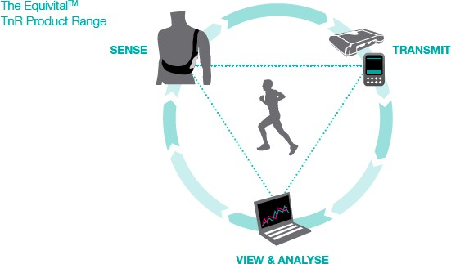

Eye-tracker device
The eye-tracker is a device used to log the features of eye movement when the eye processes visual information. The eye-tracker consists of a pupil detection sensor, scene camera and IR marker sensor. The pupil detection sensor uses infrared to find the centre of the pupil.
The eye-tracker device used was ‘Tobii Glasses’. As shown in Figure 31, the ‘Tobii Glasses’ are very similar to wearing common sunglasses or industrial eye wear protection. This is important as it minimises the risk of the participant being distracted or feeling discomfort while wearing them.

Figure: 31. ‘Tobii Glasses’ Eye-Tracker Glasses
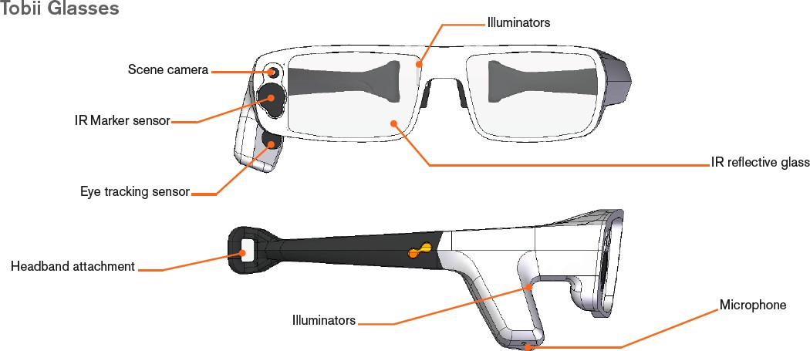

The eye-tracker was used to plot task completion times as well as to understand the confusion generated by unclear screens or hard key interfaces. The equipment was used to gauge when a user was confused and when they simply were not looking at the screen when a test request was made.

For the purpose of this research the eye-tracker was used to:
        - Identify the user’s level of confusion
        - Identify the user’s reaction when undertaking tasks (identifying what they were looking at)
        - Identifying time to complete each task

Figure: 32. Eye-Tracker Glasses for Usability Testing
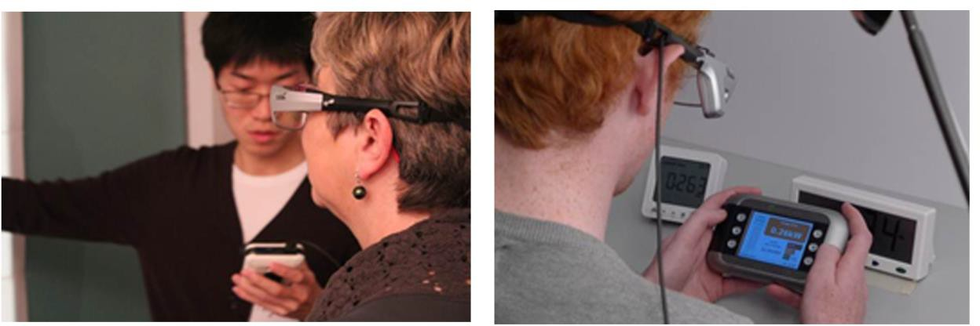

    - Qualitative Evaluation
The Qualitative Testing consisted of the following:
      - Post-test Interviews
      - Expert Review

Expert Review
An Expert Review was undertaken using the 4 selected products that were used in the Usability Testing as well as one additional product (Efergy Elite). The Expert Review was a thorough examination of the products, with an aim of identifying design attributes, features and functions that make them difficult or easy to use. This review was required to expand on difficulties which the participants had identified in the Usability Testing as well as problems identified during the Literature Review (such as access to batteries). Each product was examined and reviewed in the form of a round table discussion by three experienced product designers and usability experts.

The objective of the Expert Review was to review the design attributes, characteristics and functionality of the In-Home Displays and explore in more depth aspects and features highlighted in the user interviews.

Table 2: Purpose of the Usability testing versus the Expert review.

Purpose of the Usability Testing | Purpose of the Expert Review
Identifies what attributes, features and functions cause difficulty and whom does it affect most? | Expands on the usability study and the literature review.  Identifies why the attributes, features and functions of an In-Home Display cause difficulty?
The Usability expert team consisted of:
        - Christopher Murphy, Product Designer with expertise in human-factor design
        - Sean McNulty, Innovation Expert with expertise in user-centred design, CEO of Dolmen
        - Frazer McKimm, Usability Expert, CEO of DHS

Observational Research: Overview
Finding from the observations were categorised in a quantifiable format. A list of nine questions was generated to assess the ability of the participant to complete the tasks asked of him/her. Observations 1 to 3 and 6 to 9 were applied to the observations identified by the observer. Observations 4 and 5 were applied to observations derived from the eye-track video to observe what the participants had identified and selected.

Table 3. Observations 1-9

OBV. 1 | Participant completed the Tasks 1 to 5
OBV. 2 | Participant was capable of reading the screen.
OBV. 3 | Participant was able to identify the correct values on the screen.
OBV. 4 | Participant was able to identify the correct hard keys / buttons.
OBV. 5 | Participant selected the correct hard key / button
OBV. 6 | Participant hovered finger over the wrong key / button(s)
OBV. 7 | Participant pressed the wrong key / button(s)
OBV. 8 | Participant required prompt to complete the task.
OBV. 9 | Participant got lost and the task was ended by the facilitator

  - Product Selection
    - In-Home Display Selection
Out of a market selection of over 20 In-Home Displays, four were selected for the Usability Testing. These four In-Home Displays gave the greatest representation of the product types available. An additional In-Home Display (the Efergy Elite) was used as part of the Expert Review.

The In-Home Displays selected were:
      - Product A: PrepayPower Display Unit
The ‘PrePayPower’ display unit consisted of a monochromatic, single line display with a hard key pad. This product was a display unit for a prepaid meter. It had the simplest functionality of the In-Home Displays and was the only device to include a printed summarised user guide summary stuck to the body of the product. All the functions were accessed via the numbered keypad. This was the only device to have auditory feedback.

Figure 33: PrepayPower Display
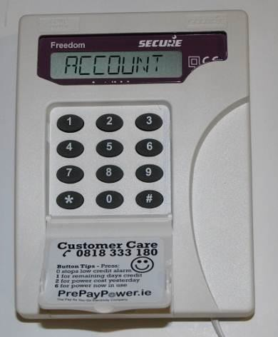

      - Product B: Efergy E2 Classic wireless energy monitor
The E2 Classic consisted of a monochromatic, backlit, multi-line display with an array of function control buttons located beneath the screen. The product had the unusual inclusion of a top mounted function control.

The E2 Classic allows the user to:
        - Download their energy data to their pc/mac
        - Instantly see the cost (€) of using energy in their home
        - View hourly, weekly, monthly or average data
        - Measure their CO₂ emission levels

Figure 34: Efergy E2 Classic
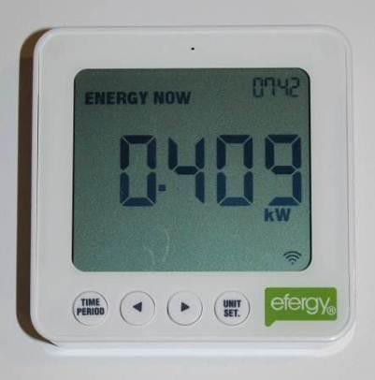
      - Product C: Eco-Eye Elite
The Eco-Eye Elite consisted of a large monochromatic LCD display.

The Eco-Eye Elite allows the user to:
        - Display room temperature and time
        - View hourly, daily, weekly, monthly or annual data
        - Measure their CO₂ emission levels.

Figure 35: Eco-Eye Elite

      - Product D: Elster AD100
The Elster AD100 consisted of a large screen full colour graphic display.

The product allows the user to:
        - View hourly, daily, weekly, monthly or annual data
        - View daily budget
        - View date and time
        - View charge bands (colour coded)
        - View electricity usage in graphical format

Figure 36: Elster AD100
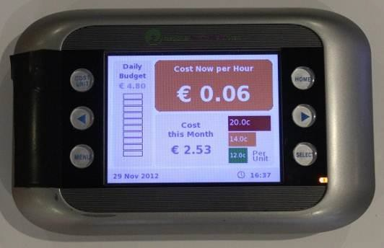

      - Product E: Efergy Elite (Used for the Expert Review Only)
The Elite consisted of a monochromatic, backlit, multi-line display with an array of function control buttons located on the top of the In-Home Display.

The Elite allows the user to:
        - Download their energy data to their pc/mac
        - Instantly see the cost (€) of using energy in their home
        - View hourly, weekly, monthly or average data
        - Measure their CO₂ emission levels

Figure 37: Efergy Elite
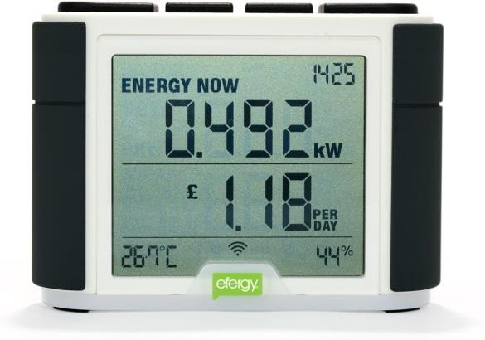

  - Participant Selection
The following table outlines the range of abilities of the participants who were involved in the Usability Testing. In total 22 participants, composed of three age categories, and with a broad range of abilities, took part in the Usability Testing. Additionally, four people were selected as a benchmark group who were deemed to be of average ability.

Number | Gender | Age | Range of Abilities
Participants who were deaf or had hearing difficulties
1 | f | 75 | hearing difficulty
5 | m | 52 | deaf (cochlear implant)
8 | f | 40 | deaf (cochlear implant)
Participants who had dexterity difficulties
4 | f | 85 | limited dexterity (arthritis)
22 | m | 24 | simulated use of one-hand
18 | m | 82 | limited dexterity (arthritis)
Participants who had mobility difficulties
12 | f | 26 | limited mobility-wheelchair user (+ cerebral palsy)
19 | f | 79 | limited mobility (wheelchair user)
Participants who had seeing difficulties
3 | f | 85 | visual impairment
6 | f | 57 | visual impairment
Participants who varied in stature
7 | m | 25 | tall stature
17 | m | 44 | small stature
Participants who had cognitive difficulties
9 | m | 56 | dyslexia
10 | m | 21 | dyslexia (and colour blind)
20 | m | 23 | cognitive disability (acquired brain injury)
21 | m | 23 | cognitive disability (downs syndrome)
Participants who were left-handed
13 | m | 33 | Left-handed
2 | f | 74 | left-handed
Benchmark Group (no disabilities)
11 | f | 21 | BENCHMARK
14 | m | 37 | BENCHMARK
15 | m | 41 | BENCHMARK
16 | m | 54 | BENCHMARK

Centre for Excellence in Universal Design
National Disability Authority 25 Clyde Road, Dublin 4
Telephone (01) 608 0400
Fax (01) 660 9935

www.nda.ie
Universal Design is the design of a building or place, products, services or information / communication technologies so that they can be accessed, understood and used to the greatest extent possible by all people, regardless of their age, size, ability or disability.

