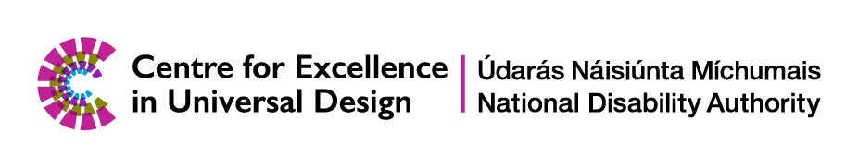

Launch: Universal Design Guidelines for Changing Places Toilets, 26 June 2024

Meet the Speakers

## Dr. Aideen Hartney, Director, National Disability Authority

Dr. Aideen Hartney became Director (Chief Executive) of the National Disability Authority (NDA) in mid-2020, having joined the organisation in 2016 as its Head of Policy, Research and Public Affairs. The National Disability Authority (NDA) is the independent statutory body, which provides evidence-based advice and research to Government on disability policy and practice and promotes Universal Design.

Aideen has had a long career in overseeing research for the public good, having managed several major funded research programmes in University College Dublin, before coming to the NDA. She also has private sector experience following 7 years as a market research consultant. Aideen holds a doctorate in Ancient History and lectured for a time at the University of Bristol.

## Anne Rabbitte T.D.

## Minister of State with responsibility for Disabilities, Department of Health and Department of Children, Disability, Equality, Integration and Youth

Appointed to this role in July 2020, Anne Rabbitte hails from a small town in the west of Ireland, Portumna, Co. Galway. A widowed mother to three children in education, she has been a TD for the Galway East constituency since the 2016 general election.

She was a member of Galway County Council from 2014 to 2016. In May 2016, she was appointed to the Fianna Fáil front bench as Spokesperson for Children and Youth Affairs. Anne worked for 25 years for a financial institution and is a qualified financial adviser. For 3 years, Anne ran a community childcare facility.

## Dr. Aoife McNicholl, Independent Living Movement Ireland

Dr. Aoife McNicholl is an Assistant Professor of Psychology and was previously the Universal Design Coordinator in Dublin City University. Aoife is a board member of Independent Living Movement Ireland and a member of the National Task Force for Digital and Assistive Technology in the HSE. As a disabled person, she has been involved in advocacy campaigns with the Irish Wheelchair Association on accessible housing and the government on the UN Convention on the Rights of Persons with Disabilities.

## Aaron Daly, Changing Places Ireland

Aaron became an advocate for Changing Places Toilets as his daughter Sophia who was born with cerebral palsy, is a wheelchair user and dependent on others for her activities of daily living. He was inspired by the UK campaign and pushed for Ireland to go along the same avenue. Changing Places Ireland are proud of the campaign to date and are thankful for all the work that has gone into where we are today.

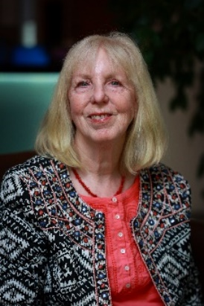**Ann Healy, Changing Places Ireland**

Ann is a mother to Ailis, a 40-year-old who is totally wheelchair dependent and needs a hoist for transfers. For years she accepted the restrictions that the lack of accessible toilet facilities placed on their family, meaning they couldn't venture more than a couple of hours from home. Ann came across Changing Places UK in 2008 and embarked on a campaign to highlight the need for these facilities to be rolled out throughout Ireland.

## Paul McDermott, Department of Housing, Local Government and Heritage

Paul is an Advisor in the Building Standards Advisory Unit of the Department of Housing, Local Government and Heritage. He was project lead on the Amendment of Part M of the Building Regulations to make provision for a Changing Places Toilet in certain buildings and a member of the NDA Technical Advisory Group assisting with the development of the Universal Design Guidelines for Changing Places Toilets. Paul is a Registered Building Surveyor and has a Post Grad Diploma in Project Management, an Honours Degree in Building Surveying, and a Degree in Architectural Technology.

## Ruth O’Reilly, Centre for Excellence in Universal Design

Ruth O’Reilly joined the Centre for Excellence in Universal Design in 2020, as Senior Built Environment Design Advisor. The Centre, which is part of the National Disability Authority, promotes universal design of the built environment, services, products, and ICT. Ruth is an architect, with an MSc in Accessibility and Inclusive Design. Ruth is passionate about her work to promote the impact that universal design can have on well-being and inclusion.

## Eoin O’Herlihy, O’Herlihy Access Consultancy

Eoin O’Herlihy is a Chartered Engineer, an independent accessibility and Universal Design consultant and Managing Director of O’Herlihy Access Consultancy (OHAC). Eoin has over 18 years’ international experience with Universal Design and is an IAAP Level 3 Certified Expert Accessibility Professional in Accessible Built Environment. He is passionate about accessibility and making all aspects of society fully accessible for everyone. Eoin recognises the barriers faced by people with disabilities and aims to support organisations remove these barriers and create a more inclusive society.

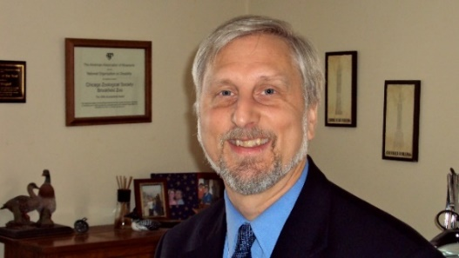**Mark Trieglaff, Accessibility Consultation and Training Services**

Mark has a B.S. in Outdoor and Therapeutic Recreation and M.S. in Park and Recreation Administration; Mark holds a certification as a Professional Associate with The National Association of ADA Coordinators. For 18 years, Mark worked as the Access Coordinator for People with Disabilities at Brookfield Zoo. As of 2024 Mark has presented at 12 International conferences on Universal Design. In February of 2023 he spoke at the UN Convention on the Rights of People with Disabilities in Vienna, Austria. He has since been asked to be on an advisory committee for the Zero Project in conjunction with the UN in Vienna.

## Ger Craddock, Centre for Excellence in Universal Design

Dr Craddock is the inaugural Chief Officer of the Centre for Excellence in Universal Design, established in 2007, as part of the National Disability Authority. The centre focuses on infusing universal design into educational curricula, developing standards and creating awareness of the benefits of universal design. He is an expert evaluator for the European Commission’s research and innovation funding programme, Horizon 2020. Dr Craddock is a graduate of Dublin City University with an Electronic Engineering degree, a Post Grad Diploma in Social and Vocational Rehabilitation Management and a PhD from the Centre of Disability Studies in UCD.