DRAFT

Universal Design Guidelines for Changing Places Toilets
Public Consultation November 2023

November 2023

Contents
Contents 2
1 Acknowledgements 5
2 Statement on Language 6
3 Introduction and Context 7
3.1 Objectives 7
3.2 What is a Changing Places Toilet? 7
3.3 Who uses Changing Places Toilets? 8
3.4 Estimated Number of Users of Changing Places Toilets 8
3.5 Benefits from providing Changing Places Toilets 9
3.6 The difference between Changing Places Toilets and Wheelchair Accessible Unisex WCs 9
3.7 National Building Regulations Requirements 11
3.8 Universal Design 11
3.9 United Nations Convention on the Rights of Persons with Disabilities (UNCRPD) 12
4 Key Considerations Overview 14
4.1 Provision 14
4.2 Location 14
4.3 Design and Installation 14
4.4 Management and Maintenance 14
5 Provision 15
5.1 Changing Places Toilets – extending the range of users 15
5.2 Minimum Requirements for the provision of a Changing Places Toilet 15
5.3 Taking a Universal Design Approach - going beyond minimum requirements 16
5.4 Planning and Building Control 17
6 Location 18
6.1 Maximising Access and Use 18
6.2 Consider Location at Early Design Stages 18
6.3 Accessibility and Security 18
6.4 Location in Existing Buildings 19
6.5 Signage and Wayfinding 19
7 Design and Installation 20
7.1 Approach 20
7.2 Size and Space 20
7.3 Doors to Changing Places Toilets 26
7.4 WC Pan 27
7.5 Changing Bench 30
7.6 Washbasin 36
7.7 Soap Dispenser 40
7.8 Hand Drying 41
7.9 Wide Paper Roll Dispenser 41
7.10 Hoist System 42
7.11 Privacy Screen 44
7.12 Waste Disposal Bins 45
7.13 Ventilation 46
7.14 Mirrors 46
7.15 Sanitary Towel Dispenser 46
7.16 Emergency Assistance Alarm System 46
7.17 Lighting 47
7.18 Heating 47
7.19 Shower 48
7.20 Accessories 49
7.21 Signage 49
7.22 Flooring and Surface Finishes 50
8 Management and Maintenance 52
8.1 Pre-Visit Information 52
8.2 Information During Visit 53
8.3 Registration of Changing Places Toilets 54
8.4 Managing Accessibility and Security 54
8.5 Staff Training 55
8.6 Routine Monitoring and Maintenance 55
8.7 Health and Safety 58

Acknowledgements
Acknowledgements to be added prior to publication.

Statement on Language
In these guidelines, the terms “people/persons with disabilities” and “disabled people” are used interchangeably. The term “disabled people” is recognised by many within the disability rights movement in Ireland to align with the social model and human rights approach of disability, as it is considered to acknowledge the fact that people with an impairment are disabled by barriers in the environment and society. However, we also recognise that others prefer the term “people/persons with disabilities” because of the inherent understanding in the term that they are first and foremost human beings entitled to human rights. This also reflects the language used in the United Nations Convention on the Rights of Persons with Disabilities. We recognise that many people with an intellectual disability, people with a mental health difficulty or psycho-social disability prefer person-first language. We also recognise that some people don’t identify with either term.
Refer to the NDA advice paper on disability language and terminology for further information.

Introduction and Context

Objectives
These guidelines are aimed at designers, building managers and owners of facilities as well as clients, industry professionals and disability stakeholders. The purpose of this document is to:
- provide good practice guidance on the provision, location, and design of Changing Places Toilets, taking a Universal Design approach.
- provide good practice guidance on managing and maintaining Changing Places Toilets.
- complement implementation of the Building Regulations (Part M Amendment) Regulations 2022, which make provision for Changing Places Toilets, having regard to the use and size of a building.

The minimum requirements for the provision of Changing Places Toilets in certain buildings are set out in the Building Regulations (Part M Amendment) Regulations 2022 and the associated Technical Guidance Document M 2022 (TGD M 2022).
While the Part M requirements may be regarded as a statutory minimum level of provision, the accompanying technical guidance states that ‘those involved in the design and construction of buildings should also have regard to the design philosophy of universal design and consider making additional provisions where practicable and appropriate.’
A Universal Design approach recognises and extends beyond minimum requirements. These guidelines include a range of good practice recommendations that in some cases go beyond the minimum requirements of the building regulations.

What is a Changing Places Toilet?
A Changing Places Toilet is an accessible sanitary facility with a toilet, hoist, basin, adult-sized changing bench, and optional shower with adequate space for use by persons with a range of abilities who may require assistance (Technical Guidance Document M, 2022). For guidance on where Changing Places Toilets should be provided, refer to Section 5 of this document.
Image 1 Example of a Changing Places Toilet at a graveyard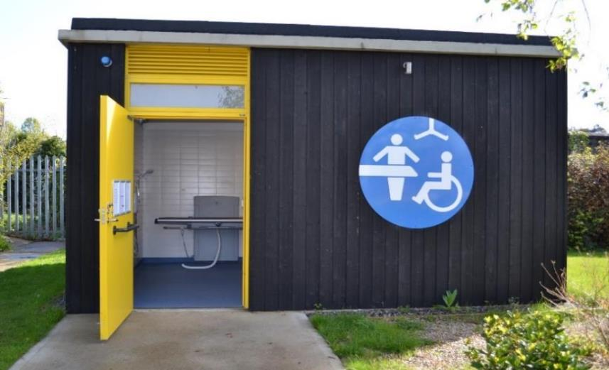

Design Features
- Clear, large, visually contrasting signage is provided.
- Visual contrast is provided between the entrance door and external wall and ground.
Design Tips
- When accessing a Changing Places Toilet, there should be unobstructed space of at least 600mm at the leading edge of a single leaf door (when it opens towards you), unless the door is opened by remote automatic control.

Who uses Changing Places Toilets?
Changing places toilets offer larger sanitary facilities that address the needs of people for whom other accessible sanitary accommodation is inadequate. They enable people with complex care needs to take part in everyday activities such as travel, shopping, family days out or attending a sporting or cultural event. This includes people using larger motorised wheelchairs. In addition, some neurodiverse people may also benefit from Changing Places Toilets as there is more space provided, and excessive noise can be avoided.

Estimated Number of Users of Changing Places Toilets
According to research carried out by the NDA between 17,100 to 37,700 or 1 in 291 to 1 in 132 people in Ireland are estimated to be potential users of Changing Places Toilets.

Benefits from providing Changing Places Toilets
There are many benefits from providing Changing Place Toilets. These include:
- Increased participation in society
Providing access to a Changing Places Toilet benefits a disabled person by preventing exclusion from society and promoting community engagement and participation. It also benefits family members and personal assistants/carers, who may assist the disabled person.
- Improved hygiene and dignity for end users
Changing Places Toilets prevent people from having to use the floor of toilets as a space to change, which is inadequate, unsafe, and unsanitary.
- Business benefits
Organisations that provide Changing Places Toilets can benefit from a wider range of people visiting their business and increased customer satisfaction.

The difference between Changing Places Toilets and Wheelchair Accessible Unisex WCs
A Changing Places Toilet is not a replacement for a wheelchair accessible unisex WC designed for independent use. It is an additional facility to address the needs of people for whom other accessible sanitary accommodation is inadequate. Changing Places Toilets are different to wheelchair accessible unisex WCs in many ways:
- Changing Paces Toilets are designed to allow Personal Assistants / Carers to assist someone in the room, whereas standard wheelchair accessible unisex WCs are designed for independent use.
- Changing Places Toilets offer other functions beyond that provided in a wheelchair accessible unisex WC, such as providing equipment and space to change clothing, attend to personal care, and in some instances showering.
- In a Changing Places Toilet both the washbasin and the WC pan are arranged differently in comparison to a wheelchair accessible unisex WC.
  - The WC pan in a Changing Places Toilet is in a peninsular arrangement (which allows space on both sides of the WC pan for wheelchair transfers or assistance from both sides of the WC pan), whereas in a wheelchair accessible unisex WC, the WC pan is in a corner arrangement (refer to Image 2 and Image 3).
  - The washbasin is not as close to the WC pan in a Changing Places Toilet as the finger rinse basin is in a wheelchair accessible unisex WC.
Image 2 WC Pan in a Changing Places Toilet with space on both sides for wheelchair transfers or for assistance to be provided (peninsular arrangement)
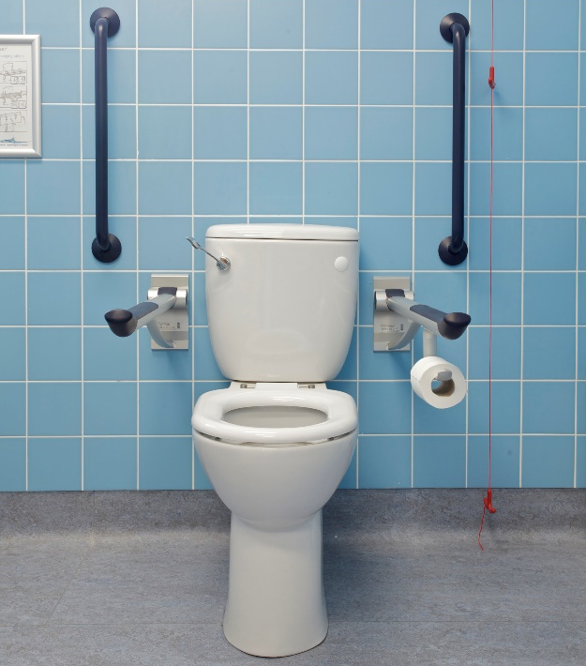

Image 3 Wheelchair Accessible Unisex WC i.e., corner WC pan arrangement and finger rinse basin within reach of the WC pan
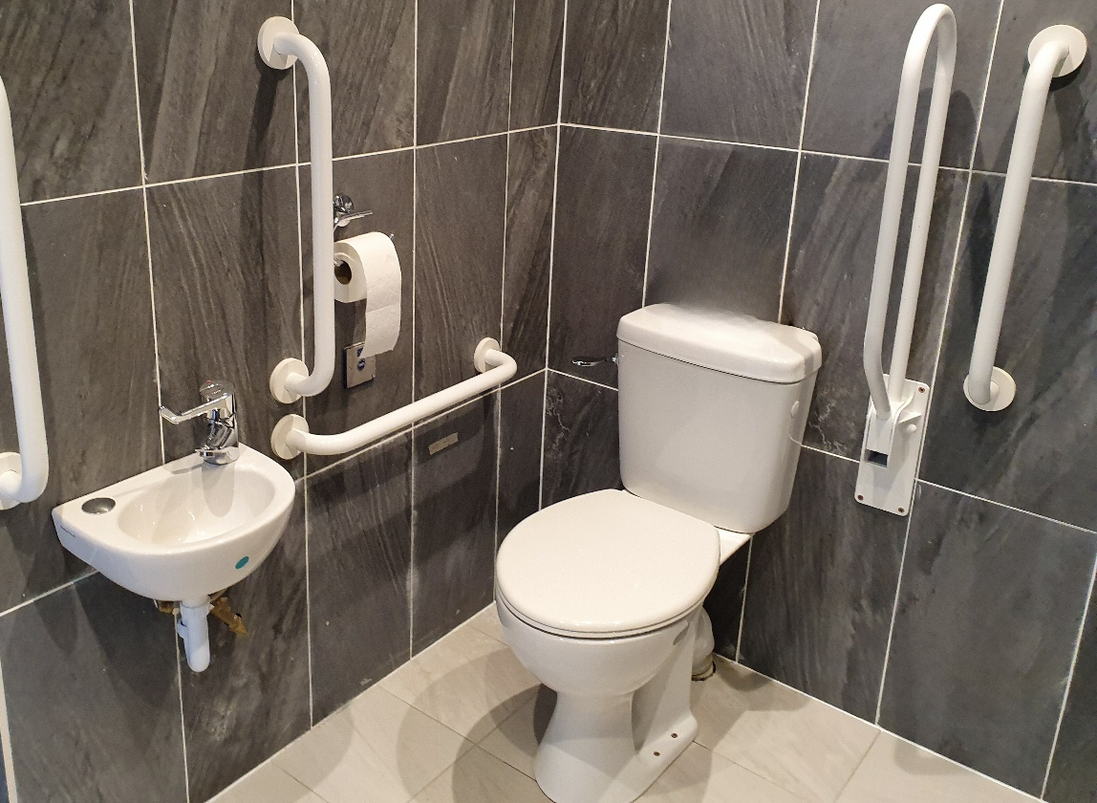

National Building Regulations Requirements
In 2022, the Building Regulations were amended by the Minister of State for Housing, Local Government and Heritage to make provision for Changing Places Toilet in certain buildings. The Building Regulations (Part M Amendment) Regulations 2022 were accompanied by a revised Technical Guidance Document M Access and Use 2022 (TGD M 2022).
M4 of the Second Schedule of the Building Regulations 2022 states: “where sanitary facilities are provided in a building, or part of a building, that is to be extended, adequate provision shall be made for people to access and use a Changing Places Toilet, having regard to the use and size of the building”.
TGD M 2022 provides guidance on the minimum provisions for Changing Places Toilets to meet the requirements of Part M of the building regulations.
Where works are carried out in accordance with the guidance in TGD M 2022, this will, prima facie, indicate compliance with Part M of the Second Schedule to the Building Regulations (as amended). However, the adoption of an approach other than that outlined in the guidance is not precluded provided that the relevant requirements of the Regulations are complied with.
TGD M 2022 does not include guidance on management or maintenance of Changing Places Toilets facilities, as this is outside the scope of the building regulations. However, it is acknowledged that management and maintenance are important functions and contribute to the ongoing accessibility of the building.

Universal Design

What is Universal Design?
Universal Design is the design and composition of an environment so that it can be accessed, understood, and used to the greatest extent possible by all people regardless of their age, size, ability, or disability.
An environment (or any building, product, or service in that environment) should be designed to meet the needs of all people who wish to use it. This is not a special requirement, for the benefit of only a minority of the population. It is a fundamental condition of good design. If an environment is accessible, usable, convenient and a pleasure to use, everyone benefits. By considering the diverse needs and abilities of all throughout the design process, Universal Design creates products, services and environments that meet peoples' needs. Simply put, Universal Design is good design.
For more information on Universal Design, refer to the Centre for Excellence in Universal Design

User involvement in the design process
A Universal Design approach involves users in the design process from an early stage. It prioritises the involvement of users with the most diverse abilities and characteristics to the greatest extent possible. When planning to provide a Changing Places Toilet, it is beneficial to engage with end users and relevant organisations at an early stage, to ensure that the facility will meet the needs and preferences of end users, as well as the minimum requirements of the building regulations. There are a range of users that could be consulted including:
- Disabled Persons Organisations
- Older Persons Organisations
- Employee Resource Groups (where a Changing Places Toilet is being provided in a workplace)
Changing Places Ireland and the access officer in the relevant local authority may be able to provide contact information for local organisations.

United Nations Convention on the Rights of Persons with Disabilities (UNCRPD)

UNCRPD and Universal Design
Ireland ratified the UN Convention on the Rights of Persons with Disabilities (UNCRPD) in 2018. Under Article 4(1)(f) of the Convention, Ireland undertakes to undertake or promote the development of universally designed facilities, which should require the minimum possible adaptation and the least cost to meet the specific needs of a person with disabilities, and to promote their availability and use, and to promote Universal Design in the development of standards and guidelines.

UNCRPD and the participation of disabled people in decision making.
Under Article 4(3), the Convention also outlines obligations on Government for how they include disabled people in the development, implementation and monitoring of policies and legislation and other decision-making processes. It applies at the local, national, and international level. The NDA guidelines 'Participation Matters: Guidelines on implementing the obligation to meaningfully engage with disabled people in public decision making' are a practical resource to support public officials at national and local level to meaningfully consult with and actively involve disabled people and their representative organisations in policy development and other decision making processes to meet obligations set out under the UNCRPD.

Key Considerations Overview

Provision

The minimum requirements for the provision of Changing Places Toilets are set out in the Building Regulations (Part M Amendment) Regulations 2022 and Technical Guidance Document M 2022 (TGD M 2022).
Changing Places Toilets are an additional and separate requirement to the provision of unisex wheelchair accessible toilets.
Consider providing a Changing Places Toilet in buildings and public spaces where they are not required in TGD M 2022, to maximise access and use for all.

Location
Ideally, locate a Changing Places Toilet at the same location as other sanitary facilities.
Consider the location at early design stages to ensure it allows for convenient access.
Consider the location of accessible parking in relation to the location of a Changing Places Toilet.

Design and Installation
Engage with end-users to identify their key needs and preferences.
Pay attention to detail in the design, equipment and finishes specified in a Changing Places Toilet.

Management and Maintenance

Provide pre-visit information and well-designed signage to enable people to easily locate and use a Changing Places Toilet.
Enable end-users to gain access easily without having to overcome complex security arrangements.
Train staff on management procedures for the facility.

Provision

Changing Places Toilets – extending the range of users
A Changing Places Toilet provides space for assistance to be provided and equipment, including a hoist and changing bench, to address the needs of people for whom other accessible sanitary facilities are inadequate. Providing a Changing Places Toilet allows access and use to people who would otherwise be excluded from using a building or public space, because of a lack of toilet facilities to meet their needs.
It is important to identify whether a Changing Places Toilet is required in a building and to consider whether more than one Changing Places Toilets should be provided. The guidance below outlines a number of factors to be considered.

Minimum Requirements for the provision of a Changing Places Toilet
From the 1st of January 2024, subject to transitional arrangements, the Building Regulations (Part M Amendment) Regulations 2022 require Changing Places Toilets to be provided in certain buildings, regarding their use and size. Table 1 of Technical Guidance Document M (TGD M) 2022 sets out fourteen relevant building uses and associated size criteria relating to the provision of a Changing Places Toilet. At least one Changing Places Toilet should be provided in the buildings with the relevant use listed in Table 1 of TGD M 2022, having regard to the use and size of the building.
In some mixed-use buildings, there may be a number of relevant building uses that exceed the size criteria in Table 1. Under TGD M 2022, it is adequate to provide a single Changing Places Toilet in such a building if it is suitably located, having regard to the operation and use patterns of all the relevant building uses. For example, it may be located adjacent to other sanitary facilities that are open to users of all the relevant building uses and available for use at the same time as those other sanitary facilities. If the building layout or management arrangements do not facilitate access to the Changing Places Toilet for users of each relevant building use, the provision of more than one Changing Places Toilet in the building may be necessary to meet the requirements of the Building Regulations for each relevant building use. For example, in a mixed-use building comprising of a shopping centre and cinema, where the sizes of both uses exceed the criteria in Table 1, access to a shared Changing Places Toilet should be available from when the shopping centre opens until the cinema closes. Alternatively, a separate Changing Places Toilet should be provided for each use to ensure access to a Changing Places Toilet is provided for users of both the shopping centre and cinema.

Table 1 also includes a requirement for a Changing Places Toilet as part of sanitary facilities associated with outdoor amenities used for assembly, recreation, or entertainment such as zoos, amusement parks and theme parks. With this relevant use, the requirement is linked to the capacity of the outdoor amenity and the distance from another building within the same amenity containing a Changing Places Toilet. A Changing Places Toilet is required in a building or part of a building containing sanitary facilities where the capacity of the outdoor amenity is more than 2,000 people (excluding staff) unless there is another building containing a Changing Places Toilet within 250 metres. This distance is measured as a straight line between buildings, rather than as a travel distance.

Taking a Universal Design Approach - going beyond minimum requirements
Consideration should be given to providing a Changing Places Toilet in buildings and public spaces where they are not required in TGD M 2022, to maximise access and use for all. In addition, consideration should be given to providing more than one Changing Places Toilet in a building, depending on its size and use. For example:
- In a theatre, providing a Changing Places Toilet backstage for performers as well as one for use by members of the audience should be considered.
- On an existing university or hospital campus, a Changing Places Toilet may be required in a new building. Consideration should also be given to also providing a Changing Places Toilet in other existing buildings on the campus to reduce the need for users to travel long distances.
- A new stadium should consider providing more than one Changing Places Toilet, depending on circulation routes and the distance a user might have to travel from one part of the stadium to another.
An analysis of the building use, building capacity and end user experience should be taken into consideration to determine whether more than one Changing Places Toilet is provided. Involving users in the design process can also inform the provision of Changing Places Toilets beyond the minimum requirements set out in building regulations. Refer to Section 3.8.2 for further information.

Improving the Access and Use of Existing Buildings
Many organisations are committed to improving the overall access and use of their facilities to improve the visitor experience for everyone. Organisations should review their diversity and inclusion initiatives and access audit findings and identify if Changing Places Toilets should be provided within their existing facilities.
Public bodies should be aware of their obligations under Section 25 of the Disability Act 2005, as this may result in a Changing Places Toilets being required in some public buildings. The definition of a public building set out in Section 25 of the Disability Act is ‘a building, or that part of a building, to which members of the public generally have access and which is occupied, managed or controlled by a public body’. Under Section 25 of the Disability Act, public buildings shall be brought into compliance with any amendment of Part M made after such commencement not later than 10 years after the commencement of the amendment. Part M Building Regulations (Part M Amendment) Regulations 2022 commenced on 1 January 2023.

Planning and Building Control
The provision of Changing Places Toilets may require planning permission and will need to meet the requirements of the Building Regulations and Building Control Regulations (for example submission of a Disability Access Certificate application). When considering installing a Changing Places Toilet, professional advice should be obtained from a competent person in the early stages of a project to ensure that all works will meet the requirements of planning and building control legislation.

Location
When installing a Changing Places Toilet, it is important to ensure that it is easy to locate, access and exit safely. Guidance on the location of Changing Places Toilets is provided below.

Maximising Access and Use
Changing Places Toilets should be conveniently located to maximise access and use for all users. Ideally, they should be located adjacent to other sanitary facilities within a building. To maximise accessibility and usability, travel distances should be kept to a minimum. For example, the location of designated accessible parking should be considered in relation to the location of the Changing Places Toilet.
When providing Changing Places Toilets in public spaces, ensure that they are conveniently located close to the arrival point and/or centrally located within the main facilities at the site. For example, if providing a Changing Places Toilet in a public park or at a beach, it should be conveniently located adjacent to other sanitary facilities.
The location of a Changing Places Toilet can impact on management and security arrangements and needs to be carefully considered in this regard. Refer to Section 6.3 below.
The route to the Changing Places Toilet should be accessible. When installing a Changing Places Toilet in an existing building or facility it will be important to review existing levels of accessibility from the approach/entry to the proposed location of the Changing Places Toilet.

Consider Location at Early Design Stages
It is important to ensure that the location of Changing Places Toilets is integrated early in the design of building works to ensure sufficient space is allocated, that the Changing Places Toilet is conveniently located, that the need for complex security arrangements can be avoided and to ensure approach routes to the Changing Places Toilet are accessible and usable for all.
Integrating Changing Places Toilet requirements (for example provision, location, and design) into specifications and the design brief for projects is one way to ensure these considerations are addressed at an early stage in the design process.

Accessibility and Security
All toilets should, wherever possible, be freely accessed to preserve the dignity and privacy of users. Some people need to use toilets more frequently than others, and some with a greater sense of urgency. Having to locate a key or member of staff will delay access, which is inconvenient and may cause unnecessary discomfort. It should be easy for users to access a Changing Places Toilet, without having to overcome complex security arrangements.
The location of a Changing Places Toilet should be selected to minimise the security arrangements necessary to access the Changing Places Toilet and to ensure that a Changing Places Toilet remains unlocked during standard opening times. A Changing Places Toilet that is in a staffed facility should be kept unlocked when not in use.
In some cases, it may be necessary to lock a Changing Places Toilet, for example in remote locations to prevent un-authorised access. For further information on managing access into Changing Places Toilets and the provision of security arrangements refer to Section 8.4.

Location in Existing Buildings
Where a Changing Places Toilet is being installed in an existing building, it should be conveniently located within easy access of the entrance of the building, or alternatively adjacent to other sanitary facilities in the building. The route leading to the Changing Places Toilet should be easy for everyone to use. This may require alterations to existing corridors and doors along the route leading to the Changing Places Toilet. For example, doors along the route to a Changing Places Toilet may need to be widened and/or held open.
TGD M 2022 includes specific provisions relating to the installation of a Changing Places Toilet in an existing building.

Signage and Wayfinding
Signage needs to be carefully designed and positioned to allow users to easily find a Changing Places Toilet. For guidance on signage to sanitary facilities, refer to ‘Section 5.10.13 of Building for Everyone: A Universal Design Approach, Booklet 5, Sanitary Facilities’.
Accessibility maps and guides should be made available through a variety of formats and media (for example, maps and guides made available at reception areas; information provided on a website; provided in community facilities; Changing Places Toilet Registration) as described in Section 8.

Design and Installation
This section of the guidelines provides technical guidance on the design of Changing Places Toilets, taking a Universal Design approach.
Careful consideration and attention to detail in the design, equipment and finishes specified in a Changing Places Toilet is required. In particular, the size of the equipment provided in a Changing Places Toilet can impact on the clear circulation space required and the overall size of the room.

Approach
Careful planning and design should ensure that approach routes leading to a Changing Places Toilet accommodate a wide range of users, in new and existing buildings. Internal doors should provide a minimum clear effective width of 850mm, although a greater width is preferred where practical. Where there are doors with door closers on the approach route, hold-open devices should be provided where possible, to maximise ease of access.
Any Changing Places Toilet door opening towards a corridor which is a major access route, or an escape route should be recessed so that when fully open, it does not project into the corridor space.
A clear unobstructed space of 1,800mm by 1,800mm minimum should be provided directly outside the door to the Changing Places Toilet. This will facilitate users to easily enter the Changing Places Toilet or to turn around if the Changing Places Toilet is already occupied.

Size and Space
The minimum overall dimensions and arrangement of equipment, circulation spaces, grab rails and other fittings within a Changing Places Toilet are shown in Figure 1 . Figure 1 is the standard layout from TGD M 2022, which positions the door on the longer wall of the Changing Places Toilet. The minimum size of the Changing Places Toilet in this example is 4,200mm by 3,000mm.
A wheelchair turning space, free from obstruction, of 1,800mm by 2,000mm minimum should be provided immediately inside the door, clear of the door swing. Heat emitters, casings and shelves should be located so that they do not project into or restrict the minimum clear wheelchair turning space or the circulation spaces beside the WC, washbasin or changing bench, nor should they be located where they may cause injury to a person using the changing bench.
Figure 1 Changing Places Toilet Plan (Option 1)
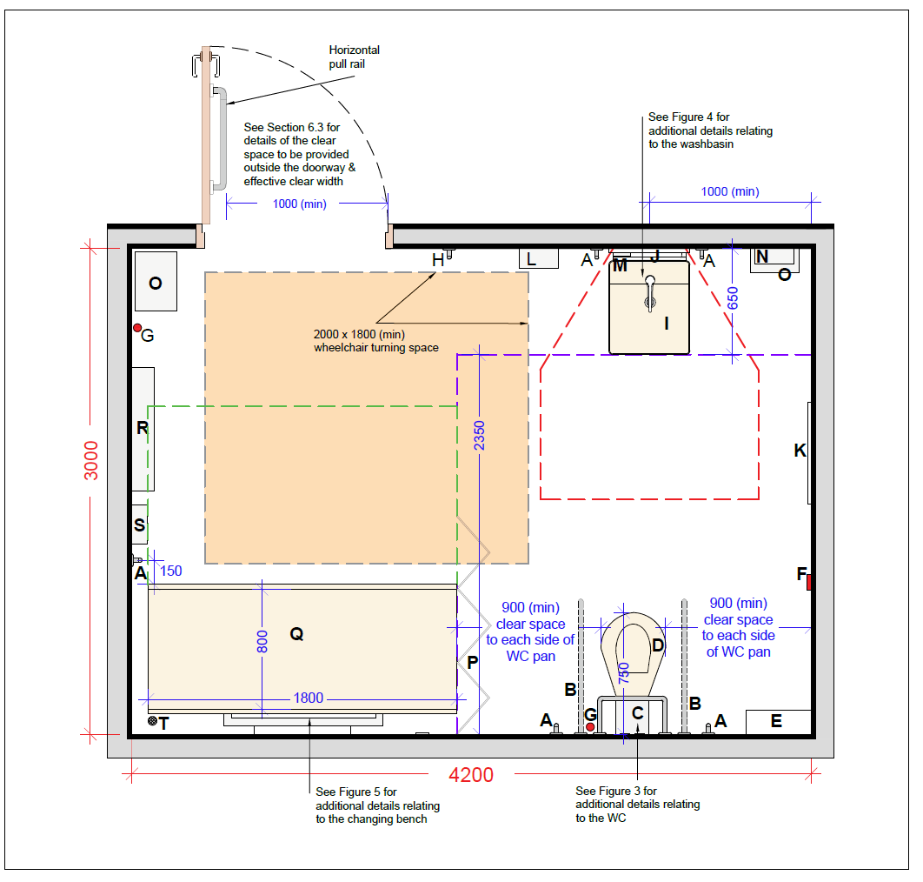
Key
A. Vertical grabrail ∅ diameter 35mm
B. Drop down rail ∅ diameter 35mm
C. Padded back rest
D. WC pan
E. Colostomy changing shelf
F. Alarm reset button
G. Alarm pull cord
H. Clothes hooks
I. Height-adjustable washbasin
J. Mirror above basin
K. Full length mirror
L. Automatic hand dryer
M. Soap dispenser
N. Paper towel dispenser
O. Disposal bin
P. Privacy screen
Q. Height-adjustable changing bench
R. Wide paper roll dispenser
S. Optional showering unit with minimum 2,000mm hose
T. Floor drain (when showering unit is provided)

Note: All dimensions in millimetres.

TGD M 2022 allows a more flexible approach to the room size and layout in an existing building once the wheelchair turning space inside the door and adequate space allowance around each piece of equipment is provided. Figure 2 illustrates the circulation space required.
Figure 2 Wheelchair turning space and circulation space required in front of equipment in new and existing buildings.
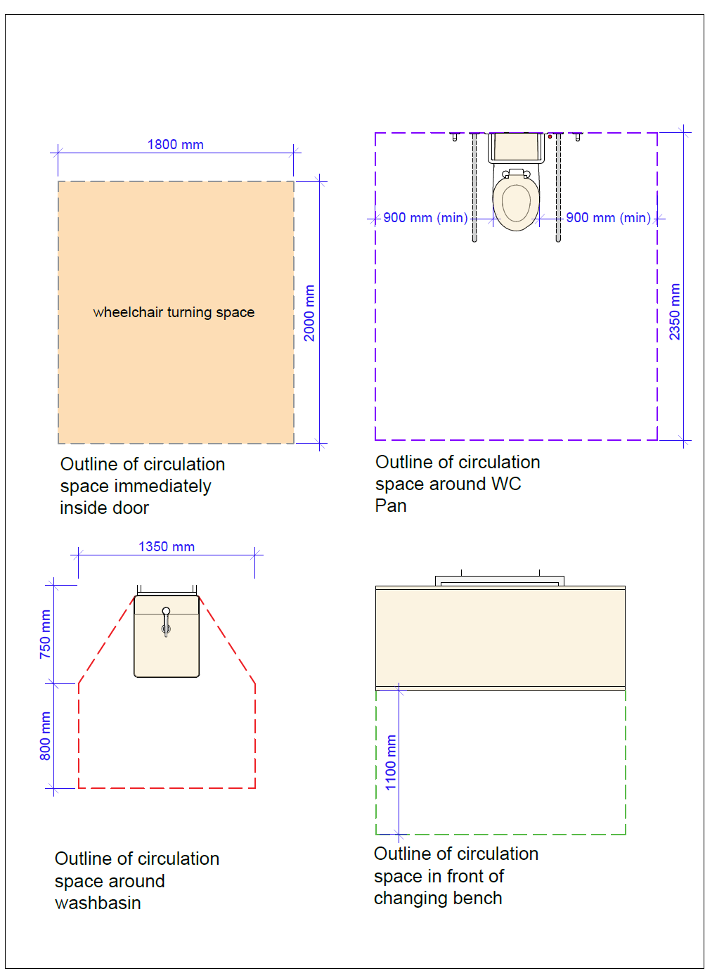
Figure 3 below indicates a layout with the door on the shorter wall of the Changing Places Toilet, entering between the WC pan and wash basin. In this example, a wash basin with an overall depth (including bracket) of 650mm is shown. In order to provide the wheelchair turning space of 2,000mm by 1,800mm directly inside the door, the room needs to be a minimum 3,200mm wide. Figure 3 does not demonstrate prima facie compliance with the provisions of the building regulations.
Figure 3 Changing Places Toilet Plan (Option 2)
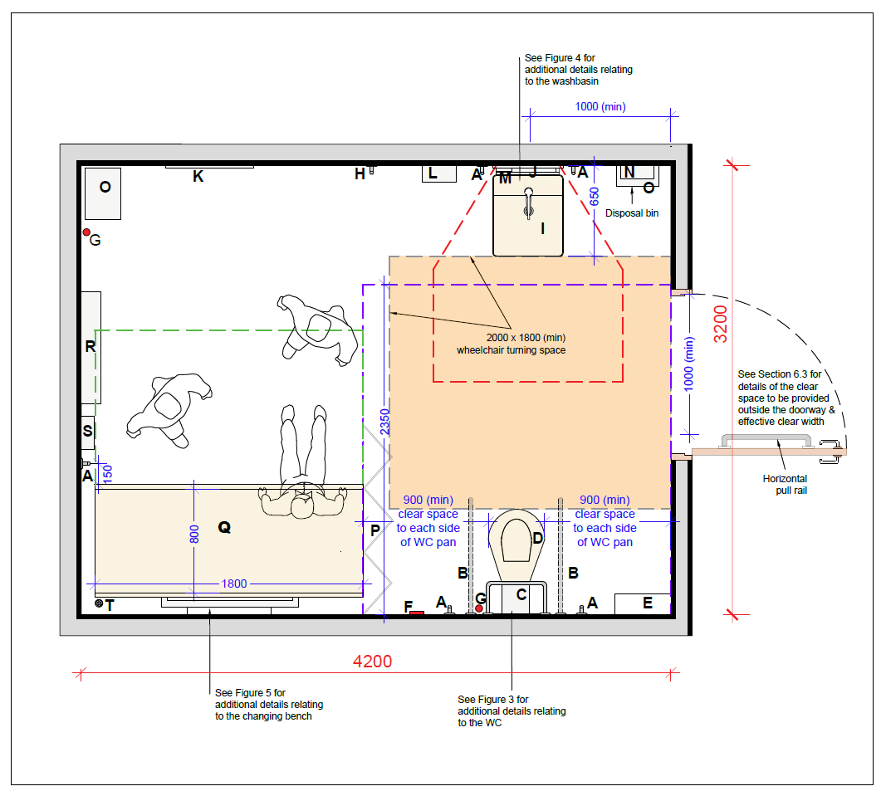
Key
A. Vertical grabrail ∅ diameter 35mm
B. Drop down rail ∅ diameter 35mm
C. Padded back rest
D. WC pan
E. Colostomy changing shelf
F. Alarm reset button
G. Alarm pull cord
H. Clothes hooks
I. Height-adjustable washbasin
J. Mirror above basin
K. Full length mirror
L. Automatic hand dryer
M. Soap dispenser
N. Paper towel dispenser
O. Disposal bin
P. Privacy screen
Q. Height-adjustable changing bench
R. Wide paper roll dispenser
S. Optional showering unit with minimum 2,000mm hose
T. Floor drain (when showering unit is provided)

Note: All dimensions in millimetres.

Doors to Changing Places Toilets
A self-closing device should not be fitted to the door of a Changing Places Toilet unless the door is an accessible power-operated door or a fire door.
If a manually operated door is provided, the door handle should be a light action lever lock. The door handle should be operable with a closed fist.
The privacy bolt or lock should incorporate a visual indicator to display whether the Changing Places Toilet is vacant or occupied.
A minimum of 1,000mm effective clear width is required on the Changing Places Toilet door. This is to accommodate large, wheeled mobility devices.
There should be an unobstructed space of at least 600mm on the pull side of the door between the leading edge of the door (when it opens towards you) and a return wall unless the door is opened by remote automatic control.
Doors to Changing Places Toilets should have an emergency release mechanism (e.g., lifting off hinges).
If a manual outward opening door is provided, it should be fitted with a 600mm long horizontal rail 900mm above finished floor level.
Provision of an outward-opening door allows for maximum wheelchair circulation space inside the facility and is the preferred option, as an outward opening door can be opened easily in an emergency if a person has fallen against the door inside the room.
Automatic doors should be provided, where possible, because opening a door while guiding a wheelchair can be difficult. Controls for automatic doors should be easy to use and should contrast visually with their background. For further guidance on automatic doors, refer to ‘Section 2.6.6 of Building for Everyone: A Universal Design Approach, Booklet 2, Entrances and horizontal circulation’.
Should sliding doors be provided, the guidance on sliding doors in ‘Section 5.10.3 of Building for Everyone: A Universal Design Approach, Booklet 5, Sanitary Facilities’ should be followed.
Acoustic privacy should be considered in a Changing Places Toilet, as it may be occupied by a disabled person as well as one or two Personal Assistants / carers. Doors should be designed with acoustic properties to enable speech privacy. Speech privacy means that when conversations are taking place, listeners may hear sounds, but cannot make out what the speakers are saying.

WC Pan
A peninsular WC layout should be provided with a clear circulation space provided around the pan. The space either side of the WC pan is to allow for Personal Assistants / Carers to assist on both sides of the WC pan. Refer to Figure 4 for the clear space required in front of and on each side of the WC pan. A distance of 750mm should be provided from the back wall to the front of the WC pan.
Wall mounted drop-down support rails and vertical grab rails should be provided on both sides of the WC pan. Refer to Figure 4 for the location of wall mounted drop-down support rails and vertical grab rails on both sides of the WC pan.
A toilet paper dispenser should be provided on at least one of the drop-down support rails and preferably on both drop-down support rails.
Vertical rails should be a minimum of 600mm in length.
Wherever possible, dropdown support rails should be height adjustable as this offers greater flexibility.
The WC pan should have a seat height of 480mm above finished floor level. The following additional provisions should be considered in consultation with users:
- an automatic ‘wash and dry’ WC pan
- a height-adjustable WC pan
Providing a separate colostomy shelf is preferred to using the WC cistern as a shelf. This is to ensure that a hygienic and safe space is provided for personal care items, which can include not only colostomy care items, but also sanitary pads, wipes, hygiene products, incontinence wear and personal protective equipment (PPE). Refer to Section 7.20 for further guidance on the provision of shelves.

Figure 4 Changing Places Toilet WC Pan Circulation Space and Fittings
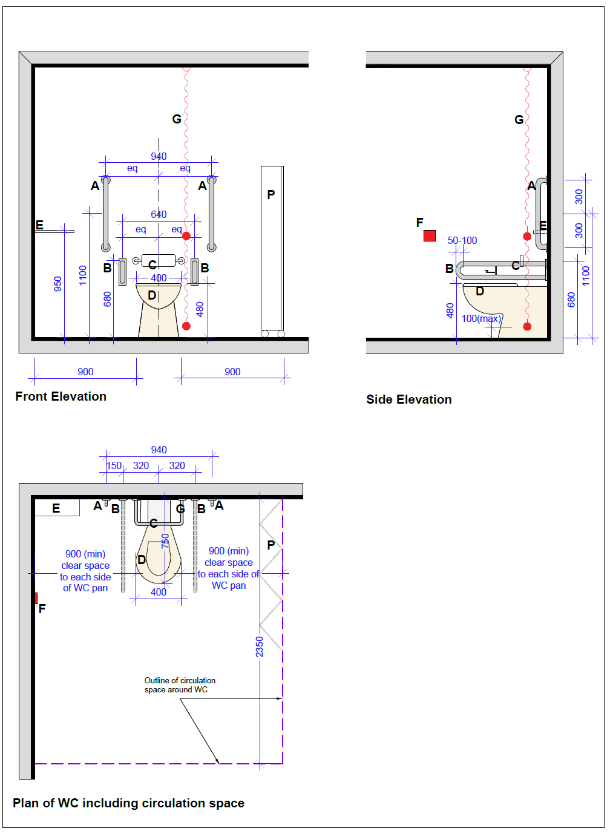
Key
A. Vertical grab rail ∅ diameter 35mm
B. Drop down rail ∅ diameter 35mm
C. Padded back rest
D. WC pan
E. Colostomy changing shelf
F. Alarm reset button
G. Alarm pull cord
P. Privacy screen
eq. Equal distance

- Height of drop-down rails to be the same as the other horizontal grabrails.
- At least one drop-down rail with toilet paper dispenser but preferably both drop-down rails to have toilet paper dispenser.
- Height subject to manufacturing tolerance of WC pan.
- A separate colostomy changing shelf 125mm to 150mm deep x 400mm minimum wide with its surface 950mm above floor level should be provided.

Note: All dimensions in millimetres.

Image 4 Peninsular WC pan arrangement
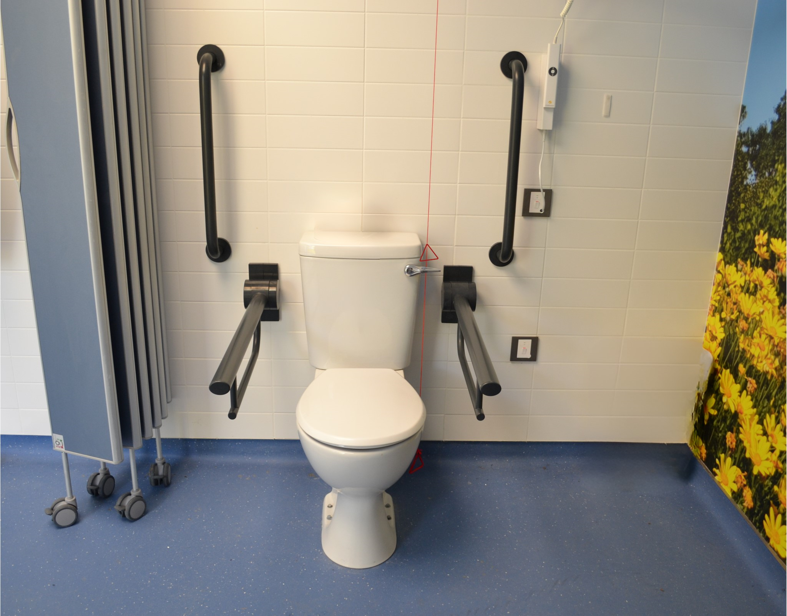
Design Tips
- Toilet paper should sit on the drop-down grab rails beside the WC pan.
- The fittings and fixtures should visually contrast with the background of which they are seen i.e., a white WC pan should not be against a white tiled wall.

Changing Bench

Wall-mounted Changing Bench
A wall-mounted adult-sized, height adjustable, changing bench should be provided, with a clear unobstructed circulation space in front of the changing bench as per Figure 5.
The height-adjustable changing bench should have a changing surface which is a minimum of 1,800mm in length by 800mm wide with a minimum certified weight capacity of 200kg. The height adjustment mechanism for wall mounted benches should be mains powered and include a pressure sensitive safety override that will prevent the changing bench from lowering if there is any obstruction underneath.
The changing bench should have a minimum range of height adjustment from 450mm to 900mm above finished floor level.
It should have retractable side safety rails along the long edge(s) that can be folded up or down.
Where a shower facility is being provided, a suitable changing bench should be provided with provision for wastewater disposal.
A vertical grab rail should be provided 150mm from the front edge of the changing bench at the available wall side as per Figure 5.
Changing bench material should be comfortable, easily wipeable and non-porous to support infection control. For example, some changing benches are padded for cushioning effect and some products have adjustable surfaces/inclined backs to prop a person’s head and/or back on the bench which can assist in dressing and hair washing.
Instructions should be provided on how to adjust the rails and the height of the changing bench.

Figure 5 Changing Places Toilet Changing Bench and Fittings
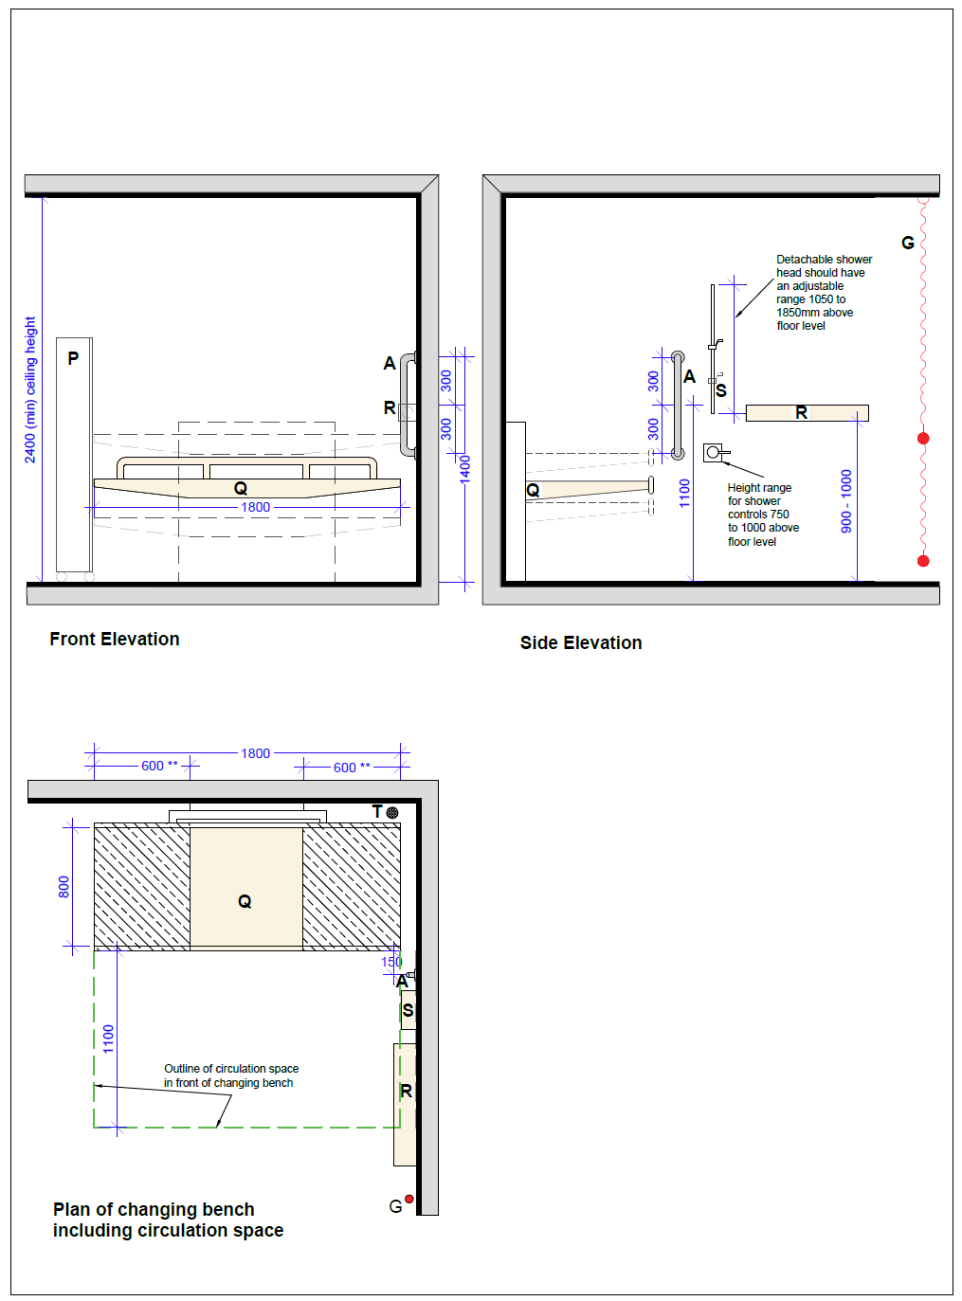
Key
A. Vertical grabrail ∅ diameter 35mm
G. Alarm pull cord
P. Privacy screen
Q. Height-adjustable changing bench
R. Wide paper roll dispenser
S. Optional showering unit with minimum 2,000mm hose
T. Floor drain (when showering unit is provided)

Note:
- The changing bench should have a minimum height adjustment range of 450mm to 900mm above floor level.
- Downlighters not to be fitted directly above the last 600mm of the head or foot of the changing bench.
- A wall mounted wide paper roll dispenser should be provided with the underside between 800mm and 1,000mm above floor level.
- A shower unit should be provided within the Changing Places Toilet in buildings where sanitary facilities combining showers and WCs for use by people other than staff are provided.

Note: All dimensions in millimetres.

Image 5 Example of a wall-mounted height-adjustable changing bench.
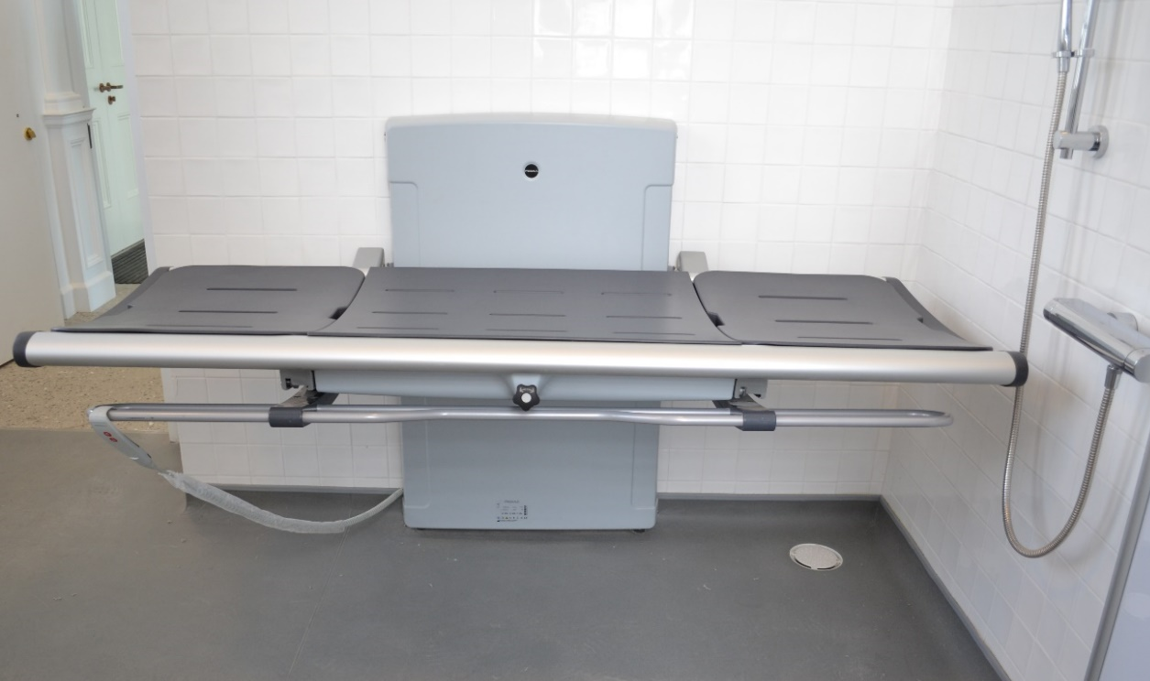

Image 6 A person using a hoist, being transferred onto a wall-hung changing bench by two assistants.
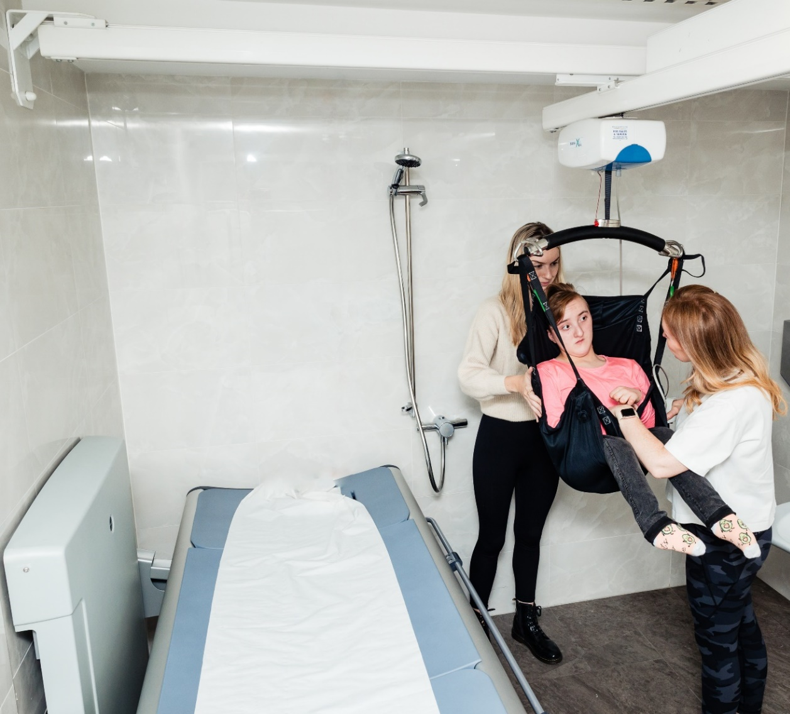
Design Features
- Paper roll has been provided for the changing bench use.

Free-standing Changing Bench
Providing a wall-mounted changing bench will ensure that the bench cannot be removed from the Changing Places Toilet and will be the most suitable option in most public buildings. A free-standing bench can be moved and enables a user to be assisted by two or more people either side of the bench, whereas a wall-hung bench enables people to be assisted on one side of the bench only. In some cases, for example in a day centre with staff who are familiar with the equipment, a free-standing changing bench may be preferred to a wall-mounted version. Providing a free-standing changing bench should be informed by stakeholder engagement and consultation with end-users.
Note: The minimum provisions in TGD M 2022 require a wall-mounted changing bench. If installing a free-standing bench in a Changing Places Toilet, the compliance report submitted with a Disability Access Certificate application should clearly state the rationale for installing same (e.g., explain the context, building use, and user needs in a particular building). The free-standing bench will need to be in situ before a certificate of compliance on completion may be issued and remain in place for compliance with the requirements of the Building Regulations to be satisfied.

Washbasin
To cater for both standing and seated users, a power-operated, height adjustable washbasin should be provided. Refer to Figure 6 above for the clear circulation space required around the washbasin. An electronically height-adjustable range of 600mm to 850mm should be provided and the knee recess under the basin should be free of obstructions. The height-adjustment mechanism should include a pressure sensitive safety override that will prevent the washbasin from lowering if there is any obstruction underneath.
A minimum washbasin size of approximately 500mm wide by 450mm deep is required, to enable people to have a full body wash, or to wash personal care equipment. There are a variety of washbasin sizes available on the market.
The drawings in these guidelines illustrate an indicative overall washbasin depth of 650mm, which includes the height-adjustable washbasin bracket and the washbasin itself. Should the installed washbasin (including bracket) be bigger than the one reflected in the drawings, the 2350mm deep clear circulation space at the WC pan should still be maintained and this will impact on the overall width of the room.
Vertical grabrails should be provided adjacent to the washbasin as this enables users to pull themselves closer to the rim of the washbasin. They also allow a person to stabilise themselves at the washbasin. The top fixings for both handrails should be 1,400mm above floor level. Refer to Figure 6 for further details on the location of vertical grab rails on both sides of the washbasin.
The washbasin should have a power-operated height-adjustable control that is visually contrasting. If controls of the washbasin have a remote control, there should be a bracket to hang the remote control.
An automatically controlled tap or a tap capable of being operable with a closed fist, such as a long lever tap, should be provided.
There should be an instruction manual with images and clear instructions, as well as signage to indicate how to operate the washbasin.
The washbasin and tap should visually contrast from the background on which they are seen.

Figure 6 Changing Places Toilet Washbasin and Fittings
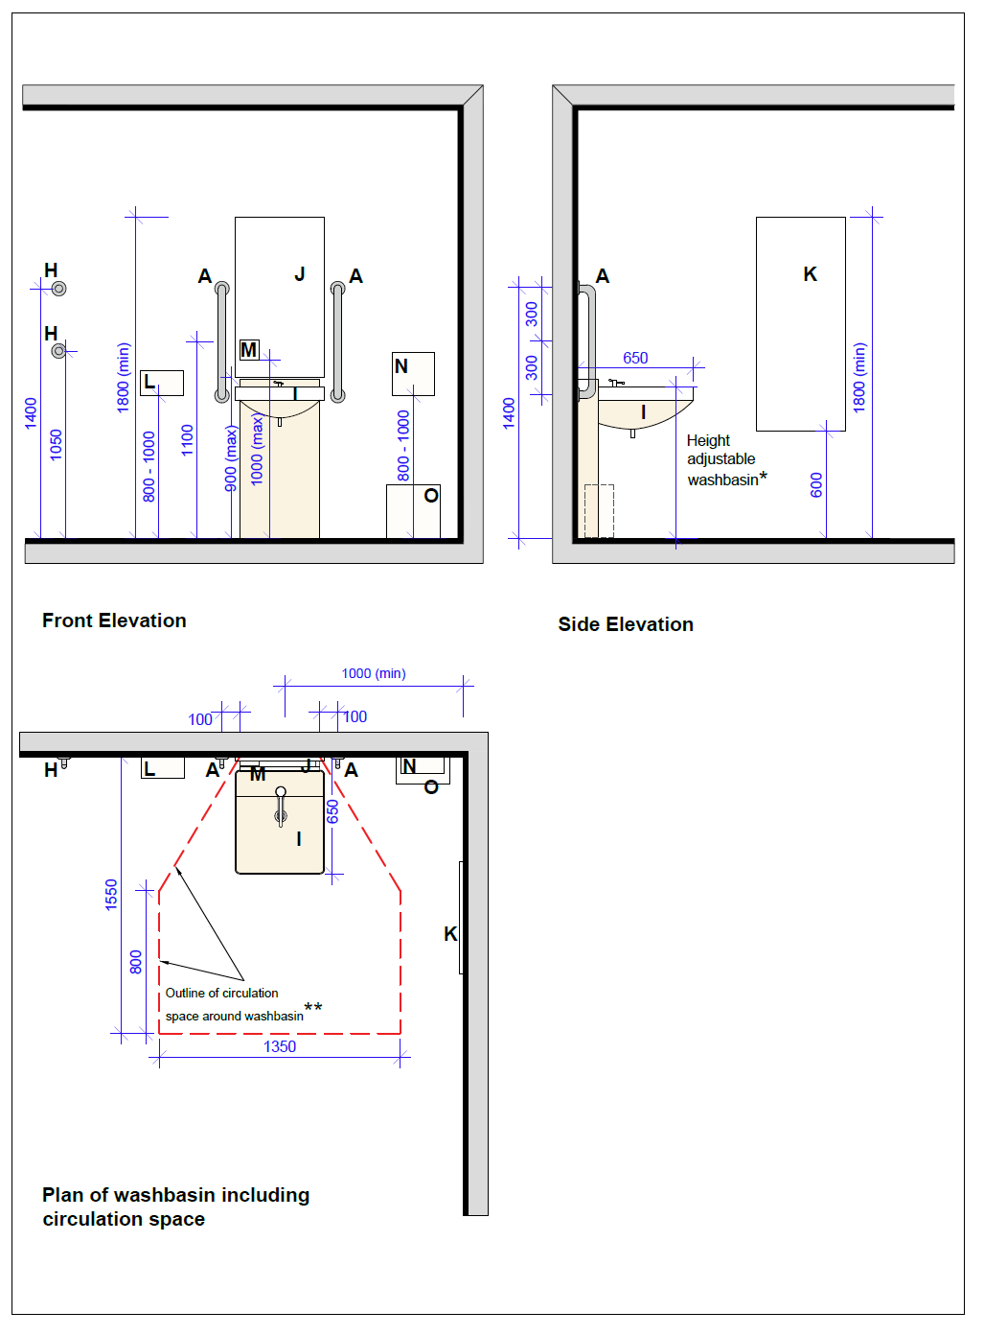
Key
A. Vertical grabrail ∅ diameter 35mm
H. Clothes hooks
I. Height-adjustable washbasin
J. Mirror above washbasin
K. Full-length mirror
L. Automatic hand dryer
M. Soap dispenser
N. Paper towel dispenser
O. Disposal bin

Note:
- The washbasin should have a range of height-adjustment of 600mm to 850mm minimum above floor level.
- The circulation space around the washbasin begins to each side of the washbasin where the washbasin abuts the wall.

Note: All dimensions in millimetres.

Image 7 Example of a height-adjustable washbasin
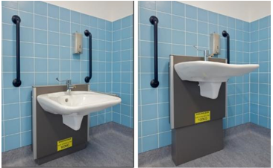
Design Features
- Grab rails are provided each side of the washbasin.
- The tap lever can be operated with a closed fist.
Design Tip
- A mirror should be installed over the washbasin.

Soap Dispenser
A soap dispenser should be wall-mounted directly above the washbasin, with its lower edge at 1,000mm above finished floor level, to allow for a sufficient gap to be maintained when the wash basin is at its highest position and for easy operation by seated and standing users.
An automated sensor soap dispenser should be provided as it requires low physical effort. Alternatively, the soap dispenser should be easy to operate with one hand.
Pump dispensers which require fine motor movement and force should not be installed.
Hand sanitizer is not a requirement, but it is recommended to provide it. It should be offered by the same low-effort mechanism as the soap dispenser.

Hand Drying
A hand dryer and a paper towel dispenser should be provided in a Changing Places Toilet.
Low noise hand dryers should be provided with a maximum noise level of 70 decibel. Louder hand dryers can cause discomfort for people who have noise sensitivity. The hand dryer should function by either a motion sensor or a push button which can be activated by a closed fist.
The hand-dryer should be provided near the washbasin with the lower edge positioned 800mm to1,000mm above finished floor level. The design of the hand dryer should not require hands to be inserted from the top of the dryer.
There should be a hand-dryer on/off switch located between heights of 900mm and 1,200mm beside the hand-dryer. This is to allow users have the option to turn the hand-dryer off and prevent noise.
There should be sufficient space in front of the hand-dryer for a wheelchair user to wheel up to it as per Figure 1 and Figure 6.
The paper towel dispenser should be wall-mounted close to the washbasin with the lower edge positioned 800mm to 1,000mm above finished floor level. The paper towel dispenser should be easy to operate with one hand.
Both the paper-towel dispenser and hand-dryer should visually contrast against the background they are seen on.

Wide Paper Roll Dispenser
A wall-mounted dispenser with a wide paper roll to match the width of the bench should be provided, adjacent to the head of the changing-bench.
The underside of the wall mounted paper roll dispenser should be positioned 800 to 1,000mm above finished floor level.
Where possible, avoid locating the wall mounted paper roll dispenser too close to where a shower is provided.

Hoist System
A continuous charging full-ceiling coverage track should be provided within the Changing Places Toilet that conforms to ‘I.S. EN ISO 10535 Hoists for the transfer of disabled persons: Requirements and test methods’. Ceiling mounted mechanical and electrical fittings should not obstruct the moving rail of the overhead hoist.
Image 8 Example of a user being hoisted within a Changing Places Toilet.
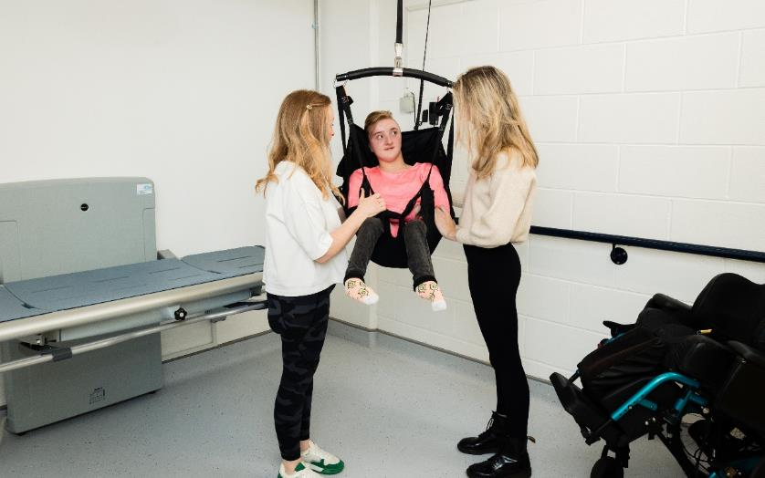
The room structure and hoist system should be capable of supporting a safe working load of not less than 200kg. The hoist, the washbasin and the changing bench should have the same lifting load to prevent a mismatch of safe lift loads. A Changing Places Toilet is not suitable for Bariatric use where load-bearing capabilities are required in excess of 200kg and increased space to accommodate very large mobility devices may be required. It is necessary to obtain specialist advice for such use.
A minimum clear ceiling height of 2,400mm should be provided. This is to accommodate the ceiling hoist space whilst providing clear headroom between the hoist track/rails and the finished floor level, which should be no less than 2,100mm.
The hoist spreader bar should be capable of extending from the hoist down to no more than 300mm from the floor level to facilitate a person being lifted from ground level if required in an emergency.
This type of track system is typically a H-frame, and it should provide full room cover.
The handset controls for the hoist should visually contrast against the background on which they are seen.
Clear and visual hoist instructions should be provided for the hoist attachment, control, and use.
Hoist signage should include the following:
- Safety features such as maximum load weight, production certification such as CE markings, date of last service (typically provided on a sticker by an equipment service engineer).
The following additional hoist provisions should be considered in consultation with users:
- Hoist Attachment – spreader bar – providing different hoist attachments which allow the attachment of different types of slings (loop and clipped).
- Hoist Attachment – a hoist with a weighing scales attachment. Some wheelchair users find it difficult to record their weight at home, and this hoist attachment could be of benefit.

Image 9 Example of a ceiling track hoist weigh-scale attachment
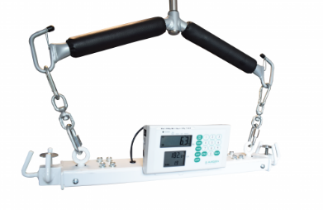

Privacy Screen

Wall mounted Privacy Screen
A privacy screen is typically a wall-mounted folding screen on castors that can be pulled out to shield the user and Personal Assistants / Carers in a Changing Places Toilet. It offers extra privacy for users of Changing Places Toilets when using the changing bench or WC pan whilst not obstructing the space to the side of the WC when it’s retracted.
Privacy screens should have an extended length of not less than 1,750mm. The screen should have a surface that is easy to clean and dry.

Free-standing Privacy Screen
Providing a wall-mounted privacy screen will ensure that it cannot be removed from the Changing Places Toilet and will be the most suitable option is most public buildings. However, a freestanding privacy screen can offer more flexibility than a wall-mounted one, as it can be positioned in different areas of the room. In some cases, for example in a day centre with staff who are familiar with the equipment, a freestanding privacy screen may be preferred to a wall-mounted version. Providing a free-standing privacy screen should be informed by stakeholder engagement and consultation with end-users. If a free-standing privacy screen is provided, it should have a sturdy castor base and not tip-over when moving.
Note: The minimum provisions of TGD M 2022 require a wall mounted privacy screen. If installing a free-standing screen in a Changing Places Toilet, the compliance report submitted with a Disability Access Certificate application should clearly state the rationale for installing same (e.g., explain the context, building use, and user needs in a particular building). In addition, the free-standing privacy screen will need to be in situ before a certificate of compliance on completion may be issued and remain in place for compliance with the requirements of the Building Regulations to be satisfied.

Image 10 Example of a wall-mounted privacy screen in the extended position, to provide privacy at the WC pan.
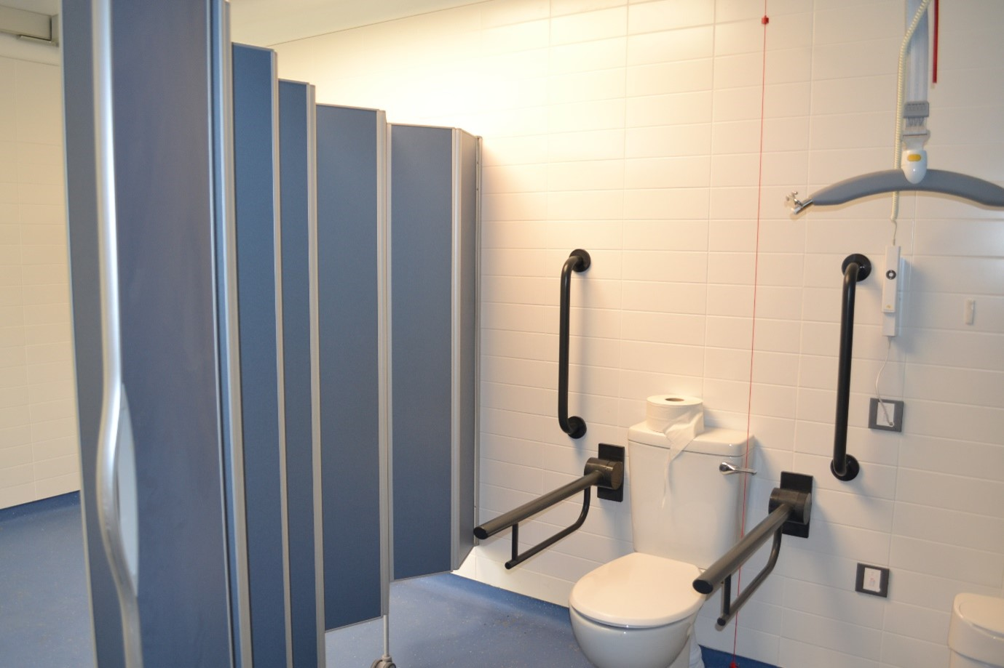

Waste Disposal Bins
Two bins should be provided in a Changing Places Toilet, one for general refuse and one for sanitary / offensive waste. Sanitary / offensive waste is non-infectious, non-clinical, non-hazardous waste that contains bodily fluids, secretions, or excretions.
The bin provided for sanitary / offensive waste should be large enough for the following:
- Personal protective equipment (PPE) such as gloves, aprons, and masks.
- Incontinence wear products such as incontinence pads, chair protection sheets, catheters, penile sheaths, stoma bags and urinary drainage bags.
The bins should, where practicable, be recessed into the wall to avoid being an obstacle.
Some users including wheelchair users may not be able to use pedal-bins. Hands free bins are good for infection control as they prevent people from touching the top of the bin. Automated or infrared sensor bins are accessible and operate on low power usage. They require infrequent battery changes.

Ventilation
Adequate ventilation should be provided to ensure the room has sufficient fresh air, including in a Changing Places Toilet where a shower is provided. Supplementary natural ventilation (for example windows) may also be beneficial.
If a ventilation extract fan is provided, it should be as quiet as possible in operation as the noise can cause distress to some people and can be a barrier to communication.
Placement of heating, ventilation and air conditioning fans should be considered so the airflow is not blowing air on top of a user. For example, avoid locating the fans over the changing bench and WC where a user can be positioned for long periods of time.

Mirrors
A mirror should be installed over the washbasin with the lower end of the mirror being 900mm above finished floor level. The mirror should have an overall length of at least 900mm.
A wall-mounted full-length mirror with unobstructed access should also be provided in the Changing Places Toilet, to enable both seated and standing users to view themselves. The full-length mirror should be at least 600mm wide and should be positioned with its lower edge no higher than 600mm from finished floor level, extending to at least 1,800mm from finished floor level. A mirror should not extend to floor level as this can create a false impression of being a door or wall opening.
A minimum gap of 300mm should be provided between the mirror and the corner of the room, to allow for ease of use for all users.

Sanitary Towel Dispenser
A sanitary towel dispenser should be provided. The controls and dispensing drawer should be positioned at a height between 750mm and 1,200mm above finished floor level. The dispenser should be located no less than 500mm from an internal corner.

Emergency Assistance Alarm System
An emergency alarm with two pull cords should be provided within the Changing Places Toilet. This will allow the user or Personal Assistant / Carer to call for help if needed. These need to be carefully positioned to avoid obstructing the operation of the overhead hoist.
The two alarm pull cords should have two red bangles, one at 100 mm, the other at 800mm to 1,000mm above floor level. This allows for the cord to be reachable by a person who has fallen to the floor, as well as someone seated or standing. For positioning of the two alarm pull cords refer to Figure 1 and Figure 4.
A reset button should be provided in the position shown in Figure 1 and Figure 3, and the lower end of the reset button should be located 800mm above finished floor level.
There should be visual and audible indicators at a central control point to alert staff that an emergency call has been activated. Additionally, there should be a visual and audible indicator provided directly outside the Changing Places Toilet so it can be seen and heard by people to give assistance. The sound should be distinguishable from the fire alarm sound.
Ensure that early planning takes place to ensure the alarms are fully integrated into the overall operational strategy for the facility (for example the alerts are sent to staffed areas and that staff are provided with training on how to assist).
Instructions on what to do in the event of triggering the emergency alarm and the information about emergency assistance process should be provided on clear signage.

Lighting
Timed lighting should not be used in a Changing Places Toilet.
Down lighters should not be installed within 600mm of the ends of the changing bench within the areas where a person lying on the table will be looking directly towards the ceiling.
Lighting should be positioned to avoid creating shadows, glare, and reflections. Ceiling lights and other mechanical fittings should be shallow or recessed and positioned away from the ceiling track to avoid causing a hoist obstruction.
Lighting should be suitable for a “wet room” environment.
The minimum lux levels when the lighting is fully on should be between 200 and 300 lux, measured at floor level. Lighting should be evenly distributed throughout the room.
Ultraviolet light should be avoided in Changing Places Toilets as it reduces lighting levels and visual contrast.
The provision of lighting that allows for variable lighting levels in the room should be considered, as it may benefit some neurodiverse people.

Heating
Changing Place Toilets need to be adequately heated to maintain a comfortable temperature for users of the space. For example, people using the facilities who maybe undressed for longer periods of time whilst changing or showering within the room will require a suitably heated space.
Consider underfloor heating in the design as it will provide consistent temperature throughout.
If radiators are installed, radiator positions should not project into or restrict the minimum clear wheelchair turning space or the circulation spaces beside the WC, washbasin or changing bench. They should not be located near the changing bench where a person could touch it and it could cause an injury, for example a burn. Low surface temperature radiators (where the surface of the radiator is kept at a low temperature without decreasing the heat performance) should be provided.
There should be controls to adjust the heating and all heating controls should be between 900 to 1,200mm above finished floor level.

Shower
The main benefit of installing a shower in a Changing Places Toilet is to allow people to wash after using the WC or whilst getting changed at the facility, for example at a leisure centre or swimming pool.
A shower is not required in all Changing Places Toilets. A shower is required in buildings where sanitary facilities combining showers and WC are provided for other users (other than staff), such as in sports and leisure centres. The provision of a shower in a Changing Places Toilet in other facilities should be informed by user consultation and consideration of the nature and use of the building.
Where a shower is provided, the shower controls should be easy to use and capable of being operated with a closed fist, for example with a lever handle operation. The markings on the shower control should be logical and clear. The shower control should be located within the range of 750 to 1,000mm above finished floor level.
The shower rail should be located adjacent to the changing bench. A vertical mounting bar and adjustable bracket should be provided to allow for the shower head to be mounted in the range of 1,050 to 1,850mm. The showerhead should be detachable and mounted on a flexible hose. The hose should be at least 2m long to allow for use on the changing bench. The temperature of the water should be adjustable, and the shower thermostat should have a maximum temperature of 43 degrees Celsius.
When installing a shower into a Changing Places Toilet, the changing bench should have a water collection tray with an integral wastewater outlet, plug and hose. The floor should be self-draining and the gradient for the shower drain should be 1:50 or less steep. The position of the shower drain should be co-ordinated with the position of the hose outlet on the Changing Bench and to avoid the hose causing an obstruction when the changing bench is folded up. Any drainage grating should be designed to not pose the risk of castor wheel, cane, or wheelchairs becoming caught.
A Changing Places Toilet with a shower will need regular cleaning as wet floors may prevent people from using it. The changing bench also needs to be dried before dressing, and therefore users should be reminded to bring their own towels.

Accessories
A personal care shelf should be provided near the WC pan and another near the changing bench to allow Personal Assistants / Carers to easily reach items such as catheters, pads, PPE, colostomy items and other personal care items. Shelving should not be positioned in such a way as to impede Personal Assistants / Carers being able to safely operate the hoist or attending to the person on the changing bench.
A minimum of two clothing hooks should also be provided at 1,050mm and 1,400mm above finished floor level. For placement of all accessories refer to Figure 1 and Figure 3.

Signage
Signage should be provided at the entrance of the Changing Places Toilet to indicate the location of the nearest accessible unisex WC and any baby changing facilities. It is also useful to provide information on the appropriate use of the Changing Places Toilet, for example in Image 11below.
Image 11 Door signage indicating the function and use of a Changing Places Toilet
Accessible signage that includes instructions on how to safely operate the changing bench, overhead hoist and height-adjustable washbasin should be provided in a Changing Places Toilet.
Information should also be provided on who to contact should the facility need to be maintained or cleaned.
Providing Braille signs on taps, hand dryers and on the WC pan near the flush should also be considered.
Refer to Section 6.5 for further information on signage.

Flooring and Surface Finishes
The floor surface should be step free, level, and slip resistant, especially when wet. The slip resistance of the flooring in Changing Places Toilets should maintain a minimum Pendulum Test Value (PTV) of 36+ in final use conditions.
The surface finish of the floor should contrast visually with the surrounding surfaces (walls and door) within the Changing Places Toilet.
Matt surface finishes should be used throughout to avoid glare.
Careful use of colour should be incorporated into the design. Strong contrasting busy patterns should be avoided throughout.
Finishes should avoid being clinical or institutional.

Management and Maintenance
The following section provides good practice guidance on managing and maintaining Changing Places Toilets. It includes guidance on the importance of pre-visit information to allow users to plan their journey and registering a Changing Places Toilet.

Pre-Visit Information
Pre-visit information allows people to plan their journey in advance. It is widely recognised that providing pre-visit information enhances the overall visit experience for everyone. It is particularly important for disabled people as it cannot always be assumed that sanitary facilities that meet their needs will be available. Pre-visit information is typically provided on a website and should include the information in the checklist below.

Appointed person to manage and maintain the facility.
- Contact person’s name, number, and e-mail.
- Explicitly state wait-time to return call/email.
- Contact person should be reachable for the duration when the facility is open.

Appointed person in case of emergency
- Contact person’s name, number, and e-mail.
- Explicitly state wait-time to return call/email.
- Contact person should be reachable for the duration when the facility is open.

Pre-visit Information
- Photographs of the Changing Places Toilet
- Location of the Changing Places Toilet
- Opening Hours
- Methods of access (unlocked, key, other) including information on any security arrangements.
- Car-parking spaces and approach routes, distance to the facility from this space and the opening hours of parking.
- Description and images of the facility and equipment in place including the size of the room (e.g., accessibility or Universal Design guide).
- Specifications on the equipment including the load weight and style of hoist and changing bench and what type of slings are compatible with the hoist.
- Downloadable instructions for using the for hoist, changing bench, washbasin etc.
- Reminder to bring own sling(s) and towels if there is a shower facility.
- Any unique functions of the facility, for example option to switch off the hand-dryer and availability of extra attachments for the hoist and where to retrieve them.
- A post-visit evaluation form.
It is also recommended that members of the local community are made aware of the availability of Changing Places Toilets. This will create an awareness amongst the community about the facility and will promote the use of the Changing Places Toilet.

Pre-visit information for existing “Step-Down Facilities”
In Ireland, there are a number of existing sanitary facilities that were installed prior to the publication of Part M 2022 that meet some but not all of the requirements for a Changing Places Toilet. For example, the room might be smaller than the recommended size, it might be missing some essential equipment, or the equipment may not meet minimum requirements such as the load/weight capacity of a hoist or changing bench. These facilities are typically referred to as “step-down” facilities.
Where an existing “step-down” facility does not meet all of the requirements for a Changing Places Toilet, pre-visit information should clearly indicate the size of the room, as well as specifications and equipment that are in place, so that users can assess in advance whether it will be accessible to them.

Information During Visit
Information about the Changing Places Toilet at the venue, including good signage to make it easy to find, will enhance the overall visitor experience Information should be made available as part of the overall accessible visitor handbook and at reception areas as well as key information points around the building or facility.
Information on Changing Places Toilets should be provided at events and festivals also. Where mobile Changing Places Toilets are provided at events, sufficient information for eventgoers should be provided to ensure an inclusive visitor experience. An information checklist is provided below:

Information at and inside the Changing Places Toilet
- Well-designed signage and wayfinding to locate the Changing Places Toilets.
- Opening hours, security and how to gain access to the Changing Places Toilet (unlocked, key, or other). Refer to Section 8.4 Accessibility and Security for further information.
- Instructions for all equipment that is operable by switches and controls and what types of slings are compatible with the hoist.
- Contact details for facility management, operational emergencies and in the event of accidents, including a protocol of who to contact in the event of the room or equipment needing maintenance or repairs.
- Cleaning schedule – showing when the last time the facility was cleaned.

Registration of Changing Places Toilets
A national voluntary register of Changing Places Toilets is maintained by Changing Places Ireland. A national map of Changing Places Toilets locations is provided on their website as well as a link to each Changing Places Toilet. Registering a Changing Places Toilet on this website allows end users to identify where Changing Places Toilets and ‘step-down’ facilities are provided throughout the country and it provides detailed pre-visit information on the design and equipment in place at each of the Changing Places Toilets. It is good practice to register a Changing Places Toilet on this website as it ensures all information is available in one location. This website is very beneficial as it provides direct links to individual websites and facility contacts for each Changing Places Toilet.
To voluntarily register a Changing Places Toilet, contact Changing Places Ireland.

Managing Accessibility and Security
As outlined in Section 6.3, it is important that disabled people can easily gain access to a Changing Places Toilet without having to overcome complex security arrangements. Ideally, a Changing Places Toilet should be left unlocked when not in use as this makes it easy for disabled people to access and use.
For safety and security purposes, on-site security staff and the use of external closed-circuit TV can be a way of monitoring the use of the Changing Places Toilet. Attention to obligations pursuant to data protection law is necessary when installing CCTV. For further information refer to The Data Protection Commission.
Where a Changing Places Toilet is locked for security reasons, the following measures should be in place:
- A management strategy with arrangements to ensure that user access is available as and when it is needed. This strategy should take into account that some users may require urgent access to a Changing Places Toilet.
- Staff training, see Section 8.5.
- Accurate pre-visit information on any security arrangements in place should be promoted and provided. If a door lock is required to prevent un-authorised access, information should be provided in advance about the type of lock and key in use (for example a Radar or Abloy universal key) and where to go upon arrival to obtain the key to the Changing Places Toilet.
- Gathering feedback from end-users, making any necessary improvements regularly and ensuring access is well maintained.
- Security arrangements for users to easily gain access to the Changing Places Toilet including for example the:
  - Provision of a Universal key system: Where a universal key system, for example a ‘Radar’ or ‘Abloy’ universal key, is in place for Changing Places Toilets, guidance on where to obtain a key should be displayed at information points and at customer services desks to facilitate visitors/customers who do not possess a universal key.
  - Provision of complementary keys, where there are regular users of the centre or facility wherever the Changing Places Toilet is located.
  - Identification of complimentary systems to a door lock. For example, alternative ways of gaining access to the Changing Places Toilet (fob access; keypad code; access via mobile phone, utilising new technologies).
  - Provision of an accessible intercom at the entrance to the Changing Places Toilet as a way for people to contact building management to gain access to the Changing Places Toilet. The design of the intercom should be accessible to all users.

Staff Training
When installing a new Changing Places Toilet, training should take place for staff to inform them of the benefits and management procedures for the facility (e.g., operation of equipment, suitable cleaning products, troubleshooting, sling compatibility with the hoist).
Information on the Changing Places Toilet should also be provided as part of regular on-going Disability Awareness Training to ensure that all staff are aware of the accessibility issues faced by disabled people, and know the relevant management procedure of the building, for example, staff are aware of where the key is stored for the accessible or Changing Places Toilet, if applicable.
Manual handling training is a requirement for people transferring disabled users/people with disabilities. Staff should be trained to understand that they should not assist in transferring of users or helping users within the Changing Places Toilet (unless the staff member is a Carer or Personal Assistant to the user). This is to prevent accidents, and the risk of injury. Staff should be trained to record any maintenance or operations issues in a comprehensive log and how to escalate issues to management.

Routine Monitoring and Maintenance
Maintaining a Changing Places Toilet is an important requirement to ensure that it is always fully accessible and usable. On-going routine monitoring and maintenance will be required. Testing of equipment needs to take place regularly. Processes and procedures should be put in place to ensure the Changing Places Toilet is clean at all times and floor is dried after use of shower.

Maintaining Equipment
Testing, servicing, and maintenance of equipment (for example, servicing of the hoist) should take place on an on-going basis in line with manufacturers’ recommendations, relevant European and international standards, and the requirements of the “Safety, Health and Welfare at Work (General Application) Regulations 2007”.
Processes should be in place to maintain the integrity of equipment by a system of ongoing monitoring. This is to ensure detection of deterioration of equipment in sufficient time to allow remedial measures to be taken. The facility management team should have a policy and procedure for regular servicing of equipment, for example a contracted service agreement with a product supplier company which includes information on the frequency of servicing. Up-to-date equipment service and inspection records should be maintained. The timing of routine tests and servicing should be carefully planned to minimise disruption to building occupants and to ensure that access to the Changing Places Toilet facility is not unnecessarily prevented.
Procedures should be in place to facilitate the prompt repair or replacement of equipment within the Changing Places Toilet.
It would be beneficial to seek feedback from users when new equipment is required within the Changing Places Toilet.

Cleaning
As with all sanitary facilities, Changing Places Toilets should be cleaned regularly to ensure a safe and pleasant environment for everyone to use. All cleaning personnel and contractors should be aware of the key requirements to maintain within the Changing Places Toilet. Routine inspections should be carried out by the facility management team to ensure the facilities are clean. Information about cleaning methods and materials for the Changing Places Toilet should be retained in the building manual.
To ensure that the Changing Places Toilet is kept clean, staff/contractors should be trained on the following standard operating procedures:
- How the Changing Places Toilet and equipment should be cleaned, and demonstrations should be provided to relevant staff.
- What cleaning agents should be used within the Changing Places Toilet (e.g., the cleaning agent used for cleaning the Changing Bench might be different to that of the cleaning agent for the floor).
- The frequency of when the facility and the equipment is cleaned.
- How to record who cleaned, what was cleaned and when (date and time) it was it cleaned.
- How to report issues in cleaning or maintenance.
- What PPE to wear when cleaning the Changing Places Toilet and how to dispose of cleaning waste and PPE.
- How to dispose of different types of refuse waste within the Changing Places Toilet (for example, disposal of PPE and incontinence pads).

Routine Maintenance and Checks
Changing Places Toilets require regular effective maintenance to ensure they function correctly and meet the needs of the end user. Routine maintenance checks should take place when cleaning is being undertaken and check the following:
- The door is easy to open, and locks and handles are operational.
- The continuous charging hoist is working.
- The changing bench is fully operational.
- The washbasin is fully operational, and taps are in working order.
- The WC pan has been flushed and is clean.
- The floor is dried after shower use.
- The grabrails are firmly secured and the drop-down rails are fully operational.
- Sufficient stock of toilet paper, paper towels, paper rolls and PPE (if supplied).
- The storage and function of any extra equipment such as spreader bars (for the ceiling hoist) that is in place.
- Lighting is fully operational and not flickering etc.
- Cleaning supplies or equipment is not stored or obstructing circulation space in the Changing Places Toilet.
- Signage and instructions– ensure all information provided is up-to date, accessible and clearly legible.
- Assistance alarms are correctly positioned and fully operational.
- Heating is fully operational.
- Good ventilation is maintained throughout.
- Fire alarms are tested regularly in line with legislative requirements and good practice.

Health and Safety

Evacuation Planning
Changing Places Toilets can be located within a building or as a stand-alone facility located in a public space. Whether located in a building or as a stand-alone facility, careful planning is required to ensure safe evacuation for everyone. This may require policies and procedures to be developed.
When identifying the location of the Changing Places Toilet in a new or existing building consider procedures and routes for emergency evacuation at the design stage.
For further guidance on evacuation planning, refer to ‘Section 8.5 of Building for Everyone: A Universal Design Approach, Booklet 8, Building Management’, and the NDA Planning and Management Guide ‘Safe Evacuation for All’.

Risk Assessments
The aim of a risk assessment is to reduce the risk of injury and illness associated with the use of the Changing Places Toilet and to ensure the health and safety of users.
A risk is the likelihood that somebody will be harmed by a hazard and how serious the harm might be. When considering risk, consider the number of people at risk from the hazard.
Risk assessments should be completed during the design stage and before opening a public Changing Places Toilet. The assessments should be based on the access and use requirement of the building where the Changing Places Toilet is provided and managing risk. For example, public parks may have a greater incidence of risk activity compared to a school or museum with a much lower risk.
Areas to consider as part of the risk assessment could include vandalism, staff responsibilities, anti-social behaviour and loitering, unauthorised entry and forced break-ins, theft, misuse of the facility and its equipment, use of slings and staffing issues.

Lárionad Foirfeachta
i nDearadh Uilíoch
Údarás Náisiúnta Míchumais
25 Bóthar Chluaidh
Baile Átha Cliath 4
Teileafón (01) 608 0400
Facs (01) 660 9935
www.nda.ie
www.universaldesign.ie

Centre for Excellence
in Universal Design
National Disability Authority
25 Clyde Road
Dublin 4
Telephone (01) 608 0400
Fax (01) 660 9935
www.nda.ie
www.universaldesign.ie

The height adjustable basin and bench must be CE marked in compliance with relevant EU Directives and standards e.g., Directive 2006/42/EC of the European Parliament and of the Council of 17 May 2006 on machinery and amending Directive 95/16/EC (recast). They should be installed in accordance with the manufacturer’s instructions and positioned to avoid entrapment or injury.
The height adjustable basin and bench must be CE marked in compliance with relevant EU Directives and standards e.g., Directive 2006/42/EC of the European Parliament and of the Council of 17 May 2006 on machinery and amending Directive 95/16/EC (recast). They should be installed in accordance with the manufacturer’s instructions and positioned to avoid entrapment or injury.
The main benefit of this system is that charging the hoist motor unit can take place anywhere along the rail as the charging connections are located within the track.

